IoT Cat Feeder
An automatic, portion-controlled cat feeder with a web dashboard on the ESP8266
Software Design Description
Chindanai Jaiman 662115012
Bachelor of Science Software Engineering Program
College of Arts, Media, and Technology, Chiang Mai University
November 2026
Project Advisor
Asst.Prof.Phudinan Singkhamfu, Ph.D.

Table of Contents
Chapter 1 Introduction 3
1.1 Purpose 3
1.2 Scope 3
1.3 Design Overview 3
1.4 Definitions 3
Chapter 2 System Architecture 4
2.1 Architectural Overview 4
2.2 Context View 4
2.3 Component View 5
2.4 Deployment and Power Design 6
2.5 Design Rationale 6
Chapter 3 Detailed Design 7
3.1 Data Design 7
3.2 Component Description 7
3.3 State Design 8
3.4 Interaction Flows 9
3.5 Interface Design 9
3.6 Timing and Resource Budget 10
3.7 Error Handling and Recovery 10
3.8 Security Considerations 11
Chapter 4 Traceability and Verification 12
4.1 Requirements Traceability Matrix 12
4.2 Test Plan 12
4.3 Known Limitations 12
4.4 Future Work 13
Appendix A Design Review Checklist 14

Chapter 1 Introduction

1.1 Purpose
This document describes how the IoT Cat Feeder is built. It is the design counterpart to the Software Requirements Specification, and it is organised around the design views named in IEEE Std 1016: decomposition, dependency, interface, and detail. Every design entity below traces back to a requirement, and every requirement traces forward to a test.
The reader this document serves is the next student who has to rebuild the device, or the examiner who has to decide whether the code and the circuit are one system or two unrelated artefacts.

1.2 Scope
The design covers the firmware in firmware/feeder/feeder.ino, the wiring in docs/wiring_nodemcu_servo.html, and the power arrangement. It excludes the mechanical construction of the cardboard hopper beyond the flap geometry, which is described only where it constrains the servo.

1.3 Design Overview
The firmware is one translation unit with no classes, no threads, and no dynamic allocation after start-up. It runs a single cooperative loop that serves HTTP, watches the clock, and closes the flap. Each of those three duties is a function call, and none of them blocks.
The single organising rule is that all feeding passes through feed(source). Three triggers converge on it: the HTTP handler, the scheduler, and the presence detector. Counting, safety, and the daily cap therefore live in one place instead of three.

1.4 Definitions
Table 1. Design terms
Term | Meaning in this document
Component | A named function or small group of functions with one responsibility.
State layer | The struct Feeder instance and the functions that read or write it.
Minute key | Integer (day * 100 + hour) * 100 + minute, used to detect a new minute.
Flap cycle | One open command followed by the automatic close.
Parts received | Hardware on the bench and wired. Firmware integration and acceptance test outstanding.

Chapter 2 System Architecture

2.1 Architectural Overview
The system has three layers. The network layer terminates HTTP and converts requests into commands. The control layer decides whether a meal should happen. The device layer drives the servo and reports electrical state. The layers are functions in one file rather than modules in separate files, because the whole program is 259 lines and a file split would add build complexity without adding clarity.
Table 2. Layer responsibilities
Layer | Components | Responsibility
Network | keepWifi, server, request handlers | Maintain the link, parse requests, serialise responses.
Control | feed, checkSchedule, markFeed, presence detector (target) | Decide when a meal occurs and record it exactly once.
Device | Servo, closeFlap, sensor driver (target) | Drive the actuator and sample the sensors.
Presentation | PAGE, dashboard script | Render state and send one command.

2.2 Context View
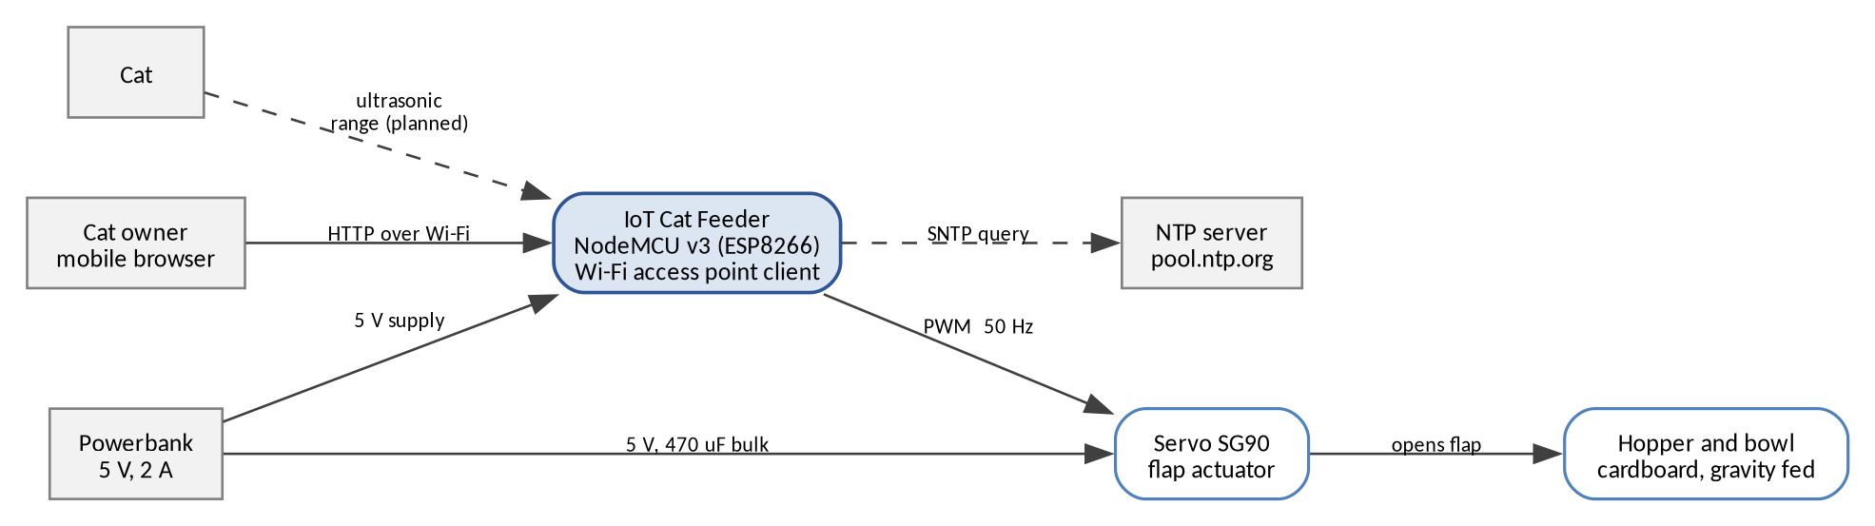
Figure 1. Context view: external entities and energy flow.

2.3 Component View
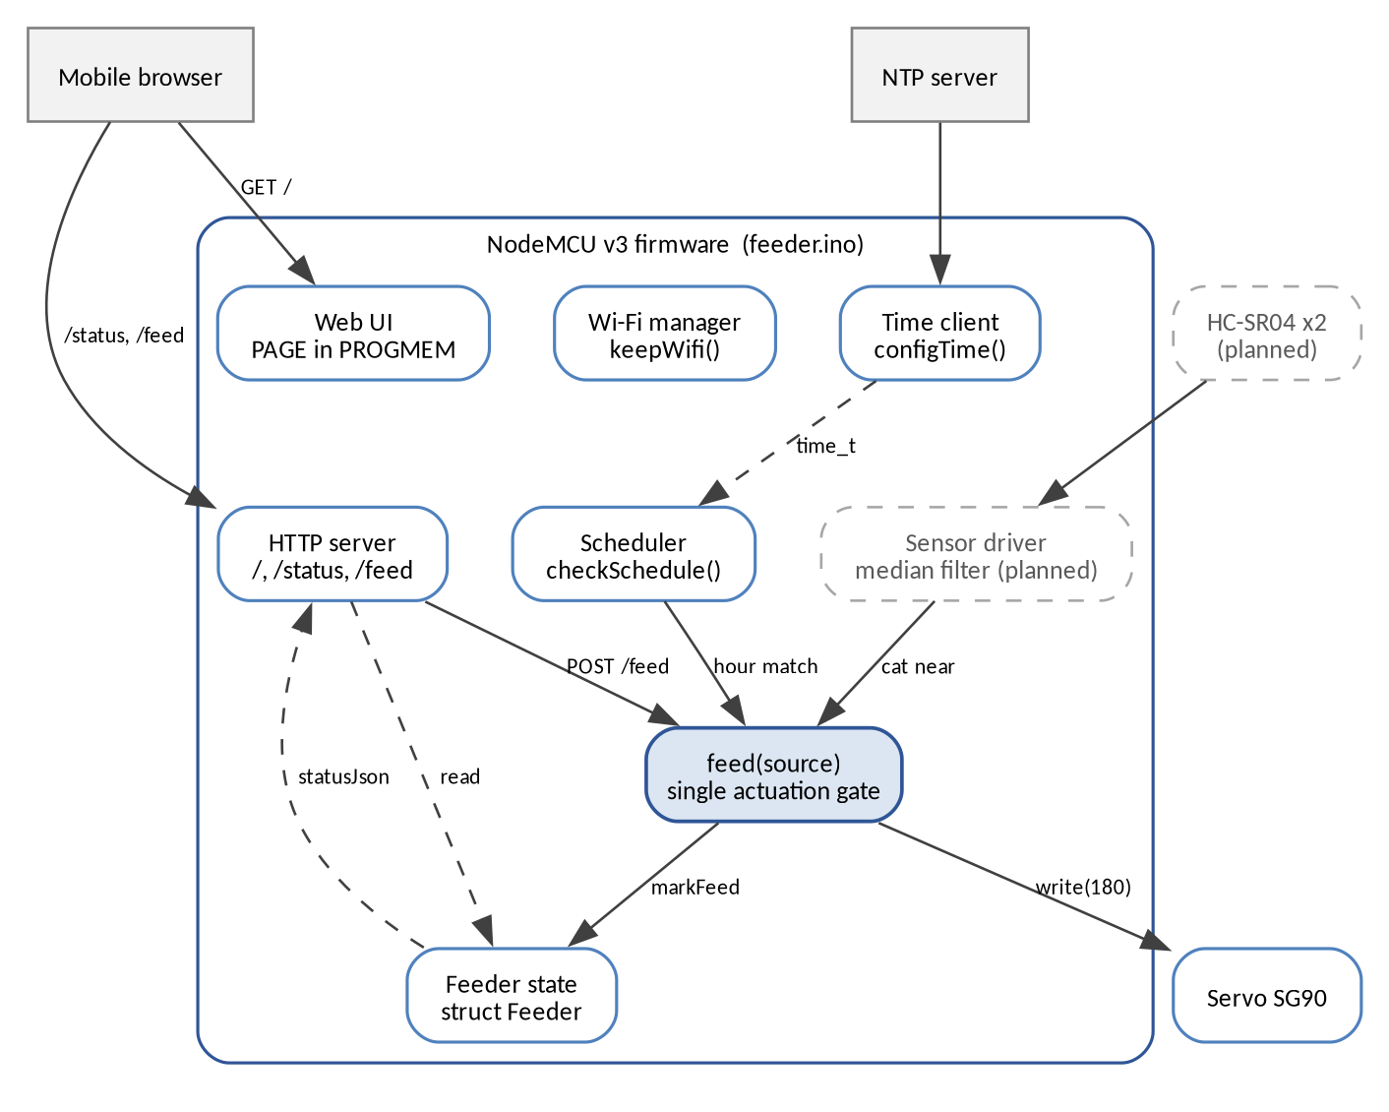
Figure 2. Component view. Dashed components are target features.
Table 3. Component catalogue
Component | Kind | Depends on | Status
PAGE | Constant string in PROGMEM | Nothing | Delivered
server | ESP8266WebServer instance | PAGE, statusJson, feed | Delivered
statusJson | Function | Feeder, clockText, scheduleText, WiFi | Delivered
feed | Function | markFeed, Servo, millis | Delivered
closeFlap | Function | Servo, Feeder | Delivered
markFeed | Function | time, Feeder | Delivered
checkSchedule | Function | time, Feeder, feed | Delivered
clockText, scheduleText | Functions | time, constant table | Delivered
keepWifi | Function | WiFi, millis | Delivered
Presence detector | Function | Ultrasonic driver, feed | Parts received
Mass controller | Function | HX711 driver, feed | Parts received

2.4 Deployment and Power Design
The device has one power input and one ground reference. The servo is the only load that draws significant current, and it is the reason the power design differs from the obvious one.
Table 4. Power distribution
Rail | Source | Loads | Notes
5 V | Powerbank, 2 A | VIN of the board, servo V+ | Servo must not be fed from 3V3.
3.3 V | On-board regulator | ESP8266 core, logic | Limited to a few hundred milliamps.
Ground | Common | Board, servo, sensors | A single ground reference for PWM to be valid.
Bulk capacitance | 470 uF, 16 V | Across 5 V and ground | Absorbs the servo inrush.

The failure that forced this design was observed during bring-up. With the servo powered from the notebook USB port, the board reset whenever the servo started. The stall current of the servo pulls the rail below the regulator dropout. Two changes fixed it: a powerbank with a higher current limit, and a 470 uF capacitor next to the servo connector. The bring-up sketch firmware/servo_test/servo_test.ino exists so that this behaviour can be reproduced without the rest of the firmware.

2.5 Design Rationale
Table 5. Design decisions and alternatives
Decision | Alternative | Why the alternative lost
Single file, functions only | Split modules with headers | 259 lines. A split adds include order problems for no gain.
Cooperative loop, no delay | delay(900) after opening the flap | delay blocks the HTTP server. The page would freeze on every meal.
Close driven by millis() in the loop | Close driven by the HTTP handler | The handler runs only if the client stays connected. The loop always runs.
One feed(source) gate | Separate functions per trigger | Three triggers would need three copies of the counting and cap logic.
Embedded HTML in PROGMEM | SPIFFS file, CDN assets | No file system to corrupt, no network fetch, one flash image.
Boolean state for the flap | Enum state machine | Two states in the delivered scope. The enum becomes justified when the target features land.
In-RAM history | Flash record, external database | The owner asks one question per day. A flash record is scheduled, a database is not justified.

Chapter 3 Detailed Design

3.1 Data Design
The program holds one state record and three constants. There is no heap use after start-up, apart from the String growth inside the JSON builder, which is bounded by the buffer size.
Table 6. State record
Field | Type | Initial | Meaning
open | bool | false | Flap is currently open.
openedAt | unsigned long | 0 | millis() at the last open command.
countToday | int | 0 | Meals since the last local date change.
lastDay | int | -1 | Day of month that countToday belongs to.
lastTime | String | - | HH:MM of the last meal.
lastSource | String | empty | Trigger of the last meal.

Table 7. Constants
Name | Value | Used by
SERVO_PIN | D5, GPIO14 | setup
CLOSED_DEG | 0 | closeFlap, setup
OPEN_DEG | 180 | feed
OPEN_MS | 900 | loop
SCHEDULE_HOUR | 8, 13, 18 | checkSchedule, scheduleText
SCHEDULE_MINUTE | 0 | checkSchedule
TZ_OFFSET | 25200 s | setup

OPEN_DEG is the commanded angle, not the delivered angle. The servo in use reaches about 95 degrees before the flap linkage stops it against the hopper. The mechanism, not the code, is the real limit. A different servo requires this value to be re-measured.

3.2 Component Description
Table 8. Function catalogue
Function | Signature | Purpose
setup | void setup() | Attach the servo, close the flap, start Wi-Fi, start the time client, register routes, start the server.
loop | void loop() | Poll HTTP, enforce the close deadline, check the schedule, keep the link.
feed | void feed(const String &source) | Record the meal, open the flap, stamp the open time.
closeFlap | void closeFlap() | Command the closed angle and clear the open flag.
markFeed | void markFeed(const String &source) | Update count, time, source, and handle the date change.
checkSchedule | void checkSchedule() | Compare local time with the meal table, at most once per minute.
clockText | String clockText() | Format the local time, or a placeholder before NTP.
scheduleText | String scheduleText() | Format the meal table for the dashboard.
statusJson | String statusJson() | Build the eight-field status object.
keepWifi | void keepWifi() | Reconnect at most once every 5 s, with one console line.

3.2.1 Algorithm: the minute key
The scheduler must fire once per scheduled minute, but loop runs thousands of times per second. The design collapses the date and time into one integer and compares it with the value from the previous iteration.
key = (tm_mday * 100 + tm_hour) * 100 + tm_min
- A repeated call inside the same minute produces the same key, so the function exits before the meal table is examined.
- The key changes at a minute boundary, at an hour boundary, and at a month boundary, because the day field is included. Two identical keys therefore indicate the same minute, not merely the same clock face.
- The design trades a rare false negative for a common false positive. A clock that jumps backward one minute re-enters a previous key and is suppressed. A clock that jumps backward by hours may re-enter a key that matches a meal time, which is the residual risk recorded in Section 3.7.

3.2.2 Algorithm: median filtering for ranging (target)
A single ultrasonic reading on a kibble surface is unreliable because the beam scatters. The target design takes ten samples, sorts them, and uses the median. A detection is confirmed only after three consecutive medians fall inside the range window, which removes one-off echoes from the hopper wall or the cat's own movement.

3.3 State Design
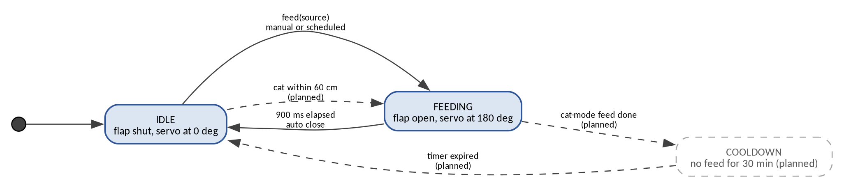
Figure 3. State design. Solid transitions are delivered, dashed are targets.
Table 9. State transitions
From | Event | Guard | To | Action
IDLE | Boot | None | IDLE | Servo to closed angle.
IDLE | feed(source) | None | FEEDING | Record meal, servo to open angle, stamp time.
FEEDING | Loop iteration | millis() - openedAt >= 900 | IDLE | Servo to closed angle.
FEEDING | Loop iteration | Close deadline not reached | FEEDING | None.
IDLE | Cat within 60 cm, three times | Cooldown expired, cap not reached | FEEDING | Record meal with source presence.
FEEDING | Presence meal completed | None | COOLDOWN | Start 30 minute timer.
COOLDOWN | Loop iteration | 30 minutes elapsed | IDLE | None.

3.4 Interaction Flows

3.4.1 Flow: manual feeding
1. The dashboard sends POST /feed with an empty body.
2. server.handleClient() in the main loop dispatches the request to the registered handler.
3. The handler calls feed("manual") and sends {"ok":true}.
4. feed calls markFeed, which reads time(), formats HH:MM, resets the count if the day changed, increments the count, and stores the source.
5. feed writes the open angle and records millis().
6. On a later loop iteration, the close condition becomes true and closeFlap writes the closed angle.
7. The dashboard, polling every 2 seconds, reads open: false and the updated count.

3.4.2 Flow: scheduled feeding
1. A loop iteration calls checkSchedule.
2. The function reads time(). If the value is below the validity epoch, it returns.
3. It computes the minute key and compares it with the stored key. If equal, it returns.
4. It stores the new key and compares the hour and minute with each row of the meal table.
5. On a match it calls feed("schedule") and returns, so a second match in the same iteration cannot occur.

3.4.3 Flow: network recovery
1. Each loop iteration calls keepWifi.
2. If the link is up and the address has not been printed since the last recovery, the address is printed once.
3. If the link is down, the function returns unless 5 seconds have passed since the last attempt.
4. It starts a connection attempt and stamps the time. The attempt does not block.

3.5 Interface Design

3.5.1 HTTP contract
Table 10. Endpoint contracts
Endpoint | Method | Success | Failure
/ | GET | 200, HTML page | 404 for other methods
/status | GET | 200, JSON, eight fields | 404 for other methods
/feed | POST | 200, {"ok":true} | 404 for other methods
Any other path | Any | Not applicable | 404, plain text

3.5.2 Response format
The status object is built with snprintf into a 260 byte buffer. The buffer is adequate for the current field lengths and has no overflow check. If a source string grows, the tail of the object is truncated silently. This is recorded as a limitation rather than fixed, because the source values are compile-time constants.

3.5.3 User interface
Table 11. Dashboard layout
Region | Content | Interaction
Header | Device name and one-line purpose | None
Status card | Five rows: flap, meals today, last meal, device time, schedule | Read only
Action | Full-width feeding button | POST /feed, then a 1300 ms lockout
Footer | RSSI and IP, or a lost-connection message | None

3.6 Timing and Resource Budget
The values below are a design budget, not measurements. The measured columns are filled during the test on 3 November.
Table 12. Timing budget
Path | Budget | Reason
HTTP request to response | 40 ms | One snprintf and one send on a local network.
Button press to flap moving | 150 ms | Network round trip plus servo dead band.
Servo travel, closed to open | 200 ms | About 95 degrees at SG90 rated speed.
Flap open dwell | 900 ms | Fixed by OPEN_MS, long enough for a portion to fall.
Total flap cycle | 1.1 to 1.3 s | Travel plus dwell plus close travel.
Dashboard refresh | 2000 ms | setInterval in the page.
Schedule detection delay | Under 1 s | The loop interval bounds the check.
Main loop period | Under 5 ms | Four non-blocking calls.

3.7 Error Handling and Recovery
Table 13. Failure modes
Failure | Detection | Response | Residual risk
Wi-Fi lost | WiFi.status() | Retry every 5 s without rebooting | Dashboard unavailable until the link returns
Time not yet valid | Epoch below 1600000000 | Scheduler disabled, placeholder clock shown | A meal during the first seconds after boot is skipped
Clock jumps backward | Repeated minute key | The meal in that minute is suppressed | A jump of hours can re-enter a meal minute
Client disconnects mid-request | Handler never returns | The loop closes the flap on schedule | The count is already incremented
Servo stalls | Not detected | None in firmware | Brownout, reboot, lost meal
Unknown path | onNotFound | 404 with no state change | None
Buffer truncation | Not detected | None | Malformed JSON if a field grows

3.8 Security Considerations
- The trust boundary is the Wi-Fi network. Any client on it can dispense food. This is accepted for a single household and is documented in the SRS limitations.
- No administrative endpoint exists, so there is no credential to steal from the device.
- The Wi-Fi credentials live in secrets.h, which is excluded by .gitignore. The repository ships secrets.example.h only.
- The device sends no telemetry outbound except the NTP query, which carries no user data.

Chapter 4 Traceability and Verification

4.1 Requirements Traceability Matrix
Table 14. Traceability
Requirement | Component | Test
FR-01, FR-02, FR-03 | checkSchedule, configTime | TC-04, TC-05
FR-04, FR-05 | feed, closeFlap, loop | TC-02, TC-03
FR-06, FR-12 | Route registration, onNotFound | TC-08
FR-07, FR-10, FR-11 | statusJson, PAGE | TC-01, TC-06
FR-08 | Dashboard script | TC-01
FR-09 | markFeed | TC-07
FR-13, FR-14 | Presence detector, target | TC-09
FR-15, FR-16 | Mass controller, target | TC-10
FR-17, FR-18 | Not implemented | Future work
NFR-RL-01 | loop close condition | TC-03
NFR-RL-02 | keepWifi | TC-11
NFR-SEC-01 | .gitignore | Inspection

4.2 Test Plan
Table 15. Test cases
ID | Case | Procedure | Pass condition
TC-01 | Dashboard loads | Open the device address on a phone. | Five rows populated within 2 s.
TC-02 | Manual feeding | Press the button, observe the flap. | Flap opens within 1.5 s.
TC-03 | Automatic close | Press 50 times with 5 s between presses. | All 50 close without intervention. No flap stays open.
TC-04 | Schedule fires | Set the next meal one minute ahead and wait. | One meal at the minute, recorded with source schedule.
TC-05 | Duplicate suppression | Observe the same minute for 60 s. | Exactly one meal.
TC-06 | Status accuracy | Compare every field with the device state. | All eight fields match.
TC-07 | Date rollover | Let the device run past local midnight. | Count returns to zero.
TC-08 | Method rejection | GET /feed, POST /status, and an unknown path. | 404 for each, with no meal dispensed.
TC-09 | Presence detection | Walk past the sensor 20 times at 50 to 70 cm. | At least 16 detections, no meal inside the cooldown.
TC-10 | Portion mass | Dispense 10 meals onto a scale. | Each within 15 percent of target.
TC-11 | Network recovery | Power cycle the router. | The device rejoins within 30 s, no reboot.

4.3 Known Limitations
Table 16. Limitations accepted in version 1.0.0
ID | Limitation | Impact | Planned fix
L-01 | History is in RAM | A reboot clears the count | Flash record, FR-17
L-02 | No authentication | Any client on the network can feed | Token, or network isolation only
L-03 | Count increments before the servo moves | A failed servo still counts a meal | Count after the close, or verify with the load cell
L-04 | Status buffer is not overflow checked | Possible truncated JSON | Larger buffer or a structured writer
L-05 | No external watchdog | A hang stops feeding until the power is cycled | Hardware watchdog timer
L-06 | Single hopper, single cat | No identity or separation | RFID collar tag

4.4 Future Work
- Persist the last 32 meals to flash with an append-only record.
- Add an ESP32-CAM module and store one still image per meal on the device.
- Identify the cat with an RFID collar tag so a second cat cannot take the portion.
- Add a hardware watchdog so a firmware hang recovers without the owner.
- Replace the cardboard body with a laser-cut enclosure that fixes the servo geometry.
- Publish state to an MQTT broker when the deployment network allows port 1883.

Appendix A Design Review Checklist
Table 17. Design review
Check | Result
Every requirement maps to a component | Yes, Section 4.1
Every component has one responsibility | Yes, Section 2.3
No blocking call in the main loop | Yes, delay is used only in the bring-up sketch
The flap has a bounded open time in every path | Yes, the loop enforces it independent of HTTP
The failure of a client does not change device state | Yes, Section 3.7
Electrical limits of each pin are respected | Partly. The echo divider is required for the target sensors and is recorded in the SRS limitations
The design states what it does not do | Yes, Section 4.3

