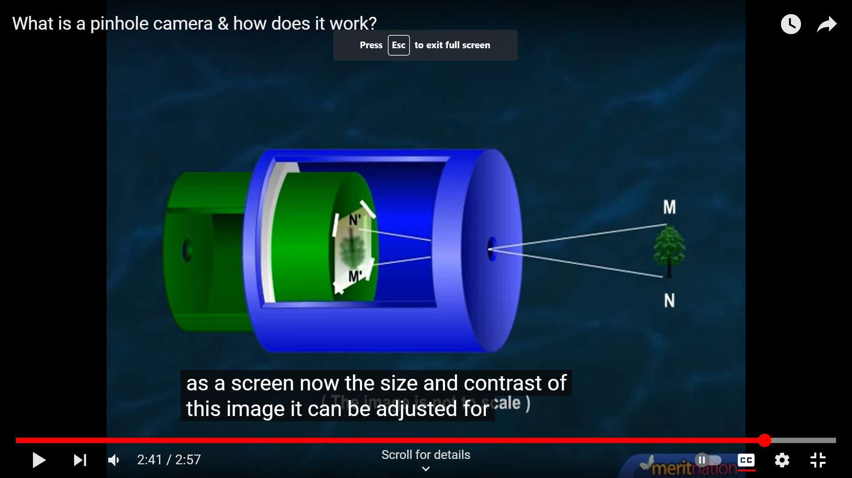Pinhole Camera Answers:
- The pinhole camera will make the image inverted (upside down) because light only travels in straight lines and because the hole in the middle is small the top point of the object will go down and the bottom up.
- A pinhole camera produces its image by having two pieces that each have a small hole and in between them is a photographic paper taped onto it. When aimed at an object it will give an inverted image because the top of the image will go to the bottom of the camera and the bottom will go to the top.
Periscopes questions:
- Where are the two mirrors placed and at what angle?
- How do the mirrors make the periscope work?
Periscopes answers:
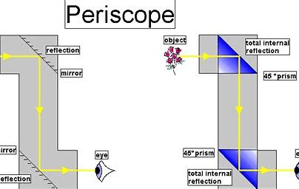
- There are two mirrors placed at 45-degree angles at both ends of the periscope.
- Light enters from the top and hits the first mirror then hits the second mirror then enter your eye.
Drawing ray diagrams on a concave mirror:
- Draw a straight line just underneath the curve in the concave mirror.
- Using that line draw an angle of reflection
- After draw a normal as accurately as you can imbetween the lines to make it accurate measure the angle between the two lines then half it to get accurate angles.
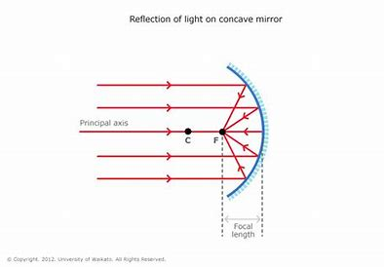

Skills: answers
- The control variable is the variable you keep the same.
- The independent variable is the variable you change.
- The dependant is the variable you measure.

Skills questions:
- What is the control variable?
- What is the independent variable?
- What is the dependant variable?

How to write hypothesis:
1. State the problem that you are trying to solve. Make sure that the hypothesis clearly defines the topic and the focus of the experiment.
2. Try to write the hypothesis as an if-then statement. Follow this template: If a specific action is taken, then a certain outcome is expected.
3. Define the variables ...
4. Scrutinize the hypothesis

How to write a good graph and data table:
- Independent variable on x axis
- Dependant on y axis
- Include the measurements of what you are measuring.
- Calculate an average if needed.
- Have multiple trials to get an accurate result.
- Discrete data is best represented using bar charts.
- Temperature graphs would usually be line graphs because the data is continuous.
- When you are graphing percentages of a distribution a pie chart would be suitable.
- When you have two variables, such as marks in a Maths test and marks in a Science test, then a scatter diagram would be the one to use.
- The other thing you need to remember is that all graphs need ‘SALT’. Make sure you remember the following information:
- S = Scale
- A = Axes
- L = Labels
- T = Title
How to find a good conclusion:
• A conclusion says what has been found out during an investigation. A good conclusion does the following: Fully describes the relationship between variables. Links the findings back to the hypothesis. Explains findings using scientific knowledge and understanding.

Angle of incidence questions:
- What is the angle of incidence?
- What is the angle of reflection?
- What is the rule of reflection?
- What is the normal?
Conclave and convex mirrors:
- What is a convex mirror?
- What is a concave mirror?
- Why does a convex mirror do and why?
- Why does a conclave mirror do and why?
- Draw a convex mirror.
- Draw a conclave mirror.
Concave and convex mirrors answers:
- A convex mirror is a curved mirror which bulges.
- A concave mirror is a curved mirror which goes in.
- A convex mirror makes objects look smaller but increases the range of sight because when the light hits the mirror the light rays scatter and don’t focus on one image, thus making the image have a longer range.
- A conclave mirror makes objects look bigger because all the light focuses to one point.
The angle of incidence:
- The angle of incidence is when the light hits the mirror.
- The angle of reflection is the reflection of the angle of incidence.
- The angle of reflection and the angle of incidence are always the same.
- A normal is a dotted line drawn perpendicular to the surface of the refracting material, at the point of entry of the light. 