5．4 系统编码

5．4．1 实体类
暂无

5．4．2 项目源文件编程
在项目源文件（吉利.cpp）的开始位置，要包括所有实体类的头文件，并定义所有实体类的全局对象数组。下面为代码：

// 吉利.cpp : Defines the class behaviors for the application.

//

#include "stdafx.h"

#include "吉利.h"

#include "吉利Dlg.h"

#ifdef _DEBUG

#define new DEBUG_NEW

#undef THIS_FILE

static char THIS_FILE[] = __FILE__;

#endif

/////////////////////////////////////////////////////////////////////////////

// CMyApp

BEGIN_MESSAGE_MAP(CMyApp, CWinApp)

//{{AFX_MSG_MAP(CMyApp)

// NOTE - the ClassWizard will add and remove mapping macros here.

// DO NOT EDIT what you see in these blocks of generated code!

//}}AFX_MSG

ON_COMMAND(ID_HELP, CWinApp::OnHelp)

END_MESSAGE_MAP()

/////////////////////////////////////////////////////////////////////////////

// CMyApp construction

CMyApp::CMyApp()

{

// TODO: add construction code here,

// Place all significant initialization in InitInstance

}

/////////////////////////////////////////////////////////////////////////////

// The one and only CMyApp object

CMyApp theApp;

/////////////////////////////////////////////////////////////////////////////

// CMyApp initialization

BOOL CMyApp::InitInstance()

{

AfxEnableControlContainer();

// Standard initialization

// If you are not using these features and wish to reduce the size

// of your final executable, you should remove from the following

// the specific initialization routines you do not need.

#ifdef _AFXDLL

Enable3dControls(); // Call this when using MFC in a shared DLL

#else

Enable3dControlsStatic(); // Call this when linking to MFC statically

#endif

CMyDlg dlg;

m_pMainWnd = &dlg;

int nResponse = dlg.DoModal();

if (nResponse == IDOK)

{

// TODO: Place code here to handle when the dialog is

// dismissed with OK

}

else if (nResponse == IDCANCEL)

{

// TODO: Place code here to handle when the dialog is

// dismissed with Cancel

}

// Since the dialog has been closed, return FALSE so that we exit the

// application, rather than start the application's message pump.

return FALSE;

}

5．4．3 主对话框源文件编程
一、包含头文件、声明全局对象数组
// 吉利Dlg.cpp : implementation file
//

#include "stdafx.h"
#include "吉利.h"
#include "吉利Dlg.h"
#include<mmsystem.h>
#pragma comment(lib,"Winmm.lib")

#ifdef _DEBUG
#define new DEBUG_NEW
#undef THIS_FILE
static char THIS_FILE[] = __FILE__;
#endif

/////////////////////////////////////////////////////////////////////////////
// CAboutDlg dialog used for App About

class CAboutDlg : public CDialog
{
public:
CAboutDlg();

// Dialog Data
//{{AFX_DATA(CAboutDlg)
enum { IDD = IDD_ABOUTBOX };
//}}AFX_DATA

// ClassWizard generated virtual function overrides
//{{AFX_VIRTUAL(CAboutDlg)
protected:
virtual void DoDataExchange(CDataExchange* pDX); // DDX/DDV support
//}}AFX_VIRTUAL

// Implementation
protected:
//{{AFX_MSG(CAboutDlg)
//}}AFX_MSG
DECLARE_MESSAGE_MAP()
};

CAboutDlg::CAboutDlg() : CDialog(CAboutDlg::IDD)
{
//{{AFX_DATA_INIT(CAboutDlg)
//}}AFX_DATA_INIT
}

void CAboutDlg::DoDataExchange(CDataExchange* pDX)
{
CDialog::DoDataExchange(pDX);
//{{AFX_DATA_MAP(CAboutDlg)
//}}AFX_DATA_MAP
}

BEGIN_MESSAGE_MAP(CAboutDlg, CDialog)
//{{AFX_MSG_MAP(CAboutDlg)
// No message handlers
//}}AFX_MSG_MAP
END_MESSAGE_MAP()

/////////////////////////////////////////////////////////////////////////////
// CMyDlg dialog
CMyDlg::CMyDlg(CWnd* pParent /*=NULL*/)
: CDialog(CMyDlg::IDD, pParent)
{
//{{AFX_DATA_INIT(CMyDlg)
// NOTE: the ClassWizard will add member initialization here
//}}AFX_DATA_INIT
// Note that LoadIcon does not require a subsequent DestroyIcon in Win32
m_hIcon = AfxGetApp()->LoadIcon(IDR_MAINFRAME);
}

void CMyDlg::DoDataExchange(CDataExchange* pDX)
{
CDialog::DoDataExchange(pDX);
//{{AFX_DATA_MAP(CMyDlg)
// NOTE: the ClassWizard will add DDX and DDV calls here
//}}AFX_DATA_MAP
}

BEGIN_MESSAGE_MAP(CMyDlg, CDialog)
//{{AFX_MSG_MAP(CMyDlg)
ON_WM_SYSCOMMAND()
ON_WM_PAINT()
ON_WM_QUERYDRAGICON()
ON_BN_CLICKED(IDC_LOGON, OnLogon)
ON_BN_CLICKED(IDC_RECORD, OnRecord)
//}}AFX_MSG_MAP
END_MESSAGE_MAP()

/////////////////////////////////////////////////////////////////////////////
// CMyDlg message handlers

BOOL CMyDlg::OnInitDialog()
{
CDialog::OnInitDialog();

// Add "About..." menu item to system menu.
PlaySound((LPCTSTR)IDR_WAVE7,AfxGetInstanceHandle(),SND_RESOURCE|SND_ASYNC);
// IDM_ABOUTBOX must be in the system command range.
ASSERT((IDM_ABOUTBOX & 0xFFF0) == IDM_ABOUTBOX);
ASSERT(IDM_ABOUTBOX < 0xF000);

CMenu* pSysMenu = GetSystemMenu(FALSE);
if (pSysMenu != NULL)
{
CString strAboutMenu;
strAboutMenu.LoadString(IDS_ABOUTBOX);
if (!strAboutMenu.IsEmpty())
{
pSysMenu->AppendMenu(MF_SEPARATOR);
pSysMenu->AppendMenu(MF_STRING, IDM_ABOUTBOX, strAboutMenu);
}
}

// Set the icon for this dialog. The framework does this automatically
// when the application's main window is not a dialog
SetIcon(m_hIcon, TRUE); // Set big icon
SetIcon(m_hIcon, FALSE); // Set small icon

// TODO: Add extra initialization here

return TRUE; // return TRUE unless you set the focus to a control
}

void CMyDlg::OnSysCommand(UINT nID, LPARAM lParam)
{
if ((nID & 0xFFF0) == IDM_ABOUTBOX)
{
CAboutDlg dlgAbout;
dlgAbout.DoModal();
}
else
{
CDialog::OnSysCommand(nID, lParam);
}
}

// If you add a minimize button to your dialog, you will need the code below
// to draw the icon. For MFC applications using the document/view model,
// this is automatically done for you by the framework.

void CMyDlg::OnPaint()
{
if (IsIconic())
{
CPaintDC dc(this); // device context for painting

SendMessage(WM_ICONERASEBKGND, (WPARAM) dc.GetSafeHdc(), 0);

// Center icon in client rectangle
int cxIcon = GetSystemMetrics(SM_CXICON);
int cyIcon = GetSystemMetrics(SM_CYICON);
CRect rect;
GetClientRect(&rect);
int x = (rect.Width() - cxIcon + 1) / 2;
int y = (rect.Height() - cyIcon + 1) / 2;

// Draw the icon
dc.DrawIcon(x, y, m_hIcon);
}
else
{
CDialog::OnPaint();
}
}

// The system calls this to obtain the cursor to display while the user drags
// the minimized window.
HCURSOR CMyDlg::OnQueryDragIcon()
{
return (HCURSOR) m_hIcon;
}

void CMyDlg::OnLogon()
{
// TODO: Add your control notification handler code here
PlaySound(NULL,NULL,SND_PURGE);
m_Dlg.DoModal();
}

void CMyDlg::OnRecord()
{
// TODO: Add your control notification handler code here
PlaySound(NULL,NULL,SND_PURGE);
m_dlg.DoModal();
}
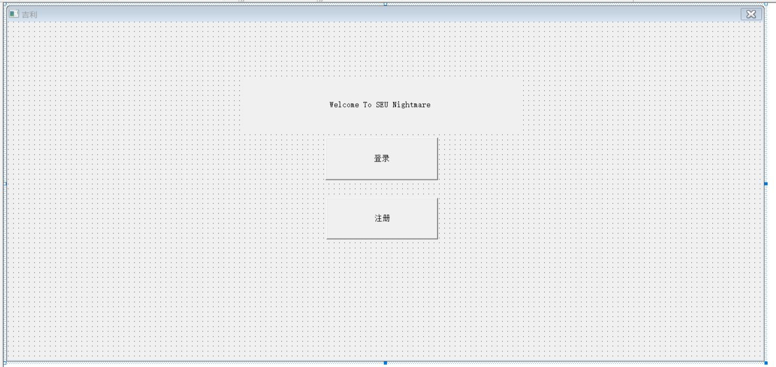

5．4．4游戏编程
以掷骰子游戏为例，
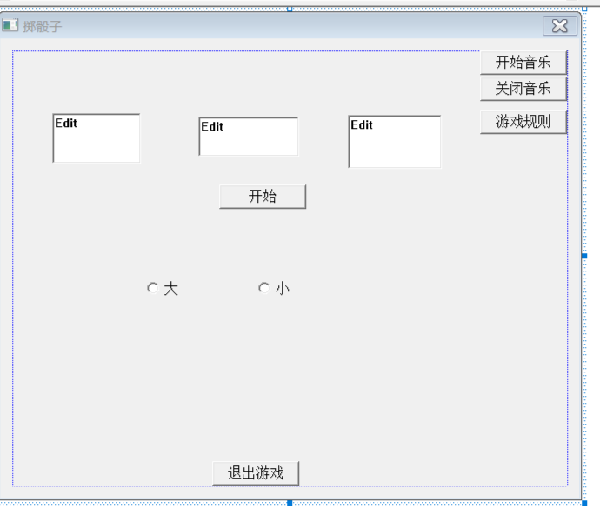
首先请玩家选择下注大或小, 押注的是三个骰子的数字总和。“大”是指数字总和为11 到17；“小” 是指数字总和为4到10，无论大小，骰子数目相同算输。
点击开始，editbox显示随机生成的三个数，并会根据规则，弹出相应的对话框，点击开始音乐，则会播放音乐，点击关闭音乐，则会关闭音乐，点击游戏规则，会弹出游戏规则对话框，点击退出游戏，则会返回游戏主界面。代码如下：
// GrambleGameDlg.cpp : implementation file
//

#include "stdafx.h"
#include "吉利.h"
#include "GrambleGameDlg.h"
#include<cstdlib>
#include<ctime>
#include<mmsystem.h>
#pragma comment(lib,"Winmm.lib")

#ifdef _DEBUG
#define new DEBUG_NEW
#undef THIS_FILE
static char THIS_FILE[] = __FILE__;
#endif

/////////////////////////////////////////////////////////////////////////////
// CGrambleGameDlg dialog

CGrambleGameDlg::CGrambleGameDlg(CWnd* pParent /*=NULL*/)
: CDialog(CGrambleGameDlg::IDD, pParent)
{
//{{AFX_DATA_INIT(CGrambleGameDlg)
m_NUM1 = 0;
m_NUM2 = 0;
m_NUM3 = 0;
m_OPERATOR = -1;
//}}AFX_DATA_INIT
}

void CGrambleGameDlg::DoDataExchange(CDataExchange* pDX)
{
CDialog::DoDataExchange(pDX);
//{{AFX_DATA_MAP(CGrambleGameDlg)
DDX_Text(pDX, IDC_NUM1, m_NUM1);
DDX_Text(pDX, IDC_NUM2, m_NUM2);
DDX_Text(pDX, IDC_NUM3, m_NUM3);
DDX_Radio(pDX, IDC_OPERATOR, m_OPERATOR);
//}}AFX_DATA_MAP
}

BEGIN_MESSAGE_MAP(CGrambleGameDlg, CDialog)
//{{AFX_MSG_MAP(CGrambleGameDlg)
ON_BN_CLICKED(IDC_GOON, OnGoon)
ON_BN_CLICKED(IDC_MUSICON1, OnMusicon1)
ON_BN_CLICKED(IDC_MUSICOFF1, OnMusicoff1)
ON_BN_CLICKED(IDC_RULE, OnRule)
//}}AFX_MSG_MAP
END_MESSAGE_MAP()

/////////////////////////////////////////////////////////////////////////////
// CGrambleGameDlg message handlers

void CGrambleGameDlg::OnGoon()
{
// TODO: Add your control notification handler code here
UpdateData(TRUE);
srand(time(0));
int a=rand()%7,b=rand()%7,c=rand()%7;
while(a==0)
{
a=rand()%7;
}
m_NUM1=a;
while(b==0)
{
b=rand()%7;
}
m_NUM2=b;
while(c==0)
{
c=rand()%7;
}
m_NUM3=c;
UpdateData(FALSE);
int sum=a+b+c;
if(a==b&&b==c)
{
PlaySound((LPCTSTR)IDR_WAVE9,AfxGetInstanceHandle(),SND_RESOURCE|SND_ASYNC);
losserDlg.DoModal();
}
else
{
if(m_OPERATOR==0)
{
if(sum>=4&&sum<=10)
{
PlaySound((LPCTSTR)IDR_WAVE9,AfxGetInstanceHandle(),SND_RESOURCE|SND_ASYNC);
losserDlg.DoModal();
}
if(sum>=11&&sum<=17)
{
PlaySound((LPCTSTR)IDR_WAVE10,AfxGetInstanceHandle(),SND_RESOURCE|SND_ASYNC);
winnerDlg.DoModal();
}
}
if(m_OPERATOR==1)
{
if(sum>=4&&sum<=10)
{
PlaySound((LPCTSTR)IDR_WAVE10,AfxGetInstanceHandle(),SND_RESOURCE|SND_ASYNC);
winnerDlg.DoModal();
}
if(sum>=11&&sum<=17)
{
PlaySound((LPCTSTR)IDR_WAVE9,AfxGetInstanceHandle(),SND_RESOURCE|SND_ASYNC);
losserDlg.DoModal();
}
}
}
}

void CGrambleGameDlg::OnCancel()
{
// TODO: Add extra cleanup here
PlaySound((LPCTSTR)IDR_WAVE1,AfxGetInstanceHandle(),SND_RESOURCE|SND_ASYNC);
CDialog::OnCancel();
}

void CGrambleGameDlg::OnMusicon1()
{
// TODO: Add your control notification handler code here
PlaySound((LPCTSTR)IDR_WAVE5,AfxGetInstanceHandle(),SND_RESOURCE|SND_ASYNC);
}

void CGrambleGameDlg::OnMusicoff1()
{
// TODO: Add your control notification handler code here
PlaySound(NULL,NULL,SND_PURGE);
}

void CGrambleGameDlg::OnRule()
{
// TODO: Add your control notification handler code here
PlaySound((LPCTSTR)IDR_WAVE13,AfxGetInstanceHandle(),SND_RESOURCE|SND_ASYNC);
gambleruleDlg.DoModal();
}

