BIOINF 580 - Assignment 1

Due on Feb 3, 2019 at 10am

After implementing each step, copy the output or the resulting figure along with the description of your results into this document. To copy a Matlab figure, click on *Copy Figure* in the edit menu of your figure. Make sure that your *x*-axis has an appropriate unit (seconds or minutes for time and Hz for frequency), all your axes are labeled and your plot has a title. Submit this document as part of your assignment along with your codes: *main_function.mat , asystole_detection.mat* .

1. Download *ecg.mat* from the assignment files and open it in Matlab. The file contains the ECG signal for a patient ending in asystole. Asystole is defined as the absence of a QRS complex for at least 4 seconds. Use Matlab to plot the signal. Carefully inspect the signal and comment on the components that you can identify in the signal.

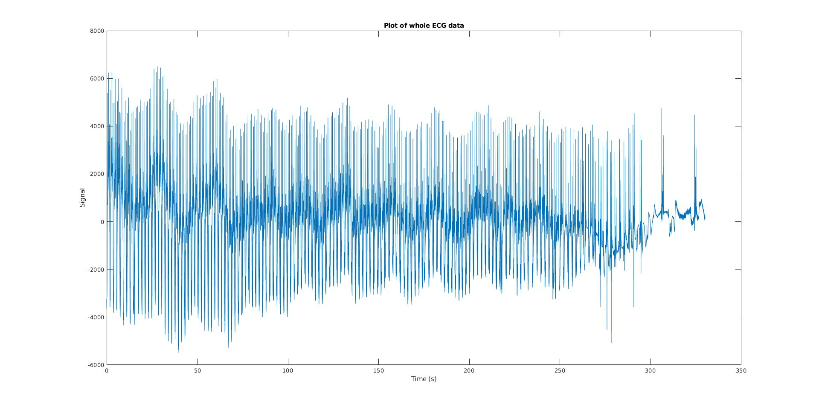*There are multiple signals presented in the ecg graph, with different frequency. The obvious high frequency signal around 0.5Hz and low frequency signal around 1/30 Hz.*

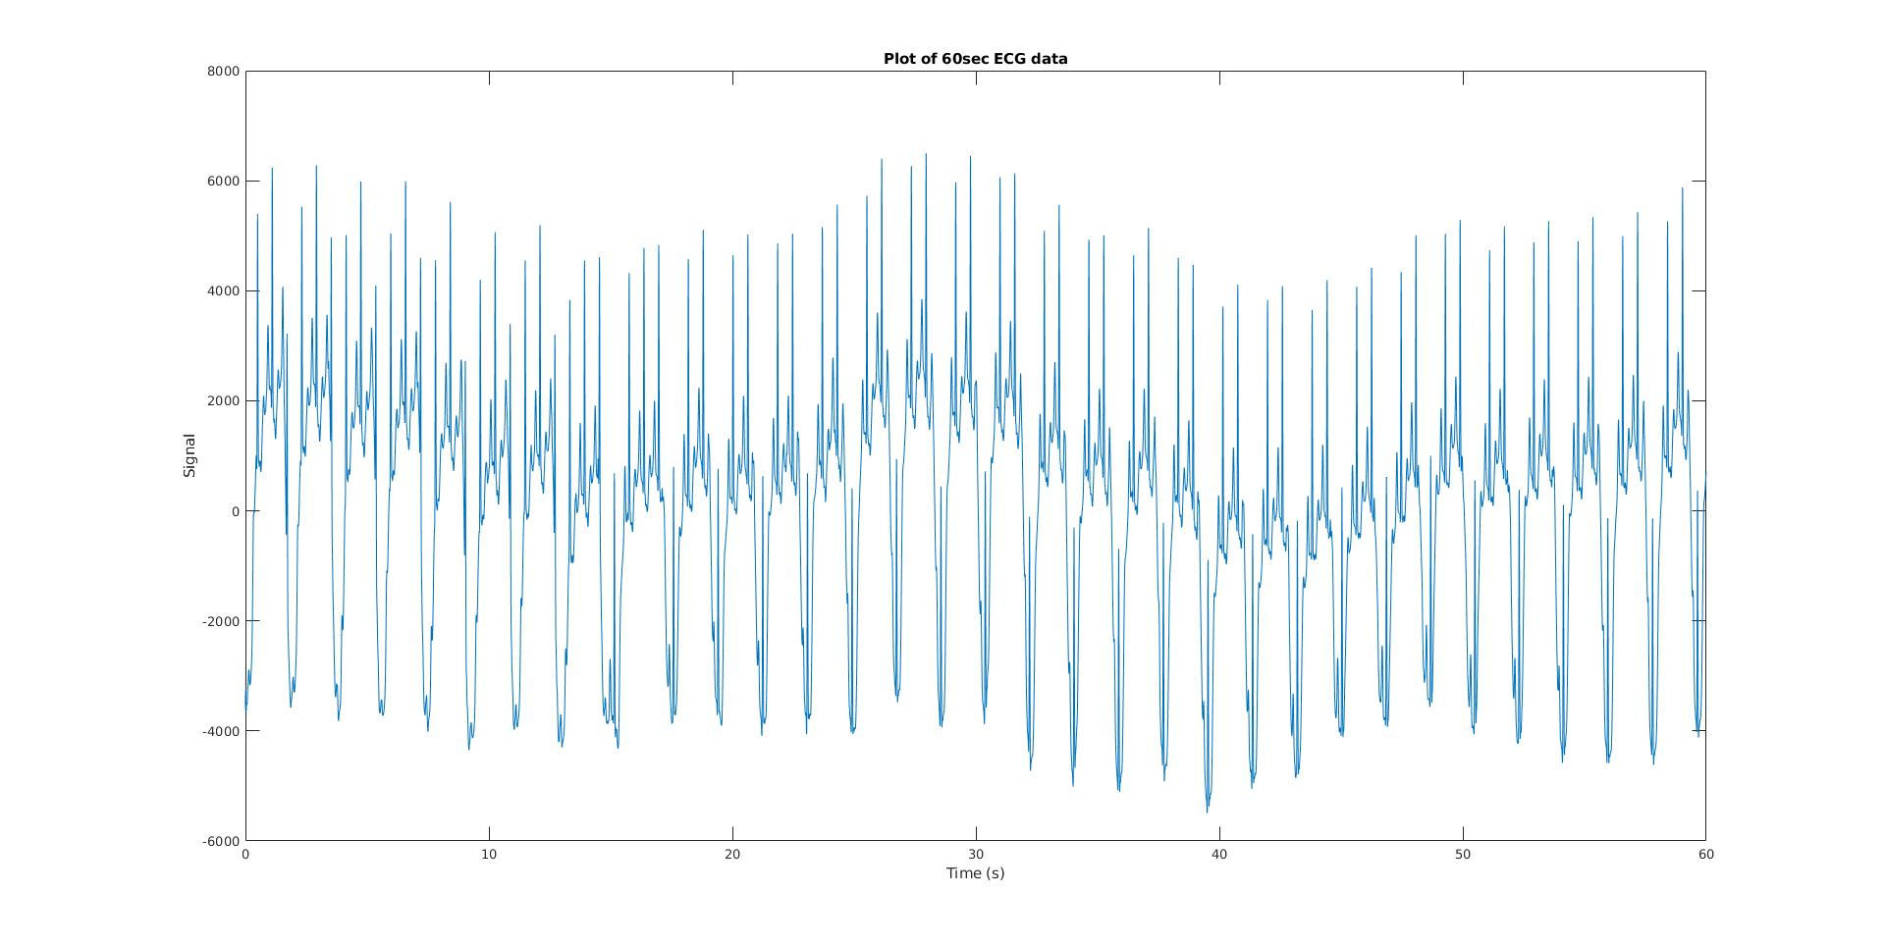

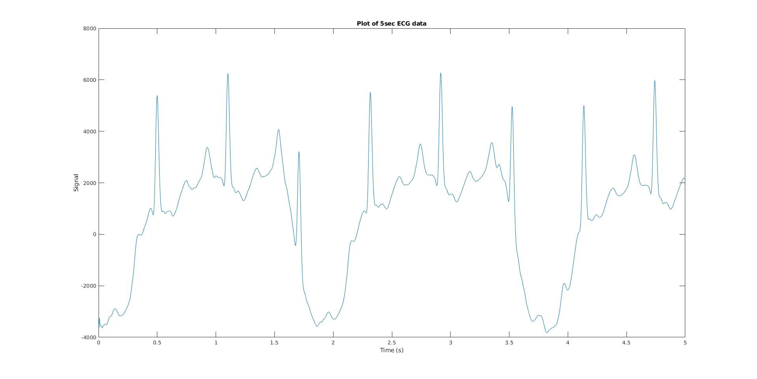

1. Find the Fourier transform (FT) of the signal and plot its magnitude.

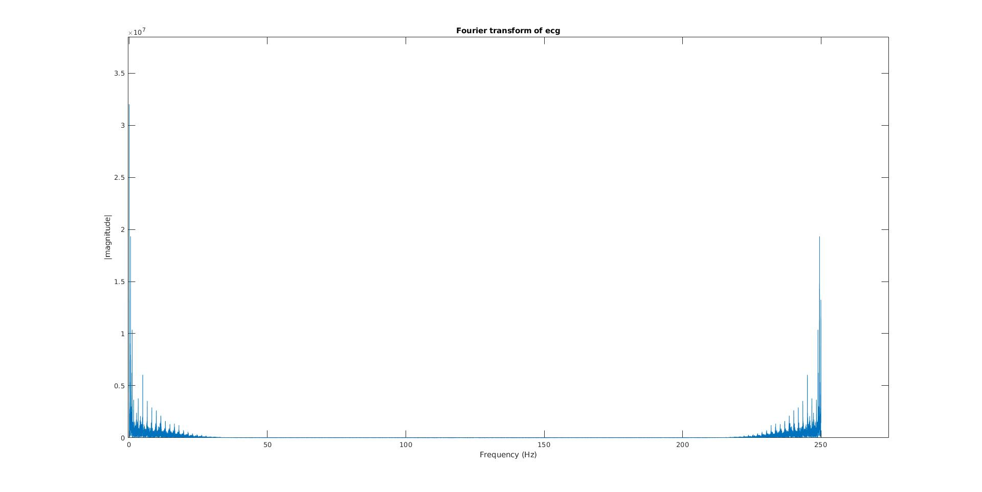

1. Comment on the dominant frequencies in the FT and what they might correspond to.

*0.03939Hz noise (the end of the noise)*

*0.52Hz noise caused by breathing*

*1.091Hz noise drift*

*1.639Hz heart beat*

1. Use a Butterworth filter to remove the noise from the signal. Play with the type of the filter, cut-off frequencies and the order of the filter to achieve the best results. Plot the filtered signal (or a portion of it) and overlay it on the original noisy signal to show the difference. Add a legend to the plot using the command *legend*. Use Matlab help to find out how you can use this command.

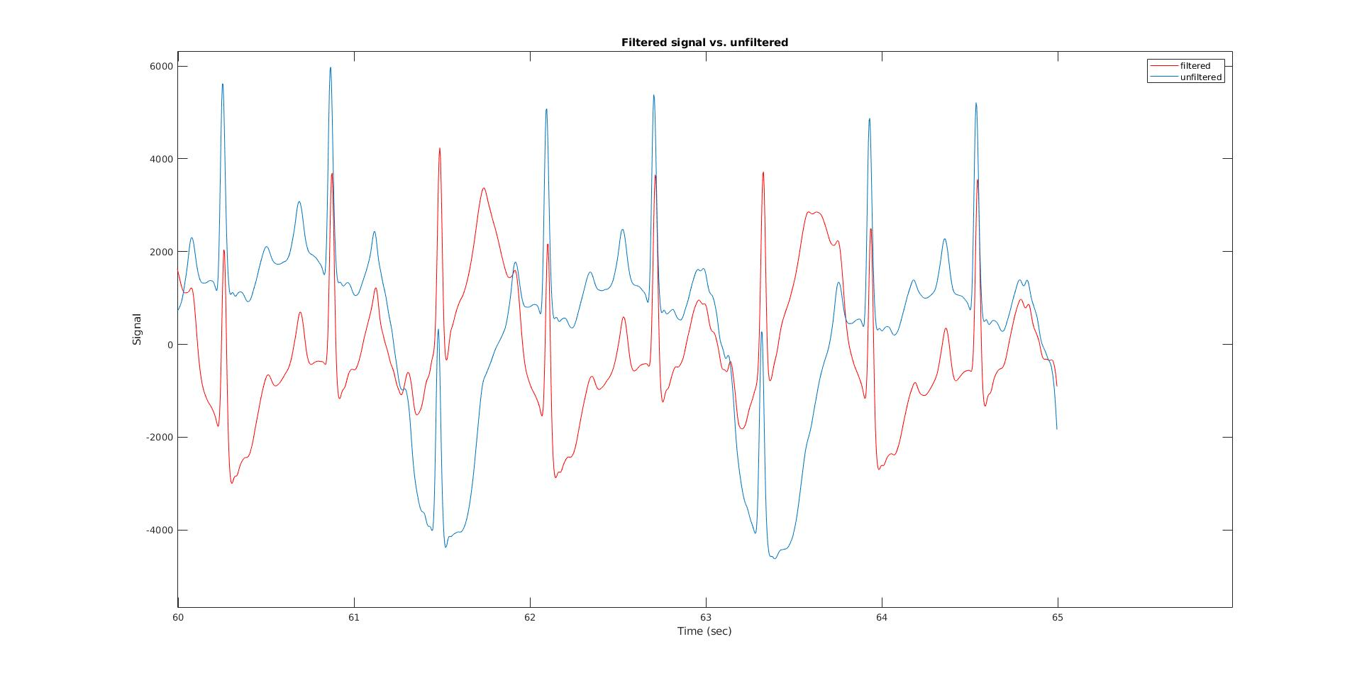

1. Plot the FT of the filtered signal and overlay it on the FT of the original signal and comment on the differences.

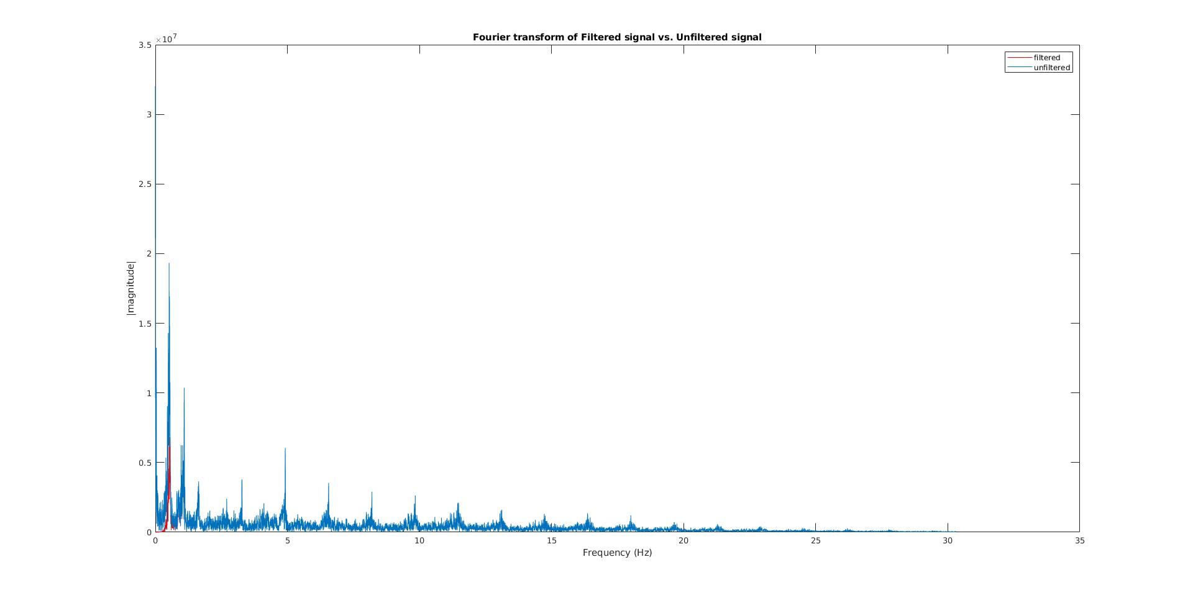*Reduced noise at frequence around 0.5Hz*

1. Write a function to raise an alarm when asystole is detected. The signature of the signal should be  
   *[alarm,t] = asystole_detection(ecg, Fs)*where *ecg* and *Fs* are the signal and the sampling rate, respectively, and *alarm* is a binary vector specifying whether the alarm was raised at a given time and *t* contains the times when the determinations were made. You need to compute a feature (value) from a sliding window in the frequency or time domain that has different values at the end of the signal. Then, threshold this value to decide whether you should raise the alarm or not. Notice that this part can be done in several different ways. So, your answer will be acceptable as long as it makes sense and it works.

Briefly describe your algorithm here, how the cutoff of filter is chosen.

*Sliding window size is choosen as 4 seconds as asystole is defined as absense of QRS complex for at least 4 seconds. Sliding window step is chosen as the sampling rate of the ECG data, 250Hz.*

*1, undergoes two stages of the filtering to filter out both low frequence noise and high frequency noise.*

*2, fourier transform the ecg data from time domain to frequency domain.*

*3, find the magnitude of the signal with frequency from 1.25Hz to 2.5Hz as this is the range of the frequency heart beat can be reside in.*

*(A few sample run suggest, the heart rate is around 1.75 Hz with magnitude around 5e5. There will be a competing signal around 1Hz, therefore choosing the heart range from 1.25Hz to 2.5Hz.)*

*A cutoff is chosen as 7e4, because if there is no absense, there will be a total of 7 heart beat in 4 seconds, so 1 heart beat in 4 seconds would have a magnitude around 5e5/7=7e4 magnitude.*

**Tips**

You might want to use break points to stop and examine when going through subjects. If error occurs and you have a hard time figuring out why, select Breakpoints > Stop on Errors. This way the code will stop right before it exits the code if error occurs.

**Submission Instructions**

Turn in the following files:

* *main_function.mat , asystole_detection.mat and* other function called inside *asystole_detection.mat* **if any!**
* This report named youruniquename_hw1.dox