BIOINF 580 - Assignment 2

Due on Feb 24, 2018 at 10 Pm

After implementing each step, copy the output, the resulting figure or a snapshot from the wavelet toolbox window along with the description of your results into this document. To copy a Matlab figure, click on *Copy Figure* in the edit menu of your figure. Make sure that your *x*-axis has an appropriate unit, all your axes are labeled and your plot has a title. To take a snapshot from the wavelet toolbox, click on *View* and select *Figure Toolbar*. Now you can save the window as a JPG image by clicking on the *Save* button*.* Submit this document as part of your assignment along with your code(s).

1. Download *ecg.mat* from assignment 1 (also available in assignment 2 package) and open it in Matlab. Use the GUI for the Wavelet toolbox (*wavemenu*) to analyze the signal.
   1. Use *Wavelet 1-D* to decompose the ECG signal using db4 up to level 7. Comment on different levels of detail and approximation coefficients and what components of the signal they represent. Can you identify the respiratory in the wavelet coefficients? Tip: to zoom in, click on a subplot, hold the mouse button down and drag the cursor. Then, click on XY+ to zoom in. You can use the <<- button to go back to the initial view. **(5 points)**

**Answer***: Used parameter db4 and level 7.*

*a7: around 0.5Hz, with y oscillate between magnitude 2000.*

*d7: around 1.2Hz, with y oscillate between magnitude 2000.*

*d6: around 3.5Hz, with y oscillate between [-1000,2000]*

*d5: around 5Hz, with y oscillate between [-1000,2000]*

*d4: y oscillate between [-2000,2000]*

*d3: y oscillate between [-1000,1500]*

*d2: y oscillate between [-400, 400]*

*d1: y oscillate between [-40, 40]*

*The low frequency noise (a7, d7, d6), was caused by respiratory noise or drift. The high frequency noise (d5 … d1) may caused by electric current, radio signal, powerline. The high frequency wavelet have a lower amplitude while low frequency wavelet have a higher amplitude. The respiratory is captured in a7*

* 1. Use the *Denoise* module to find the best combination of coefficients that would model the respiratory component of the signal. Start by setting all the thresholds to their maximum levels by moving the scroll bars all the way to the right. This would result in a reconstructed signal that only contains a7. Then, click on the *Residual* button to inspect the residual signal (original signal minus the denoised signal). Zoom in and check if the respiratory component of the signal is completely removed (it is not.) Then starting from d7, set the threshold for the detail levels to zero one by one and inspect the residual signal at each step. Stop when there is almost no respiratory component remaining in the signal and before the morphology of the ECG signal starts getting distorted. Include images of the denoisedand residual signal in your submission (zoom in and make sure at least 10 periods of the ECG signal are visible). Which coefficients are set to zero? **(15 points)**

**Answer:** *The coefficient of d7, d6, d5 is set to zero to get respiratory component. After the they are set to 0, only high frequency noise is presented on the residual signal.*

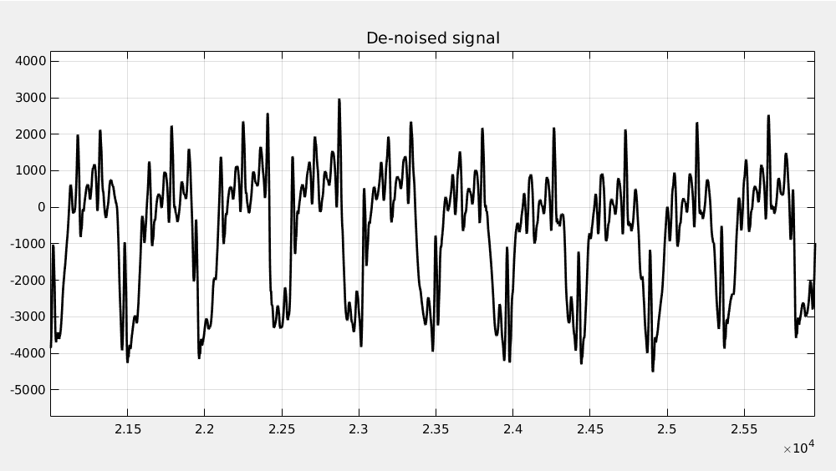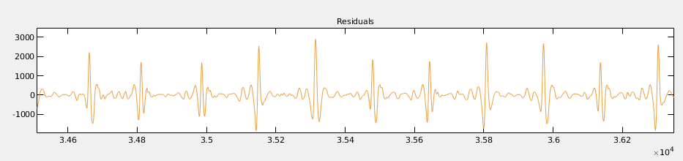

1. Reproduce the denoised signal of 1b in the command prompt.

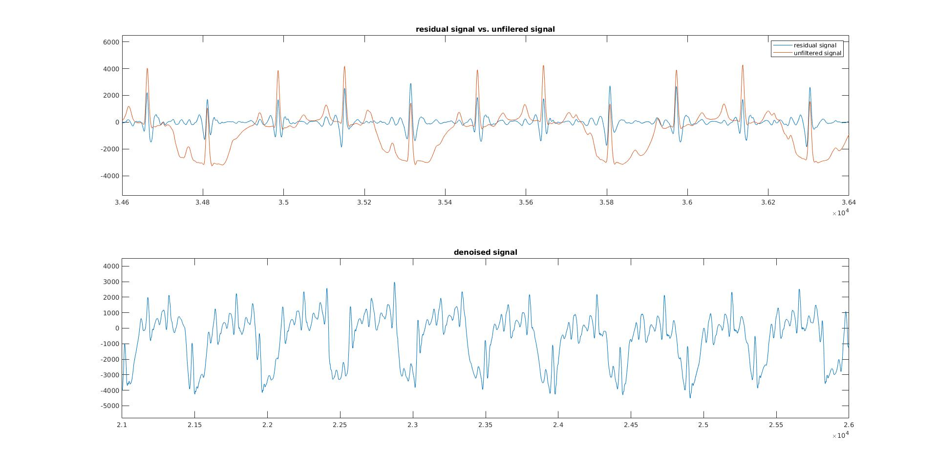Use the *wavedec* command to decompose the ECG signal (read the Matlab help entry for *wavedec* to understand the structure of its outputs). Keep the approximation and/or the detail levels that you want and set all the other ones to zero. Then, use *waverec* command to reconstruct the ECG signal. Plot the original and filtered ECG signals in the same figure and include it in your submission. **(15 points)**

1. Similar to part 6 of assignment 1, write a function that raises an alarm when asystole is detected but use the Wavelet coefficients to do so instead. Plot alarm vs t and include it in your report. **(20 points)**

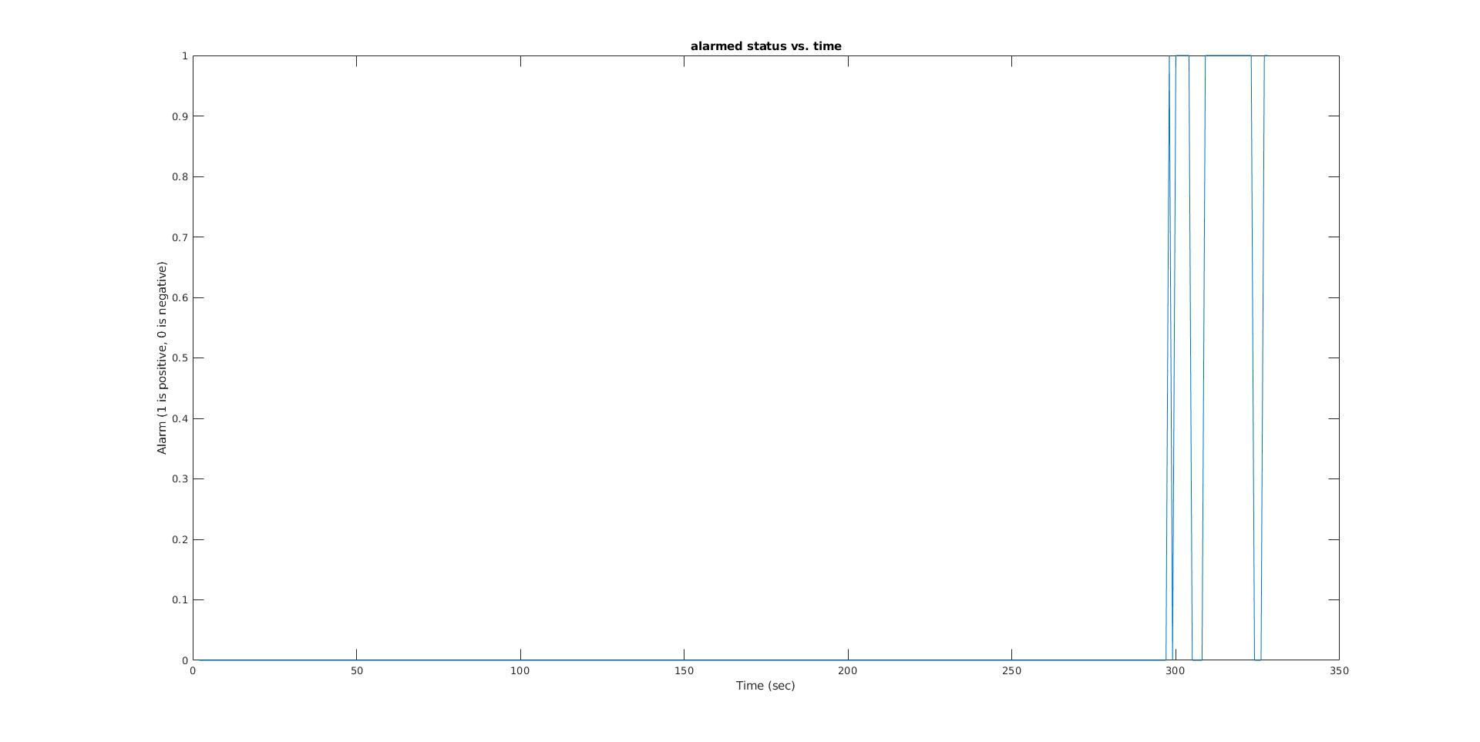

Turn in the following files:

* *main_function.mat , asystole_detection.mat and* function other than find_power.mat that called inside *asystole_detection.mat* **if any!**
* This report named youruniquename_hw2.dox