BIOINF 580 - Assignment 3

Due on Mar 24, 2018 at 10pm

After implementing each step, copy the output, the resulting figure along with the description of your results into this document. **Make sure that your *x*-axis has an appropriate unit, all your axes are labeled and your plot has a title**. Submit this document as part of your assignment along with your code(s).

1. Complete the *renyi_entro.mat* function to include the Shannon and Hartley entropy definition as well. (10 points)
2. Download *ecg.mat* (also available in assignment 1 and 2 packages) and open it in Matlab. Reproduce the denoised signal from assignment 2, question 2 (hint: filter out a7 and d7 coefficient). Calculate Shannon entropy of the filtered ecg signal as function of time by sliding a 4-second window, with 1-second step size. (15 points)
3. Plot the denoised ecg and the entropy signals in a figure with two stacked subplots. Is there a difference between healthy and asystole sections? Is this expected? Why or why not? (10 points)

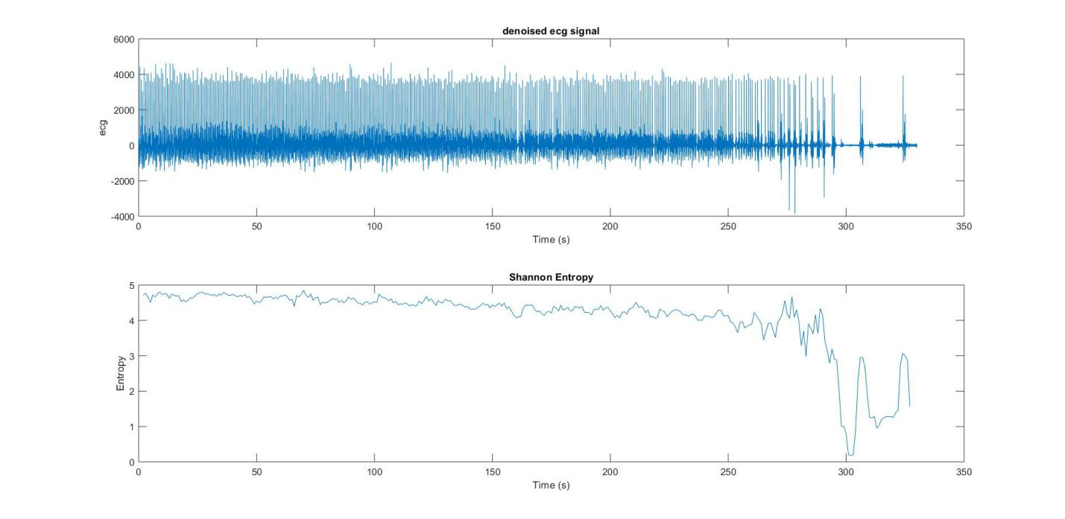

*Yes, there is differences between the Shannon Entropy of healthy and asystole section. The entropy sharply decreased . Yes, it is expected. During the asystole section, there are less signals presented (ecg from heart is missing), less information is presented in the signal, thus less entropy level. Therefore, the entropy level of asystole section is smaller than that of a healthy section.*

Turn in the following files:

* *main_function.mat, renyi_entro.mat* functions
* This report named youruniquename_hw3.dox