CS 255 Project One Business Requirements Document

System Components and Design

Purpose
What is the purpose of this project? Who is the client and what do they want their system to be able to do?
• DriverPass is the client for this project. The purpose is to design a web-based system that helps customers prepare for DMV driving tests through online learning, practice exams, and optional on-the-road training.
• The system will support customers as well as DriverPass staff, including the owner, IT officer, and secretary, with role-appropriate access to the functions they need.
• The system should centralize scheduling, training records, account management, reporting, and customer activity so DriverPass can operate the business efficiently.

System Background
What does DriverPass want the system to do? What is the problem they want to fix? What are the different components needed for this system?
• DriverPass was created to address a gap in driver training: many students fail their DMV tests after relying mainly on previous test questions instead of receiving broader preparation.
• The proposed solution combines online classes and practice exams with in-person instruction and driving lessons. Customers can choose from three training packages, and each driving session is two hours long.
• Major components include customer and account management, reservation scheduling, driver and vehicle assignment, package management, online training and practice tests, test-progress tracking, driver notes, activity history, and reporting.
• The system should be web based, preferably hosted in the cloud, and usable from computers and mobile devices. Selected reports and information should also be downloadable for offline use.
• The system must record who created, changed, or canceled reservations and should notify DriverPass when the DMV provides new rules, policies, or sample questions.

Objectives and Goals
What should this system be able to do when it is completed? What measurable tasks need to be included in the system design to achieve this?
• Provide account-based access for customers and DriverPass employees with permissions appropriate to each role.
• Allow a customer or secretary to register a student and store contact, payment, pickup, and drop-off information.
• Allow customers to create, modify, and cancel driving lesson reservations online, while allowing the secretary to schedule appointments for customers who call or visit the office.
• Associate each reservation with the correct customer, driver, vehicle, date, and time and schedule driving lessons in two-hour blocks.
• Support the three current DriverPass packages and allow DriverPass to disable a package so new customers cannot select it.
• Track practice-test progress and driver notes, maintain an activity history, provide reports, and keep training content aligned with DMV updates.

Requirements

Nonfunctional Requirements
The following nonfunctional requirements describe how the DriverPass system must operate in order to support the client’s business needs.

Performance Requirements
What environments does this system need to run in? How fast should the system run? How often should the system be updated?
• The system will operate as a web-based application and should support normal use from both computers and mobile devices.
• All changes to live business data must be performed while connected to the central system so DriverPass does not create duplicate or conflicting records.
• The interview does not specify a numeric response-time target or fixed update interval; these targets should be finalized during detailed design and testing.
• DMV content changes should become available after the external DMV source provides an update and the information is processed by the system.

Platform Constraints
What platforms should the system run on? Does the back end require any tools, such as a database, to support this application?
• The solution should run through a web browser and preferably be hosted in the cloud so DriverPass does not have to maintain local backup and security infrastructure.
• The interface must work on desktop/laptop computers and mobile devices.
• The back end requires centralized persistent storage for accounts, reservations, training records, packages, drivers, vehicles, activity history, and test results.
• Downloaded reports may be used offline, but live records cannot be modified offline because that could create data redundancy.

Accuracy and Precision
How will you distinguish between different users? Is input case-sensitive? When should the system inform the admin of a problem?
• Each user must be identified through an individual account so the system can apply the correct role and permissions.
• Reservations must accurately associate a customer with the correct driver, vehicle, date, and time, and each driving lesson must use a two-hour time block.
• The system must record who created, modified, or canceled a reservation so DriverPass can produce an accurate activity report.
• Customer registration and payment fields should be validated before a record is accepted. The transcript does not define case-sensitivity rules, so those rules should be standardized during detailed design.
• Account or data-integrity problems should be visible to the IT officer so corrective action can be taken.

Adaptability
Can users be added, removed, or modified without changing code? How will the system adapt to platform updates? What type of access does the IT admin need?
• The IT officer should be able to maintain user accounts, reset accounts, and block access without requiring changes to application code.
• DriverPass should be able to disable an existing training package when it no longer wants new customers to register for it.
• Adding or removing major modules or creating new package structures would require a developer or systems analyst, as described in the interview.
• The web-based design should avoid dependence on a single desktop operating system and should be maintained as browsers and cloud services change.

Security
What is required for login? How can the connection or data exchange be secured? What should happen after repeated failed logins or when a user forgets a password?
• Users must authenticate before accessing account-specific functions, and permissions must be enforced according to role.
• The IT officer must be able to reset accounts and block access when an employee leaves or an account is compromised.
• Customers should be able to reset a forgotten password through an automated recovery process.
• Because the system handles personal and credit-card information, client-server communication and stored sensitive data should be protected with appropriate security controls.
• Repeated failed login attempts should be limited or temporarily locked, with the event available to the IT administrator for review.

Functional Requirements
Each functional requirement below describes a function the DriverPass system must provide.
• The system shall allow users to log in and receive access based on their assigned role.
• The system shall allow the IT officer to reset accounts, block accounts, and maintain user access.
• The system shall allow a customer or secretary to register a student and store required contact, payment, pickup, and drop-off information.
• The system shall allow customers to create, modify, and cancel driving lesson appointments online.
• The system shall allow the secretary to create and manage appointments for customers who call or visit the office.
• The system shall associate each scheduled lesson with a customer, driver, vehicle, date, and time.
• The system shall support the three DriverPass training packages and allow an authorized user to disable a package.
• The system shall provide online classes and practice tests to customers with access through their selected package.
• The system shall record practice-test name, time taken, score, and status as not taken, in progress, failed, or passed.
• The system shall store lesson start time, end time, and driver comments.
• The system shall record who created, modified, or canceled each reservation and shall allow DriverPass to print an activity report.
• The system shall allow selected reports and information to be downloaded for offline work.
• The system shall receive DMV update information and notify DriverPass when new rules, policies, or sample questions are available.
• The system shall provide an automated password-reset process for customers.

User Interface
What are the needs of the interface? Who are the different users and what must each be able to do?
• The interface should be web based and responsive so it can be used from computers and mobile devices.
• Customers need pages for account access, student information, package information, appointment scheduling, online classes, practice tests, test progress, and password recovery.
• The secretary needs screens for registering students and creating or updating appointments on a customer’s behalf.
• The IT officer needs administrative screens for user-account maintenance, password/account recovery, and access blocking.
• The owner needs access to business information and reports, including activity history.
• The interface should display online test progress and driver notes in clear tables and provide a way to contact DriverPass and contact students.

Assumptions
What assumptions are being made about users, technology, and information that were not fully specified?
• Users will have an internet connection and a current web browser when making changes to live data.
• DriverPass will use a cloud hosting environment that provides the backup and infrastructure support requested by the client.
• The DMV will provide a usable external source or interface for transmitting rule, policy, and sample-question updates.
• DriverPass will provide and maintain the staff, driver, vehicle, package, and customer information needed by the system.
• The project schedule assumes the customer approves the design on March 10-11 without requesting changes that require rework.

Limitations
What limitations exist related to resources, time, technology, or the current system scope?
• The system will not support editing live business data while offline; offline use is limited to downloaded reports or information.
• Nontechnical users will not be able to add or remove major software modules without help from a developer or systems analyst.
• The current release focuses on the requirements identified in the interview; future features have not yet been defined.
• Exact budget limits, service-level targets, infrastructure specifications, and detailed compliance requirements were not provided and will need to be defined later.
• The system depends on external services such as cloud hosting and DMV update availability, so outages or changes to those services may affect system behavior.

Gantt Chart
The schedule below follows the tasks, start dates, end dates, overlaps, and dependencies stated in the DriverPass interview transcript.
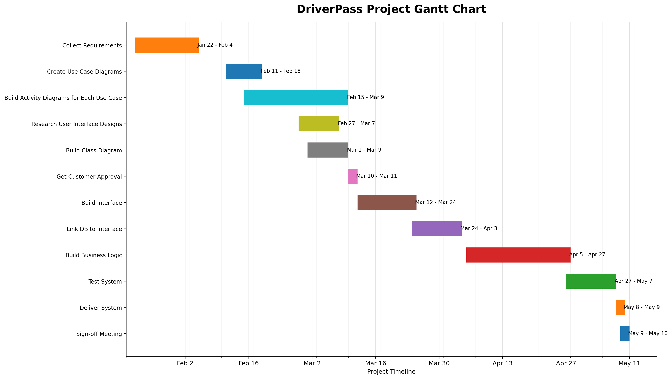
DriverPass project Gantt chart.

