CS 255 System Design Document
DriverPass
Project Two
Chingiz Dadashev

UML Diagrams
Figure 1. DriverPass UML Use Case Diagram
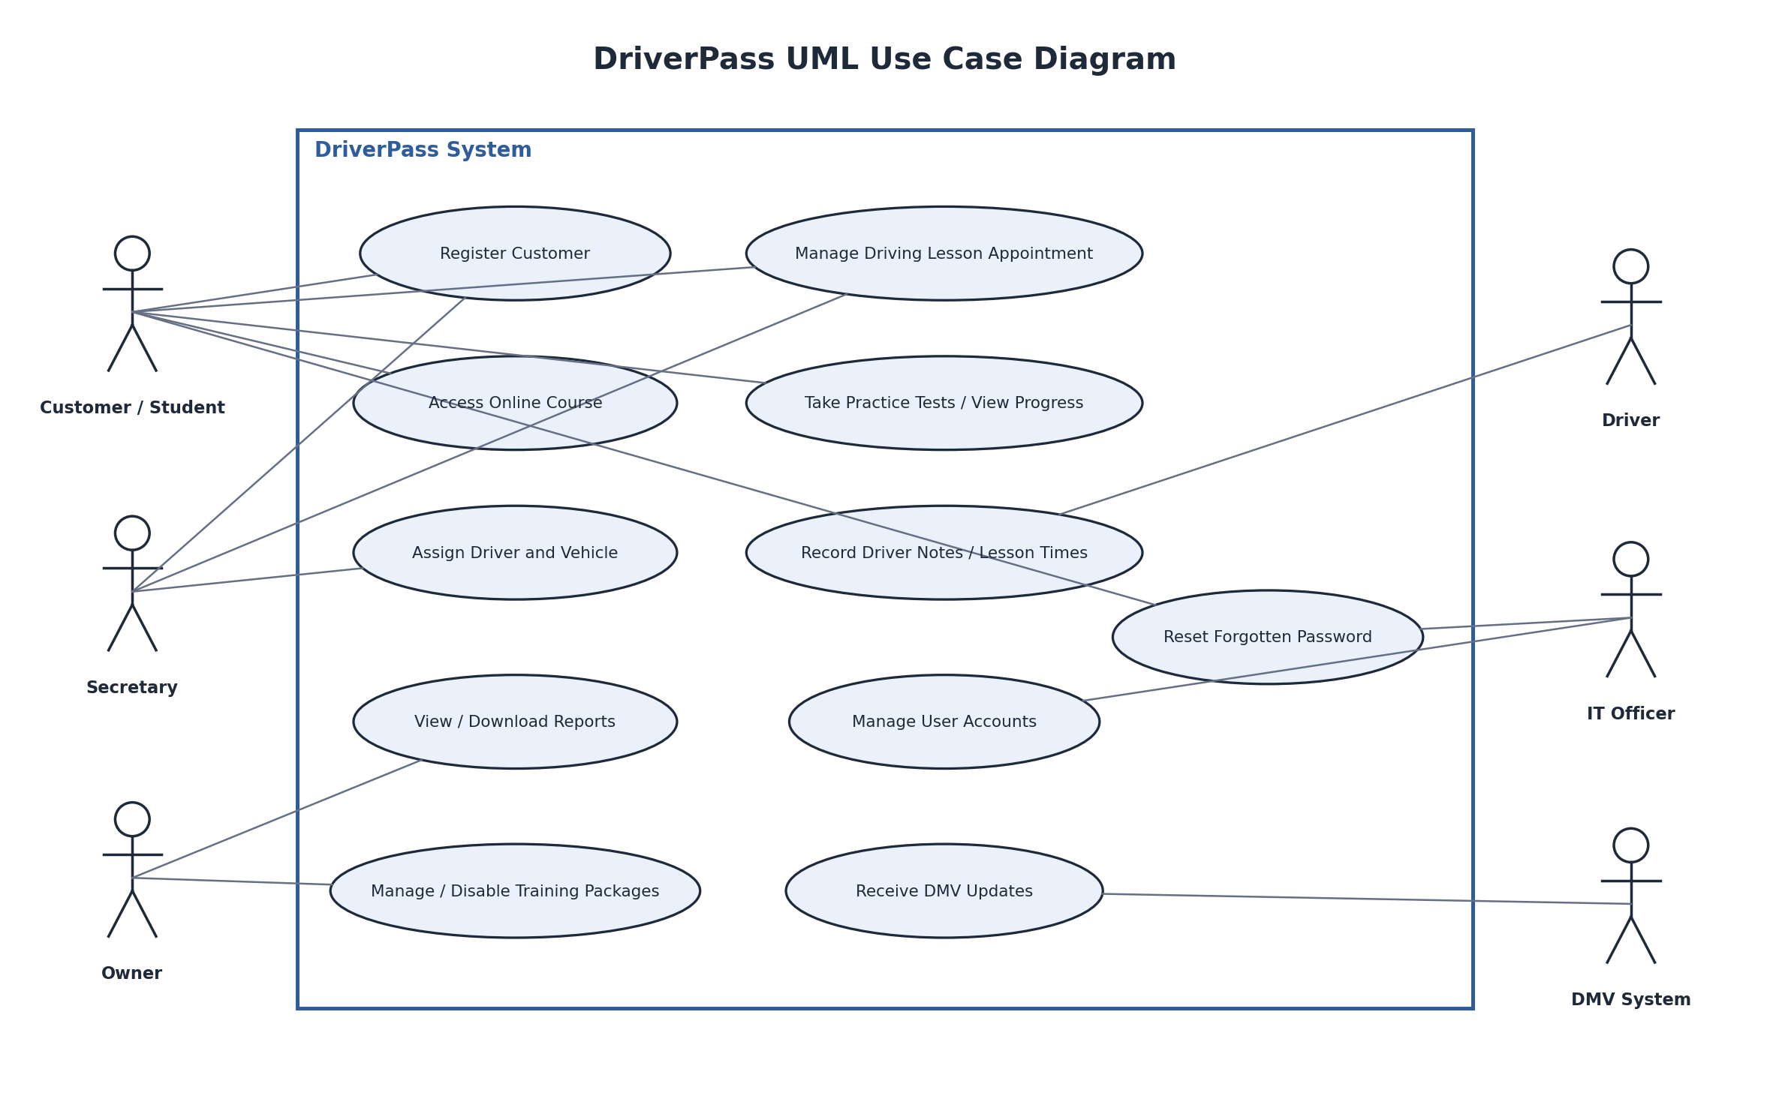

UML Activity Diagrams
Figure 2. Manage Driving Lesson Appointment
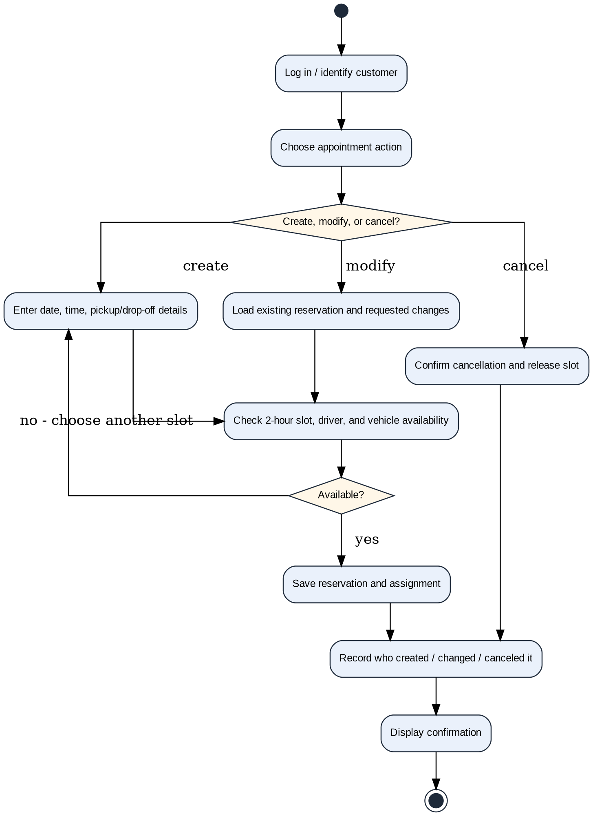

UML Activity Diagrams
Figure 3. Take Practice Test
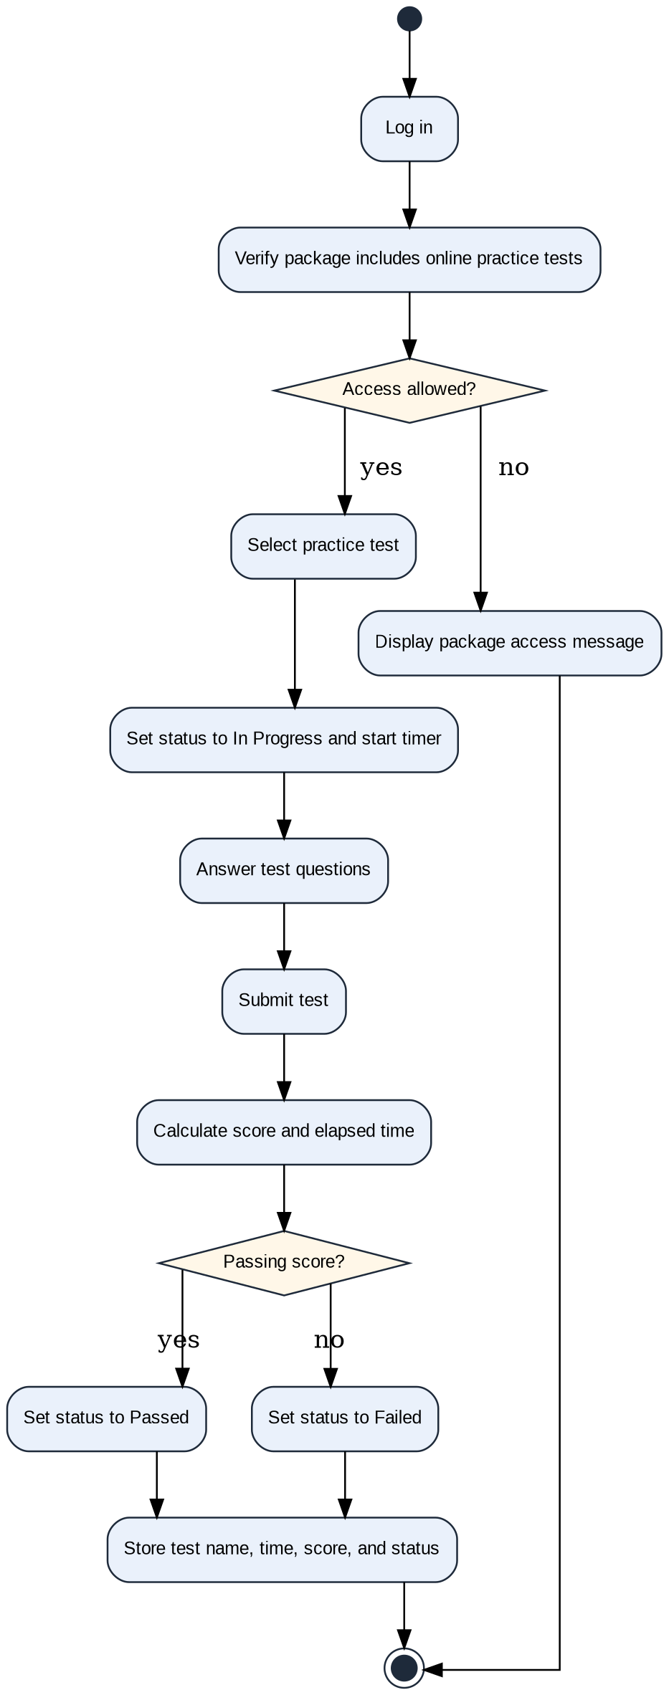

UML Sequence Diagram
Figure 4. Manage Driving Lesson Appointment
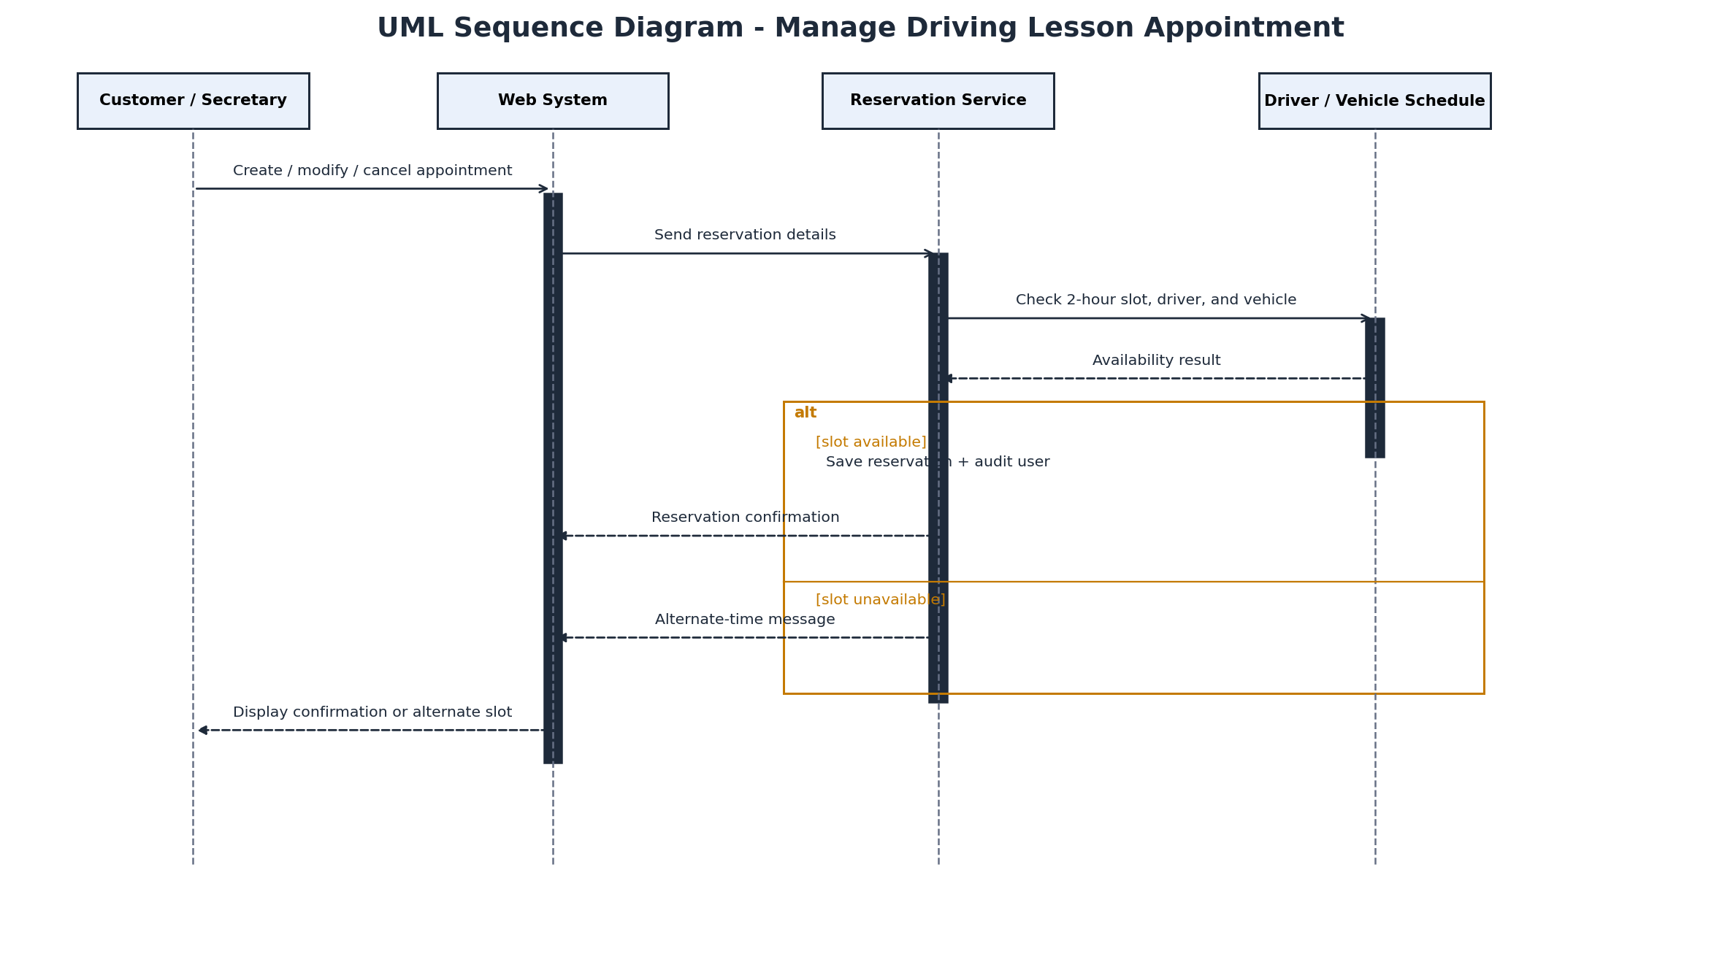

UML Class Diagram
Figure 5. DriverPass UML Class Diagram
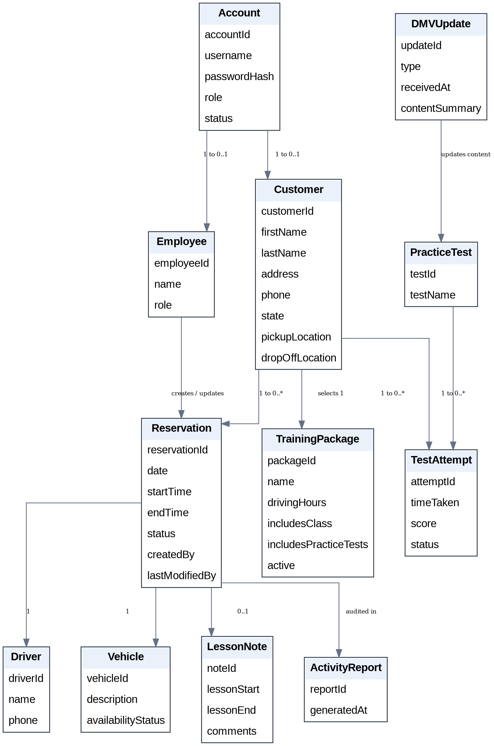

Technical Requirements
The DriverPass system requires the following hardware, software, tools, and infrastructure to support the proposed design and client requirements.
Hardware and Client Access
• Users need a desktop, laptop, tablet, or smartphone with a current web browser and reliable internet access for live system transactions.
• DriverPass staff require office computers capable of printing activity reports and exporting selected information for offline work.
Application Software
• A responsive web application will provide role-specific interfaces for customers, the secretary, the owner, drivers, and the IT officer.
• The application must support registration, package selection, two-hour lesson scheduling, online classes, practice tests, test-progress tracking, driver notes, password recovery, reporting, and account administration.
• The browser interface should work across common desktop and mobile platforms so the solution is not tied to one operating system.
Data and Back-End Services
• A centralized relational database is required for user accounts, customer and payment records, packages, reservations, driver/vehicle assignments, test attempts, lesson notes, activity history, and DMV updates.
• All live changes must be written to the central data store while online to avoid duplicate or conflicting records. Downloaded reports may be used offline, but they are not synchronized edits.
• Reservation logic must check the customer, driver, vehicle, date, and two-hour time block before saving to prevent conflicting assignments.
Cloud and Infrastructure
• The system should be hosted in a managed cloud environment that provides web hosting, database hosting, backup, recovery, monitoring, and scaling.
• The solution requires secure connectivity between browsers, application services, the central database, and an external DMV data source that can provide rules, policies, or sample-question updates.
Security and Administration
• Users must authenticate before account-specific functions are available, and role-based access control must restrict each user to authorized functions.
• Sensitive traffic must use encrypted connections. Personal and payment information must be protected in storage with appropriate access controls and encryption or payment tokenization.
• The system must support automated customer password recovery, IT-controlled account resets and blocking, rate limiting or temporary lockout after repeated failed logins, and audit logging of reservation creation, changes, and cancellations.
Development and Support Tools
• A CASE tool such as Lucidchart is used to maintain the UML design models. Development also requires source control, automated testing, deployment tooling, database administration tools, and cloud monitoring/logging.
• Exact capacity targets, response-time service levels, detailed compliance obligations, and budget-specific infrastructure sizing remain to be finalized during implementation planning and testing.

