Bob Lin

Math381

Homework5

Here, I will explore the distance of several city I like in Asian and label them as cities that are close together which means the largest distance among each of pair will less than 5000 km. I first collect a chart containing the distance information between them as following (the distance is the air distance):

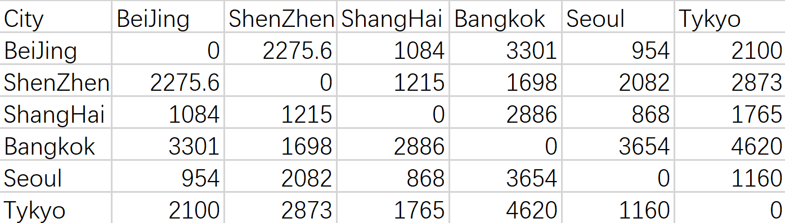

To better analyze the model, I also collect a chart containing the distance information among some “far away” city which has at least one distance greater than 5000, and the chart is following:

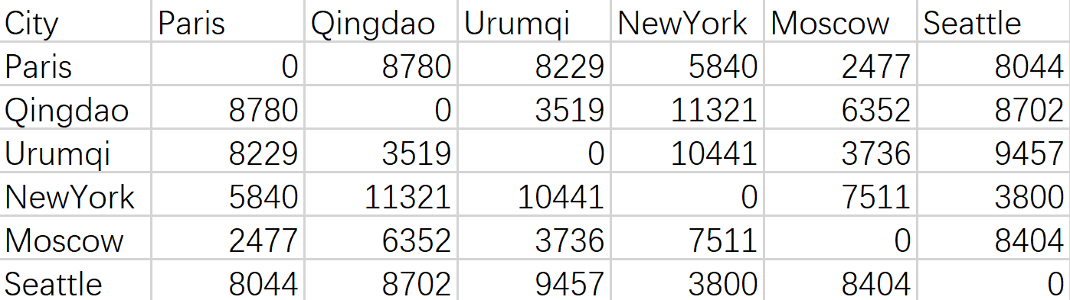

To see the 1,2,3 dimensional models, I will use R to apply MDP(multidimensional scale) to this distance matrix, below is the code:

distances <- read.csv(file="381matrix.csv",

head=FALSE,sep=",")

model1 <- cmdscale(distances,k=1)

plot(model2,asp=1,

ylab="",xlab="")

Also I use following code to generate the text plot which is clear to see the city position:

distplusnames <- read.csv(file="381name.csv",head=TRUE,sep=",")

text(model1[,1],

cex=1)

This creates the following textplot with name in each position:

The plot is a 1D model of cities close together:

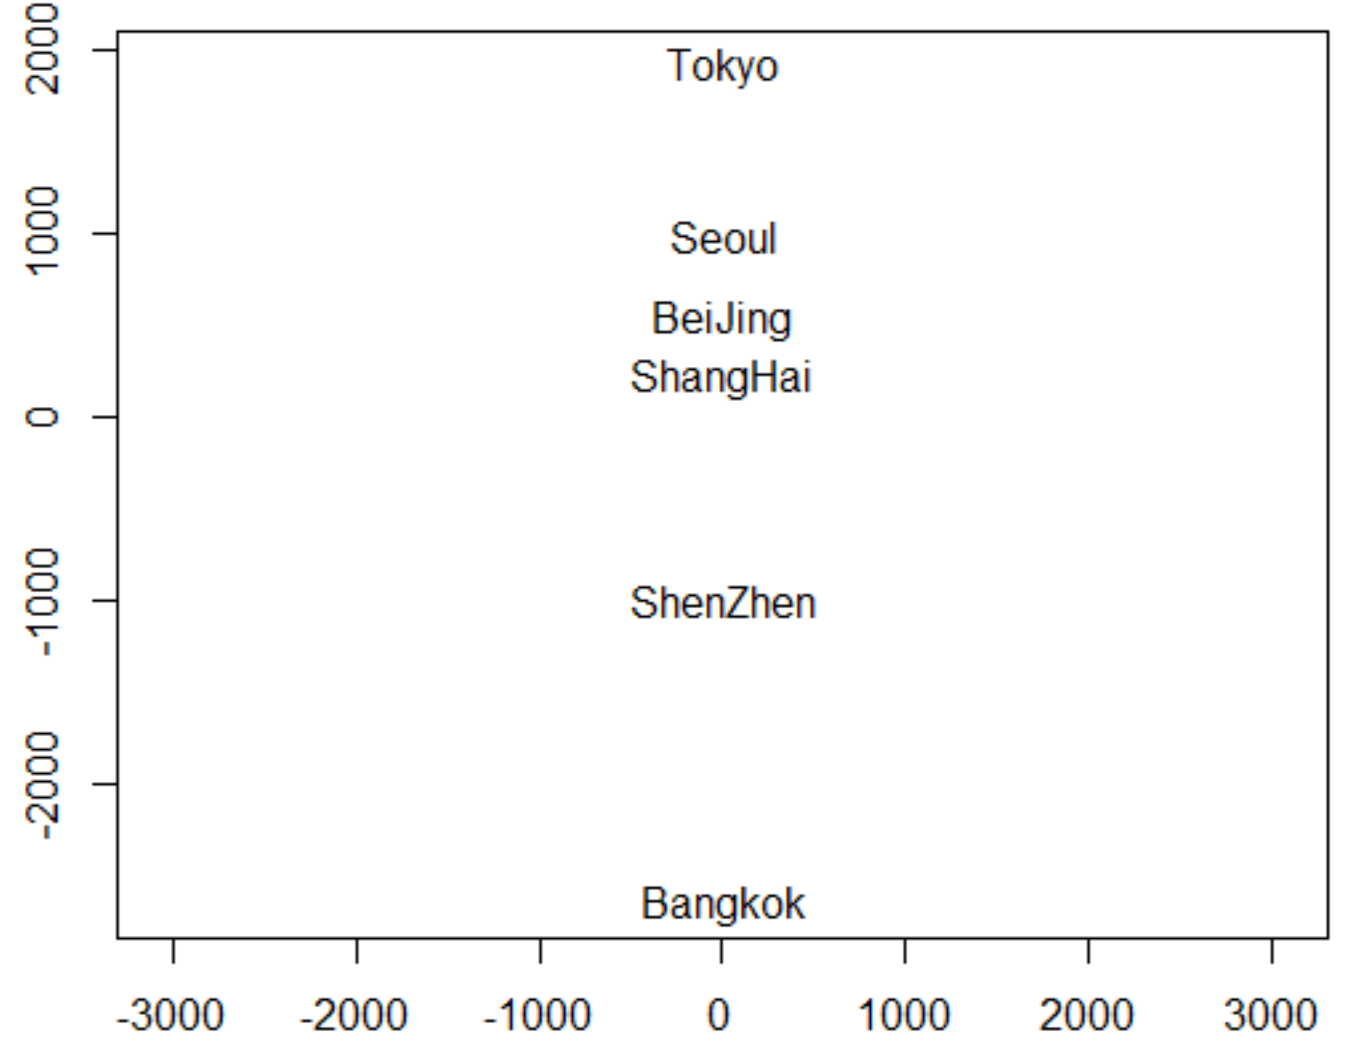

The city that far away from other is Bangkok, and others seem to be close.

Then I change the k of the code in the “cmdscale” part to 2 and 3 to creates 1 and 3-dimensional scale.Then it is a 2D and 3D model for us to see the cities that are close together:

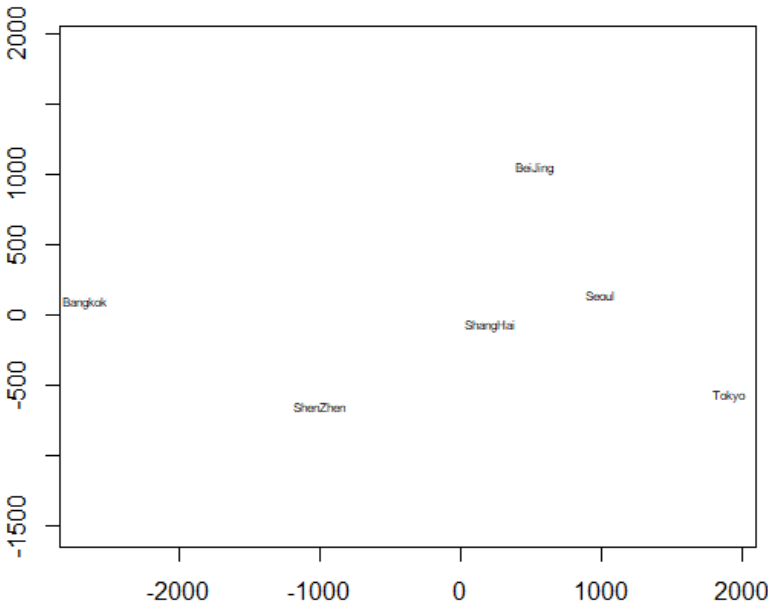

It is seems that BeiJing, ShangHai, and Seoul are pretty close to each other.

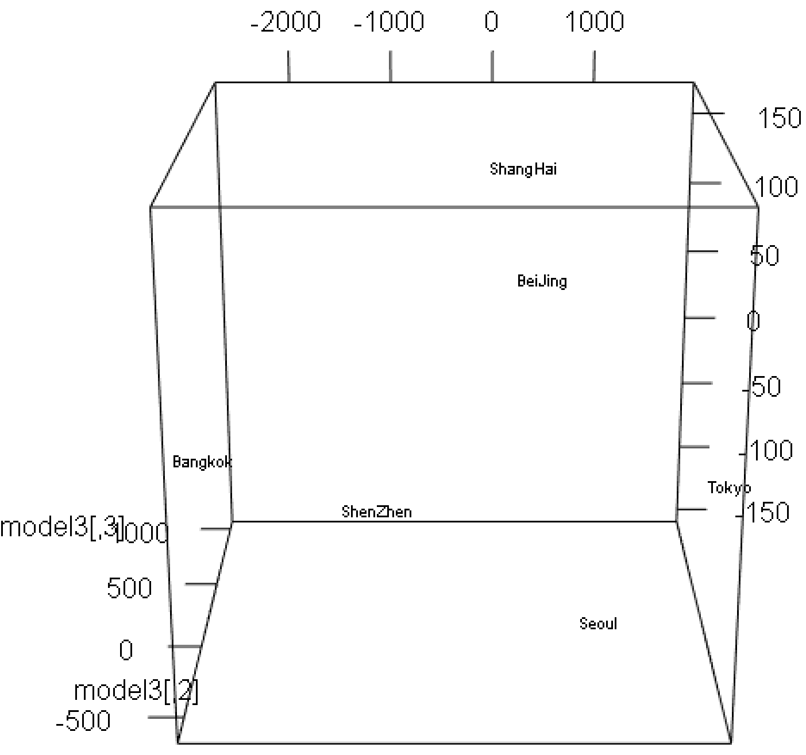

It is not so clear, to see, but I see that Bangkok and Tokyo has greatest distance

For the far away cities I listed above, I did the same thing, and below are the plots:

The plot with text in 1-dimensional:

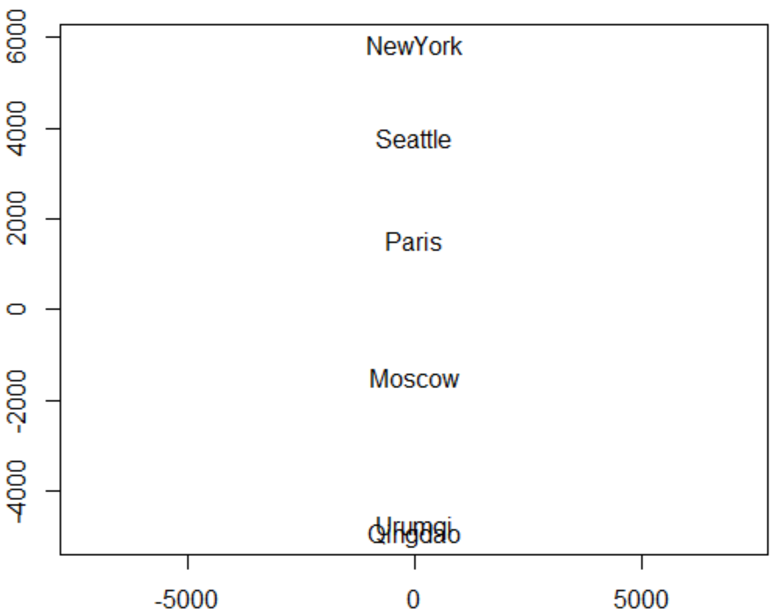

I see that Urumqi and Qingdao are close

The plot with text in 2-dimensional:

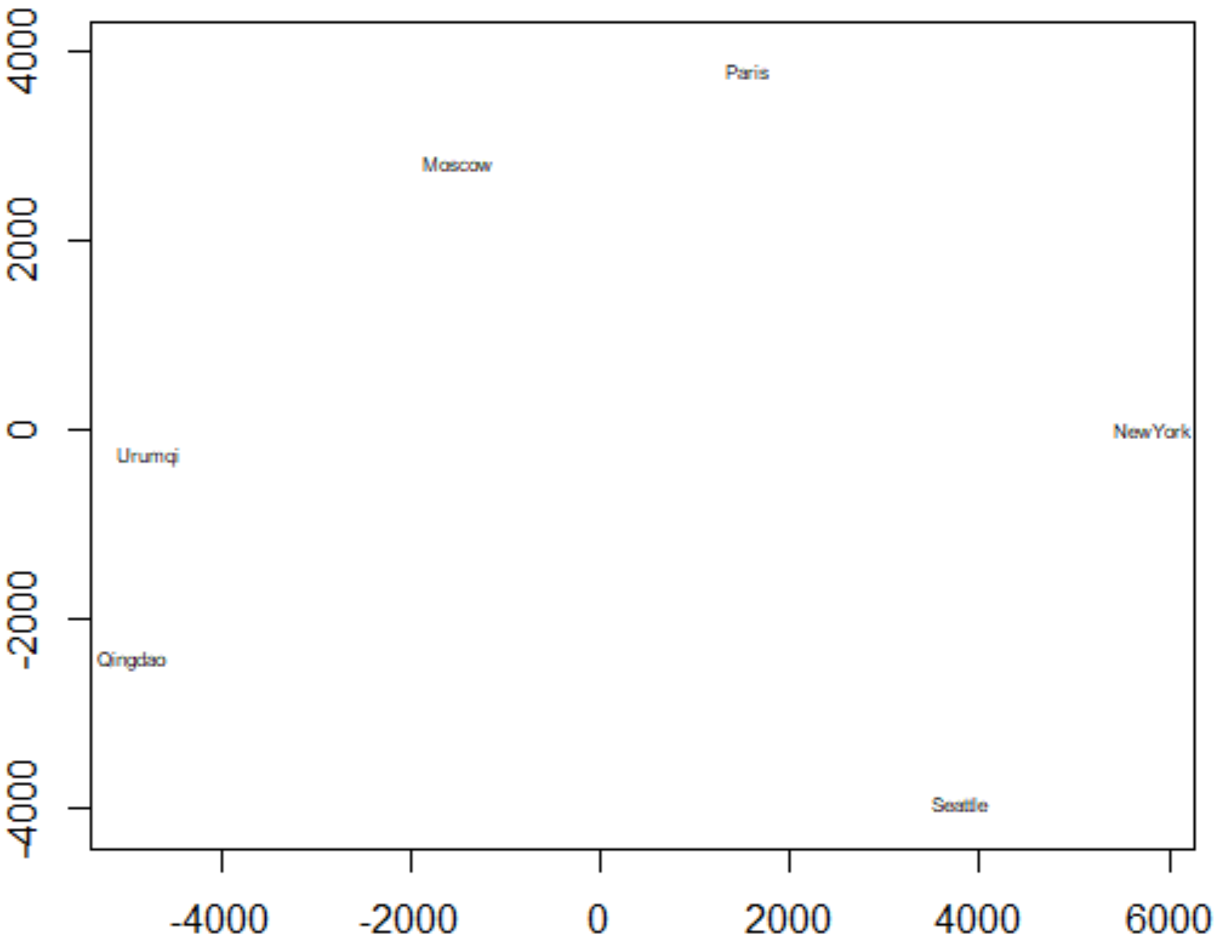

I see that Seattle and New York are far away from other, and I think this is because they are cities from America

The plot with text in 3-dimensional:

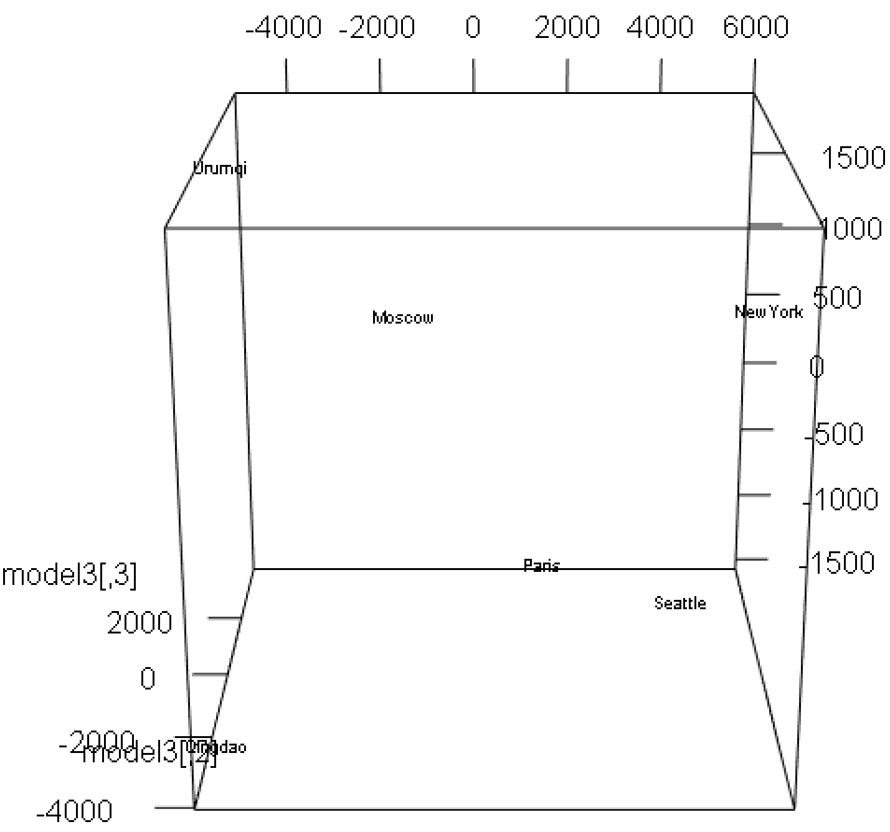

I see that New York and Seattle are still close.

To see how good the models are, I will investigate the eigenvalue for them from the largest to smallest:

Eigenvalue for cities that are close together:

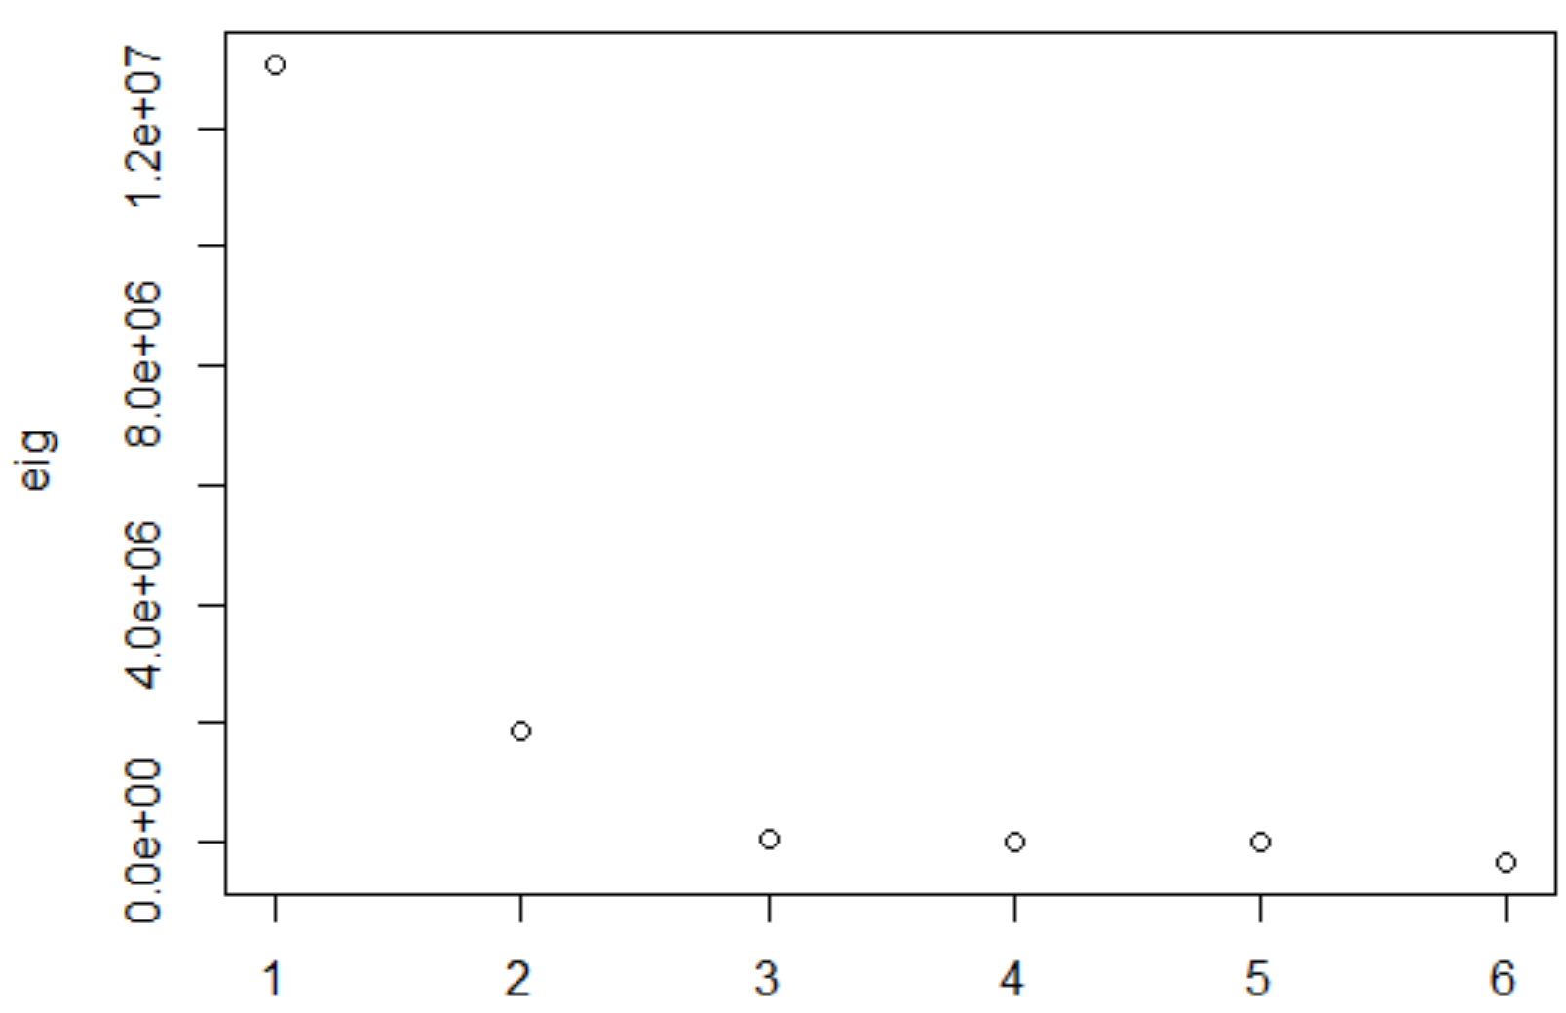

In the plot, I see that the first eigen value seems to be larger than other, and the third to sixth seem to be close to 0

Eigenvalue for cities that are far away:

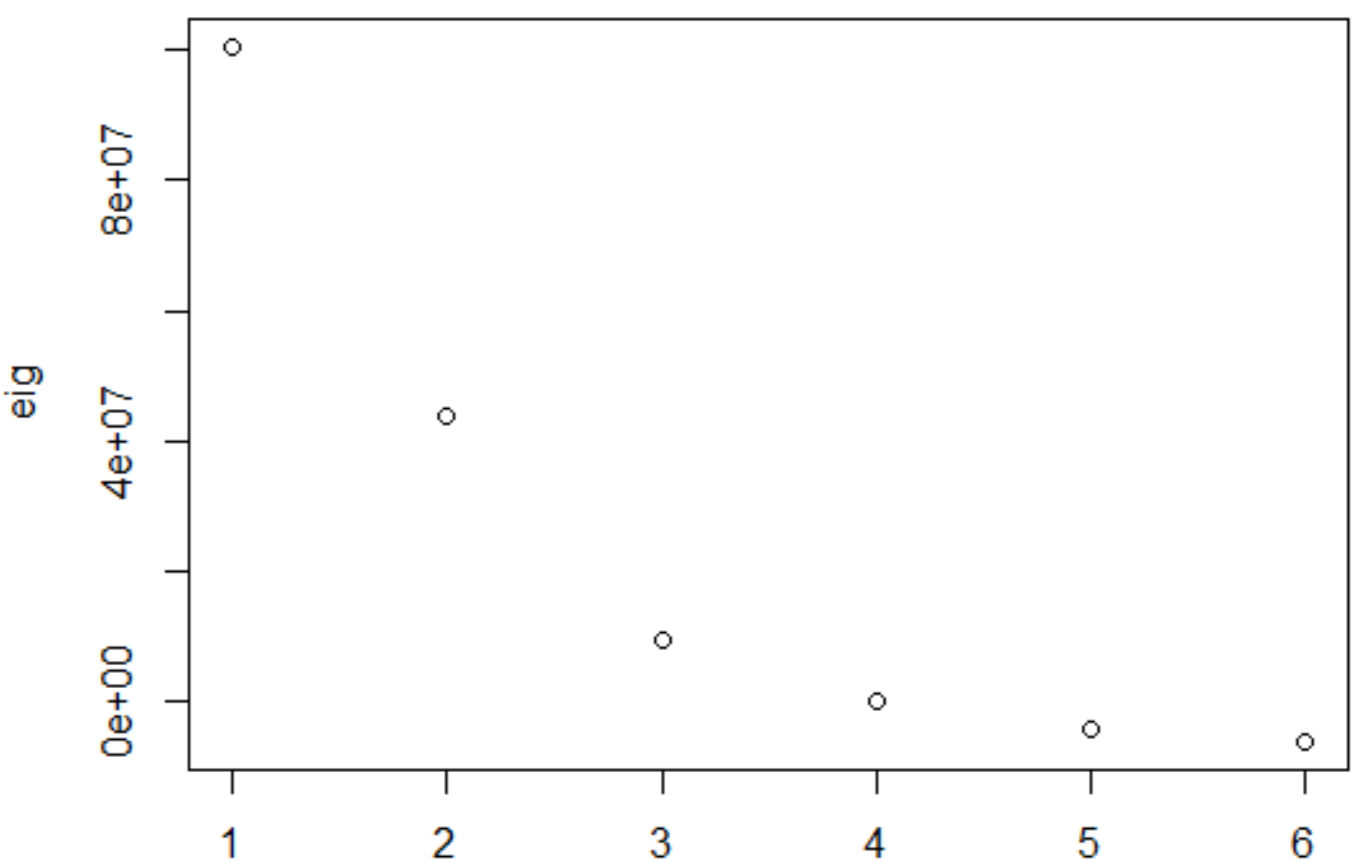

In the plot, the last two eigenvalues seem to be zero

We see that about the first 3 are clearly non-zero, which means that 20-dimensional space fits the data best. Also, because first two eigenvalues are not small, 1-dimensional model and 2-dimensional model will not fit them perfectly.

Also, there is another way to see how good each model is, which is comparing the distance in model with original distance in plot. The plot is shown below:

Original distance vs distance in 1,2,3-dimendional model of close together cities:

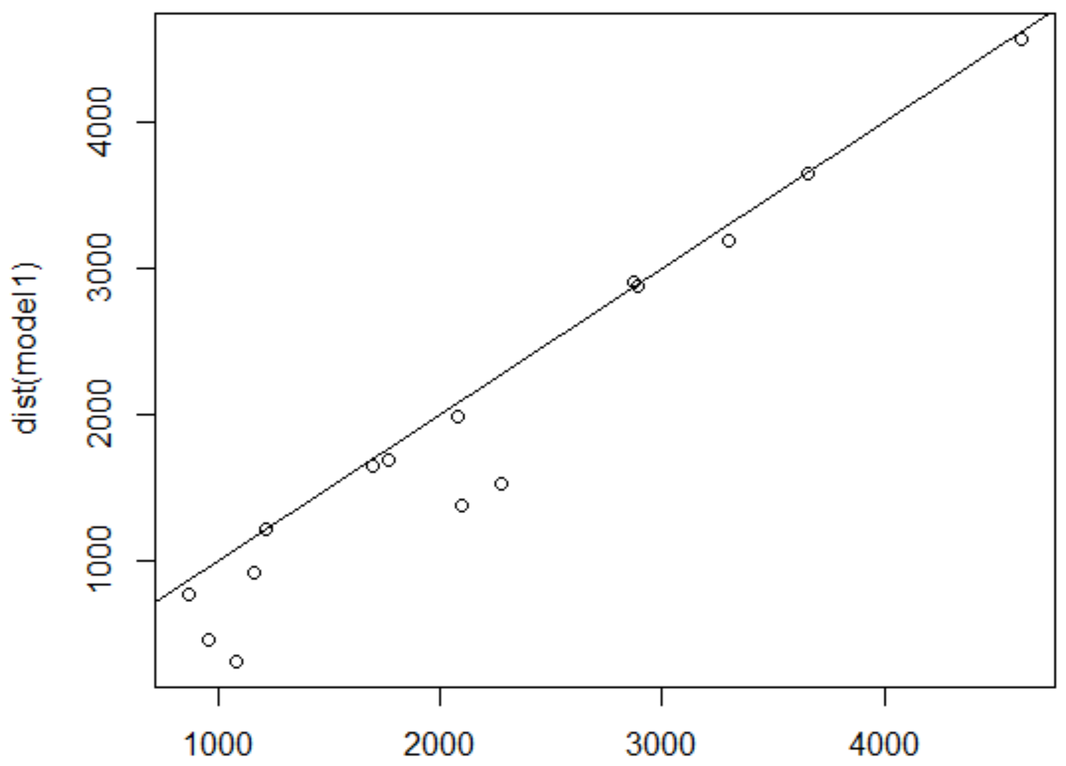

I see that the original number less that 3000 is disarray

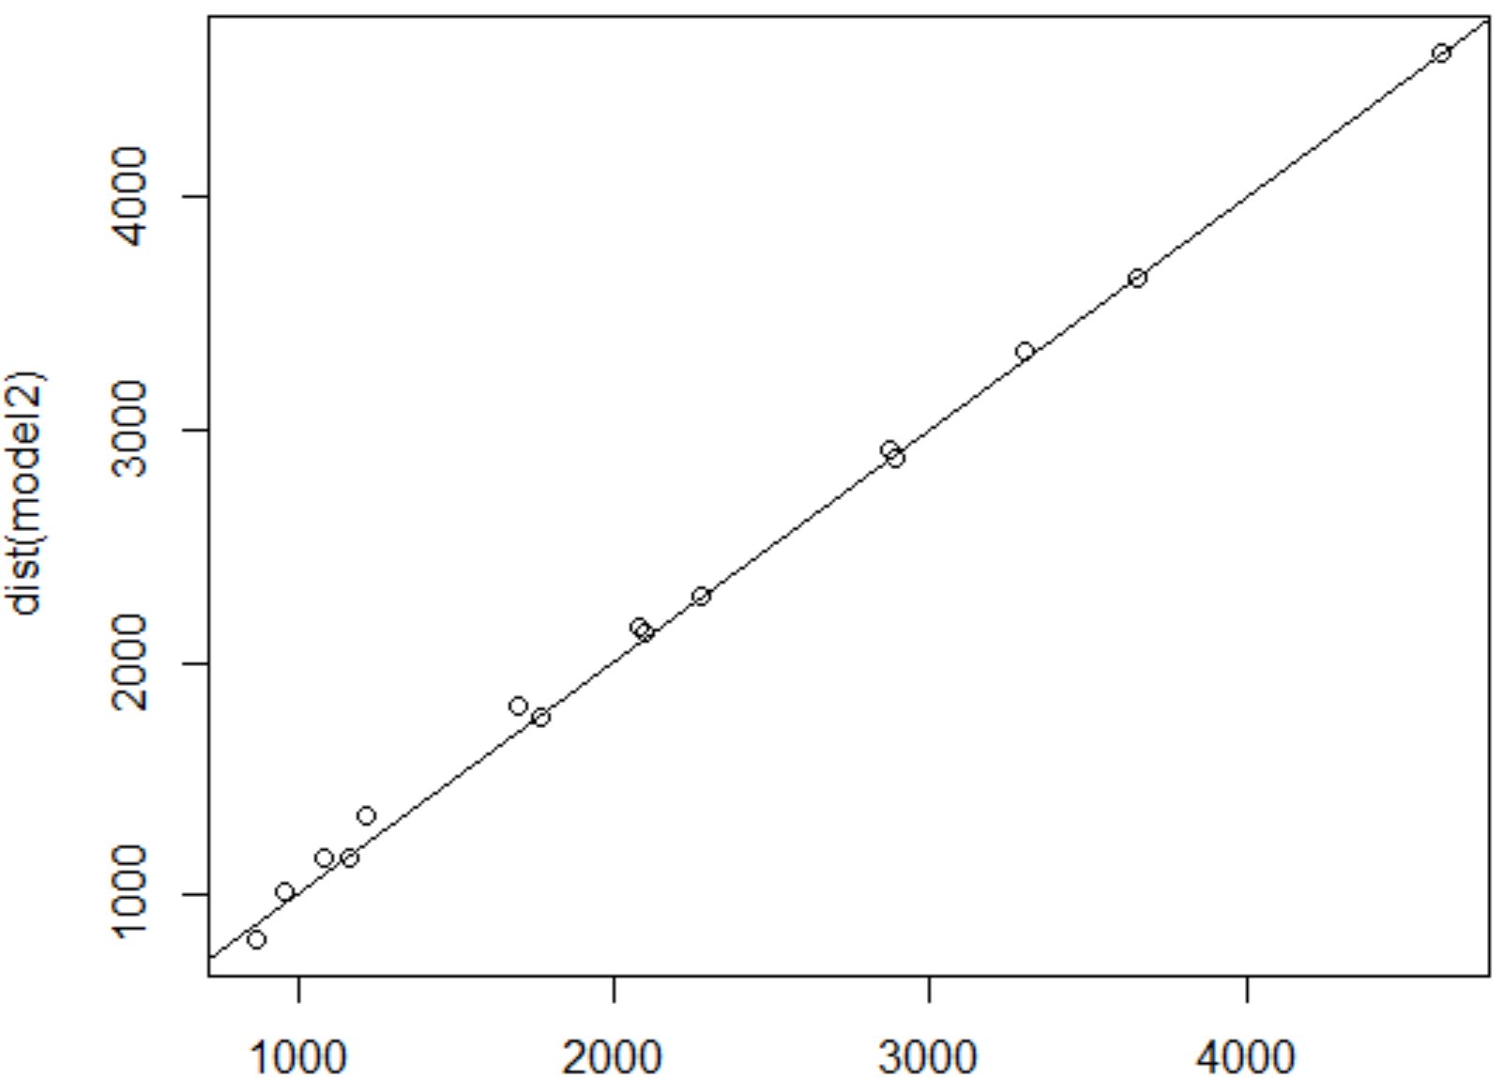

I see that all points seem to form a line

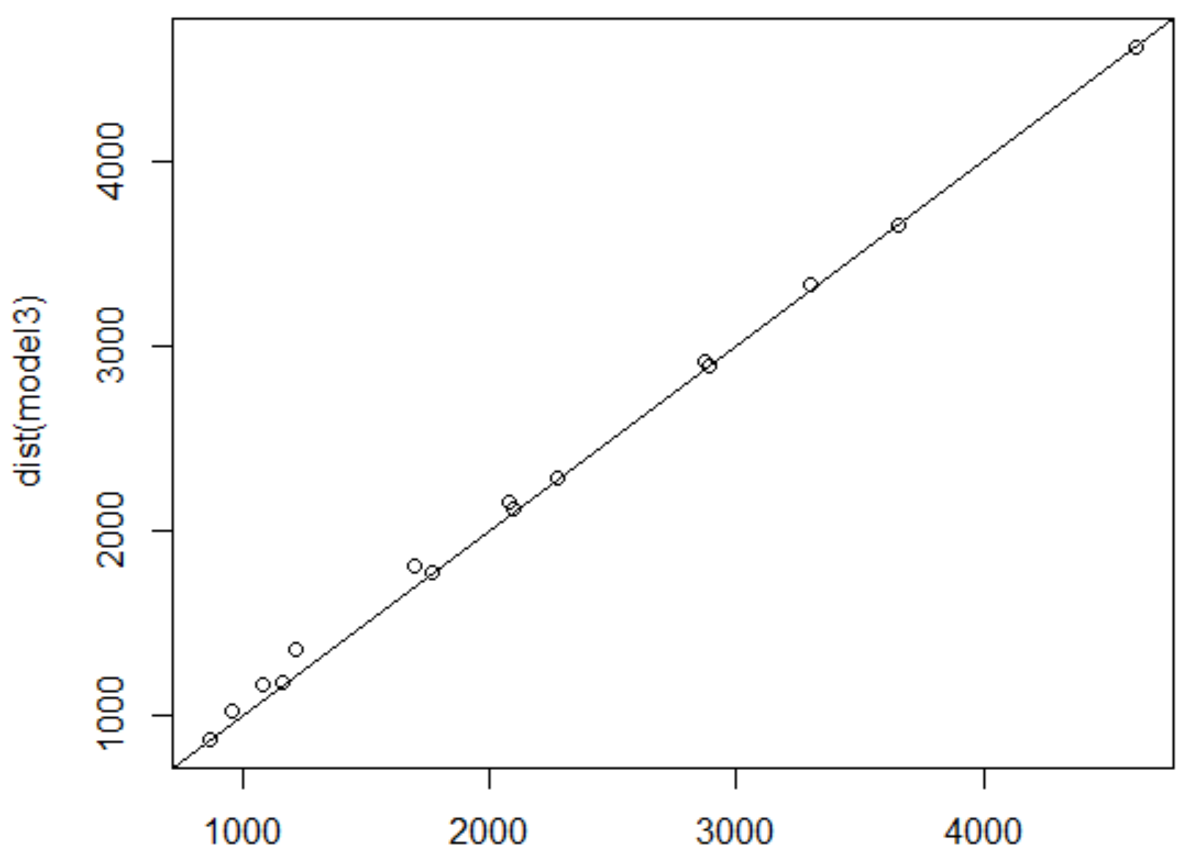

This plot is like the model2

Original distance vs distance in model among cities that are far away:

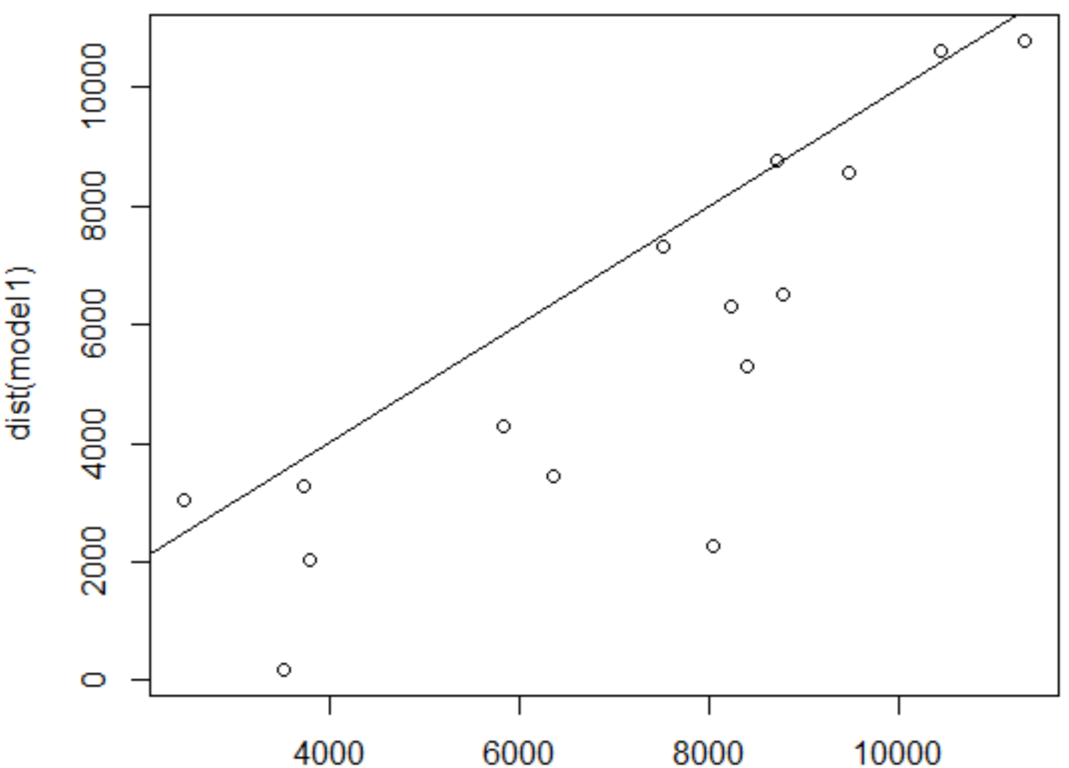

I see that all the points are scattering

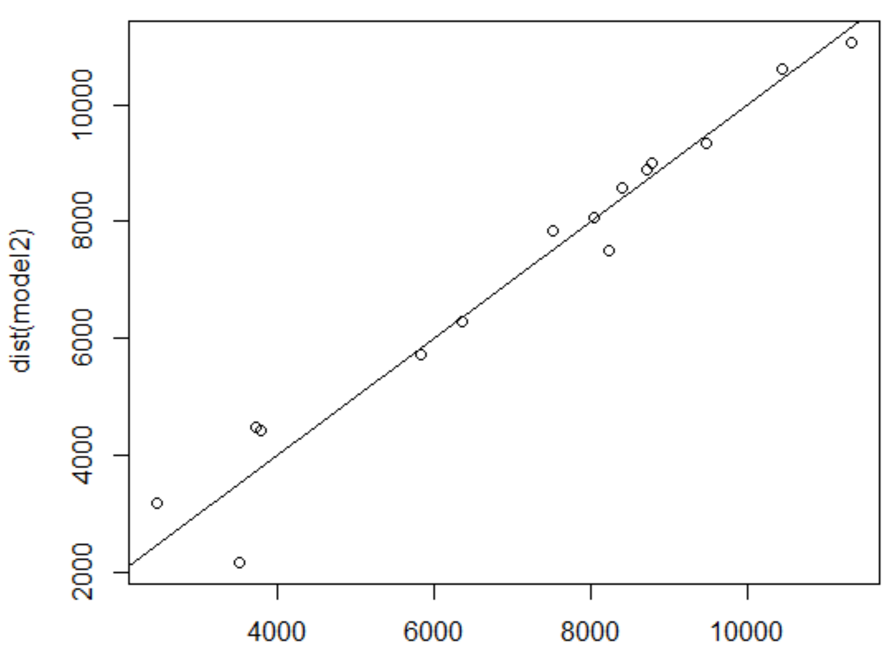

I see that most of points near the line y = x

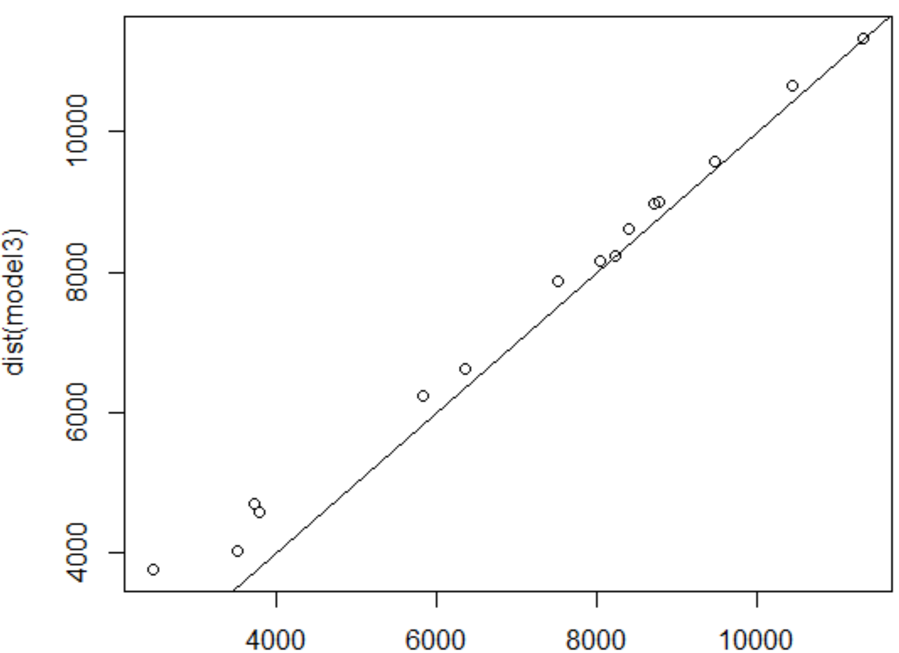

I see that all points almost lie in a line.

The most ideal situation is all the dots lies in y = x. From the plots above, I see that the points almost lie in a line in the model3 vs original distance for the cities far away, and I see that the points almost lie in a line in the model3 vs original distance and model2 vs original distance for the cities close together. Thus, the model2 and model3 of cities that are close together is nice, and the model3 of cities that are far away is also nice.

Also, I compare all the distance model and the input distance below:

The table includes the difference between model distance of model1 and input distances for cities that are close togehter:

BJ SZ SH BK SE

SZ 741.364064

SH 767.514214 -2.750150

BK 107.461557 38.697493 8.947343

SE 492.276436 86.040500 89.790650 -1.262007

TO 718.358668 -42.877267 66.872882 44.820226 240.082232

The table includes the difference between model distance of model2 and input distances for cities that are close together:

|  |
| --- |
| BJ SZ SH BK SE  SZ -7.268472  SH -78.337387 -130.410206  BK -31.797270 -117.658583 4.214980  SE -57.446910 -64.812401 59.694876 -1.652445  TO -23.945938 -43.901924 -3.722896 -2.511024 -4.020633  The table includes the difference between model distance of model3 and input distances  for cities that are close together:  V1 V2 V3 V4 V5  V2 -7.614751  V3 -86.247411 -141.820925  V4 -32.450355 -117.847873 -2.843107  V5 -74.487873 -69.817720 -2.185030 -3.636750  V6 -24.171112 -43.915305 -11.566995 -2.643932 -14.363676 |
|  |
| |  |  |  | | --- | --- | --- | | |  |  | | --- | --- | | |  | | --- | |  | |   We see that the difference become smaller in model2 and model3, but model2 seems perform better | |  | |

The table includes the difference between model distance of model1 and input distances for cities that are far away:

Pa QD UR NY MO

QD 2281.13267

UR 1915.84609 3333.28658

NY 1547.97708 530.10975 -164.17683

MO -557.50706 2887.63973 457.35315 184.47002

SE 5786.03954 -54.82779 885.88563 1765.93753 3111.53248

The table includes the difference between model distance of model2 and input distances for cities that are far away:

Pa QD UR NY MO

QD -229.94602

UR 719.32256 1337.43911

NY 103.45226 258.92326 -167.38171

MO -711.73082 52.94948 -767.35492 -341.82034

SE -21.89279 -182.86006 130.64201 -631.66041 -184.25539

The table includes the difference between model distance of model3 and input distances for cities that are far away:

Pa QD UR NY MO

QD -229.9771911

UR -0.6211164 -512.2202122

NY -390.3061867 -10.1101829 -208.5439229

MO -1293.9027732 -268.0991800 -966.3091503 -352.9323226

SE -116.1432734 -271.8079426 -109.3989491 -789.7247958 -219.26301

I see that model2 has the lowest difference, so this is better than other two.

And all data seems to have to greater difference in model3 like -189.25539

become -219.26301

Because the data is limited, the histogram is not an ideal choose for analyzing the model. But there is more I can do:

GOF is a property of the model from 0 to 1 with a value of 1 means a perfect fit. There is an interested thing that the GOF of the model will positively increases with the dimension until it reaches the dimension of the data. So, I calculate the GOF in 1-3 dimensions to see how GOF will change with dimension:

For cities that are close together:

1-Dimension: GOF = 0.8513311 0.8718616

2-Dimension: GOF = 0.9729172 0.9963798

3-Dimension: GOF = 0.9764522 1.0000000

For cities that are far away:

1-Dimension: GOF = 0.6126508 0.6535741

2-Dimension: GOF = 0.8809303 0.9397740

3-Dimension: GOF = 0.9373853 1.0000000

So, from both graph and data, I think that 3-dimensional model fit the data better than other two, and 2-dimensional model is clear to see. In my opinion, I think it is because I choose places as my data, and the earth looks like a 3d model, so 3-dimensional model fit them well. Also, a map is in 2d, so the 2-dimensional model is easy for us to see.