**Assignment 03 Group 6 -- Yixuan Huang, Ada Li, Xinyu Wang, Jingsi Wu**

**Answer the following questions:**

1. **(1 pt.) What is the value for chain_te for row id 258692579?**

**0.131497**

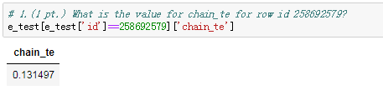

1. **(1 pt.) What is the value of market_te for the same row?**

**0.121452**

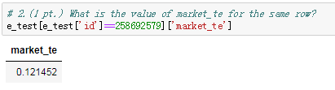

**(Comments: For question 1&2, our results are based on the code given by the key of Assignment 2 where we enforced same measurement levels in h2o and pandas when reading data into the H2oFrame.)**

1. **(1 pt.) What is the test AUC of your best GBM model?**

**0.70453**

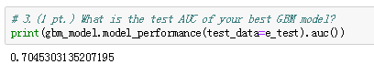

1. **(3 pts.) What are the three most important variables for your best GBM? Paste a screenshot of your output here.**

**The three most important variables for your best GBM are chain_te,week, avg_categry_amount.**

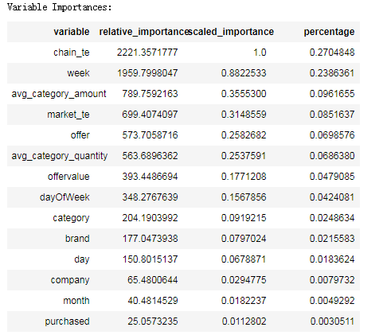

1. **(1 pt.) Paste the partial dependence plot of the most important variable in the GBM model’s test data here.**

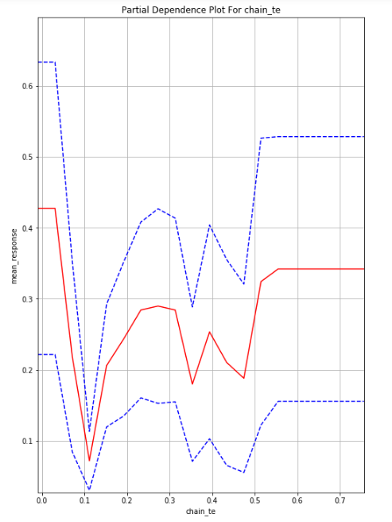

1. **(1 pt.) What is the test AUC of your best MLP model? Paste a screenshot of your output here.**

**0.693898**

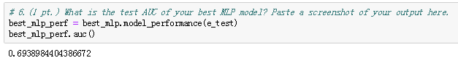

1. **(1 pt.) Paste the partial dependence plot of the same variable in #5, but for your best ANN model’s test data, here.**

