GPS-Agent: A State-Constrained Multi-Agent Framework for Reducing Answer-Giving in Vietnamese Mathematics Tutoring
Revised conference report generated after code unification and metric audit
Prepared from the current GPS_AIedu repository and reproducible evaluation scripts.

Abstract
Large language models used as tutors often fall into the Answer-Giving Trap: they provide complete solutions before students have performed meaningful reasoning. This report presents GPS-Agent, a state-constrained multi-agent tutoring framework that routes dialogue through Guide, Practice, and Solve phases. We revise the project code so that all manuscript claims are regenerated from deterministic metrics rather than hard-coded reports. The current data include a foundation log of 5 students across 45 questions (225 sessions; 810 labeled turns), a controlled evaluation of 100 GPS-Agent sessions versus 100 single-agent baseline sessions, and 49 cross-model Phi-3 stress-test sessions. GPS-Agent reduces Solve-bypass answer leakage from 54.0% to 9.0% and increases phase-valid tutoring from 0.0% to 75.0%. VAI is retained only as a secondary engagement metric because the current logs show no statistically significant difference (0.331 vs. 0.318, p=0.687). The audit also identifies remaining weaknesses: high stall/scaffolding-pressure rate, low current IRR agreement, and an incompletely validated 45-question bank. These results support GPS-Agent as a credible system paper centered on pedagogical control, while clarifying which claims require further human annotation before a stronger learning-outcome paper can be submitted.

1. Introduction
LLM-based tutoring systems are attractive because they can respond instantly and personalize explanations. However, a tutor optimized for helpfulness often solves the task for the learner. In mathematics education, this behavior is problematic because the central learning signal is not whether the final answer appears in the conversation, but whether the student produces the reasoning steps needed to reach it.
GPS-Agent addresses this issue through architectural control rather than prompt-only instruction. A Supervisor routes the conversation through three pedagogical states: Guide [G], Practice [P], and Solve [S]. The key design constraint is that a final solution should only be confirmed after the learner has passed through conceptual orientation and at least one practice step.
The main revision made here is methodological. Earlier drafts over-emphasized VAI and included a hard-coded IRR claim. The revised code centralizes metrics in one deterministic module, recomputes all tables from the data, and reframes the paper around the strongest reproducible result: reduced answer-giving leakage and improved phase compliance.

2. Contributions
- A state-constrained multi-agent tutoring architecture that implements Guide-Practice-Solve routing for Vietnamese probability and combinatorics tutoring.
- A reproducible metric layer for direct-answer leakage, phase validity, VAI, Math Density, stall/scaffolding pressure, language leakage, and IRR audit.
- A multi-layer data audit separating foundation/pilot interactions, controlled simulations, cross-model stress tests, and expanded augmented data.
- A revised empirical narrative that avoids unsupported learning-gain and IRR claims while preserving the strongest system-level evidence.

3. GPS-Agent Architecture
GPS-Agent is implemented as a LangGraph-style state machine. The Supervisor receives the latest student utterance and the current AgentState, then routes to one of three specialized tutor nodes. The Guide node asks conceptual questions and avoids computation. The Practice node decomposes the problem into a small actionable step. The Solve node confirms the answer and should trigger reflection after the student has attempted the reasoning.
The design differs from a single-agent tutor because state transitions are explicit and auditable. This makes it possible to measure whether a conversation follows the intended protocol rather than relying only on natural-language impressions of helpfulness.
The code revision adds `src/evaluation/metrics/pedagogy_metrics.py` as the single source of truth for paper metrics. Existing scripts now call this module, and `MathVerifier` is kept as a backward-compatible wrapper that can parse both Vietnamese (`Thầy/Em`) and English-style (`AI/Student`) speaker labels.

4. Data and Audit
The project should not present all generated data as one homogeneous gold standard. The revised report separates the evidence into four layers.
Layer | Scale | Use in paper
Foundation/pilot log | 5 students, 45 questions, 225 sessions, 810 turns | Protocol calibration and real/pilot interaction evidence
Controlled evaluation | 100 GPS-Agent + 100 Single-Agent sessions over 25 unique questions | Primary system comparison
Cross-model stress test | 49 Phi-3 student-simulator sessions | Robustness and failure analysis, not victory claim
Expanded augmented corpus | 2824 rows; 24 rows have Independence_Index > 1 | Exploratory appendix until manually audited
Question bank | 45 questions; 15 missing answers; 43 with blank options | Use full set for interaction; restrict correctness claims to validated items
Table 1. Evidence layers used in the revised paper. The expanded corpus is deliberately treated as exploratory.

5. Metrics
The revised evaluation uses process metrics rather than accuracy-only measures. This is appropriate because the main question is whether the tutor preserves student reasoning opportunities.
- Direct-answer leakage: whether answer-like or computation-heavy tutor content appears before the session reaches a Solve state. This is the primary Answer-Giving Trap metric.
- Phase validity: whether a GPS trace reaches Solve only after Guide and Practice have occurred.
- VAI: the share of explicit mathematical expressions contributed by the student. This remains useful as a secondary engagement signal, but not as the main claim in the current results.
- Math Density: explicit mathematical expressions per student turn.
- Stall/scaffolding pressure: long repeated phase runs, especially repeated Guide or Practice states, indicating that scaffolding may be too persistent.
- IRR audit: computed from observed rater-score files. The previous hard-coded kappa value has been removed.

6. Results
System | N | Questions | VAI | MD | Leakage | Phase valid | Stall | Non-VN
GPS-Agent | 100 | 25 | 0.331 | 1.115 | 9.0% | 75.0% | 41.0% | 0.0%
Single-Agent | 100 | 25 | 0.318 | 0.969 | 54.0% | 0.0% | 0.0% | 0.0%
Cross-Model Phi-3 | 49 | 25 | 0.362 | 0.721 | 42.9% | 100.0% | 79.6% | 28.6%
Table 2. Main reproducible comparison. VAI and Math Density are secondary; leakage and phase validity are primary system-control metrics.
The strongest result is answer-control rather than learning gain. GPS-Agent reduces Solve-bypass answer leakage from 54.0% in the single-agent baseline to 9.0%. Fisher's exact test gives p=0.000000 and odds ratio=0.084.
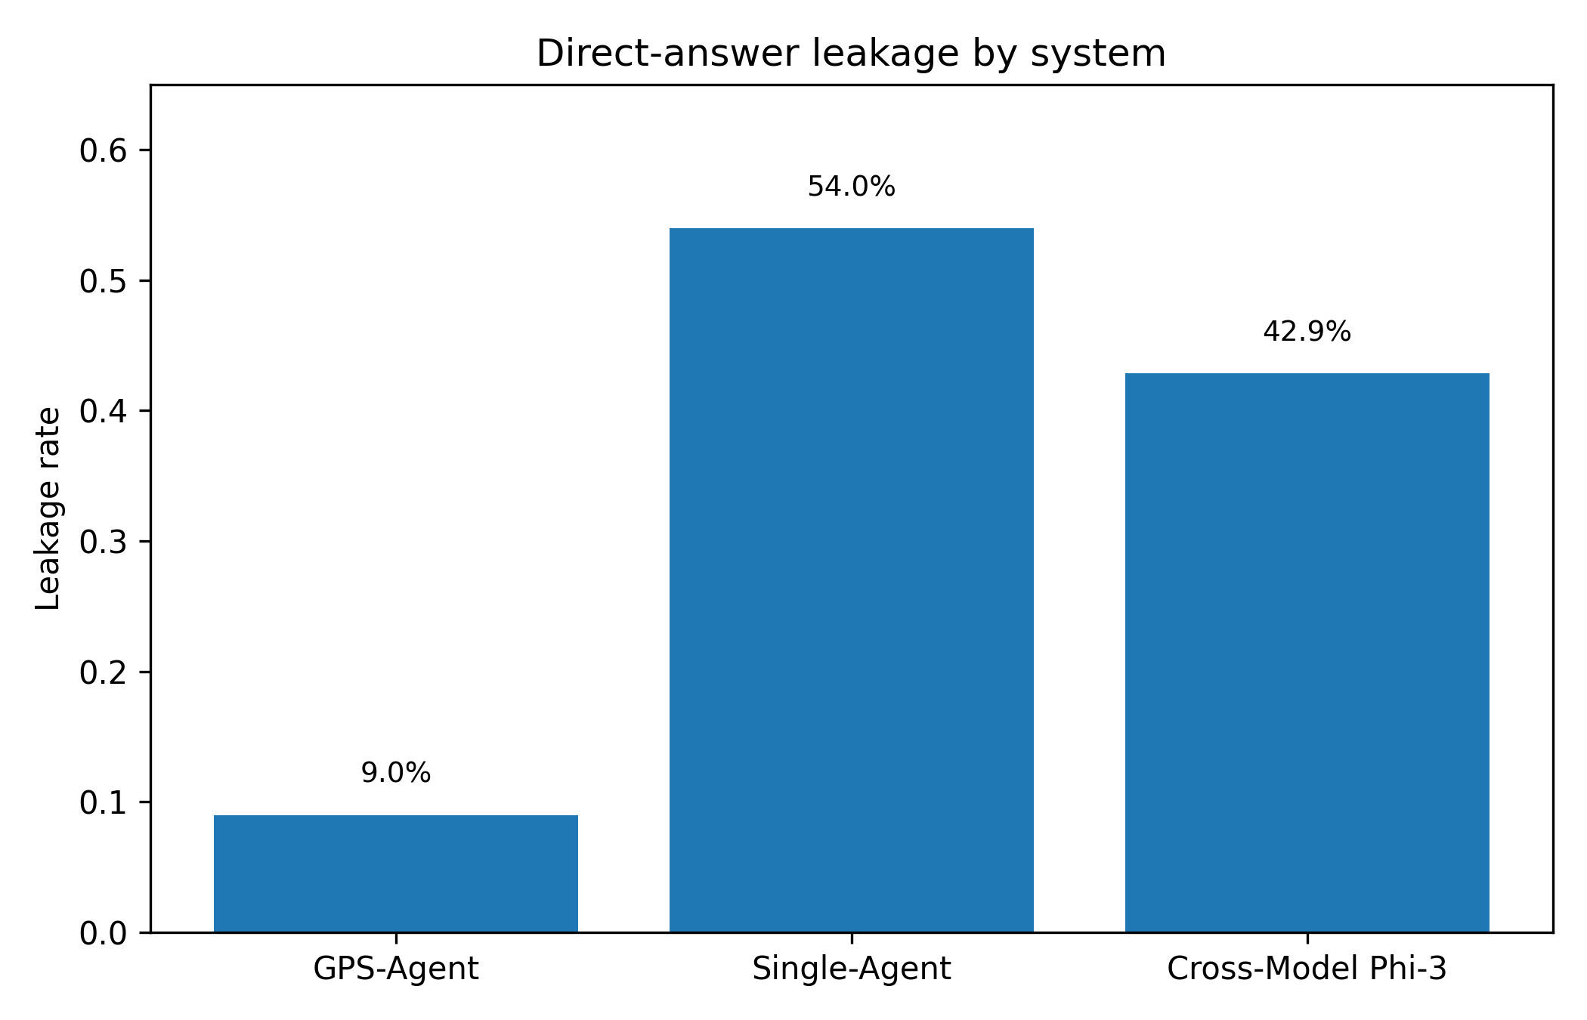
Figure 1. Direct-answer leakage by system.
The second strong result is phase compliance. GPS-Agent produces 75.0% phase-valid sessions, while the single-agent baseline has no explicit GPS structure and therefore scores 0.0%. This supports the architectural claim that state constraints provide auditable pedagogical control.
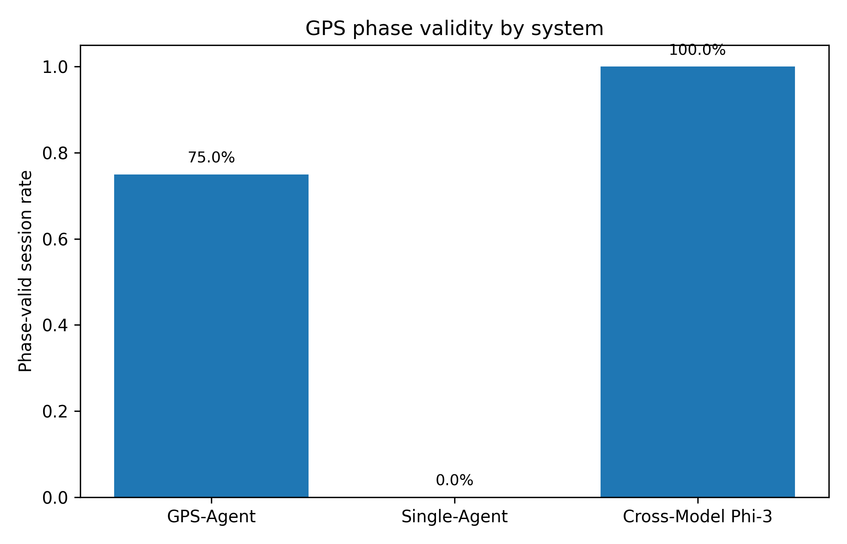
Figure 2. Phase validity by system.
VAI does not currently support a strong improvement claim. GPS-Agent has mean VAI 0.331, while the baseline has 0.318; the Welch test is not significant (p=0.687). This is why the revised report moves VAI out of the abstract's main empirical claim and treats it as secondary.
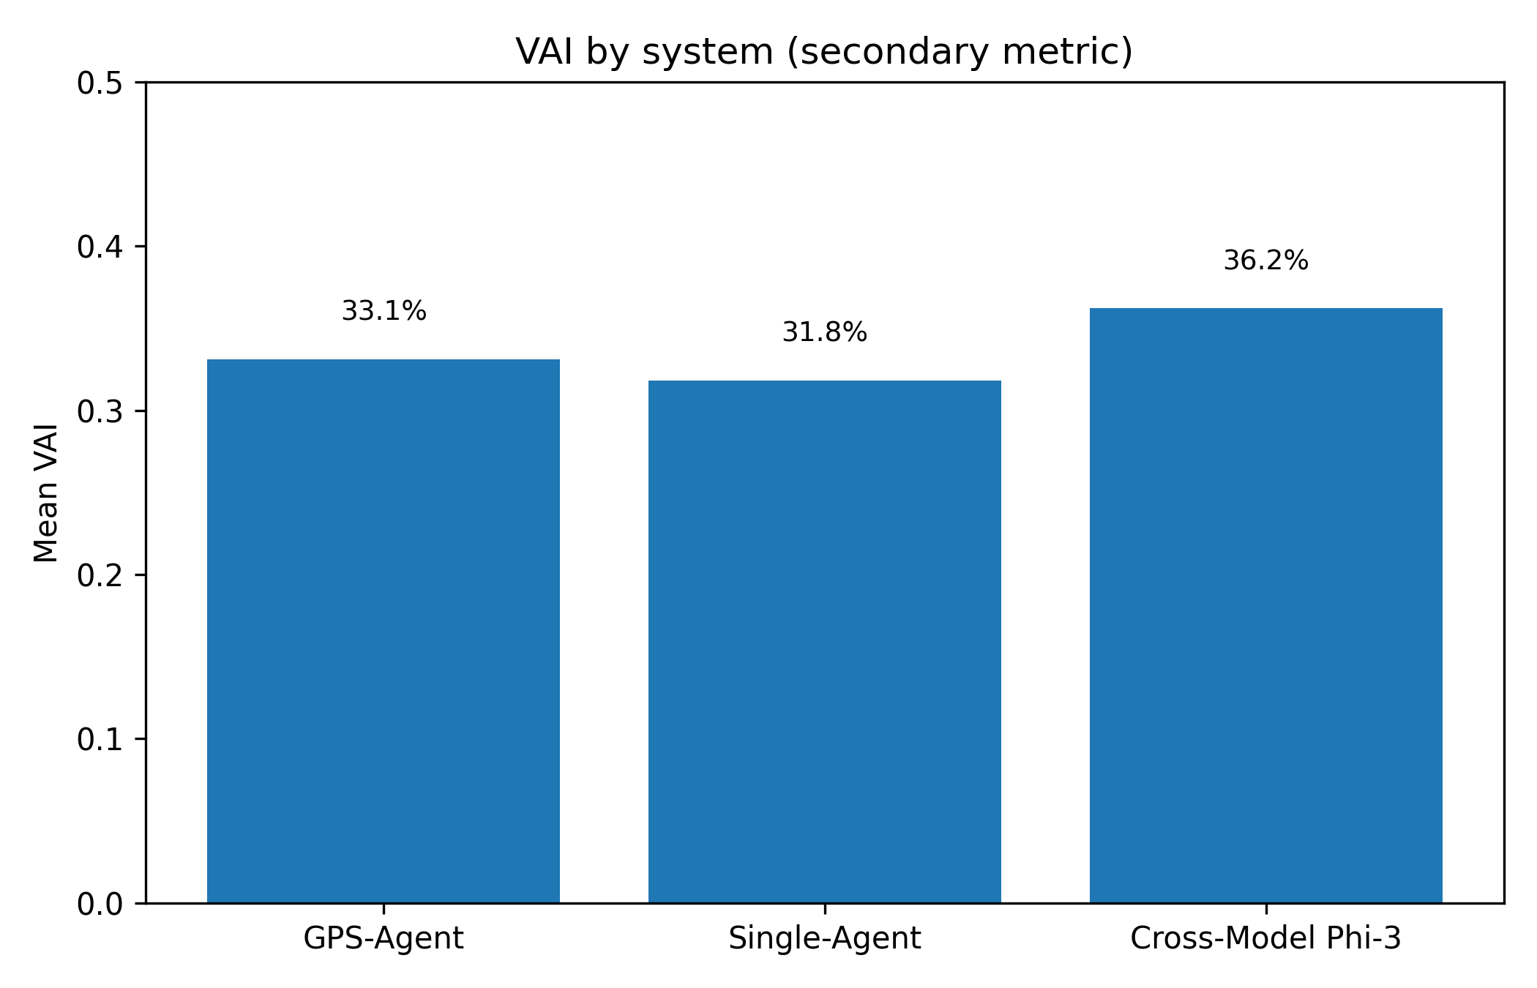
Figure 3. VAI by system. Current difference is not statistically significant.
The main limitation is scaffolding pressure. GPS-Agent has a stall signal of 41.0%, while the baseline has no GPS-state stall by definition. This should be reported as a limitation and used to motivate Anti-Stagnation routing rather than hidden from the analysis.
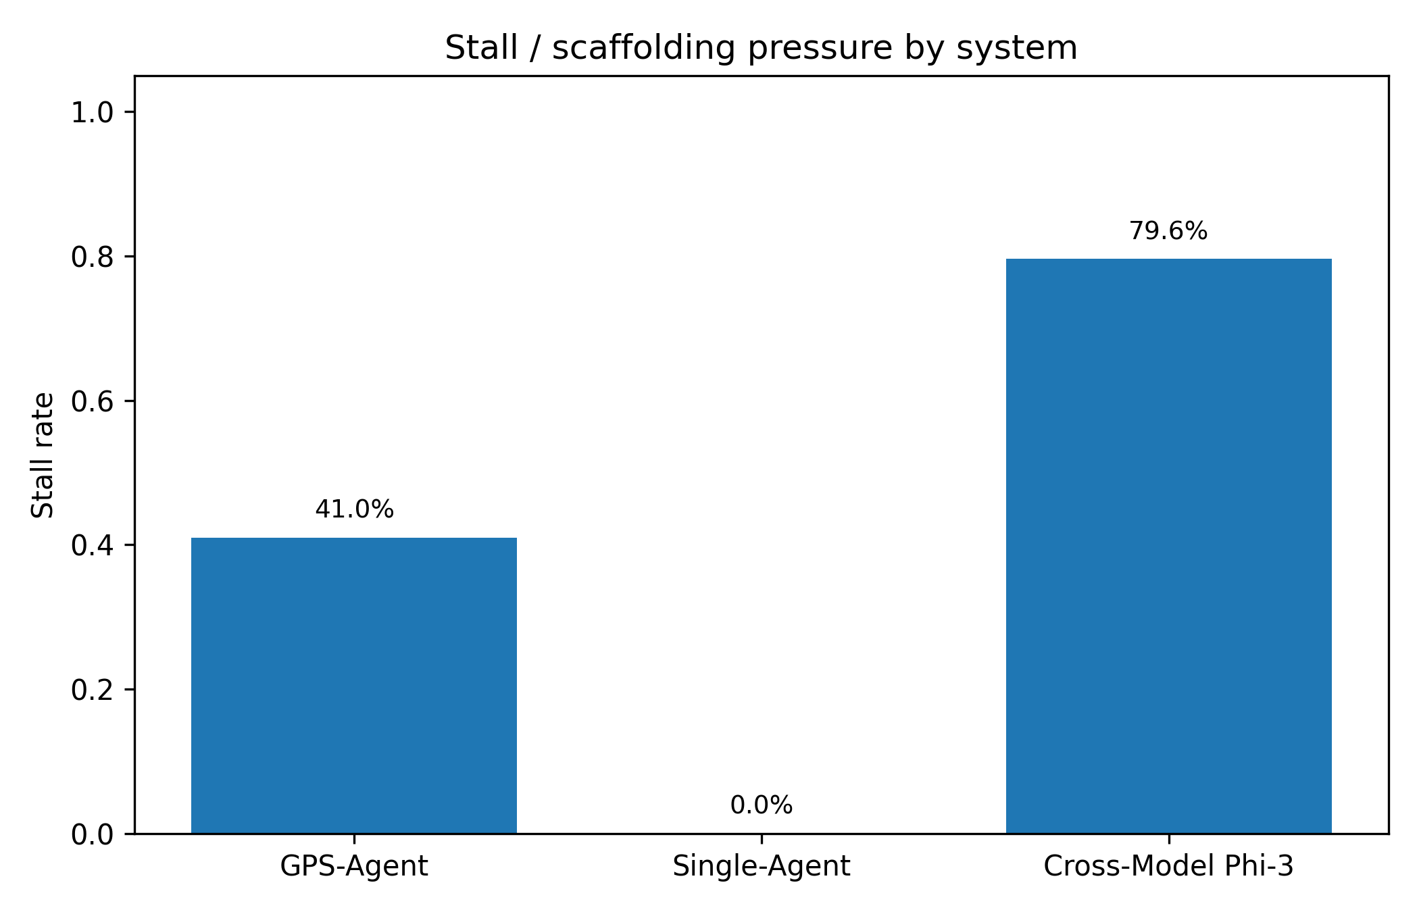
Figure 4. Stall/scaffolding-pressure rate by system.

7. Cross-Model and Failure Analysis
The Phi-3 condition should be framed as a stress test. It reaches 100.0% phase validity but also shows 42.9% leakage, 79.6% stall, and 28.6% non-Vietnamese leakage. This reveals that protocol structure can survive a different student simulator, but generation quality and language control still degrade.
Failure type | Count | Share
SCAFFOLDING_PRESSURE | 42 | 52.5%
OTHER | 38 | 47.5%
Table 3. Failure analysis of anomaly sessions.
The dominant category is SCAFFOLDING_PRESSURE, indicating that the system sometimes keeps asking for intermediate steps even when the learner is not progressing. This directly motivates an Anti-Stagnation mechanism that forces routing changes after repeated same-phase turns.

8. Code Changes Made in This Revision
- src/evaluation/metrics/pedagogy_metrics.py: added deterministic metrics, data-layer audits, IRR recomputation, question-bank audit, and statistical helpers.
- src/evaluation/metrics/math_verifier.py: refactored as a backward-compatible wrapper using the unified dialogue parser and supporting AI/Student as well as Thầy/Em labels.
- scripts/generate_evaluation_report.py: replaced hard-coded VAI/IRR report with reproducible tables, figures, JSON, and text summary.
- scripts/generate_research_stats.py: reframed the large corpus as exploratory and added quality checks for invalid Independence_Index values.
- scripts/audit_question_bank.py and scripts/generate_conference_assets.py: added one-command reproducible asset generation.
- tests/test_pedagogy_metrics.py: added regression tests for speaker parsing, leakage, phase validity, stall detection, VAI, and MathVerifier compatibility.

9. Data Quality and Claim Boundaries
The current IRR file gives quadratic weighted kappa -0.017 and unweighted kappa -0.005 over 100 paired sessions. Therefore, the paper must not claim substantial inter-rater agreement until the annotation protocol is rerun with a calibrated rubric or human raters.
The question bank contains 45 extracted questions, but the audit finds 15 missing answers and 43 questions with blank options. This does not invalidate the tutoring-interaction experiments, but it means correctness and post-test claims should be restricted to validated items until the question bank is cleaned.
The expanded corpus contains 2824 rows and 24 Independence_Index values greater than one. The report now treats this file as an expanded behavioral corpus, not as a validated gold standard.

10. Next Steps Before Submission
- Clean and validate all 45 questions, including options, answer key, and solution rationale.
- Add a prompt-only Socratic baseline to prove that GPS-Agent improves over prompting alone, not only over a direct single-agent baseline.
- Rerun IRR with binary labels first: direct-answer leakage, phase validity, and reflection present/absent. Then add 1-5 autonomy labels after calibration.
- Report learning outcomes only if there is real pre/post-test evidence. Until then, describe the result as pedagogical-control improvement.
- Use the expanded corpus as a robustness appendix, with invalid rows filtered or explicitly audited.

11. Conclusion
After code unification and metric audit, GPS-Agent is best positioned as a credible system paper about enforcing pedagogical control in LLM tutoring. The revised evidence shows a strong reduction in Solve-bypass answer leakage and a large increase in phase-valid tutoring. At the same time, the audit prevents overclaiming: VAI is not statistically significant, current IRR is weak, the question bank needs cleanup, and the expanded corpus remains exploratory. This makes the paper more defensible because its strongest claims are now directly reproducible from code and data.

References
Bloom, B. S. (1956). Taxonomy of Educational Objectives.
Cohen, J. (1988). Statistical Power Analysis for the Behavioral Sciences.
Hake, R. R. (1998). Interactive-engagement versus traditional methods. American Journal of Physics.
Koedinger, K. R., & Corbett, A. (2006). Cognitive tutors. Cambridge Handbook of the Learning Sciences.
Macina, J. et al. (2023). MathDial: A dialogue tutoring dataset with rich pedagogical properties.
Ryan, R. M., & Deci, E. L. (2000). Self-determination theory. American Psychologist.
Tack, A., & Piech, C. (2022). The AI Teacher Test.
VanLehn, K. (2011). The relative effectiveness of human tutoring, intelligent tutoring systems, and other tutoring systems.
Vygotsky, L. S. (1978). Mind in Society.
Wood, D., Bruner, J. S., & Ross, G. (1976). The role of tutoring in problem solving.

