CS 518 Quantum Networking and Security, Spring 2024

*Homework – 3*

* ***Read Sections 4.4, 4.5, 4.6 and 4.7- Parag Lala; all materials covered in the lectures***
* ***Read Section 3.11 (Identity Operator)***

1. Write is qubit? Point with arrows- the state of the qubit, probability of |0> state (logical basis state) and probability of |1> (logical basis state) in a general formula of single qubit.

A qubit, or quantum bit, is the basic unit of quantum information—the quantum version of the classical binary bit physically realized with a two-level quantum system. Unlike a classical bit, which can be in one of two states, 0 or 1, a qubit can be in a superposition of both states simultaneously, thanks to the principles of quantum mechanics.

In the general formula for a single qubit state, it can be represented as:

∣ψ⟩=α∣0⟩+β∣1⟩

where ∣ψ⟩ is the state of the qubit, ∣0⟩ and ∣1⟩ are the logical basis states (often referred to as the computational basis), and α and β are complex numbers that describe the probability amplitudes of the qubit being in the ∣0⟩ and ∣1⟩ state, respectively.

* State of the qubit: ∣ψ⟩
* Probability of ∣0⟩ state: The probability of finding the qubit in the ∣0⟩ state upon measurement is given by ∣α∣2.
* Probability of ∣1⟩ state: Similarly, the probability of finding the qubit in the ∣1⟩ state is ∣β∣2.

It's important to note that ∣α∣2+∣β∣2=1, ensuring the total probability is always 1.

1. Describe Qubit represented as Bloch Sphere with a diagram showing
   1. Ground state of qubit (North pole), excited state of qubit, intermediary state of qubit, and angles defining the vector of the intermediary state.

The Bloch sphere is a representation of a qubit's state as a point on the surface of a sphere. In this representation:

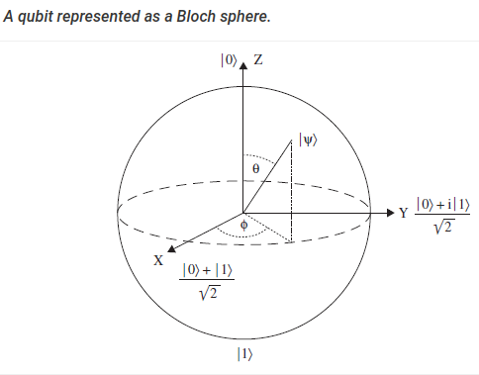

* The North Pole of the sphere corresponds to the ground state of the qubit, ∣0⟩.
* The South Pole represents the excited state of the qubit, ∣1⟩.
* An intermediary state of the qubit lies somewhere on the surface between these poles.
* The angles defining the vector of the intermediary state are θ (theta), which is the angle from the positive Z-axis, and ϕ (phi), the azimuthal angle in the XY-plane from the positive X-axis.

Let's illustrate this with a diagram of the Bloch Sphere highlighting these points and angles.

I will create a diagram showing the Bloch Sphere with the ground state, excited state, intermediary state, and the angles θ and ϕ.

1. What is Quantum register? Write the expression for 3-qubit and 2-qubit registers.  
     
   A quantum register is a system comprising multiple qubits, allowing the representation and manipulation of quantum information in a quantum computing system. Quantum registers are crucial for performing complex computations and can be entangled, leading to the powerful parallel processing capabilities of quantum computers.  
     
   where ∣00⟩, ∣01⟩, ∣10⟩, and ∣11⟩ are the basis states of the 2-qubit system  
     
   Two logical basis state |0> and |1>

mathematical model for qubit   
|Ѱ> = α|0> + β|1> 1 and 0 is basis state

α2 + β2=1,

where ci​ are the complex amplitudes for each of the 8 possible states (∣000⟩, ∣001⟩, ∣010⟩, ∣011⟩, ∣100⟩, ∣101⟩, ∣110⟩, ∣111⟩)  
000,001,010,011,100,101,110,111

Thus, a 3-qubit register can be represented in a superposition of the above 8 states:

|ψ> = c0|000> + c1|001> + c2|010>,………+ c6|110> + c7|111>

where the numbers *c*0, *c*1, *c*2, … …, *c*7 are complex coefficients such that

∣c0∣2 + ∣c1∣2 + ∣c2∣2 +………………+ ∣c7∣2 = 1

1. What unique property that makes the quantum computing so special (describe with an example).  
     
   The unique property that makes quantum computing so special is quantum entanglement, combined with the principle of superposition. Quantum entanglement allows particles to be in a correlated state, where the state of one (no matter the distance from the other) can instantaneously affect the state of another. This property, when applied to qubits, allows quantum computers to perform many calculations simultaneously.

A quantum computer, utilizing entangled qubits in superposition, can perform the equivalent of many trials simultaneously, potentially reducing the problem to polynomial time.   
Superposition in the Mach-Zehnder Interferometer challenges classical concepts of measurement and outcome. Unlike classical physics, where measurement results in an average or intermediate state, quantum superposition yields discrete outcomes, defying intuition. In this quantum realm, each photon interferes with itself, allowing it to be in both beams simultaneously, leading to probabilistic outcomes. The probability of finding the photon in a certain direction after measurement is determined by the square of the coefficient, reflecting the wave-like nature of superposition. This aspect underscores the interconnectedness of states, wave functions, and vectors in quantum mechanics. Consequently, to comprehend the state of the system fully, multiple measurements are necessary. These measurements are not merely a means of averaging outcomes but are essential to assess the probabilities and reconstruct the quantum state, as the results are not intermediate but distinct and probabilistic in nature. This reveals a profound difference in how outcomes are determined in quantum mechanics compared to classical physics.  
In summary, bits are binary units of information in classical computing, while qubits leverage quantum properties like superposition to represent and process information in a fundamentally different and potentially more powerful way in quantum computing. Quantum computers have the potential to revolutionize fields such as cryptography, optimization, and materials science by harnessing the unique capabilities of qubits.