1. Write one page summary of Quantum Teleportation protocol (steps)

Quantum teleportation is a fascinating phenomenon in quantum mechanics that allows the transfer of an unknown quantum state from one location (Alice) to another (Bob) distantly, even faster than the speed of light (though not transmitting actual information). Here's a concise overview with a key derivation:

**Basic Protocol:**

1. **Bell State Preparation:** Alice and Bob share a pre-established entangled state called a Bell state, typically written as:

|Ψ> = (|00> + |11>) / sqrt(2)

This state represents a correlation between their qubits (quantum bits), where measuring one qubit instantly determines the state of the other.

1. **State Encoding:** Alice has a qubit in an unknown state, represented as:

|αβ> = α |0> + β |1>

where α and β are complex numbers representing the probabilities of finding the qubit in |0> or |1> state.

1. **CNOT Operation:** Alice performs a Controlled-NOT (CNOT) operation on her unknown qubit and her half of the Bell state. The target qubit (unknown state) is controlled by the control qubit (half of the Bell state). If the control qubit is |1>, the target qubit flips. This effectively encodes Alice's unknown state onto the shared Bell state.
2. **Basis Measurements:** Alice measures both her qubits in the basis {|0>, |1>}. The measurement outcomes (classical bits) are sent to Bob via a conventional communication channel (slower than light).
3. **State Correction:** Based on Alice's measurement results, Bob applies corrective operations (single-qubit rotations) to his half of the Bell state to recover the original unknown state Alice had.

**Key Derivation (State Transformation):**

Let's explore how the CNOT operation transforms the initial state:

* Start with the combined state of Alice's unknown qubit and her half of the Bell state:

|αβ> ⊗ |Ψ> = (α|0> + β|1>) ⊗ (|00> + |11>) / sqrt(2)

* Apply the CNOT operation, where the control qubit is the second qubit (half of the Bell state):

= (α|00> + β|11>) / sqrt(2)

* Analyze the resulting state:
  + If Alice measures her control qubit (half of the Bell state) as |0>, the target qubit remains unchanged (|αβ>).
  + If Alice measures her control qubit as |1>, the CNOT operation flips the target qubit, resulting in |βα>.

Therefore, depending on Alice's measurement outcome on the control qubit, the target qubit (originally in an unknown state) becomes either |αβ> or |βα>. This effectively encodes the unknown state onto the shared Bell state.

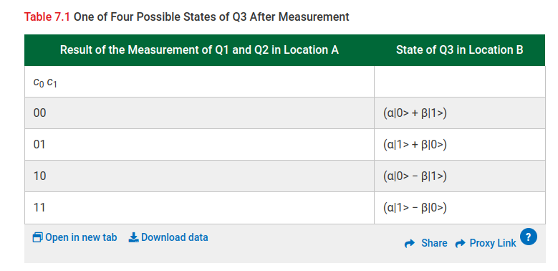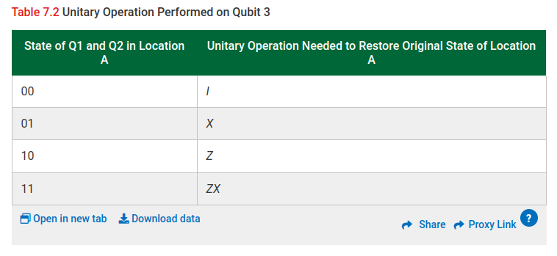

1. Write Qiskit Program for the following teleportation circuit based on what you have learned in the class.

Note: The steps are for your understanding, in your code, you are required to run and show the circuit below. (IBM as well as AER)

code output

