What is Superdense coding ?

Superdense coding is a quantum communications protocol that allows a user to send 2 classical bits by sending only 1 qubit.

The protocol

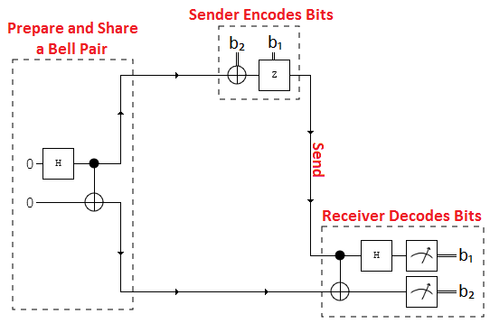

Circuit diagram showing the Superdense coding protocol

1. Step 1-
2. Step 2
3. Step 3
4. Step 4

Step 1: Preparing the Bell pair

First a bell pair consisting of 2 qubits is prepared. Where q0 is the senders qubit and q1 is the receivers qubit. To do this q0 is put in to a superposition of states using a hadamard gate.

Then a CNOT operation is performed with q0 being the control and q1 being the target.

Step 2: Encode the information on to q0

Next the sender has to encode the information they want to send on to q0 by applying certain operations to it.

* If they want to send 00 then they perform no operation.
* If they want to send 01 then they perform a Pauli-Z operation where q1s state is flipped.
* If they want to send 10 then they apply a Pauli-X gate.
* If they want to send 11 then apply a Pauli-Z gate followed by a Pauli-X gate

Step 3: Receiver decodes the information

Next q0 is sent and the receiver has to decode the qubit. This is done by applying a CNOT where the received q0 is the control and q1 is the target. Then a hadamard gate is applied to q0.

How to run the program

1. Copy and paste the code below in to a python file
2. Enter your API token in the IBMQ.enable_account('Insert API token here') part
3. Save and run

Code

print('\n Superdense Coding') print('--------------------------\n') from qiskit import QuantumRegister, ClassicalRegister, QuantumCircuit, execute,IBMQ from qiskit.tools.monitor import job_monitor IBMQ.enable_account('ENTER API TOKEN') provider = IBMQ.get_provider(hub='ibm-q') q = QuantumRegister(2,'q') c = ClassicalRegister(2,'c') backend = provider.get_backend('ibmq_qasm_simulator') print('Provider: ',backend) #################### 00 ########################### circuit = QuantumCircuit(q,c) circuit.h(q[0]) # Hadamard gate applied to q0 circuit.cx(q[0],q[1]) # CNOT gate applied circuit.cx(q[0],q[1]) circuit.h(q[0]) circuit.measure(q,c) # Qubits measured job = execute(circuit, backend, shots=10) print('Executing Job...\n') job_monitor(job) counts = job.result().get_counts() print('RESULT: ',counts,'\n') #################### 10 ########################### circuit = QuantumCircuit(q,c) circuit.h(q[0]) circuit.cx(q[0],q[1]) circuit.x(q[0]) # X-gate applied circuit.cx(q[0],q[1]) circuit.h(q[0]) circuit.measure(q,c) job = execute(circuit, backend, shots=10) print('Executing Job...\n') job_monitor(job) counts = job.result().get_counts() print('RESULT: ',counts,'\n') #################### 01 ########################### circuit = QuantumCircuit(q,c) circuit.h(q[0]) circuit.cx(q[0],q[1]) circuit.z(q[0]) # Z-gate applied to q0 circuit.cx(q[0],q[1]) circuit.h(q[0]) circuit.measure(q,c) job = execute(circuit, backend, shots=10) print('Executing Job...\n') job_monitor(job) counts = job.result().get_counts() print('RESULT: ',counts,'\n') #################### 11 ########################### circuit = QuantumCircuit(q,c) circuit.h(q[0]) circuit.cx(q[0],q[1]) circuit.z(q[0]) # Z-gate applied circuit.x(q[0]) # X-gate applied circuit.cx(q[0],q[1]) circuit.h(q[0]) circuit.measure(q,c) job = execute(circuit, backend, shots=10) print('Executing Job...\n') job_monitor(job) counts = job.result().get_counts() print('RESULT: ',counts,'\n') print('Press any key to close') input()

Output

After running the code you will see something like the following printed on the screen :

My output:-

