# Foundations of Robotics – Project 3 Report

Chinmay Prashanth

cp3873

The Manipulator parameters are,

The frames are depicted into the figure and the DH parameters are,

Part 1:-

Methodology:

Here, in this part we’ve used Matlab/Simulink algorithm to obtain accelaration of the given manipulator .

To find the accelaration we’ve considered the following,



Depending on te characteristics, we can represent the length travelled as,

Where,

For computing path on operation space,

Where Position of each point is,

For J = 1,2…….,N.

**Result:**

1. 3D generated Trajectory:

1. Position:

1. Velocity:

1. Acceleration:

**Part 2:**

**Methodology:**

The Inverse Dynamic control approach is achieved by the idea to find a control vector, as system of state which can realize the input/output relationship of linear type. It is defined as follows,

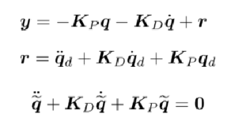

The Dynamics of the manipulator is found by using Lagrangian of the mechanical system and it is defined as,



Here,  it contains the configuration dependent terms g, which represents the moment generated at the joint axis of the manipulator and is the 4X4 matrix in the current configuration. F denotes the matrix of viscous frictional forces in motor. g(q) is the potential energy in the manipulator.

**Results:**

1. **Joint Position:**

1. **Joint Position Error:**

1. **Joint Velocity Error:**

