A Project Report On

Submitted in partial fullfillment of the
Requirements for the award of the Degree of

BACHELOR OF SCIENCE (INFORMATION TECHNOLOGY)
By
Mr. Chinmay Ravindra Ghogale

Under the esteemed guidance of Assistant Professor Miss. U.V.Samant.



DEPARTMENT OF INFORMATION TECHNOLOGY MANDAL'S
PADMASHREE BABASAHEB VENGURLEKAR, PANDUR
(Affiliated to University of Mumbai)

PANDUR, 416521
MAHARASHTRA
2025-26

MANDAL’S

PADMASHREE BABASAHEB VENGURLEKAR

MAHAVIDYALAYA, PANDUR.
(NAAC ACCREDITATION “C” GRADE)

----------------------------------------------------------------------------

CERTIFICATE

This is to certify that Mr. Chinmay Ravindra Ghogale has satisfactorily carried out his project work entitled,

“LIBRARY MANAGEMENT SYSTEM”

As per the syllabus prescribed for T. Y. B.Sc. (Information Technology) of
Mumbai University, Mumbai.
It is also certifying that this is his own work completed during academic year 2025-26. The work done is satisfactory and is presented as per the specifications.

PROJECT GUIDE EXTERNAL EXAMINER HEAD OF DEPARTMENT

DATE:
PLACE: Pandur.
DECLARATION

To
THE HEAD,
DEPARTMENT OF INFORMATION TECHNOLOGY,
P.B.V.M. COLLEGE, PANDUR
Respected Sir,
I undersigned, hereby declare that the project on “LIBRARY
MANAGEMENT SYSTEM” is developed under the guidance of our
Asst. Prof. U. Samant.
The conclusion in this report is based on the data, which is collected by me. I am declaring that this is my original work. I have not copied any materials, which are useful to my work, or other reports that are submitted to the P.B.V.M. COLLEGE, PANDUR this year.

DATE:
PLACE: PANDUR. (Mr. Chinmay Ravindra Ghogle)

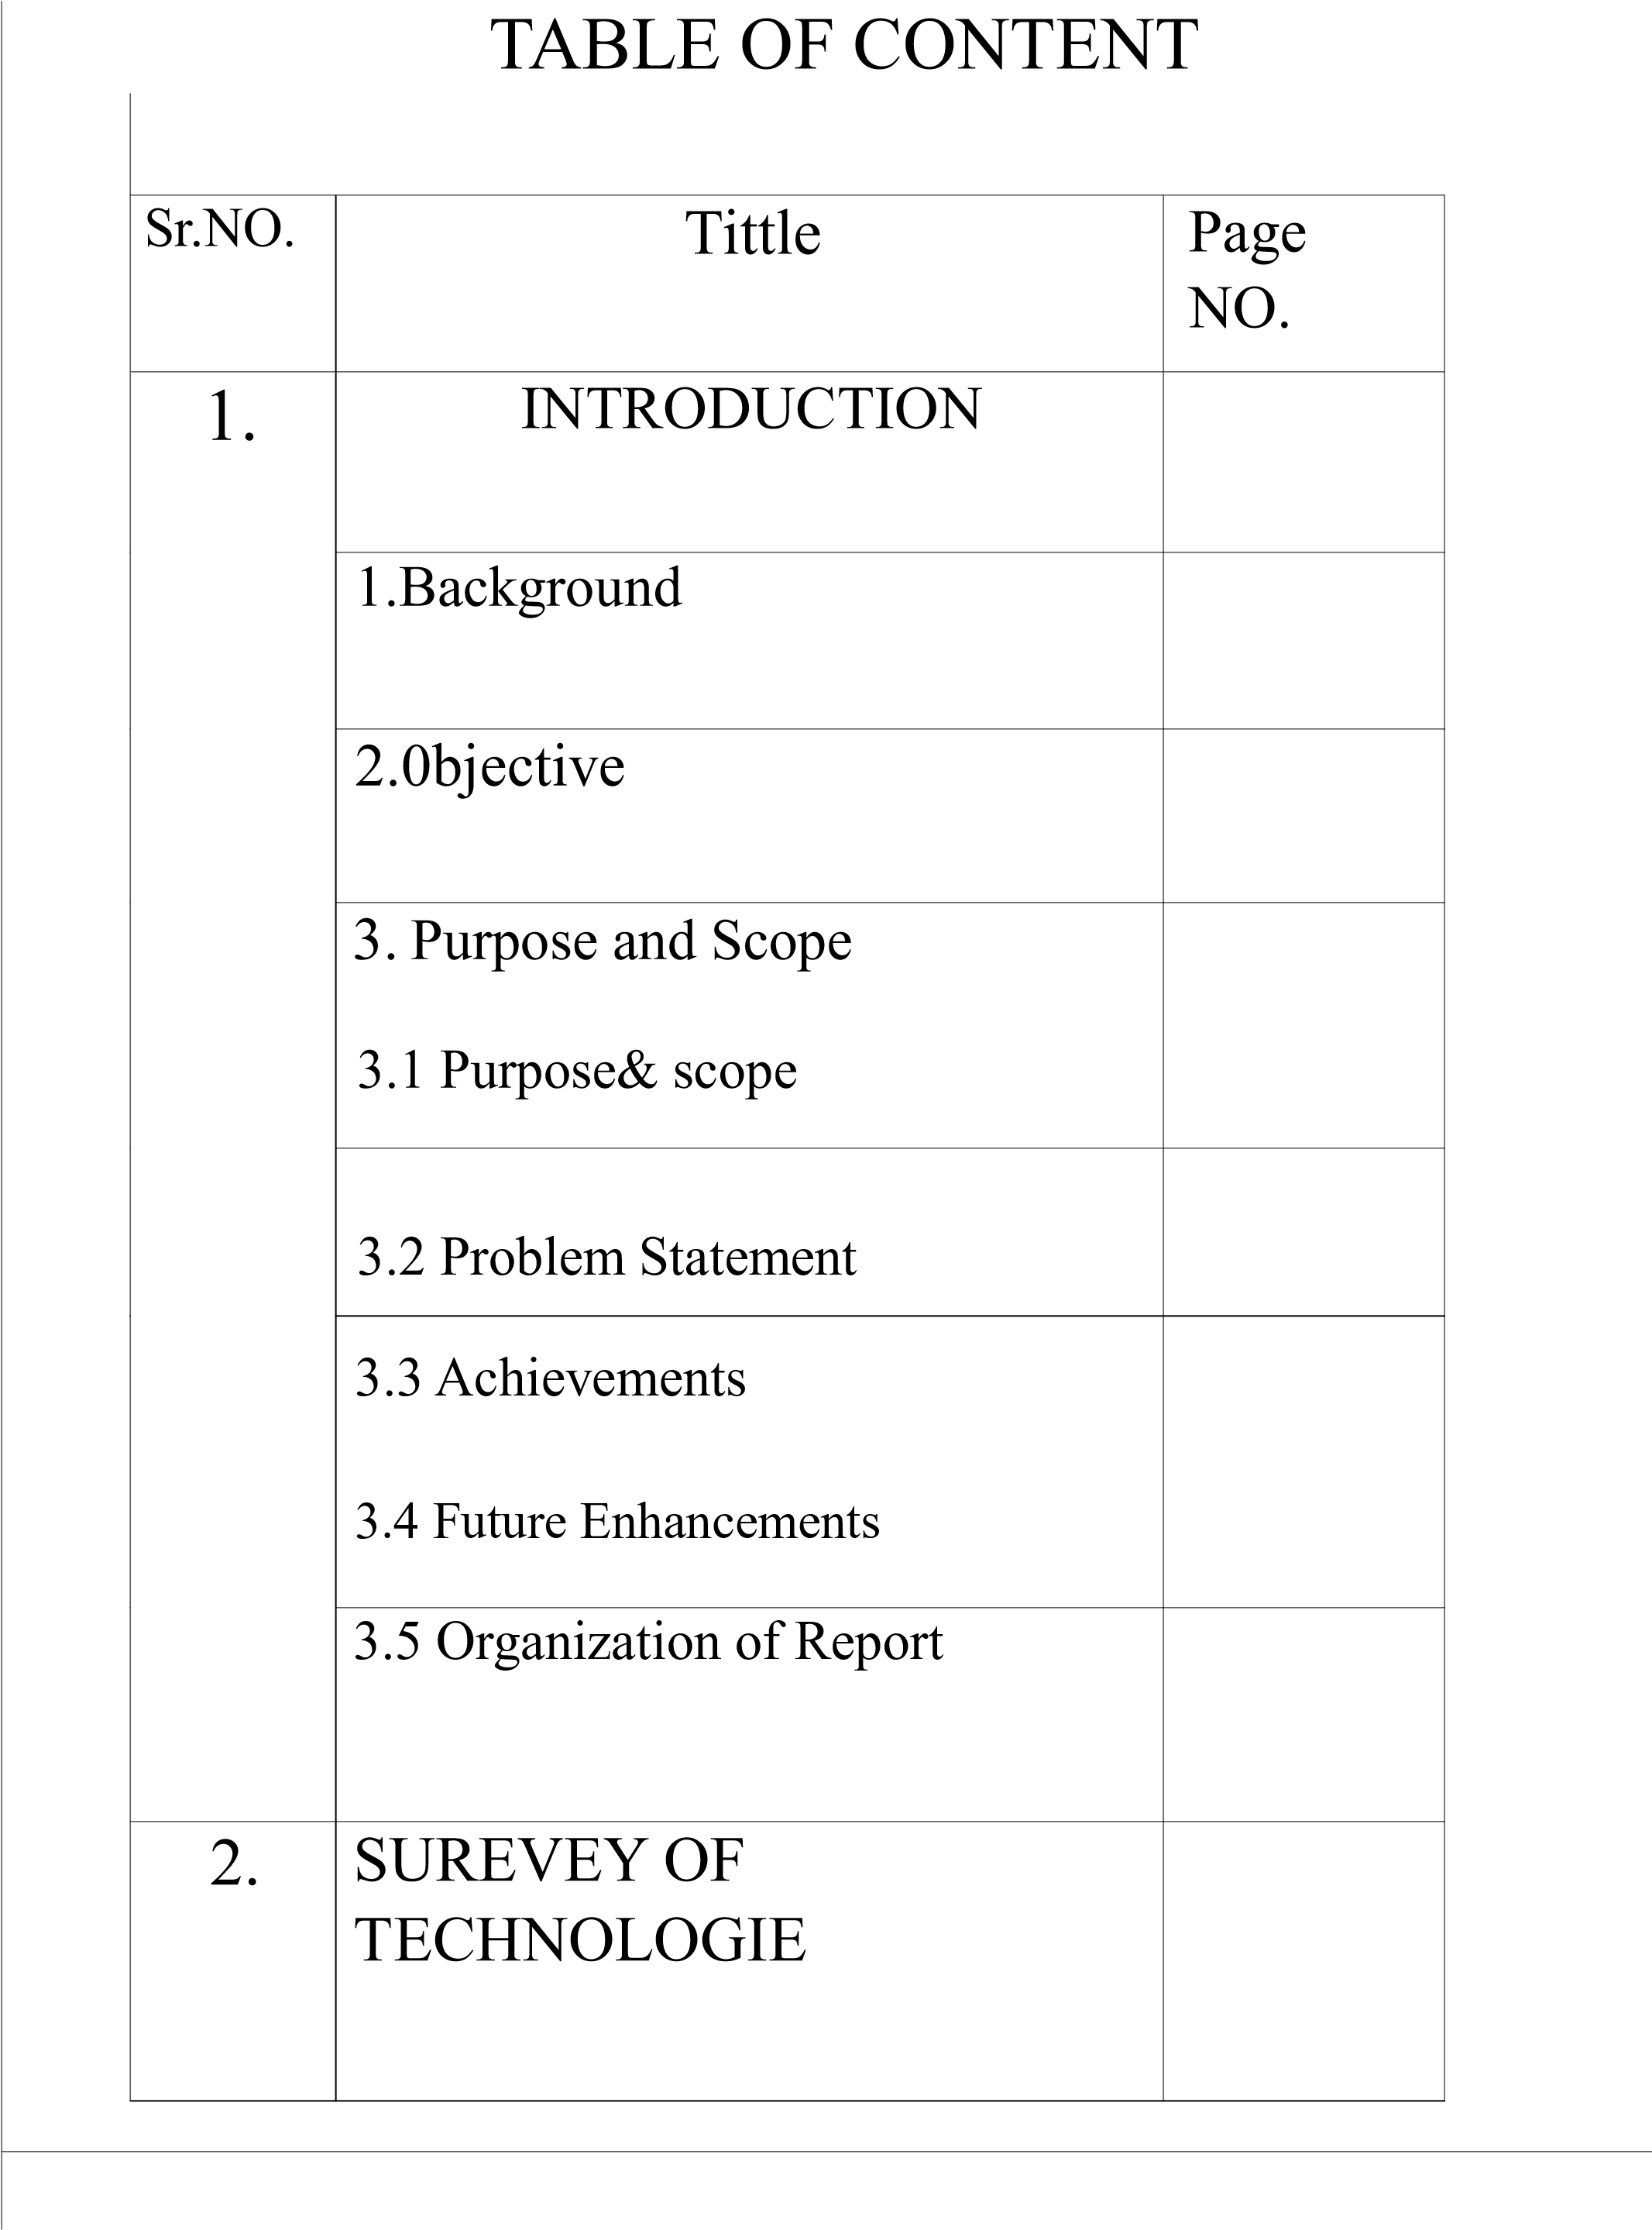
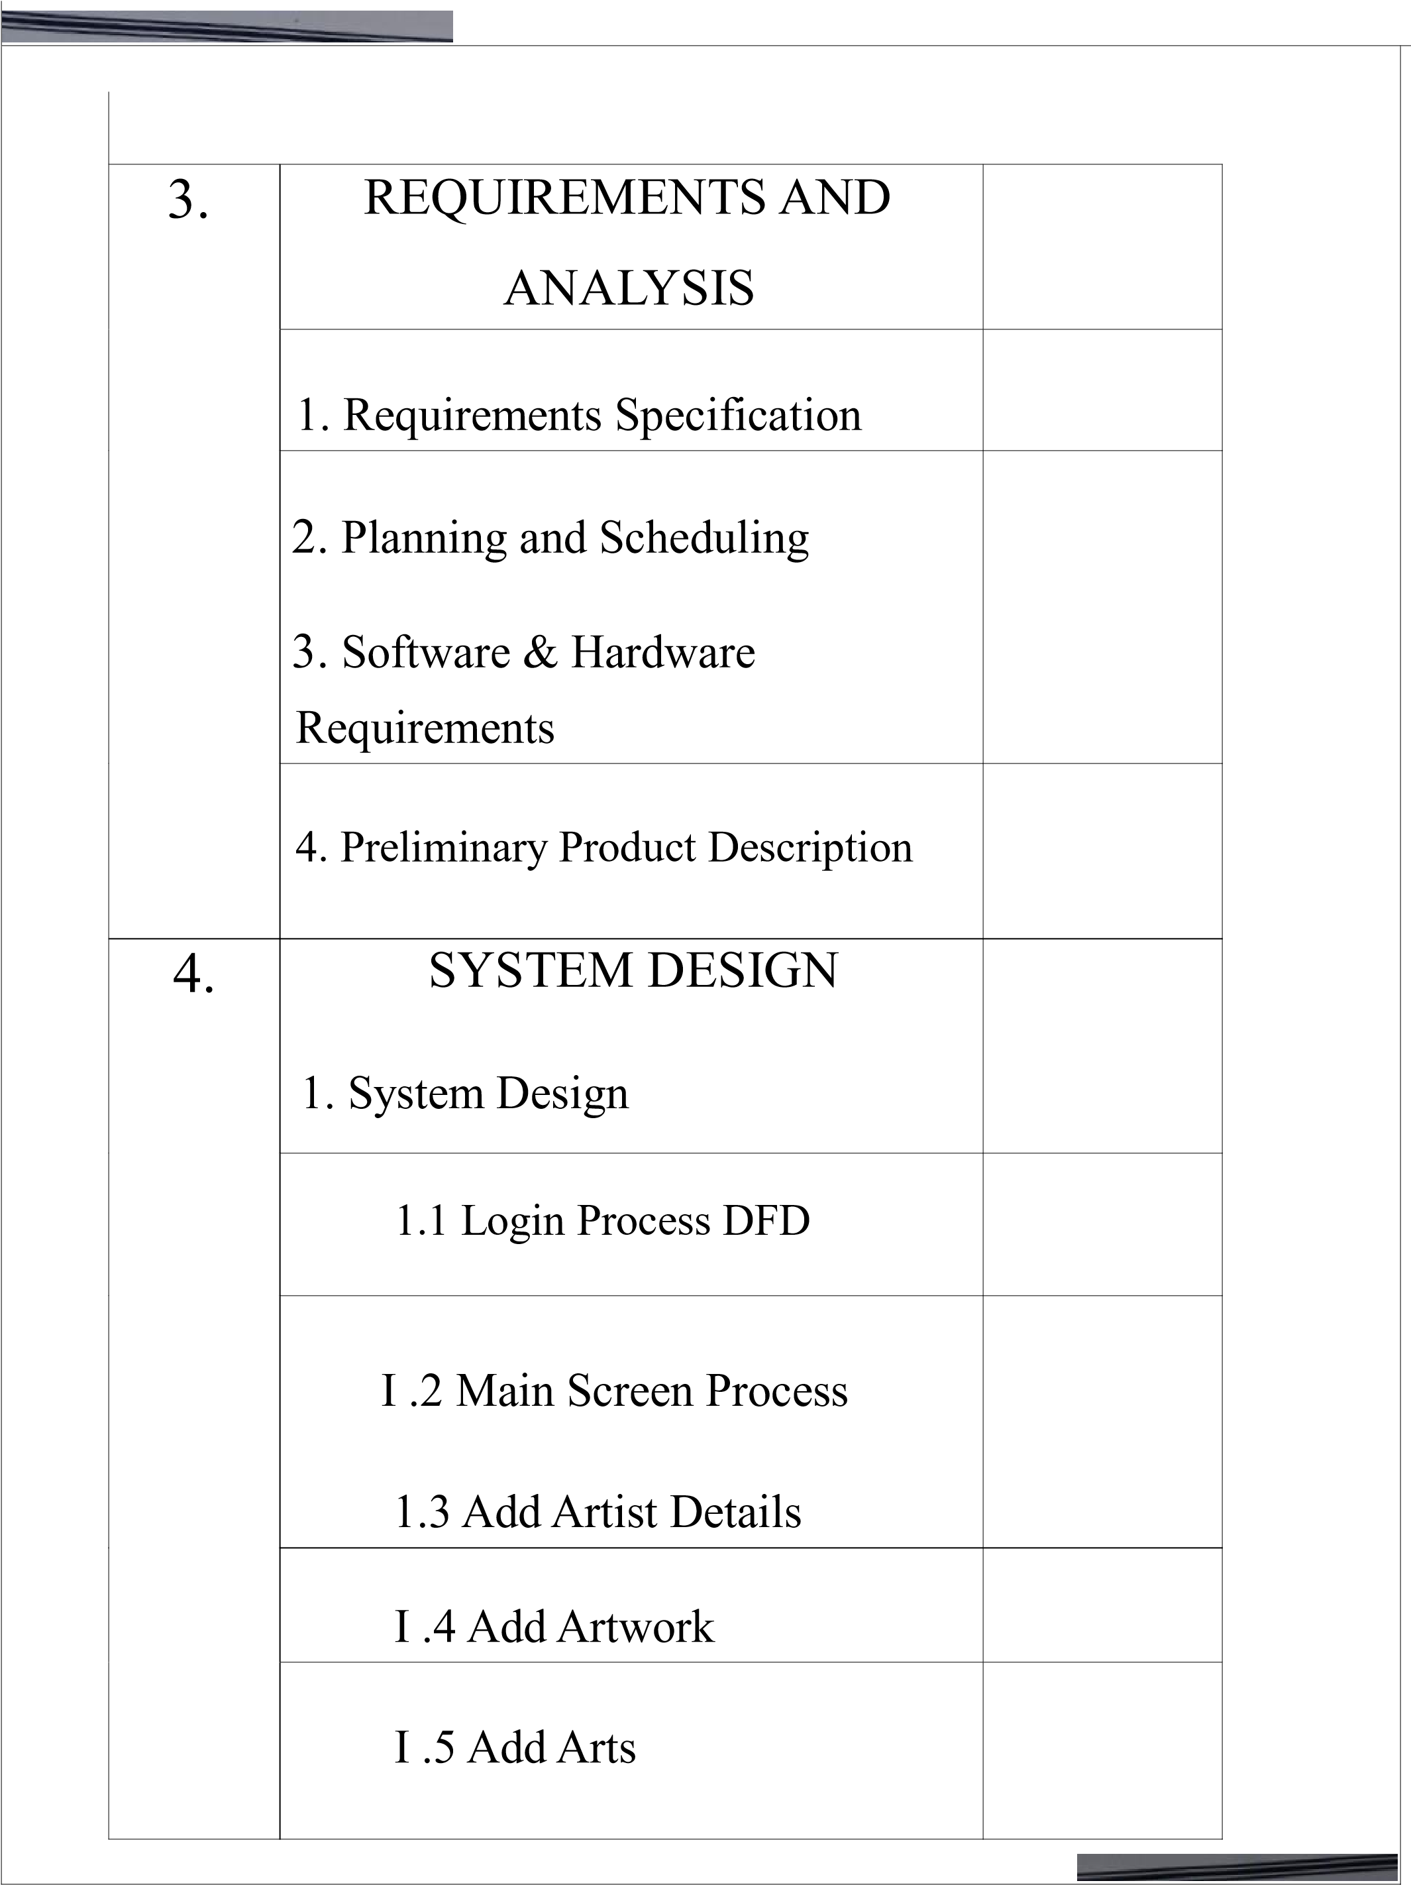
 |  | 1.6 Add Billing
 |  | 2. System Development
3. System tables

3.1 ERD-Diagram
 |  | 3.2 Use-Case Diagram
 |  | 3.3 Data Flow Diagram
 |  | 3.4 Class Diagram
 |  | 3.5 Sequence Diagram
 |  | 3.6 UML Diagram
 |  | 3.7 Activity Diagram
 | 5. | 3.8 Flow Chart  References

BSc IT Final Year Project Documentation
Project Title
Library Management System – A Web-Based Solution for Modern Libraries
Project Report
This project is a comprehensive web-based Library Management System developed using the Flask framework. The system is designed to automate and streamline various library operations such as book cataloging, user registration, book issuance, return management, and fine calculation. It eliminates the inefficiencies of traditional manual systems by providing a centralized digital platform accessible through a web browser. The system also ensures secure login, role-based access (Admin, Librarian, and User), and accurate real-time tracking of books and users. With a user-friendly interface and robust backend database support, the application improves efficiency, reduces human errors, and enhances the overall library experience for both librarians and students. This solution contributes to digital transformation in education by making library services faster, smarter, and more reliable.

Certificate
Acknowledgment
I would like to express my sincere gratitude to [Your Gui^^^^^^^] for their guidance and support throughout this project. I also thanks [Institution Name] for providing the necessary resources and infrastructure.
Declaration
I hereby declare that this project work titled "Library Management System" is my genuine work carried out under the guidance of [Guide's Name] at [Institution Name]. This work has not been submitted elsewhere for any degree or diploma.

1. Introduction
The Library Management System is a modern solution designed to automate library operations, making it easier for librarians to manage books, members, and transactions efficiently. This system replaces traditional paper-based methods with a digital solution
The Library Management System is a comprehensive software solution that simplifies and automates the day-to-day operations of a library. It helps librarians and institutions manage resources such as books, journals, magazines, and digital content efficiently, eliminating the need for traditional paper-based methods.
Book Management – Add, update, search, and categorize books with details such as title, author, ISBN, and availability status.
Member Management – Maintain records of library members, including personal information, membership type, and borrowing history.
Transaction Management – Automate issuing, returning, and renewing of books, while calculating fines for late returns.

2. Background (Existing System)
Traditional library systems often rely on:
- Manual record-keeping of books and members
- Paper-based tracking of borrowing/returning
- Time-consuming book search and inventory management
- Manual attendance tracking
- Limited reporting capabilities
- Manual Record-Keeping
- Librarians must maintain handwritten registers for books, members, and transactions.
- This increases the risk of human errors, data loss, and duplication.
- Paper-Based Borrowing/Returning
- Issuing and returning books require filling out slips or registers manually.
- Tracking overdue books and calculating fines becomes difficult and time-consuming.
- Inefficient Book Search and Inventory Management
- Students and librarians need to browse shelves or check physical records to find a book.
- Inventory updates are slow, making it difficult to know the real-time availability of books.
- Manual Attendance Tracking
- Student visits and usage of library resources are often recorded manually.
- This leads to incomplete or inaccurate attendance records.
- Limited Reporting and Analytics
-Generating reports such as most borrowed books, overdue lists, or member activity requires manual compilation.
- Lack of data insights prevents effective decision-making for resource management.

3. Objectives
- Automate library operations and reduce manual work
- Implement efficient book tracking and management
- Provide easy member management and authentication
- Enable quick book search and categorization
- Implement automated notification system
- Track library attendance digitally
- Generate comprehensive reports
- Minimize manual record-keeping by digitizing all book, member, and transaction records.
- Streamline day-to-day tasks such as issuing, returning, and renewing books.
- Efficient Book Tracking and Management
- Maintain real-time information on book availability, borrowed items, and due dates.
- Reduce errors in book cataloguing and prevent duplication.
- Easy Member Management and Authentication
- Provide secure member registration, login, and profile management.
- Track borrowing history and membership details efficiently.
- Quick Book Search and Categorization
- Enable advanced search by title, author, subject, or keywords.
- Categorize books systematically for faster retrieva
- Automated Notification System
- Send reminders for due dates, overdue books, and membership renewals via email or alerts.
- Keep members updated about new arrivals or important announcements.
- Digital Attendance Tracking

- Purpose
To create a modern, efficient, and user-friendly library management system that streamlines library operations and enhances user experience.
The purpose of the Library Management System is to design and implement a modern, efficient, and user-friendly platform that addresses the shortcomings of traditional library operations. The system aims to
Streamline Library Operations
Replace manual, paper-based processes with an automated solution that minimizes human error and saves time.
Enhance User Experience
Provide students and staff with a simple, intuitive interface to search, borrow, and return books efficiently.
Improve Resource Management
Ensure accurate tracking of books, members, and transactions in real-time to maximize the utilization of library resources.
Enable Data-Driven Decisions
Offer comprehensive reports and analytics that help librarians and institutions plan better, identify usage patterns, and manage resources effectively.
Promote Digital Transformation
Shift from traditional record-keeping to a fully digital environment, making the library smarter, faster, and more accessibility

- Scope
User authentication and authorization
- Book management (add, delete, update)
- Member management
- Borrowing and returning processes
- Attendance tracking
- Automated notifications
- Report generation
- Data import/export capabilities 6. Sources & Technologies o Frontend - HTML5
- CSS3
- JavaScript
- Bootstrap
Flask Templates (Jinja2)
Backend
- Python 3.x
- Flask Framework
- SQL_Alchemy ORM
- SQLite Database
- System Analysis
for the Library Management System focuses on understanding the current manual process of handling books, members, and transactions. In the existing system,
all records are maintained in registers, which increases the chances of errors, duplication, and data loss. Borrowing and returning books require filling slips manually, which is time-consuming and inefficient. Searching for a book also becomes difficult as students and librarians need to browse shelves or check physical records. Through analysis, the proposed computerized system is designed to overcome these issues by automating book management, member registration, and transaction tracking.
Functional requirements include book issue/return, fine calculation, and availability checking, while non-functional requirements focus on performance, security, and user-friendliness. Data Flow Diagrams (DFD) and Entity-Relationship Diagrams (ERD) are used to model the system processes. The feasibility study confirms technical, operational, and economic viability of implementation. Overall, system analysis ensures the new system improves efficiency,
reduces workload, and provides accurate real-time information.
Problem Definition
Traditional library systems face challenges with:
- Manual record keeping
- Book tracking
- Member management
- Attendance monitoring - Report generation o Requirement Specification

- User Management
• Allows registration, updating, and removal of users (students, faculty, staff)
• Each user is assigned a unique ID
• Stores detailed user info: name, department, contact, membership type
• Categorizes users: student, librarian, admin, etc.
• Implements role-based access control

- Example: Only librarians can issue books or manage fines
• User authentication via login credentials for security
• Maintains borrowing history for each user
• Tracks:

- Issued and returned books
- Membership validity
- Overdue fines
- Account status
• Reduces manual errors and time spent on administrative tasks
• Ensures accurate and secure record-keeping
members.

2. Book Management
Add/Edit/Delete books
Search and filter books
Track book status
Import books via CSV
3. Member Management
Add/Edit/Delete members
Track borrowed books
Manage member types
Import members via CSV

4. Transaction Management
Book borrowing
- Book returning
- Fine calculation
- Transaction history

5. Attendance System
- Check-in/Check-out
- Attendance reports
- Visitor tracking

**Non-Functional Requirements:**
      - Security
      - Performance
- Usability
- Reliability
- Maintainability

8. Gantt Chart

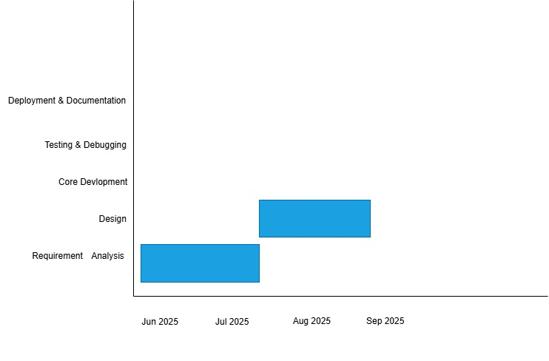

+
- Existing System & Limitations
• Manual record-keeping using registers and logbooks
• Time-consuming process for borrowing and returning books
• Inefficient book search (physical browsing or index cards)
• Difficulty in tracking overdue books and calculating fines
• Book availability status not updated in real-time
• Data not properly maintained — no structured database system
• High risk of data duplication, loss, or misplacement
• Frequent human errors in recording and updating data
• Reports (e.g., borrowing history, popular books) are hard to generate
• No data security or user access control
• Not scalable for large or growing libraries
• Heavy reliance on manual effort and librarian time
• Overall system is outdated, unreliable, and inefficient

10. Proposed System
o Advantages
- Automated Operations
- Real-time Updates
- Efficient Search
- Automated Notifications
- Digital Attendance Tracking
- Comprehensive Reporting
- Data Import/Export
- User-friendly Interface
- Limitations Overcome
- Eliminated manual record keeping
- Automated book tracking
- Digital attendance system
- Instant report generation
- Automated notification system
- Efficient data management

11. Technology Used Hardware Requirements
- Processor: Intel Core i3 or higher
- RAM: 4GB minimum
- Storage: 10GB minimum
- Internet connectivity
o Software Requirements
    - Operating System: Windows/Linux/MacOS
    - Python 3.x
    - Flask Framework
    - SQLite Database
    - Modern Web Browser
o Language / Tools
- Python
- HTML/CSS/JavaScript
- SQLite
- Git
- Visual Studio Code
- Flask and its extensions

12. System Design
1. Login Process (DFD Point)
User enters username and password.
System validates credentials against the database.
If valid → access granted to the main system.
If invalid → error message is displayed.
2. Main Screen Process (DFD Point)
After successful login, the system displays the main dashboard.
Dashboard shows options like Add Artist, Add Artwork, View Records, and Logout.
User selects the desired operation → corresponding process is initiated.
3. Add Artist Details (DFD Point)
User selects Add Artist option.
Input details: Artist ID, Name, Contact, Specialization, etc.
System validates input fields.
Data is stored in the Artist Database Table.
Confirmation message is displayed.
4. Add Artwork (DFD Point)
User selects Add Artwork option.
Input details: Artwork ID, Title, Artist ID, Category, Price,
System cross-checks Artist ID from the database.
Artwork details are stored in the Artwork Database Table.
Confirmation message is displayed.
5. Add Artist (General Process DFD Point)
This process ensures new artists are registered before linking
Input artist information → validate → store in database.
Creates a unique Artist ID for future references.
System updates the Artist Master Table.

14. Diagrams
ER Diagram
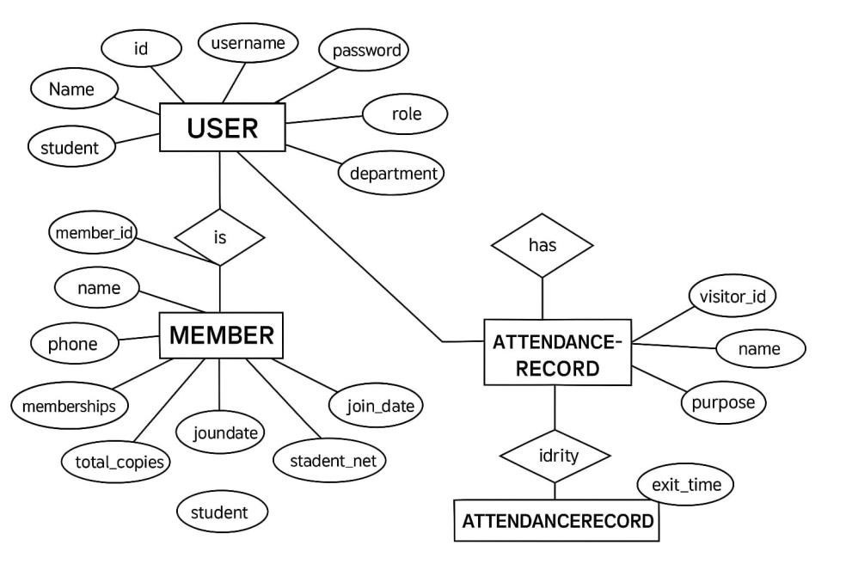

- Use Case Diagram
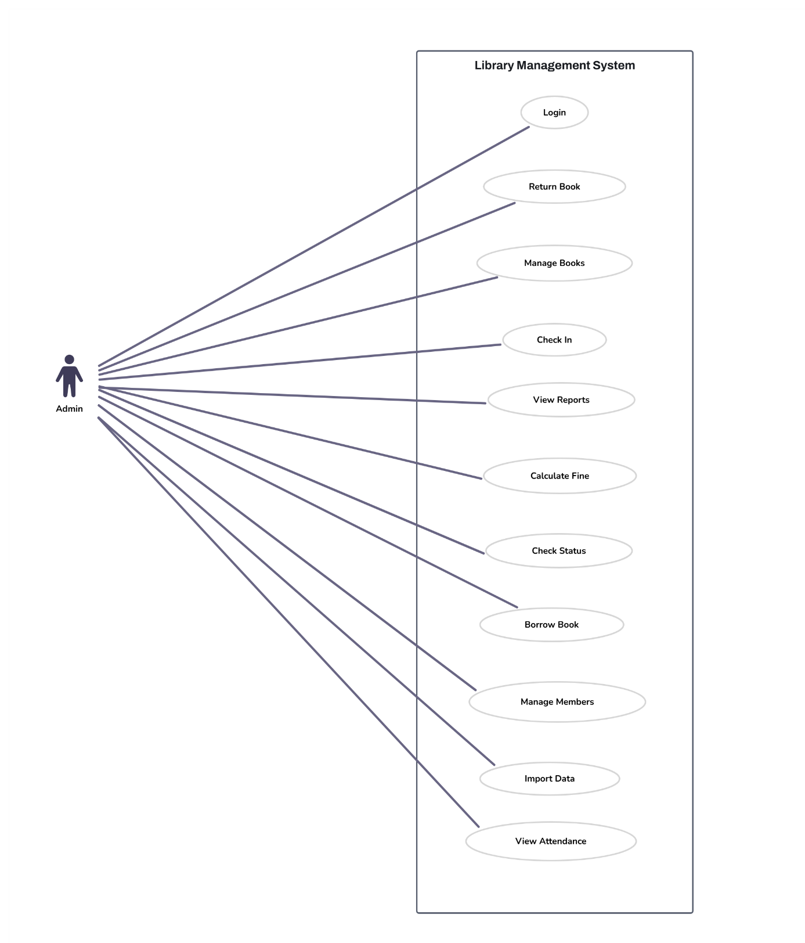

- Data Flow Diagram
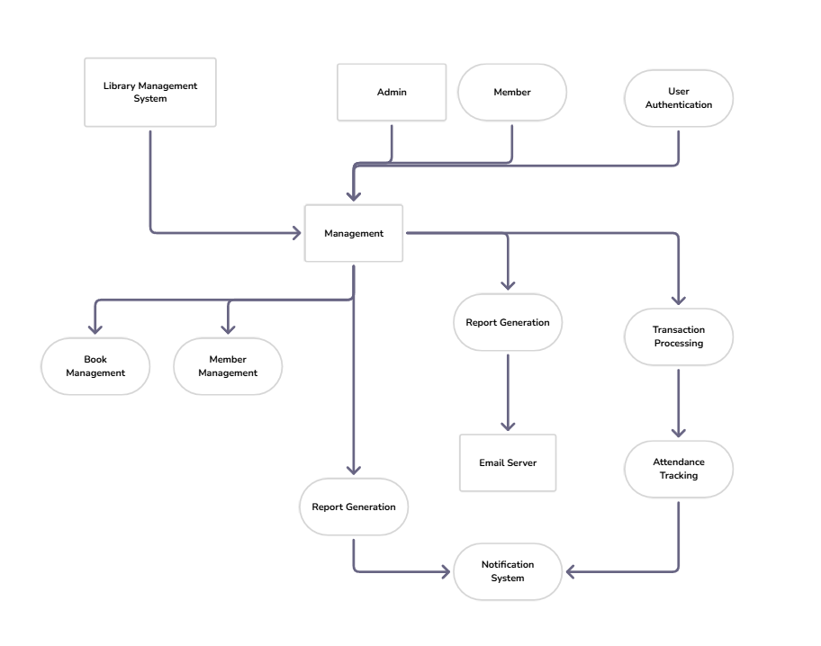

- Class Diagram
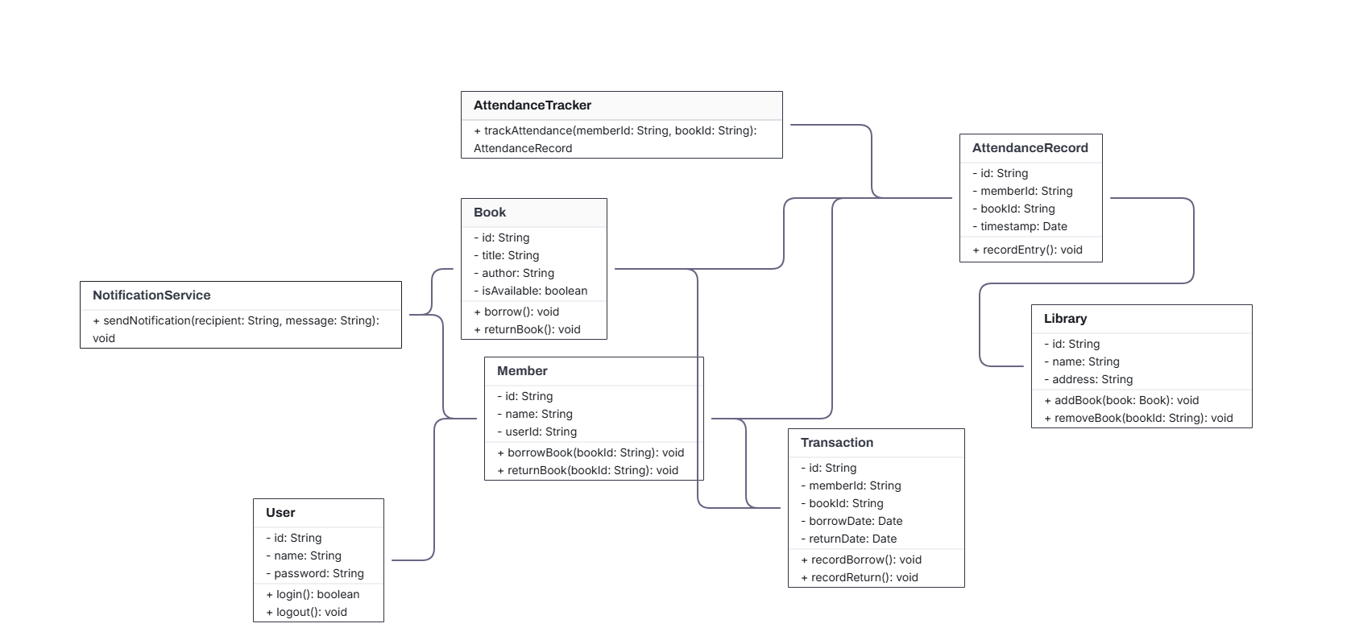

- Object Diagram
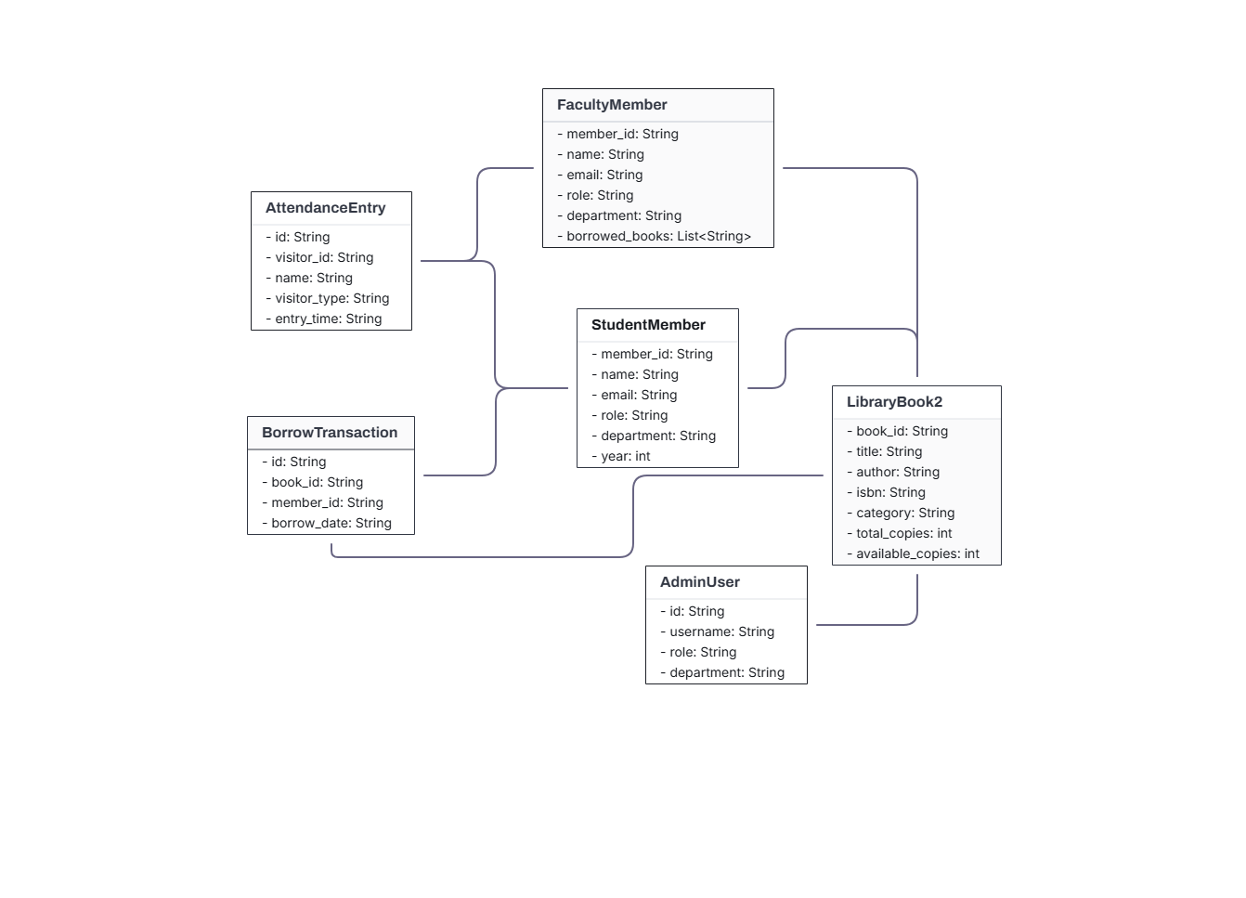

- Activity Diagram
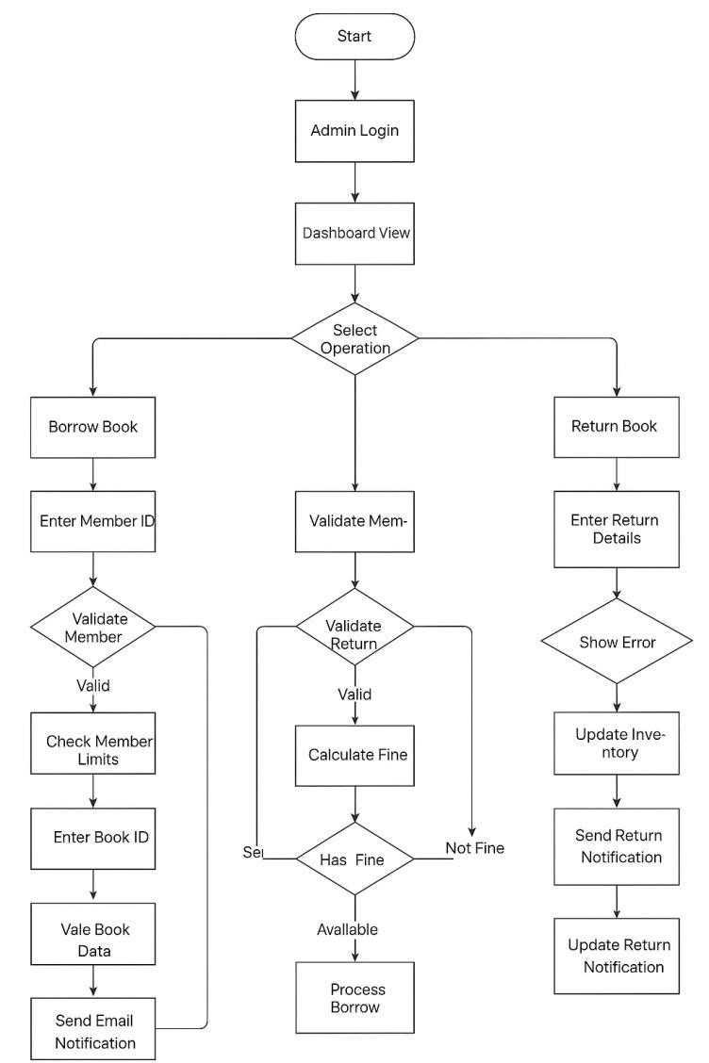

- Key implementation files:
- app.py: Main application file
- models.py: Database models - routes.py: URL routing
- templates/: HTML templates
- static/: CSS, JS, and image files

- References / Bibliography
- Flask Documentation: https://flask.palletsprojects.com/
- SQLAlchemy Documentation: https://www.sqlalchemy.org/
- Bootstrap Documentation: https://getbootstrap.com/
- Python Documentation: https://docs.python.org/

