Project Report
On
Image Processing Studio
Image & Video Processing

Submitted by
Akshat Katiyar (E272)
Chinmay Soni (E221)
Atharva Khandelwal (E226)
B.Tech Computer Science (3rd Year), Semester V
Under the guidance of
Dr. Sachin Chavan
DEPARTMENT OF COMPUTER SCIENCE
Mukesh Patel School of Technology Management & Engineering
SVKM’s NMIMS, Shirpur
ACADEMIC SESSION: 2026-27

DEPARTMENT OF COMPUTER SCIENCE
Mukesh Patel School of Technology Management & Engineering
Abstract
Classical image-processing operators such as Otsu thresholding, gradient edge detectors and sharpening filters assume a clean, evenly lit image. Real photographs are often noisy, badly exposed, low in contrast or unevenly lit, and the operators then fail silently: they return a wrong mask or a noisy edge map without any warning. This project, Image Processing Studio, is a web application that makes classical image processing measurable, automatic and explainable. Every image is first diagnosed with ten measurements whose thresholds were calibrated on 391 labelled images; the system then prescribes only the fixes the image needs, applies the requested operation and verifies the result by running the same operation directly and after fixing, and scoring both with quantitative metrics.
The dashboard offers brightness and contrast correction, noise removal, sharpening, edge detection, Otsu segmentation with morphological clean-up, and three forms of transform compression: whole-image DCT, Walsh–Hadamard and a from-scratch JPEG-style coder with quantisation tables and chroma subsampling. On images with known ground truth, fixing first raised segmentation IoU from 0.14 to 0.99 under uneven lighting and edge F1 from 0.51 to 0.91 under salt-and-pepper noise; JPEG-style coding reached the same quality as whole-image DCT with a 6.3 times smaller file. A new half-scale test detects noise in screenshots that standard estimators miss (0 of 170 detected before, 170 of 170 after). The system is built with Python (NumPy, OpenCV), FastAPI and React, every algorithm is also implemented from scratch in NumPy and verified against OpenCV, and the application is deployed on Vercel.
Keywords: image enhancement, noise estimation, Otsu thresholding, morphology, DCT, Walsh–Hadamard transform, JPEG quantisation, PSNR, SSIM.

Index
Page No.
1. Introduction 1
2. Literature Review 3
3. System Design 4
4. Methodology & Implementation 6
5. Results & Discussion 13
6. Testing & Validation 19
7. Applications 20
8. Conclusion & Future Scope 21
9. References 22

1. Introduction
1.1 Background
Digital images are the input to almost every modern vision system, from medical imaging and document scanning to plant-disease and currency recognition. Before such systems can analyse an image, the image usually has to be corrected: its brightness and contrast adjusted, its noise removed and its lighting evened out. The classical techniques for these steps (point transforms, spatial filters, morphology, thresholding and transform coding) are well established [1], but they are usually applied one at a time, on grayscale images, with parameters chosen by hand. In practice, a user rarely knows which defect an image has, which technique fixes it, which parameter to use, or whether the fix actually improved the result.
1.2 Problem Statement
Classical operators fail silently on real images. A single global Otsu threshold applied to an unevenly lit image separates the bright half from the dark half instead of objects from background; salt-and-pepper specks riddle segmentation masks with holes; edge detectors fire on sensor grain and report thousands of false edges; and sharpening amplifies noise. None of these operators reports that it has failed. Compression is often described as “keep fewer coefficients”, which does not explain why real image files become small. The problem addressed by this project is therefore: to build a system that measures what is wrong with an image, fixes only that, applies the requested operation, and proves with numbers whether the fix helped, for both grayscale and colour images.
1.3 Objectives
1. Diagnose every image with objective measurements: exposure, contrast range, noise σ, salt-and-pepper density, enlarged noise in screenshots, lighting unevenness and Otsu separability.
2. Fix only what is needed with calibrated rules applied in a safe, explained order (Auto Fix).
3. Provide every standard tool (contrast, denoising, sharpening, edges, compression) with presets and advanced settings, working correctly on colour images.
4. Verify each operation by running it directly and after fixing, scoring both with IoU, edge F1, Otsu separability, fragmentation and false-edge density.
5. Compare compression methods fairly: DCT vs Walsh–Hadamard at equal coefficient budgets, and a JPEG-style coder at equal quality, measured on real file sizes.
6. Deliver it as a deployed web application that works within free hosting limits.
1.4 Scope
The project covers image enhancement, noise removal, morphology, edge detection, segmentation, image transforms and compression. It works on single still images (grayscale or RGB, up to 25 megapixels). Deep learning is deliberately out of scope: every decision is made by an explainable formula, needs no training data and runs on an ordinary CPU.
2. Literature Review
Image enhancement and filtering. Gonzalez and Woods [1] describe the point transforms used in this project (power-law gamma correction, contrast stretching and histogram equalisation), the linear smoothing filters (box and Gaussian), the order-statistic median filter, which removes impulse noise without blurring edges, and sharpening by unsharp masking and the Laplacian. They also describe the first-order gradient operators of Roberts, Prewitt and Sobel used for edge detection.
Thresholding. Otsu [2] proposed choosing the threshold that maximises the between-class variance of the gray-level histogram; the ratio of that variance to the total variance, η, measures how separable the two classes are. Otsu’s method is optimal for bimodal histograms but assumes uniform illumination, which is why background flattening with a morphological top-hat [1] is applied first when the lighting is uneven.
Noise estimation. Immerkær [3] showed that the noise standard deviation of an image can be estimated from a single 3×3 mask that is the difference of two Laplacians: the mask cancels constant and linearly varying regions, so its average absolute response is proportional to the noise σ. This estimator is the basis of the project’s grain detection.
Transforms and compression. Ahmed, Natarajan and Rao [4] introduced the discrete cosine transform and showed that it compacts the energy of correlated signals almost as well as the optimal Karhunen–Loève transform. The Walsh–Hadamard transform [1] uses ±1 square waves instead of cosines and needs only additions and subtractions. Wallace [5] and the JPEG standard ITU-T T.81 [6] describe how real image files become small: YCbCr colour conversion, chroma subsampling, 8×8 block DCT, quantisation with perceptually designed tables (Annex K) and entropy coding.
Quality assessment. PSNR measures pixel error; Wang et al. [7] proposed SSIM, which compares local luminance, contrast and structure and agrees better with human judgement. The implementation uses NumPy [8] and OpenCV [9]; test images come from scikit-image [10].
Gap addressed. These techniques are well established individually, but they are normally applied manually and without verification. This project combines them into one system that diagnoses the image, chooses the technique and parameter, and measures whether the result improved.
3. System Design
3.1 Architecture
The system has three layers (Figure 1). The React dashboard [12] offers three tabs: Tools, Compare and Auto Fix. The FastAPI back end [11] validates uploads, calls the pipeline and returns preview images with metrics; full-quality files are produced only when the user downloads. The ivp_pipeline Python package contains every algorithm, written with OpenCV calls and, independently, from scratch in NumPy. The application is deployed on Vercel.
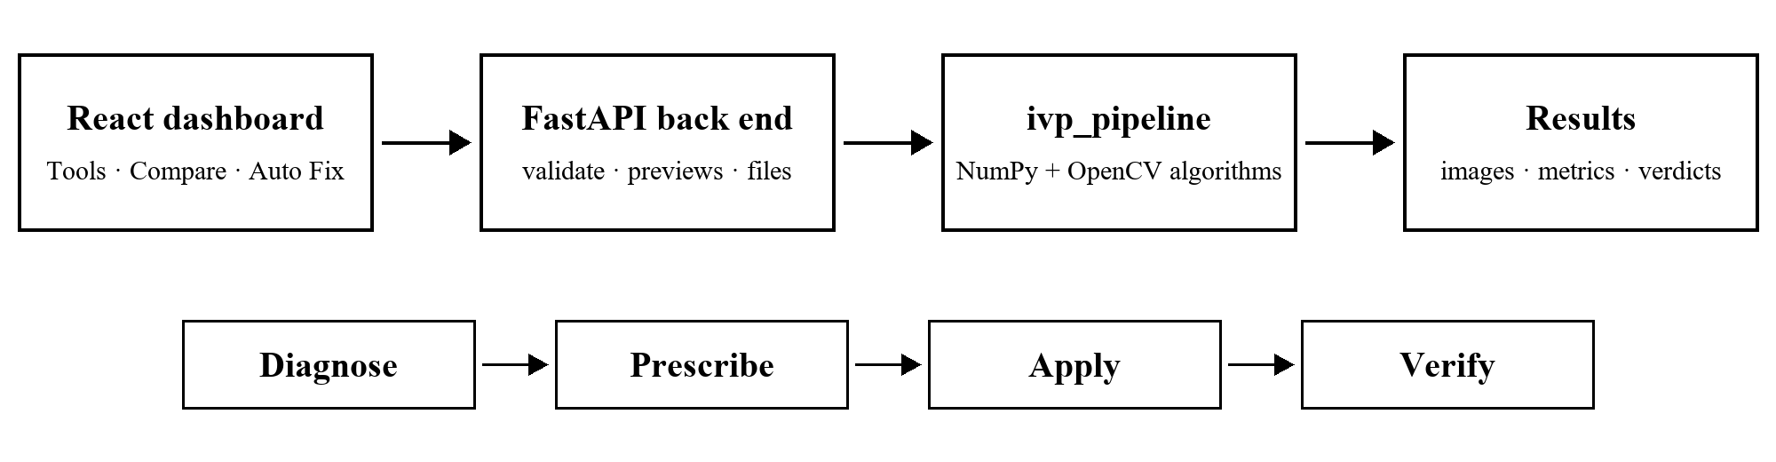
Figure 1: System architecture (top) and the processing loop used by every feature (bottom)
3.2 The Processing Loop: Diagnose → Prescribe → Apply → Verify
• Diagnose: ten measurements are computed and compared with calibrated thresholds (Section 4.1).
• Prescribe: rules choose the fix and its parameter, for example a 3×3 or 5×5 median filter depending on the speck density (Section 4.2).
• Apply: the chosen tool runs: enhancement, denoising, edges, segmentation or compression.
• Verify: the operation is run directly and after fixing; one metric per fix decides the verdict (Section 4.8).
3.3 Handling Colour (RGB) Images
Most image-processing operators are defined for a single gray plane. A colour image has three planes (R, G, B), and applying a contrast curve to each plane separately changes the ratio R:G:B and shifts the hue (Figure 2b). Each feature therefore uses the representation that suits it (Table 1). Brightness Y and chrominance are obtained with the ITU-R BT.601 conversion:
Y = 0.299 R + 0.587 G + 0.114 B
C_{b} = 128 + 0.564 (B − Y), C_{r} = 128 + 0.713 (R − Y)
Y is identical to the grayscale conversion; C_{b} and C_{r} measure how much bluer or redder the pixel is than its brightness, with 128 meaning no colour. The conversion is exactly reversible.
Table 1: How each feature processes a colour image
Strategy | Used by | Reason
Each plane R, G, B separately | Noise removal, DCT and Hadamard compression | The same filter or transform on all three planes keeps them consistent
Brightness Y only (YCrCb) | Light & contrast, sharpening | Cr and Cb are untouched, so colours cannot shift
Gray Y only | Image Health tests, edges, Otsu | The output is a number, an edge map or a mask
YCbCr + subsampling | JPEG-style compression | The eye is less sensitive to colour detail

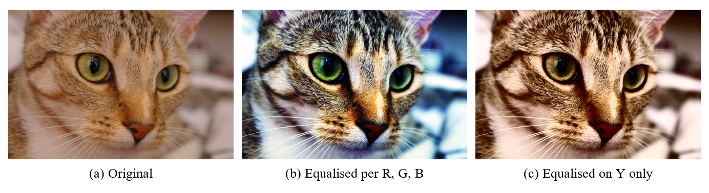
Figure 2: Histogram equalisation of a colour image: (b) per R, G, B shifts the colours; (c) on Y only keeps them
3.4 Deployment Constraints
Vercel limits each request and response to 4.5 MB. A 12-megapixel photograph originally produced responses of up to 113 MB. The back end now returns previews of at most 1280 pixels (1024 pixels for the compression comparison) and generates the full-resolution file only on download, falling back from PNG to high-quality JPEG when a file would exceed the limit. The largest response is now 2.6 MB. Uploads are checked against the limits (4.2 MB and 25 megapixels on Vercel, 15 MB locally) with a clear message.
4. Methodology & Implementation
4.1 Image Health (Diagnosis)
When an image is loaded, the measurements in Table 2 are computed on the brightness Y. Each threshold was tested on 187 labelled images (clean and degraded versions of 17 source images) and 204 screenshot-like images (Section 6.2).
Table 2: Image Health measurements, thresholds and actions
Test | What it measures | Finding when | Auto Fix action
Brightness | Mean of Y (0 = black, 1 = white) | < 0.30 or > 0.70 | Auto gamma
Contrast range | P99 − P1 of Y | < 100 levels | Contrast stretch
Grain | Noise σ (Immerkær) | σ > 5 (strong > 8) | Gaussian σ 0.6 / 1.0
Specks | Share of extreme odd-one-out pixels ρ | ρ > 0.75 % | Median 3×3 (5×5 if > 10 %)
Enlarged specks | Speck density at half scale ρ_{½} | ρ_{½} > 2.3 % | Median 5×5 (7×7 if > 5 %)
Enlarged grain | Noise σ at half scale σ_{½} | σ_{½} > 5 and > 3.5 σ | Gaussian σ 1.5
Uneven lighting | Background variation U | U > 0.15 | Used in Compare
Separability | Otsu η | η < 0.70 | Information
Clipping | Pixels at pure black / white | > 5 % | Cannot be recovered

Noise σ (Immerkær’s method)
The 3×3 mask N = [1 −2 1; −2 4 −2; 1 −2 1] gives zero on flat regions and on linear ramps, so after filtering only the noise remains. The noise standard deviation is
σ_{n} = √(π/2) · (1/6) · mean |f ∗ N|
where the factor 1/6 undoes the mask’s gain (√36 = 6) and √(π/2) converts a mean absolute value into a standard deviation for Gaussian noise. The 20 % strongest Sobel edge pixels are excluded, so real detail is not counted as noise.
Salt-and-pepper density and lighting unevenness
A pixel is counted as a speck if it is nearly black or white (f ≤ 5 or f ≥ 250) and differs from its 3×3 median by more than 50 levels; ρ is the fraction of such pixels. Lighting unevenness is U = (P₉₅(B) − P₅(B)) / 255, where the background B is the morphological opening (or closing) of the image with a large disk that removes the objects.
Enlarged noise in screenshots
Enlarging an image during a screenshot smears each noise dot over 2–3 pixels, so neighbouring pixels become similar and the pixel-scale tests see a clean image. Taking every second pixel makes the noise pixel-sized again; the speck and grain tests are repeated on this half-scale image. Isolated groups of at most two pixels count as specks, so edges and textures are not mistaken for noise.
4.2 Auto Fix (Prescription)
Auto Fix applies at most five rules in a fixed order and measures the image again after every step:
1. Specks → median filter (3×3, 5×5 for heavy or enlarged specks, 7×7 for heavy enlarged specks).
2. Grain → Gaussian blur (σ 0.6 moderate, 1.0 strong, 1.5 enlarged).
3. Exposure → auto gamma, so the mean brightness moves to mid-gray.
4. Low contrast → contrast stretch with 1 % clipping.
5. Sharpen → mild unsharp masking (k = 0.6), only if no noise was found at any scale.
The order matters. Specks are removed first because each speck is a large jump that inflates the grain measurement; on the salt-and-pepper test image the noise σ was 20.0 only because of the specks, and after the median filter the re-measured grain was below the threshold, so no blur was added. Noise is removed before brightening because brightening also amplifies noise, and sharpening comes last because it amplifies any remaining noise.
4.3 Light & Contrast
Each preset is a lookup table s = T(r) that maps every input brightness r (0–255) to an output s, applied to Y only. Auto brightness uses the power law
s = 255 (r / 255)^{γ}, γ = ln 0.5 / ln m
where m is the mean brightness on a 0–1 scale; γ is chosen so that the mean maps to mid-gray and is limited to 0.3–3. For a dark image with m = 0.27, γ = 0.52. Boost contrast stretches the range between lo and hi, the darkest and brightest levels after ignoring 1 % of pixels at each end:
s = 255 (r − lo) / (hi − lo)
Equalize histogram maps each level k to the share of pixels at or below it:
s_{k} = round( (L − 1) Σ_{j=0..k} p(r_{j}) ), L = 256
where p(r_{j}) is the fraction of pixels with level j. The result has an almost flat histogram (mean ≈ 128, σ ≈ 74). Advanced settings expose the method, the γ value (0.1–3 or auto) and the clip percentage (0–5 %). For segmentation, background flattening g = Y − B + mean(B) removes uneven lighting.
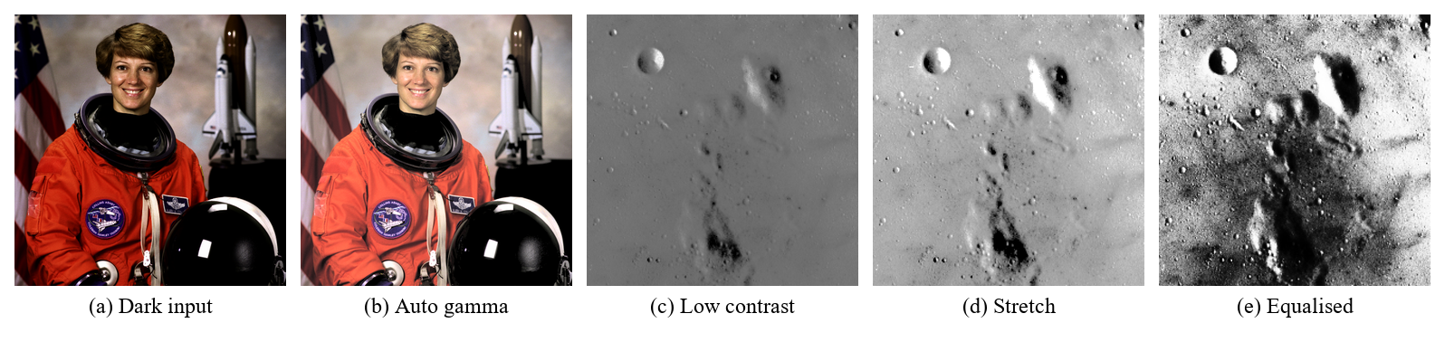
Figure 3: Light & contrast presets: auto gamma on a dark photo; stretch and equalisation on a low-contrast image
4.4 Noise Removal
The median filter sorts the K×K neighbourhood and takes the middle value; for the window 12, 10, 255, 11, 13, 9, 0, 12, 11 the median is 11 while the mean is 37, so specks are removed instead of smeared. A speck is removed only if fewer than half of the window pixels are bad, which is why denser or larger (enlarged) specks need 5×5 or 7×7 windows. The Gaussian filter is a weighted average with kernel size 2⌈3σ⌉ + 1, applied separably; the box filter is a plain 3×3 average. Presets cover salt and pepper (3×3), heavy specks (5×5), big screenshot specks (7×7), grain (σ 1), coarse grain (σ 1.5) and a simple blur; advanced settings choose the filter, the window size (3, 5, 7) and σ (0.5–3). Each filter runs on R, G and B separately.
4.5 Sharpening and Edge Detection
Unsharp masking extracts the detail as the difference between the image and its blurred version and adds it back with gain k:
g = f + k (f − G_{σ} ∗ f)
Flat regions give zero detail and are unchanged; at an edge, the dark side becomes darker and the bright side brighter, which makes the edge look crisper. Presets use k = 1 (sharpen) and k = 2 (high-boost); the Laplacian preset uses the mask [−1 −1 −1; −1 A+8 −1; −1 −1 −1], where A = 1 sharpens and A = 0 returns only the edges. Advanced settings expose k (0.2–3), the blur σ (0.5–3) and A.
Edges are found with gradient masks: Sobel G_{x} = [−1 0 1; −2 0 2; −1 0 1] and its transpose G_{y}, Prewitt (weights 1-1-1), and Roberts (2×2 diagonal differences). The gradient magnitude is
M = √(G_{x}² + G_{y}²) or M = |G_{x}| + |G_{y}|
and a pixel is an edge if M exceeds a chosen fraction of the strongest response (0.2 in the black-and-white preset). Sobel’s 1-2-1 weights also smooth across the edge, so it tolerates more noise than Prewitt and Roberts. Advanced settings choose the operator, the magnitude formula, the displayed component (magnitude, G_{x} or G_{y}) and the threshold.
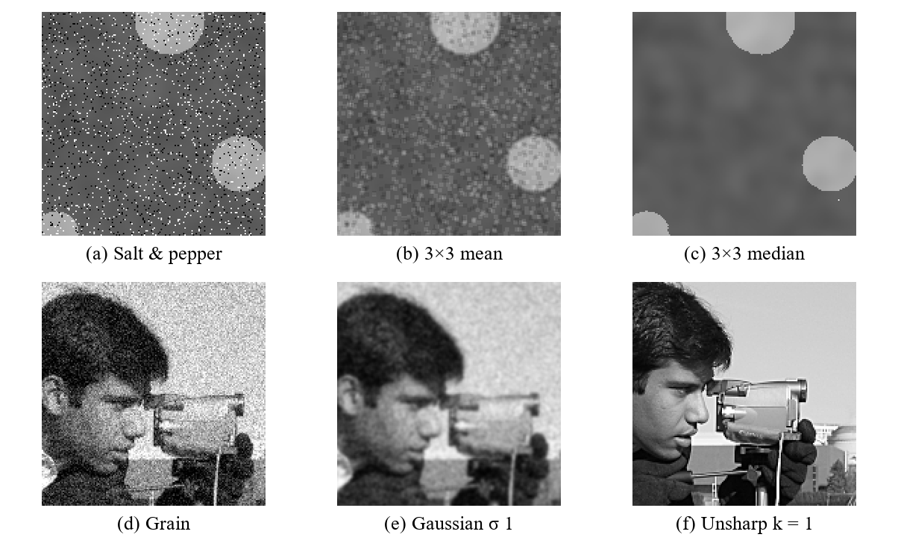
Figure 4: Noise removal and sharpening: median vs mean on specks, Gaussian on grain, unsharp masking
4.6 Compression: DCT and Walsh–Hadamard
Both transforms rewrite an image as a weighted sum of basis patterns (Figure 5a, 5b). The orthonormal 2-D DCT of an N×N image f is
F = C f C^{T}, C[k, x] = α(k) cos( π (2x + 1) k / 2N ), f = C^{T} F C
with α(0) = √(1/N) and α(k) = √(2/N) otherwise. The Walsh–Hadamard transform F = H f H^{T} uses a matrix H whose entries are ±1/√N, sorted by the number of sign changes (sequency); it needs only additions and subtractions, and the image is mirror-padded to power-of-two sides and cropped back. Each of R, G and B is transformed, a chosen set of coefficients is kept, the rest are set to zero, and the inverse transform is clipped to 0–255 (never stretched per channel, which would shift the colours).
The coefficient selection setting decides which coefficients survive: the largest N % anywhere (the average term is always kept), every |F| above a threshold T, or a zone of low frequencies by position (square: rows and columns below k; L-shape: zero only where both are at least k). Natural images are smooth, so cosines fit them better than square waves: at 10 % of the coefficients the DCT keeps 99.57 % of the energy and reaches 30.0 dB, against 99.22 % and 27.7 dB for Hadamard, which also leaves blocky artefacts (Table 3).
Why a PNG becomes larger after DCT. PNG is lossless and shrinks a file by finding repetition. A flat background of identical pixels costs almost nothing, but the DCT reconstruction is a full image in which every pixel is off by a few levels, so the repetition disappears. In one test a 2000×2000 PNG of 1.9 MB became about 11 MB, close to its 12 MB raw size. Keeping fewer coefficients reduces information, not file size; quantisation and entropy coding are needed for a small file.
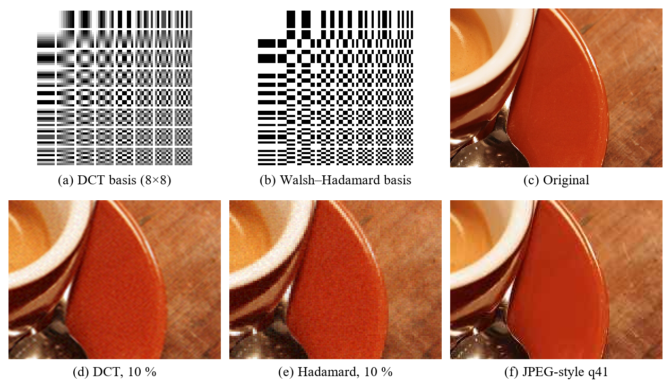
Figure 5: DCT and Walsh–Hadamard basis patterns and reconstructions of the same crop at 10 % of the coefficients, compared with JPEG-style coding at equal quality
4.7 Compression: JPEG-Style Coding and Quantisation
The JPEG-style coder is implemented step by step from the standard [5], [6]:
1. RGB → YCbCr, separating brightness from colour (Section 3.3).
2. Chroma subsampling: Cb and Cr are stored at half width and height (4:2:0), half width (4:2:2) or full size (4:4:4), because the eye sees colour detail poorly.
3. 8×8 blocks are level-shifted by −128 and transformed with the DCT: one average (DC) coefficient and 63 detail coefficients per block.
4. Quantisation: every coefficient is divided by a step size and rounded.
5. Entropy coding (zig-zag order, run lengths, Huffman codes) stores the resulting integers; the real file size is measured with OpenCV’s encoder.
q(u, v) = round( F(u, v) / Q(u, v) ), F′(u, v) = q(u, v) · Q(u, v)
Q is the 8×8 table from Annex K of the standard [6], built from visibility experiments: small steps for coarse patterns the eye notices and large steps for fine detail. Rounding is the only lossy step. In a real block from the test photograph, F(0,0) = −403 and Q = 16 give q = −25 (decoded as −400), while small detail coefficients divided by large steps become 0: 61 of the 64 values are zero, and entropy coding stores them as “end of block”. The quality setting scales the whole table:
S = 5000 / q (q < 50), S = 200 − 2q (q ≥ 50), Q = ⌊(Q₅₀ S + 50) / 100⌋
so the first step is 3 at quality 90, 8 at 75, 16 at 50 and 40 at 20. Lower quality means coarser steps, more zeros and a smaller file (Table 4, Figure 6).
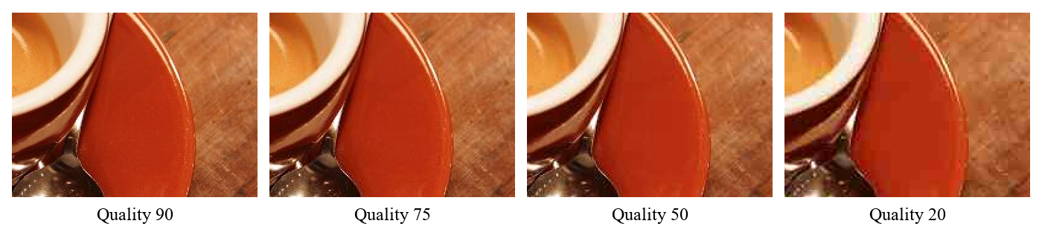
Figure 6: JPEG-style coding of the same crop at the four quality presets
4.8 Otsu Thresholding and Guided vs Direct Verification
For every threshold k Otsu’s method splits the histogram into a dark class (≤ k) and a bright class and computes the between-class variance
σ_{B}²(k) = (μ_{T} ω(k) − μ(k))² / ( ω(k) (1 − ω(k)) )
where ω(k) = Σ_{i≤k} p_{i} is the share of pixels at or below k, μ(k) = Σ_{i≤k} i p_{i} is the running first moment and μ_{T} is the mean of the whole image. The expression equals ω₀ ω₁ (m₀ − m₁)²: it is large when the two class means are far apart and both classes are reasonably large. The threshold k* maximises σ_{B}² (Figure 7), and the separability
η = σ_{B}²(k*) / σ_{G}²
lies between 0 and 1, where σ_{G}² is the total variance. The mask is cleaned by morphological opening (removes specks smaller than the disk) and closing (fills small holes) with a disk of radius 3.
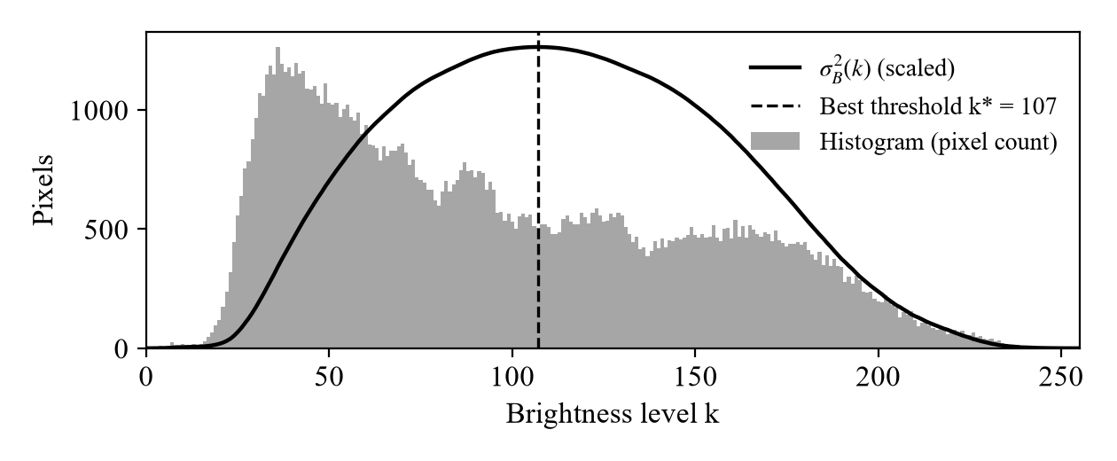
Figure 7: Otsu’s method on the coins image: histogram, between-class variance and the chosen threshold k* = 107 (η = 0.76)
Guided vs direct. The Compare tab runs the same operation twice: directly, and after a prerequisite chain that applies only the fixes the diagnosis asks for (median for specks, Gaussian for grain, flattening for uneven lighting). Noise is fixed only above each operator’s measured break-even point (σ > 8 for Otsu, 15 for Sobel and Prewitt, 12 for Roberts). One measurement per fix decides the result: fragmentation (islands + holes) for denoising before segmentation, an increase of η by at least 0.02 for flattening, and false-edge density in flat regions for denoising before edge detection. The verdict is “Fixing first clearly helps” (all checks pass), “Partly better”, “Did not help here” or “Image is ready”, and a difference map shows where the two results disagree (Figure 13).
Quality metrics
PSNR = 10 log₁₀( 255² / MSE )
PSNR (Peak Signal-to-Noise Ratio) expresses the pixel error in decibels: every +10 dB means ten times less error power, and above about 40 dB the difference is invisible. SSIM (Structural Similarity Index Measure) [7] compares local mean, contrast and structure in 7×7 windows (1 = identical). IoU = |A ∩ B| / |A ∪ B| scores a mask against the true mask, and edge F1 = 2PR / (P + R) combines the precision and recall of edge pixels matched within one pixel.
5. Results & Discussion
5.1 The Dashboard
Figures 8 to 11 show the deployed dashboard. The Tools tab (Figure 8) shows the Image Health card, the tool and preset lists, a before/after slider, the brightness histogram and result details; here auto gamma (γ = 0.52) corrects a dark photograph. The Auto Fix tab (Figure 9) lists every step with its reason and the health measurements before and after.
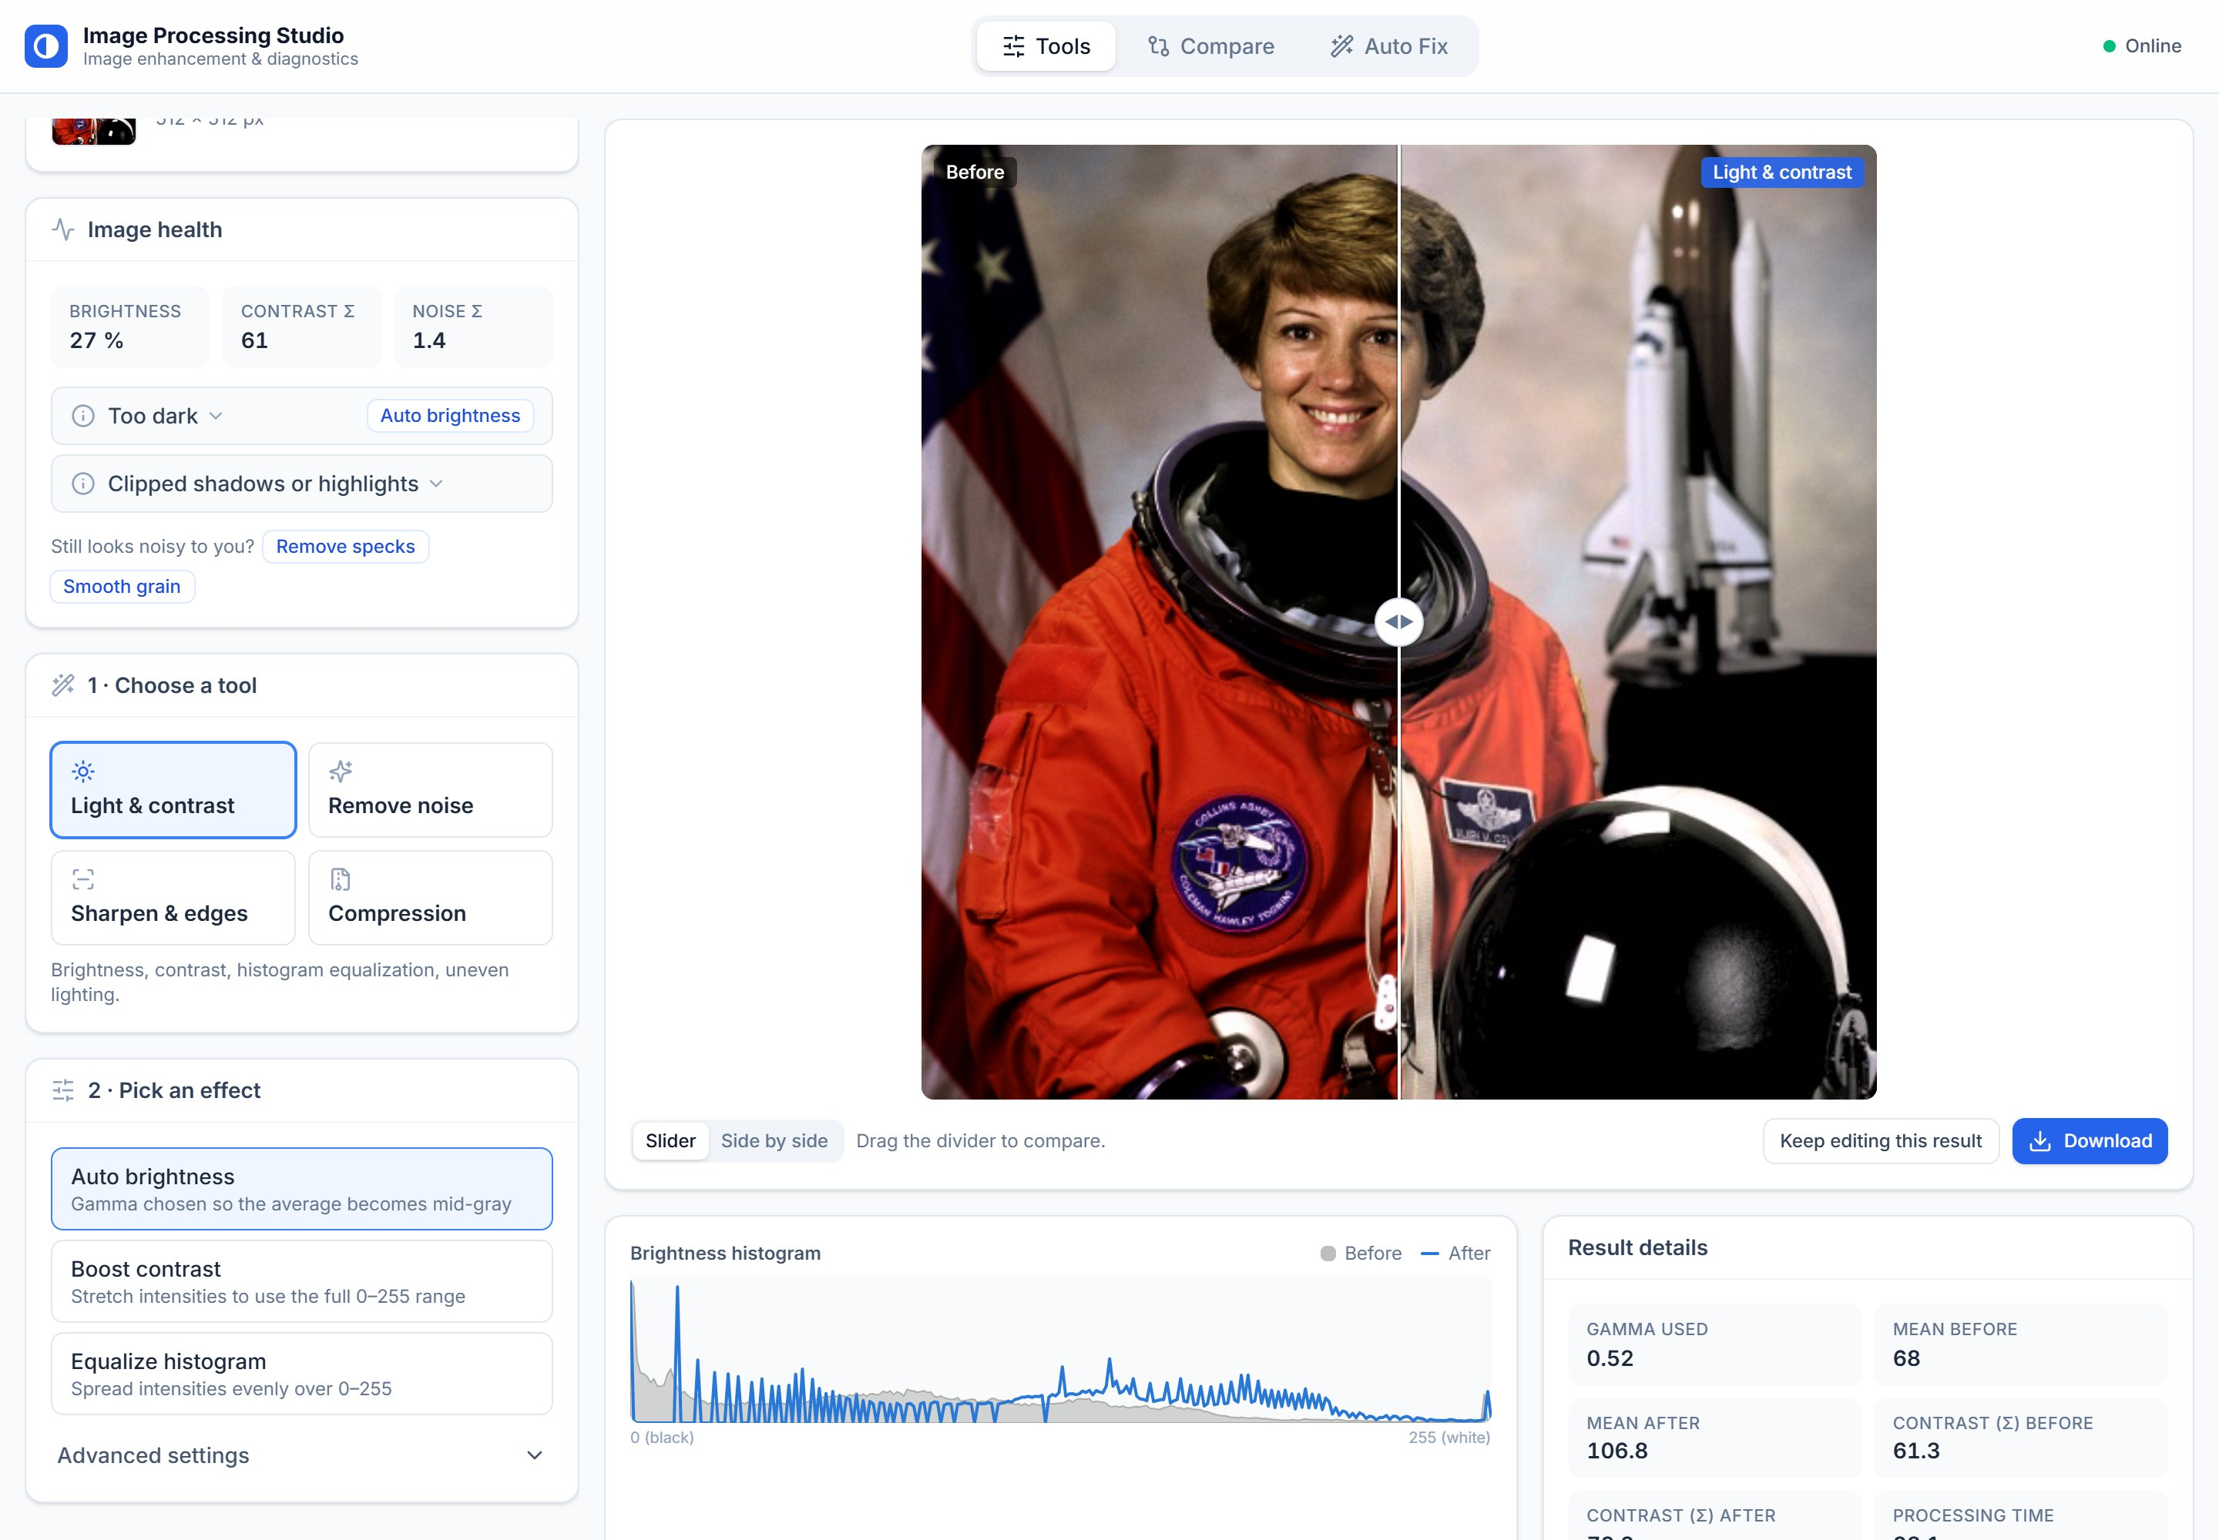
Figure 8: Tools tab: Image Health, presets, before/after slider, histogram and result details
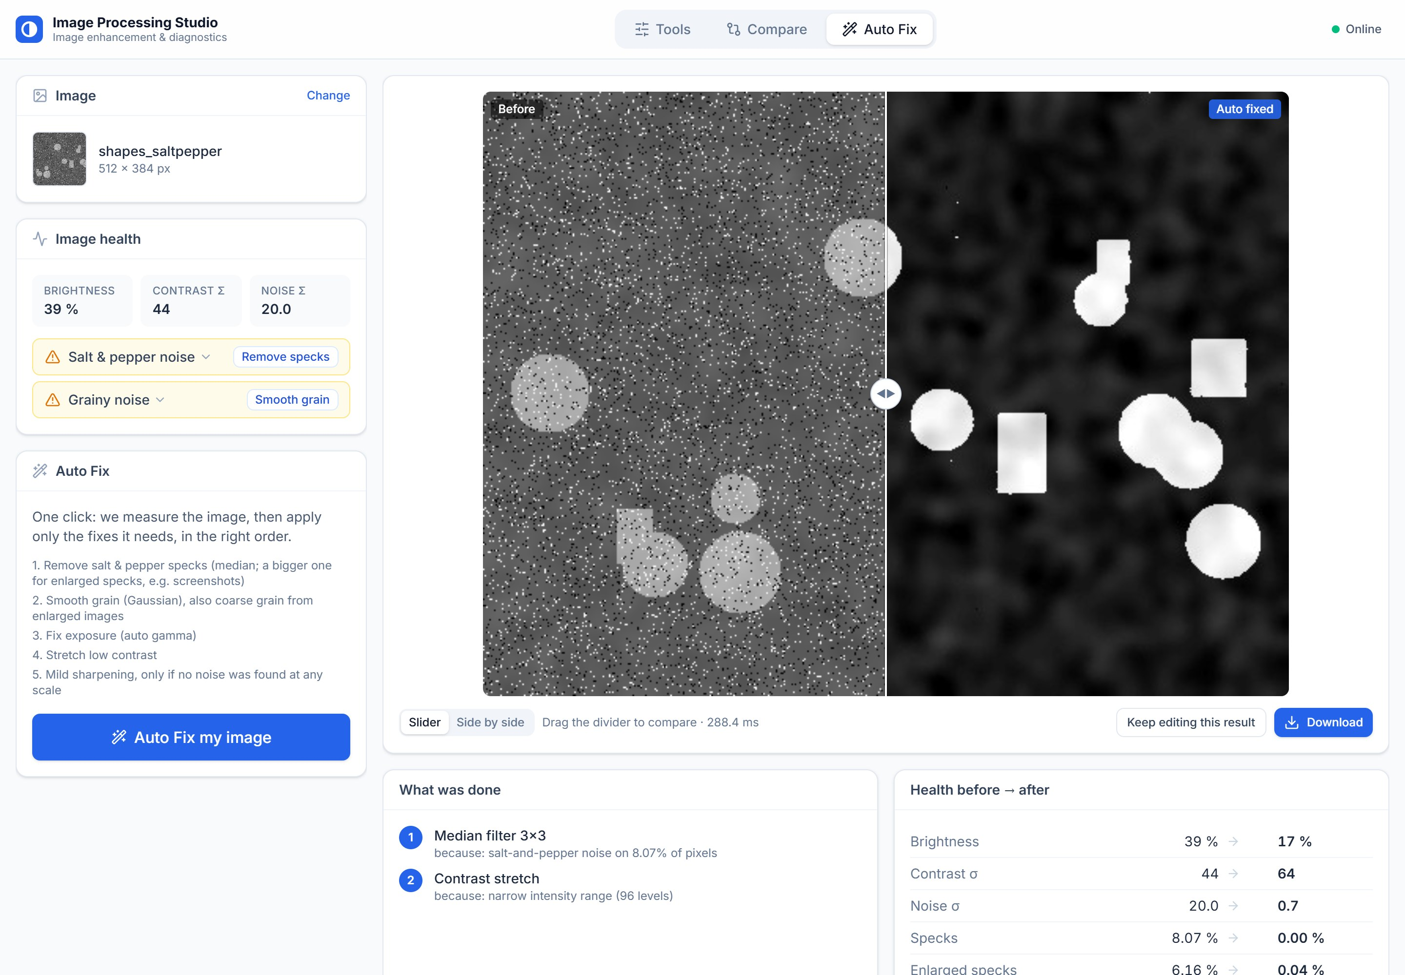
Figure 9: Auto Fix on a salt-and-pepper image: median filter, then contrast stretch, with the health measurements before and after
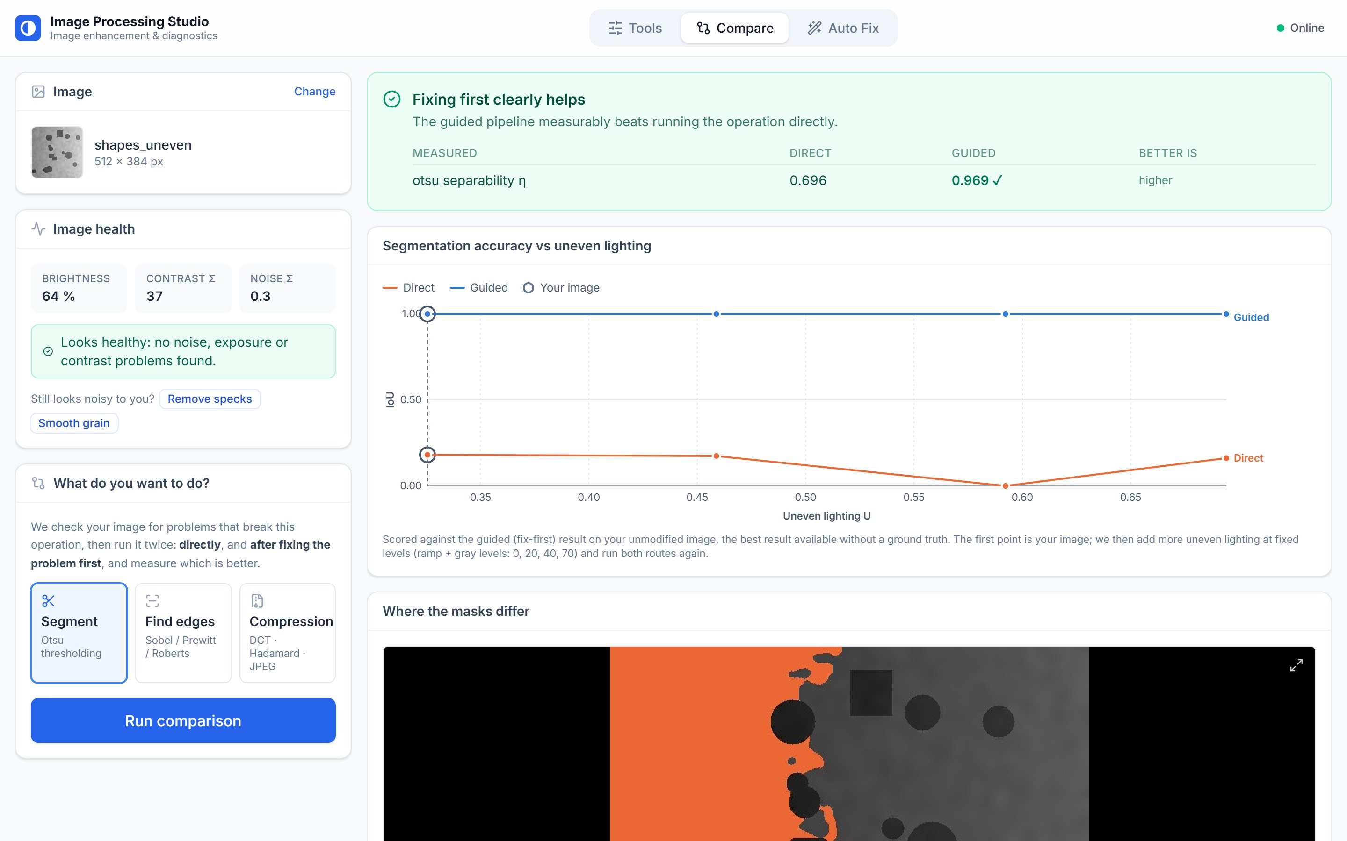
Figure 10: Compare → Segment on an unevenly lit image: verdict (η 0.696 → 0.969), accuracy under increasing unevenness and the difference map
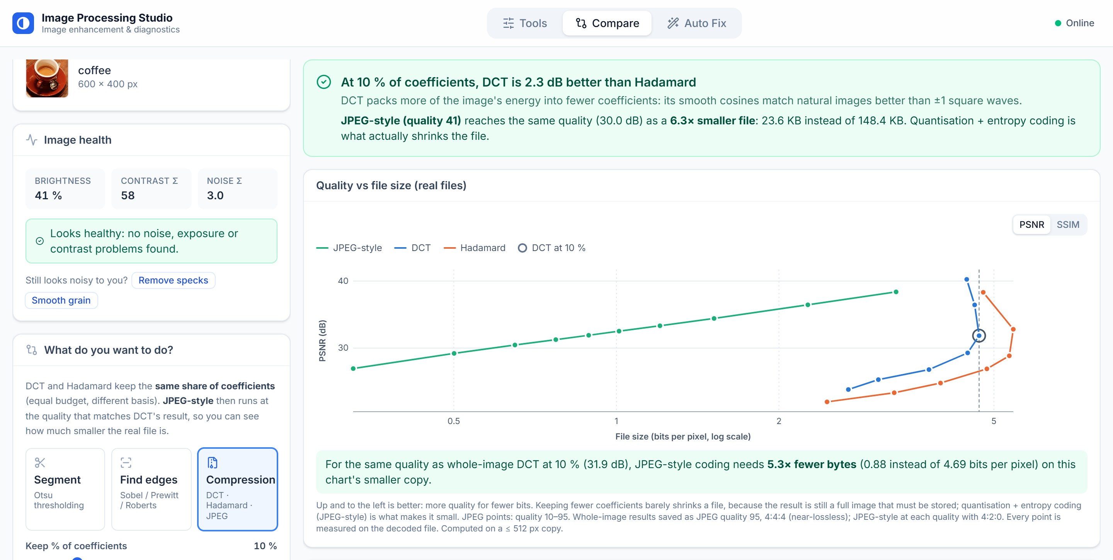
Figure 11: Compare → Compression: DCT vs Hadamard at 10 % and JPEG-style at matched quality, with the quality-versus-file-size chart
5.2 Guided vs Direct Benchmark
Synthetic scenes with an exact ground-truth mask were degraded with salt-and-pepper noise, a lighting ramp and Gaussian noise. Segmentation is scored with IoU and edges with edge F1 (Figure 12).
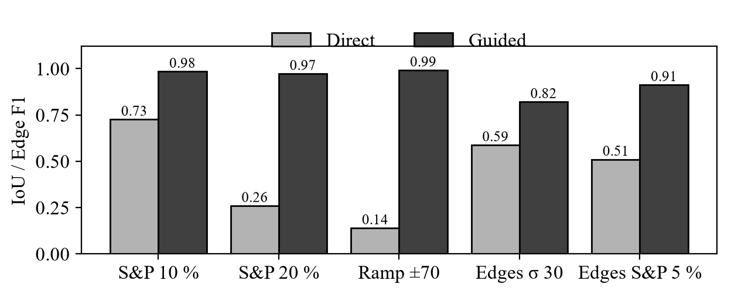
Figure 12: Direct vs guided processing on images with known ground truth
Fixing first wins wherever a defect is present. At 20 % salt and pepper direct Otsu collapses to an IoU of 0.26 while the guided route keeps 0.97; with a ±70 lighting ramp IoU rises from 0.14 to 0.99. On a noisy photograph Sobel marks 6.7 % of flat regions as edges directly but only 0.11 % after smoothing, and on the uneven-lighting sample flattening raises η from 0.70 to 0.97 (Figure 13).
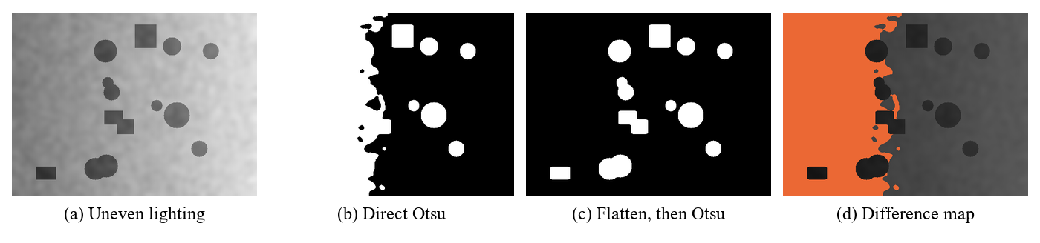
Figure 13: Uneven lighting: direct Otsu splits by lighting, flattening first finds every object; orange marks pixels segmented only by the direct route
5.3 Compression
Table 3: DCT and Hadamard at equal budget, JPEG-style at equal quality
Method (coffee photo, 600×400) | Coefficients | PSNR (dB) | SSIM | File (KB)
Whole-image DCT | 10 % | 29.98 | 0.808 | 148
Walsh–Hadamard | 10 % | 27.69 | 0.710 | 166
JPEG-style, quality 41 | quantised | 30.00 | 0.856 | 24

At the same 10 % budget the DCT is 2.3 dB better than Hadamard. JPEG-style coding reaches the DCT’s quality with a 6.3 times smaller file, which confirms that quantisation and entropy coding, not coefficient removal, make files small. Table 4 shows the quality presets and the subsampling option.
Table 4: JPEG-style quality presets and colour subsampling
Setting | File (KB) | PSNR (dB)
Quality 90 | 71 | 35.51
Quality 75 | 41 | 32.43
Quality 50 | 27 | 30.50
Quality 20 | 15 | 28.05
Lossless PNG of the same photo | 449 | ∞
Quality 75 with 4:4:4 / 4:2:2 / 4:2:0 | 51 / 45 / 41 | –

Table 5: Coefficient selection modes
Coefficient selection (DCT) | Kept | PSNR (dB)
Largest 10 % | 10.0 % | 30.0
Threshold T = 500 | 0.1 % | 20.4
Zonal square, k = 1/8 | 1.0 % | 23.5
Zonal L-shape, k = 1/8 | 19.8 % | 26.2

Keeping coefficients by size beats keeping them by position: the L-shaped zone keeps almost twice as many coefficients as “largest 10 %” and still scores 3.8 dB lower.
5.4 Case Study: Noise in Screenshots
A screenshot of a visibly noisy image was reported as “no issues” by the original Image Health card. The cause was enlargement (Section 4.1). On 204 screenshot-like test images (saved as JPEG and shown 1.5× or 2× larger) the pixel-scale tests detected 0 of 68 grainy and 0 of 102 speckled screenshots; with the half-scale tests all 170 are detected, with one false alarm in each group. Enlarged specks also need a larger median window (Figure 14).
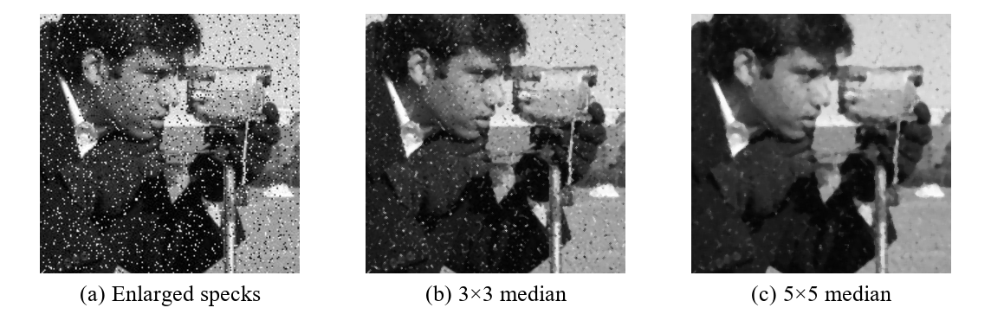
Figure 14: Enlarged specks from a screenshot: a 3×3 median leaves them, a 5×5 median removes them
5.5 Case Study: Field Photographs for Machine Learning
A real CC0 photograph of a tomato leaf with late blight [13] was degraded in three ways that field photographs suffer, then diagnosed and fixed automatically. Because the clean original is available, SSIM measures how close the fixed image is to it, and mask IoU measures whether a downstream Otsu segmentation gives the same answer as on the clean photograph (Table 6, Figure 15).
Table 6: Automatic correction of a degraded field photograph
Simulated condition | Found → fix | SSIM vs clean | Mask IoU vs clean
Low light: sensor grain | σ 10.7 → Gaussian σ 1.0 | 0.46 → 0.86 | 0.65 → 0.93
Dust / dead pixels: 8 % specks | ρ 7.9 % → median 3×3 | 0.14 → 0.96 | 0.55 → 0.96
Shade: dark and noisy | mean 0.21 → auto gamma | 0.38 → 0.38 | 0.43 → 0.73

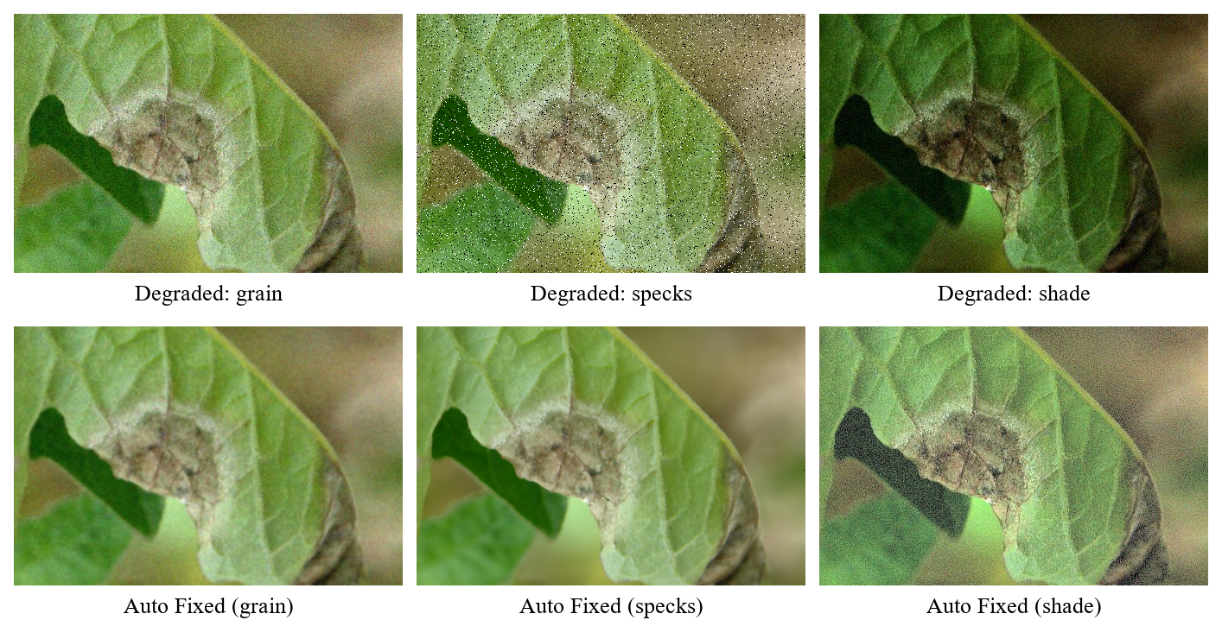
Figure 15: Tomato leaf under three simulated field conditions, before and after Auto Fix
For grain and specks the system finds the correct defect and nearly restores the photograph. In the shaded case brightening recovers the segmentation (IoU 0.43 → 0.73) but reveals noise that was hidden in the shadows; because grain is checked before exposure, that noise is not removed. This limitation was found by the experiment and is listed as future work.
6. Testing & Validation
6.1 Automated Tests
The pipeline has 294 automated tests (pytest), including 68 that check that every NumPy-from-scratch implementation gives the same result as the corresponding OpenCV call, and 26 for the half-scale noise tests. The back end has 60 API tests, including a 12-megapixel photograph sent through every endpoint with each response checked to stay below 3.5 MB. Synthetic test images with exact ground truth are generated by the pipeline itself, so results are reproducible.
6.2 Threshold Calibration
Table 7: Calibration of the Image Health thresholds
Rule | Images | Precision | Recall | F1
Noise σ > 5 | Normal (119) | 0.944 | 1.000 | 0.971
Salt & pepper > 0.75 % | Normal (187) | 0.986 | 1.000 | 0.993
Lighting U > 0.15 | Normal (187) | 0.370 | 1.000 | 0.540
Grain at any scale | Screenshots (102) | 0.986 | 1.000 | 0.993
Specks at any scale | Screenshots (204) | 0.990 | 1.000 | 0.995

Every rule has a recall of 100 %. The lighting threshold has low precision because large scene regions such as sky and ground resemble uneven lighting; it is kept low on purpose, because a false alarm only costs an extra guided run that reports “did not help”, while a miss would hide the largest improvement the system can make (IoU 0.14 → 0.99).
6.3 Manual Testing
All tabs were tested in the browser on the bundled samples and on user photographs: upload limits and error messages, before/after previews, full-quality downloads with format notes, chaining results into further tools at full resolution, every Compare view, and screenshot detection followed by the 5×5 median in Auto Fix.
7. Applications
• Dataset quality control for machine learning: flag dark, noisy or unevenly lit images and correct them before training, as in the tomato-leaf case study.
• Pre-processing for recognition systems such as plant-disease or currency detection, where the classifier inherits any defect of the input photograph.
• Document scanning: background flattening removes shading before binarising a page.
• Microscopy and counting: Otsu thresholding with morphological clean-up separates cells or coins.
• Industrial inspection: denoising before edge detection removes false edges.
• Screenshots and forwarded images: the half-scale tests detect and remove enlarged noise.
• Choosing a compression level for web or mobile from measured PSNR, SSIM and file size.
• Explainable processing: every decision is shown with its formula, measurement and reason.
8. Conclusion & Future Scope
8.1 Conclusion
Image Processing Studio turns a set of classical techniques into a system that diagnoses an image, chooses the technique and parameter it needs, applies it and proves the result. Calibrated measurements detect noise, specks, exposure, contrast and lighting problems, including noise in screenshots that standard estimators miss. Guided processing improved segmentation IoU from 0.14 to 0.99 under uneven lighting and edge F1 from 0.51 to 0.91 under impulse noise, and the compression study showed that quantisation and entropy coding, not coefficient removal, make files small: JPEG-style coding matched the DCT’s quality with a 6.3 times smaller file. All operations work on colour images without shifting the colours, all algorithms are implemented from scratch and tested against OpenCV, and the system runs as a public web application.
8.2 Future Scope
• Measure noise again after brightening and denoise if needed (the limitation found in Section 5.5).
• Measure classifier accuracy before and after correction with a disease-detection model.
• Direct-to-storage uploads so photographs larger than 4.5 MB can be processed on Vercel.
• Additional operators: CLAHE, bilateral and non-local-means denoising, Canny edges.
• Adaptive and multi-level thresholding for scenes with more than two classes.
• Frame-by-frame diagnosis and temporal denoising for video.
9. References
[1] R. C. Gonzalez and R. E. Woods, Digital Image Processing, 4th ed. New York, NY, USA: Pearson, 2018, ISBN 978-0-13-335672-4.
[2] N. Otsu, “A threshold selection method from gray-level histograms,” IEEE Trans. Syst., Man, Cybern., vol. SMC-9, no. 1, pp. 62–66, Jan. 1979, doi: 10.1109/TSMC.1979.4310076. [Online]. Available: https://doi.org/10.1109/TSMC.1979.4310076
[3] J. Immerkær, “Fast noise variance estimation,” Comput. Vis. Image Underst., vol. 64, no. 2, pp. 300–302, 1996, doi: 10.1006/cviu.1996.0060. [Online]. Available: https://doi.org/10.1006/cviu.1996.0060
[4] N. Ahmed, T. Natarajan, and K. R. Rao, “Discrete cosine transform,” IEEE Trans. Comput., vol. C-23, no. 1, pp. 90–93, Jan. 1974, doi: 10.1109/T-C.1974.223784. [Online]. Available: https://doi.org/10.1109/T-C.1974.223784
[5] G. K. Wallace, “The JPEG still picture compression standard,” IEEE Trans. Consum. Electron., vol. 38, no. 1, pp. xviii–xxxiv, Feb. 1992, doi: 10.1109/30.125072. [Online]. Available: https://doi.org/10.1109/30.125072
[6] ITU-T, Information technology – Digital compression and coding of continuous-tone still images – Requirements and guidelines, Recommendation T.81, Sep. 1992. [Online]. Available: https://www.itu.int/rec/T-REC-T.81-199209-I/en
[7] Z. Wang, A. C. Bovik, H. R. Sheikh, and E. P. Simoncelli, “Image quality assessment: From error visibility to structural similarity,” IEEE Trans. Image Process., vol. 13, no. 4, pp. 600–612, Apr. 2004, doi: 10.1109/TIP.2003.819861. [Online]. Available: https://doi.org/10.1109/TIP.2003.819861
[8] C. R. Harris et al., “Array programming with NumPy,” Nature, vol. 585, pp. 357–362, 2020, doi: 10.1038/s41586-020-2649-2. [Online]. Available: https://doi.org/10.1038/s41586-020-2649-2
[9] OpenCV team, “OpenCV 4.x documentation.” [Online]. Available: https://docs.opencv.org/4.x/
[10] S. van der Walt et al., “scikit-image: Image processing in Python,” PeerJ, vol. 2, p. e453, 2014, doi: 10.7717/peerj.453. [Online]. Available: https://doi.org/10.7717/peerj.453
[11] S. Ramírez, “FastAPI documentation.” [Online]. Available: https://fastapi.tiangolo.com/
[12] Meta Open Source, “React documentation.” [Online]. Available: https://react.dev/
[13] S. Nelson, “Tomato late blight leaf sporulating lesions 1,” Wikimedia Commons, CC0. [Online]. Available: https://commons.wikimedia.org/wiki/File:Tomato_late_blight_leaf_sporulating_lesions_1_(5816170621).jpg
[14] A. Katiyar, C. Soni, and A. Khandelwal, “Image Processing Studio,” GitHub repository, 2026. [Online]. Available: https://github.com/AkshatKatiyar081/IVP_2026

