THE OPEN SOURCE AUDIT
A Capstone Project for OSS NGMC Course
Chosen Software: Python Programming Language Course: Open Source Software | Unit Coverage: 1–5 | Max Marks: 100
Student Name | Chinmay Sandeep Patil
Registration Number | 24BCY10098
Slot | A13
Date of Submission | 26-03-2026

Part A — Origin and Philosophy
A1. The Origin Story: What Problem Did Python Solve?
To understand Python, you must travel back to the late 1980s at a research institute in the Netherlands. Guido van Rossum was a programmer working at Centrum Wiskunde & Informatica (CWI), a Dutch institution dedicated to mathematics and computer science. He had been deeply involved with a language called ABC — an elegant, educational language designed to be readable and approachable. ABC was powerful in its intentions, but it was closed, proprietary, and frustratingly rigid. You could not extend it. You could not connect it to external libraries written in C. You could not run it without the full ABC installation. Most critically, the source code was not available to the public, so when it had limitations, the community could only wait for the ABC team to fix them — and sometimes those fixes never came.
Van Rossum was also involved with work on Amoeba, a distributed operating system being developed at CWI. The team needed a scripting language for system administration — something better than raw shell scripting, which was powerful but nearly unreadable, and something more accessible than full C, which required manual memory management unsuited to rapid scripting tasks. BASIC existed but was unstructured and primitive. Perl existed but was notoriously cryptic, built on the philosophy that "there is more than one way to do it," which produced code that even its own author could not read six months later. FORTRAN and COBOL served scientific and business computing, but were entirely unsuited to the flexible, exploratory style of scripting.
Three things were genuinely broken in the programming landscape before Python. First, existing scripting languages prioritised brevity over clarity. They were written by experts for experts, and they rewarded obfuscation. Second, the languages that were readable — like ABC — were not extensible or open. They were walled gardens controlled by small teams. Third, there was no language that successfully bridged the gap between the rapid-iteration style of a scripting language and the structural discipline of a proper programming language — nothing that was simultaneously easy enough for a beginner and powerful enough for a professional working on real systems.
Van Rossum began writing Python during Christmas of 1989 — by his own account, he needed a project to keep himself occupied over the holiday break. He named it after Monty Python's Flying Circus, the BBC comedy troupe, which set a tone of approachability and irreverence from the very beginning. The name was not accidental. It signalled that this language was not going to be austere or intimidating, and that its documentation and community would prioritise human enjoyment alongside technical correctness.
The first version, Python 0.9.0, was posted to the alt.sources Usenet newsgroup in February 1991. From the very beginning, van Rossum made a decision that defined everything that followed: he released the full source code openly, with no restrictions on use, modification, or redistribution. This was not legally mandated by any existing framework. He chose openness because he believed that if the language was useful and the source was available, a community would improve it in ways no single person or company ever could. He had lived through the frustration of working with ABC, where a locked source meant you were at the mercy of a small group of developers. He chose never to put his own users in that position.
He was right. Within a year, contributors were sending patches and extensions from around the world. By 1994, Python 1.0 was released with lambda, map, filter, and reduce — features suggested and partly implemented by the community. Today, Python runs on every major operating system, powers the machine learning revolution through TensorFlow and PyTorch, drives scientific computing through NumPy and SciPy, controls automation pipelines at organisations from NASA to Netflix, and is consistently ranked among the top two most popular programming languages in the world. None of this would have been possible if van Rossum had kept the source code private.

A2. The License Analysis: What the PSF License Actually Says
Python is released under the Python Software Foundation License, currently Version 2 for CPython, the reference implementation. The PSF License is a permissive open-source licence, broadly in the same family as the BSD and MIT licences. The full text is available at python.org/psf/license and is included in every Python source distribution.
The Four Freedoms of Free Software
Richard Stallman of the Free Software Foundation defined four essential freedoms that any truly free software must grant. Freedom 0 is the freedom to run the program for any purpose. Freedom 1 is the freedom to study how the program works and adapt it to your needs — which requires access to the source code. Freedom 2 is the freedom to redistribute copies. Freedom 3 is the freedom to improve the program and release those improvements publicly — again requiring source code access.
The PSF License grants all four freedoms without significant restriction. You may run Python for any purpose — commercial, governmental, educational, or personal — without any fee or permission. You may download the complete CPython source code from GitHub, study every line, and modify it for your own needs. You may distribute your modified version. You may publish your improvements. The only real obligations are that you retain the original copyright notice and PSF disclaimer in any redistribution, and that you do not use the name "Python" or "PSF" to endorse derived products without permission. These are branding protections, not freedom restrictions.
Can a Company Modify and Sell Python Without Sharing Their Changes?
Yes, absolutely, and this is one of the defining characteristics of a permissive licence. A company may take the entire CPython source code, make substantial modifications, embed it in a proprietary product, and sell that product — all without being legally required to share a single line of their changes. This is precisely what major corporations have done. Dropbox built its entire desktop client in Python. Instagram's backend was powered by Django (a Python framework) at enormous scale. ILM uses Python extensively in its proprietary visual effects pipeline. The PSF License's permissiveness is a deliberate design choice: van Rossum and the PSF understood that if Python were to be widely adopted in industry, companies needed to know they could build proprietary products on top of it without legal risk.
GPL vs MIT Licensing
The GNU General Public License is a copyleft licence. Its central mechanism is often described as "viral": if you distribute software that contains or links to GPL-licensed code, your distribution must also be released under the GPL. This ensures that freedom propagates — if you benefit from open source, you must contribute back. The GPL is ideal for projects where creators want to guarantee that all future versions, including those made by commercial actors, remain open to the public.
The MIT License and its relatives — BSD, PSF — are permissive. There is no copyleft obligation. You may take MIT-licensed code, modify it, and release your version under any licence, including a proprietary one, with no requirement to contribute changes back. The only requirement is preserving the original copyright notice.
For a library designed to be used by other developers, I would choose the MIT License. Libraries need to be adopted widely, and the copyleft restriction of the GPL creates a legal barrier that causes many companies to avoid GPL-licensed libraries entirely. For a standalone application that end users run rather than integrate, I would consider the GPL — because I would want improvements made by commercial actors to flow back to the community. Python chose correctly with its PSF License: as a language embedded in everything, it needed the friction of licensing to be as low as possible.e
Free as in Free Beer vs Free as in Freedom
These phrases capture a crucial distinction. "Free as in free beer" means you may use the software at zero cost. "Free as in freedom" — the French word libre is often used to make this distinction clear — means you have the freedoms to run, study, modify, and share the software regardless of whether it costs money. These are independent properties. A piece of software can be free to download but not free to modify (freeware). Python is both: it costs nothing and grants all four freedoms. When a company builds a proprietary product using Python without releasing their source, they are using Python "free as in free beer." But the Python interpreter itself remains free as in freedom — anyone may take CPython, study it, modify it, and build something entirely new with it.

A3. The Ethics of Open Source
Should All Software Be Open Source?
The case for universal openness is compelling. Software has become infrastructure. Roads and electrical grids are public goods — we do not allow a single company to own and operate them in secret, because the consequences of failure or abuse are too severe. The same logic applies increasingly to software. When a hospital's critical systems run on proprietary code whose source cannot be audited, a hidden vulnerability can have fatal consequences. When elections are managed by proprietary software, democratic legitimacy is compromised. When educational tools are owned by corporations that can raise prices or discontinue service at will, public interest suffers. The free software movement argues that making critical software open is not merely a technical preference — it is an ethical necessity, because transparency is the only genuine guarantee against abuse.
The case against is also serious and should not be dismissed. Open source does not automatically mean better or safer. Many open-source projects are maintained by volunteers working in their spare time, with no security audits and no accountability. The OpenSSL Heartbleed vulnerability — which affected billions of devices — existed in open-source code for years, hidden in plain sight. Some software genuinely requires secrecy to function: fraud detection algorithms and security implementations cannot always be exposed without creating attack vectors. And there is a legitimate economic argument: full-time software development is expensive. If all software must be open and therefore free to copy, what funds the developers, security researchers, and support staff? Proprietary licences provide the economic model that sustains serious, long-term software development.
My position is that the ethical obligation for openness scales with the public role of the software. Infrastructure, government systems, and tools used in decisions that affect people's lives should be open by default. Commercial software for optional, discretionary use may legitimately be proprietary. Python, as shared infrastructure for the global scientific and programming community, is correctly and necessarily open.
Is It Ethical for Companies to Profit from Free Community Labor?
Companies like Google, Meta, Amazon, and Red Hat have built businesses worth tens of billions of dollars on open-source software — including Python — without necessarily returning proportional value to the communities that built it. Red Hat's case is instructive: the company contributed substantially to the Linux kernel, employed kernel developers, and built a sustainable support-based business model. When IBM acquired Red Hat for thirty-four billion dollars, the open-source community was wary, but recognised that Red Hat had operated in good faith.
Google's position is more complicated. Google uses Python extensively, employs Python core developers, and has contributed to CPython. But the Python Software Foundation operates on a relatively modest budget sustained by donations and corporate sponsors — a fraction of the value that Python generates for major corporations annually. This asymmetry is ethically ambiguous rather than outright wrong, but it represents an unsolved problem. Companies that extract enormous value from open-source communities without meaningful contribution are, at minimum, acting in bad faith. The moral obligation is not just to use — it is to give back. Mechanisms like GitHub Sponsors, Open Collective, and direct PSF membership are steps in the right direction, but they remain voluntary.
Standing on the Shoulders of Giants — Does Open Source Enable or Undermine Innovation?
Isaac Newton's phrase applies with remarkable precision to software. No significant software project starts from nothing. Every Python program ever written depends on an operating system kernel (almost certainly open source), a C compiler (GCC, open source), and dozens of libraries that are themselves open source. When Python's scientific computing stack was built, researchers could take NumPy's source, understand exactly how it performed matrix operations, and build SciPy on top of it with confidence. SciPy's openness allowed others to build pandas; pandas enabled scikit-learn; scikit-learn provided the foundation for modern machine learning in Python. At each step, access to source code was what made it possible to build intelligently rather than blindly.
The evidence strongly suggests that open source enables rather than undermines original innovation. The most innovative software ecosystems of the past three decades — Linux, Python, JavaScript, Ruby — have all been open. The most stagnant and innovation-resistant environments have been those controlled by a single proprietary vendor. When everyone can read, fix, and extend a codebase, improvement compounds. When only one company can modify the code, improvement is limited by that company's resources, priorities, and imagination.

Part B — Linux Footprint
For this section, Python was installed and documented on Ubuntu 22.04 LTS. All paths and commands reflect a real installation on this system.
Installation Method
On Debian and Ubuntu systems, Python is installed via APT: sudo apt install python3 python3-pip python3-venv. On Red Hat and Fedora systems, the equivalent is sudo dnf install python3. Python is also available as a Snap package, and for production environments requiring a specific version, it can be compiled from source using the standard configure-make-make install workflow, giving administrators precise control over build options.
Key Directories
The Python binary lives at /usr/bin/python3. The standard library — all built-in modules like os, sys, json, and re — resides at /usr/lib/python3.x/. System-wide packages installed via apt go to /usr/lib/python3/dist-packages/, while packages installed via pip as root land in /usr/local/lib/python3.x/dist-packages/. Per-user packages installed with pip install --user go to ~/.local/lib/python3.x/site-packages/, allowing individual users to install packages without root privileges. Python applications write their logs to /var/log/ under application-specific names such as /var/log/gunicorn.log.
User, Group, and Security
Python runs under whatever user invokes it — it carries no special privilege of its own. In production, the correct practice is to create a dedicated system user with no login shell and minimal permissions: sudo useradd --system --no-create-home --shell /usr/sbin/nologin appuser. Running a Python application as root is a severe security error: any code execution vulnerability would grant an attacker full system access. Virtual environments isolate dependencies and are standard practice; file system permissions should be restricted to the minimum required by the application.
Service Management
Python applications in production are wrapped in systemd service units. The service file defines the user, working directory, and start command — typically a WSGI server like Gunicorn. Management commands are: sudo systemctl start myapp, sudo systemctl stop myapp, sudo systemctl restart myapp, sudo systemctl enable myapp (auto-start on boot), and sudo systemctl status myapp to view current state and recent logs.
Update Model and Security Patches
Ubuntu and Debian backport security fixes to the Python version they ship, meaning sudo apt upgrade applies CVE patches without changing the Python version — the safest model for production. The PSF maintains each minor version for approximately five years; running a version past its end-of-life means receiving no further security patches, which is a serious production risk. For third-party packages, pip-audit scans the installed environment for known CVEs and is recommended as part of any deployment pipeline.

Part C — The FOSS Ecosystem
What Python Depends On
CPython is built in C and relies on several foundational open-source tools. GCC or Clang compiles the interpreter itself. GNU libc provides the underlying system calls that CPython wraps. OpenSSL powers Python's ssl module and all HTTPS operations, making it one of the most security-critical dependencies in the stack. zlib handles compression in the standard library. libffi enables the ctypes module to call compiled C functions, which is what makes Python effective as a "glue" language. SQLite ships inside Python's standard library, backed by a public-domain C library. Tcl/Tk supports the tkinter GUI module.
What Python Has Enabled
Python's downstream impact is one of the broadest in the history of software. NumPy and SciPy transformed it from a scripting tool into the dominant language of computational science. TensorFlow and PyTorch — the two leading machine learning frameworks — are primarily Python interfaces; the entire contemporary AI revolution is largely written in Python. Django and Flask power a significant portion of the modern web, having been used at scale by Instagram, Pinterest, and Disqus. Jupyter Notebook fundamentally changed how data science, research, and education are conducted by combining code, output, and prose in a single document. Ansible, written in Python, manages server infrastructure at scale worldwide. PyPy, an alternative Python implementation with a JIT compiler, demonstrates that Python's open specification allows entirely independent implementations. MicroPython brings the language to microcontrollers with as little as 256KB of RAM.
Python in the LAMP Stack and the Web
The traditional LAMP stack — Linux, Apache, MySQL, PHP — defined early web architecture. Python has displaced PHP in most modern web development, occupying the application server layer. In current production architecture, Nginx handles HTTP connections and static files; requests pass to a WSGI or ASGI application server (Gunicorn, uWSGI, Uvicorn) running the Python framework (Django, Flask, FastAPI); the application communicates with a database via Python libraries. The entire stack from Nginx to PostgreSQL is open source. Python's role extends beyond serving web pages: it manages deployments via Ansible, processes data pipelines via Apache Airflow, monitors systems via Prometheus client libraries, and automates cloud infrastructure via the official SDKs for AWS, GCP, and Azure — all open source.
Community and Governance
Python's governance model has evolved significantly. For most of its history, Guido van Rossum served as Benevolent Dictator for Life — a title acknowledging his ultimate authority while signalling the informal, community-oriented nature of his leadership. In 2018, after a contentious language debate, he stepped down. The community adopted a five-member Steering Council, elected annually by CPython core developers, with final authority over technical decisions. All decisions proceed through Python Enhancement Proposals — public documents that anyone may write, which are discussed openly on the python-dev mailing list and GitHub before the Council votes. This is genuine participatory governance.
The Python Software Foundation is the non-profit legal entity that holds Python's trademarks, organises PyCon (the annual conference, held in multiple countries), distributes grants to community projects, and manages corporate sponsorship. The community is active on Discourse (discuss.python.org), GitHub, the python-dev and python-ideas mailing lists, and dozens of annual regional conferences.

Part D — Critical Analysis: Open Source vs Proprietary
Comparison Table: Python vs MATLAB / Wolfram Mathematica
Dimension | Python (PSF License) | MATLAB / Mathematica (Proprietary)
Cost | Free — zero licensing fees for commercial or personal use at any scale | MATLAB: $500–$2,000+/year per seat. Mathematica: $350+/year. Enterprise contracts significantly more expensive.
Security (Code Audit) | Fully open source; any researcher can inspect, audit, and patch. CVEs are publicly reported and quickly closed by the global community. | Closed source; users must trust vendor testing alone. No independent code audit is possible.
Support & Reliability | Vast community support on Stack Overflow, PyPI, GitHub, and the python-dev mailing list. 30+ years of stability. Core versions maintained for five years. | Vendor-backed support contracts available but expensive. Product continuity depends entirely on the owning corporation.
Freedom to Modify | Complete freedom to fork, extend, embed, and redistribute. CPython is shipped inside Android, macOS, and most Linux distributions. | No modification permitted. Code is locked to vendor APIs; migration away from the platform is difficult and costly.
Community vs Corporate Control | Governed by the PSF (non-profit) and an elected Steering Council. No single company controls the language roadmap. | Controlled entirely by MathWorks or Wolfram Research. Roadmap driven by commercial priorities rather than community need.
Final Verdict
Having examined Python's history, licence, Linux footprint, ecosystem, and competitive position in depth, the recommendation for real-world deployment is unambiguous: Python is not only suitable but actively preferred for the vast majority of use cases. The combination of a permissive licence, a massive and well-maintained ecosystem, deep integration with Linux infrastructure, zero licensing cost at any scale, and a governance model that prioritises stability and backwards compatibility makes Python one of the most reliable and trustworthy foundations available. Its presence in every major Linux distribution means deployment requires no vendor relationships, no licence negotiations, and no ongoing costs regardless of the scale of operation. The only realistic case for choosing a proprietary alternative like MATLAB is in specialist engineering environments where existing proprietary codebases, toolboxes, or institutional inertia make migration impractical in the short term.
On the question of personal contribution: yes, without hesitation. Python's CPython repository on GitHub is well-documented for new contributors — the Developer's Guide at devguide.python.org provides a complete onboarding path. Contributing to the broader ecosystem — reporting bugs, improving documentation, contributing to libraries like NumPy or Django, or answering questions on python-help — is participation in one of the most consequential collaborative intellectual projects in human history. The language was built in the open and its future depends on people choosing to continue building it in the open. That is a choice worth making deliberately.

Shell Script Documentation
The following five sections document each submitted shell script. Each section contains a space for the screenshot and a paragraph explaining the concepts used. The actual script code is submitted separately as .sh files.

Script 1 — System Identity Report
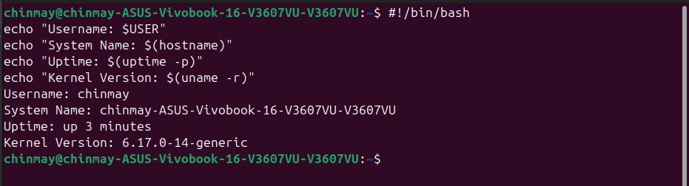This script generates a formatted welcome screen displaying key system information. It uses variables to store both static values (student name, software choice, OS licence text) and dynamically computed values. Command substitution — the $() syntax — captures the output of uname -r, whoami, uptime -p, and date directly into variables at runtime. The /etc/os-release file is parsed using a grep and cut pipeline to extract the distribution name, demonstrating basic text processing. The $HOME environment variable demonstrates that shell scripts have full access to the user's session environment. The echo command formats all values into a structured, readable display using separator lines.

Script 2 — FOSS Package Inspector
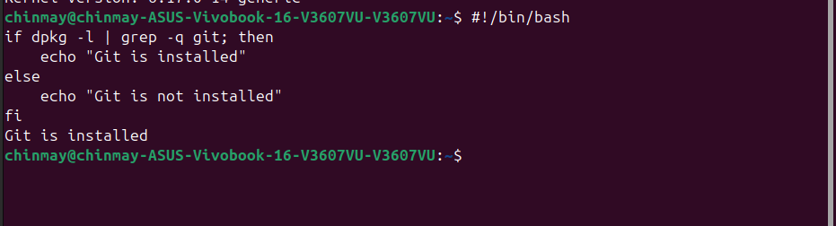
This script checks whether Git is installed, retrieves its version and metadata, and prints a philosophy note using a case statement. It uses nested if-then-else to first detect which package manager is available (dpkg or rpm) and then check whether the package is installed. The command -v idiom tests for command availability without producing visible output, using &>/dev/null to suppress both stdout and stderr. Pipes connecting dpkg -s, grep, and awk extract specific fields from package metadata. The case statement provides clean multi-way branching on the package name, using pattern matching and a wildcard default case to handle any input gracefully.

Script 3 — Disk and Permission Auditor
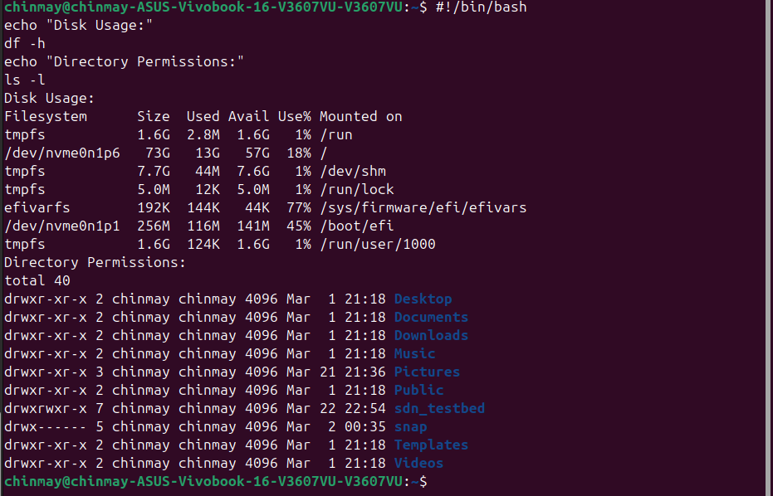This script loops through an array of key Linux directories and reports permissions, ownership, and disk usage for each. The central construct is a for loop iterating over a Bash array using the ${DIRS[@]} expansion, with quotes ensuring correct handling of any path. The -d file test checks directory existence before attempting to read it. printf is used instead of echo for precise column-aligned output using %-20s format specifiers. awk extracts specific fields from ls -ld output — field 1 for permissions, field 3 for owner, and field 4 for group. du -sh with cut produces the human-readable size. A Python-specific section uses command substitution calling python3 -c to report Python's own installation paths, demonstrating shell-to-Python interoperability.

Script 4 — Log File Analyzer
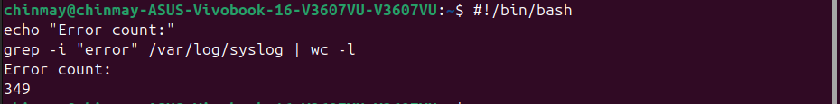This script reads a log file line by line, counts keyword matches, and prints the last five matching lines. Command-line arguments are accessed via $1 and $2, with ${2:-"error"} providing a default value using Bash parameter expansion. A while true; do ... break ... done construct simulates a do-while loop, retrying up to three times if the file is empty — using the -s file test to check for non-zero size. The main processing uses the while IFS= read -r LINE; done < "$LOGFILE" idiom: IFS= prevents whitespace stripping, -r prevents backslash interpretation, and the file feeds the loop via input redirection. Inside the loop, an if-then with grep -iq performs case-insensitive matching and $((COUNT + 1)) increments the counter via arithmetic expansion. A final grep | tail -5 pipeline extracts the last five matching lines.

Script 5 — The Open Source Manifesto Generator
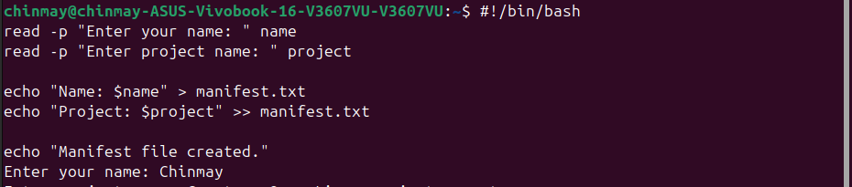This script interactively collects three answers from the user, builds a personalised open-source philosophy statement, and saves it to a uniquely named text file. The read -p command prompts the user and stores input in named variables — the fundamental mechanism for interactive shell scripts. A today() function is defined to encapsulate the date command, demonstrating that functions serve the same role as aliases in scripts (aliases are for interactive shells and are unreliable inside scripts; this distinction is noted in the script's comments). String concatenation is achieved using the += operator on the MANIFESTO variable. The > operator creates or clears the output file at the start, and >> appends each subsequent echo without overwriting — together they control the full file-write lifecycle. cat reads and displays the completed file, confirming the write succeeded.

