**The testing project**

**Intro –** Here is the description and flow of my assignment that I did today .

**Objective –** To automate the login dasbord using test flag .

**Planning and approaching the problem –** Till today I didn’t have a good knowledge of testing and automation testing so I started with first understanding the concepts of testing so that I can understand the problem . then I go to testcafe official website to have a look on documentations .

**Steps involved –**

1. First of all I created a folder for the project .
2. Then after I updated my node and npm version ,and due to a error in the some internal thing I have to use different ways to update ,but after some iterations I finally updated it to the latest version 20.
3. Then I install the testcafe using npm in my pc and in the local directory as well.
4. After doing that I started thinking about the problem.
5. After undrerstanding the requirments as per the documentation given on internshala I proceeded further.
6. Then I read the documentation of testcafe and I proceeded further .
7. Starting with importing the testcafe I gave the link of the website using .page command .
8. And then after inspecting all the selectors for the elements present at the login dashboard I write the code for both valid or invalid situation .
9. In valid situation I used the welcome message that pops up after successful login at element h5 .and similarly error-message-notify element for the invalid situation
10. And then after using the command “ testcafe chrome,edge test.js” for running the testcases for the chrome and edge browser .
11. Although I don’t have mozilla browser but I tried to convert my code for making it suitable for it also

**Images of the following tasks**

**The code –**

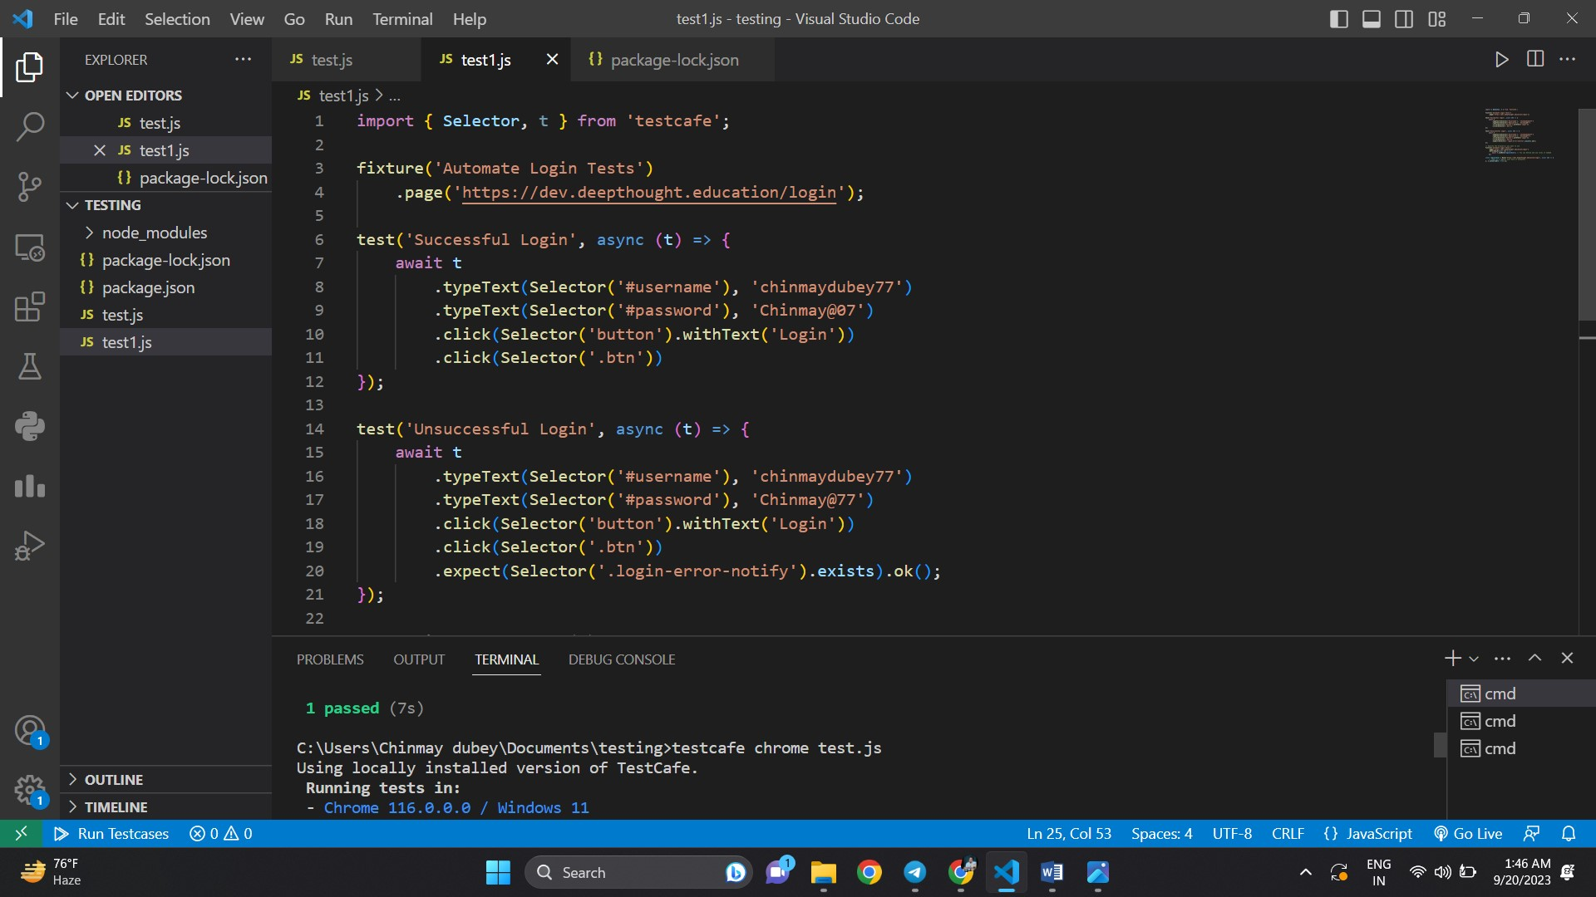

**Running testcafe command-**

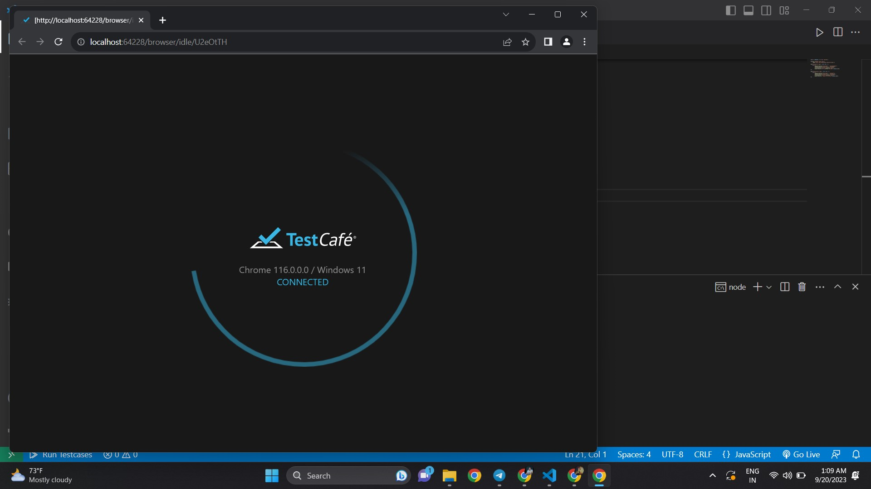

**Testcases –**

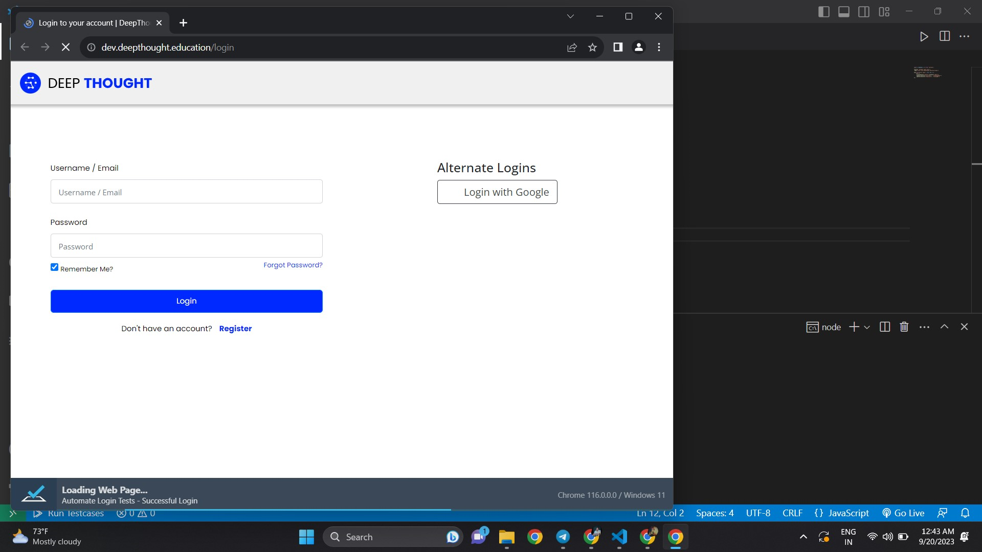

**Valid –**

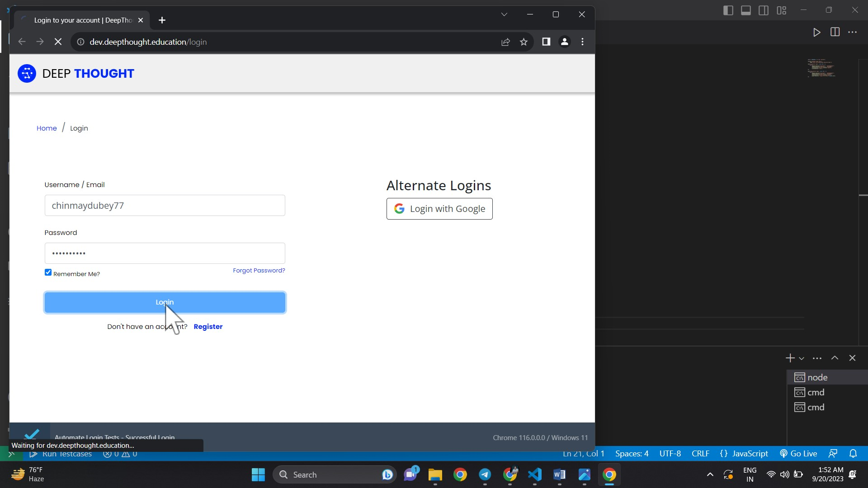

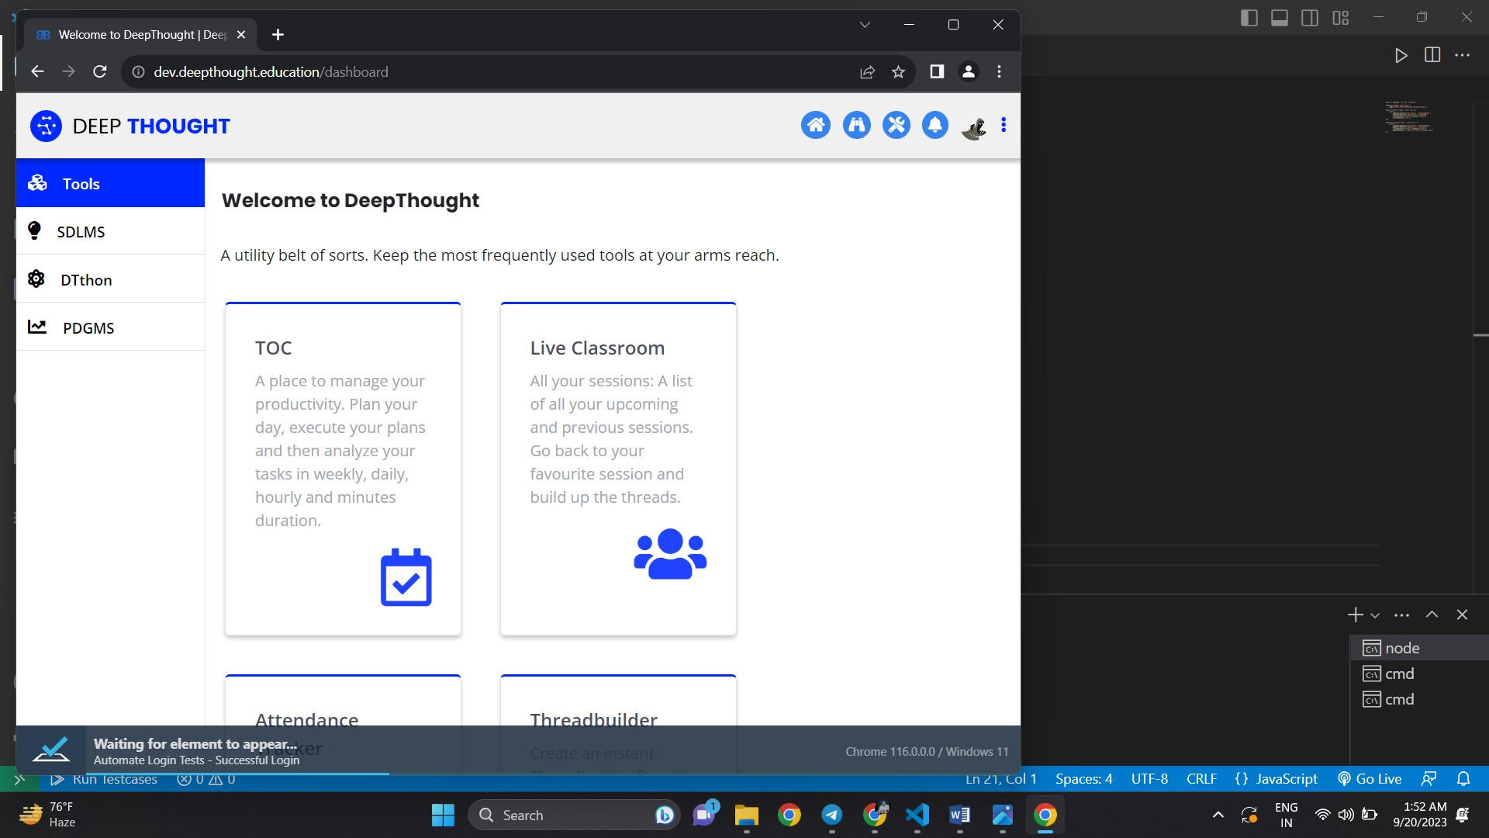

**Invalid login – using wrong password**

