**UML**

# Classes

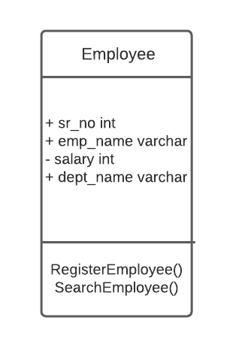

Note: - Sign indicates Private

* Sign indicates Public

## E - R Diagram

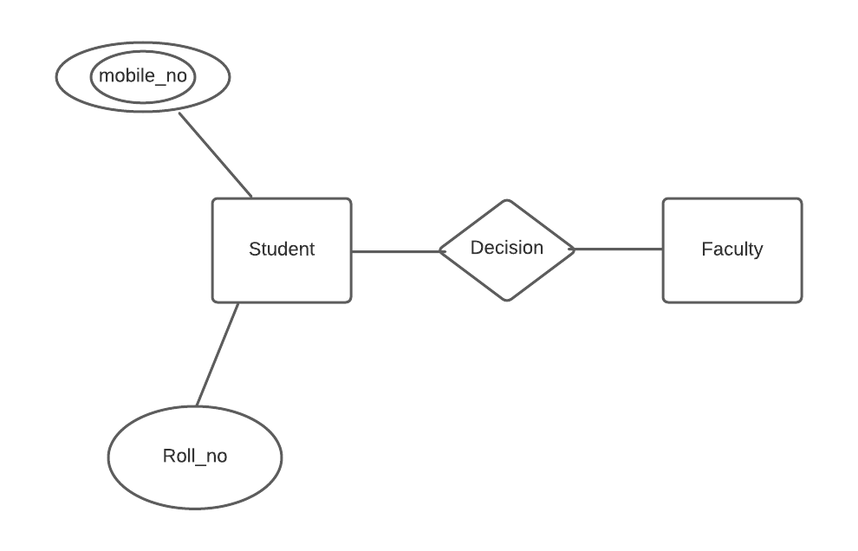

* Here, Square represents Entity and the Diamond shape represents relationship
* Single oval shape represents Single valued Attribute
* Double oval represents Multi-valued Attribute

## 