1.What is the overall Complaint Ratio for each insurance company?

SELECT

Company_Name,

sum(Ratio) as Ratio,

sum(Upheld_Complaints)as up_held_Complaints,

SUM(Question_of_Fact_Complaints) as Question_of_Fact,

SUM(Not_Upheld_Complaints) as Not_Upheld,

sum(Premiums_Written_in_Millions) as Preminums_Written

FROM

Automobile_Insurance_data

GROUP BY

Company_Name

order by Ratio DESC;

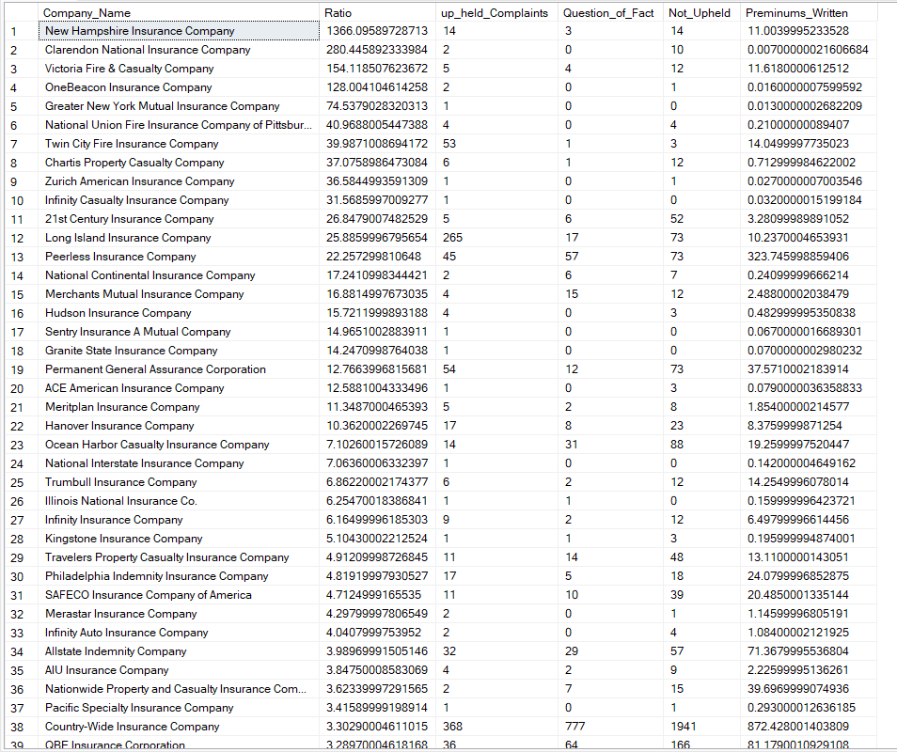

2. Which insurance companies have the highest and lowest Complaint Ratios?

Highest Complaint Ratios ->

SELECT TOP(1)

Company_Name,

SUM(Ratio) as Total_Ratio,

SUM(Upheld_Complaints) as Total_Upheld_Complaints,

SUM(Premiums_Written_in_Millions) as Total_Premiums_Written

FROM

Automobile_Insurance_data

GROUP BY

Company_Name

ORDER BY

Total_Ratio DESC ;



Lower Complaint Ratio ->

SELECT TOP(1)

Company_Name,

SUM(Ratio) as Total_Ratio,

SUM(Upheld_Complaints) as Total_Upheld_Complaints,

SUM(Premiums_Written_in_Millions) as Total_Premiums_Written

FROM

Automobile_Insurance_data

GROUP BY

Company_Name

ORDER BY

Total_Ratio ;



3. What types of complaints are most common?

SELECT

SUM(CASE WHEN Upheld_Complaints > 0 THEN 1 ELSE 0 END) AS Total_Upheld_Complaints,

SUM(CASE WHEN Question_of_Fact_Complaints > 0 THEN 1 ELSE 0 END) AS Total_Question_of_Fact_Complaints,

SUM(CASE WHEN Not_Upheld_Complaints > 0 THEN 1 ELSE 0 END) AS Total_Not_Upheld_Complaints

FROM

Automobile_Insurance_data;



4. Is there a correlation between premiums written and Complaint Ratios?

WITH PremiumsAndComplaints AS (

SELECT

Company_Name,

SUM(Premiums_Written_in_Millions) AS Total_Premiums_Written,

SUM(Upheld_Complaints) AS Total_Upheld_Complaints,

SUM(Ratio) AS Complaint_Ratio

FROM

Automobile_Insurance_data

GROUP BY

Company_Name

)

SELECT

(COUNT(*) * SUM(Total_Premiums_Written * Complaint_Ratio) - SUM(Total_Premiums_Written) * SUM(Complaint_Ratio)) /

(SQRT((COUNT(*) * SUM(Total_Premiums_Written * Total_Premiums_Written)) - (SUM(Total_Premiums_Written) * SUM(Total_Premiums_Written))) *

SQRT((COUNT(*) * SUM(Complaint_Ratio * Complaint_Ratio)) - (SUM(Complaint_Ratio) * SUM(Complaint_Ratio)))) AS Correlation

FROM

PremiumsAndComplaints;



5. What is the total number of unique insurance companies in the dataset?

SELECT COUNT(DISTINCT Company_Name) AS Total_Insurance_Companies

FROM Automobile_Insurance_data;



6. How many complaints were filed in total across all insurance companies?

SELECT SUM(Total_Complaints) AS Total_Complaints_Filed

FROM Automobile_Insurance_data;



7. What is the average complaint ratio across all insurance companies?

SELECT AVG(Ratio) AS Average_Complaint_Ratio

FROM Automobile_Insurance_data;



8. How many complaint cases were upheld in total?

SELECT SUM(Upheld_Complaints) AS Total_Upheld_Complaints

FROM Automobile_Insurance_data;

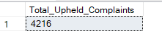

9. What is the average number of upheld complaints per insurance company?

SELECT AVG(Upheld_Complaints) AS Average_Upheld_Complaints

FROM Automobile_Insurance_data;

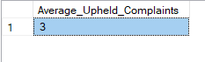

10. Which insurance company had the highest number of upheld complaints?

SELECT TOP(1)Company_Name, MAX(Upheld_Complaints) AS Highest_Upheld_Complaints

FROM Automobile_Insurance_data group by Company_Name order by Highest_Upheld_Complaints desc;



11. How many question of fact complaints were filed in total?

SELECT SUM(Question_of_Fact_Complaints) AS Total_Question_of_Fact_Complaints

FROM Automobile_Insurance_data;



12. What is the average number of question of fact complaints per insurance company?

SELECT AVG(Question_of_Fact_Complaints) AS Average_Question_of_Fact_Complaints

FROM Automobile_Insurance_data;



13. Which insurance company had the highest number of question of fact complaints?

SELECT top(1)Company_Name, MAX(Question_of_Fact_Complaints) AS Highest_Question_of_Fact_Complaints

FROM Automobile_Insurance_data group by Company_Name order by Highest_Question_of_Fact_Complaints desc;

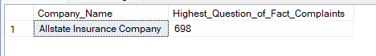

14. How many complaints were not upheld in total?

SELECT SUM(Not_Upheld_Complaints) AS Total_Not_Upheld_Complaints

FROM Automobile_Insurance_data;

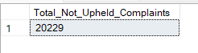

15. What is the average number of not upheld complaints per insurance company?

SELECT AVG(Not_Upheld_Complaints) AS Average_Not_Upheld_Complaints

FROM Automobile_Insurance_data;

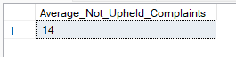

16. Which insurance company had the highest number of not upheld complaints?

SELECT top(1)Company_Name, MAX(Not_Upheld_Complaints) AS Highest_Not_Upheld_Complaints

FROM Automobile_Insurance_data group by Company_Name order by Highest_Not_Upheld_Complaints desc;

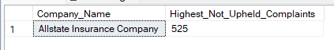

17. What is the total amount of premiums written across all insurance companies?

SELECT SUM(Premiums_Written_in_Millions) AS Total_Premiums_Written

FROM Automobile_Insurance_data;



18. What is the average premiums written per insurance company?

SELECT AVG(Premiums_Written_in_Millions) AS Average_Premiums_Written

FROM Automobile_Insurance_data;



19. Which insurance company had the highest premiums written?

SELECT top(1)Company_Name, MAX(Premiums_Written_in_Millions) AS Highest_Premiums_Written

FROM Automobile_Insurance_data group by Company_Name order by Highest_Premiums_Written desc;

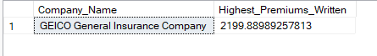

20. How many unique filing years are present in the dataset?

SELECT Filing_Year,COUNT(DISTINCT Filing_Year) AS Unique_Filing_Years

FROM Automobile_Insurance_data group by Filing_Year;

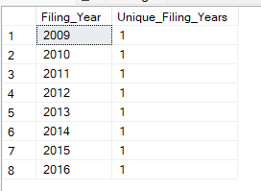

21. How many complaints were filed in each filing year?

SELECT Filing_Year, SUM(Total_Complaints) AS Total_Complaints

FROM Automobile_Insurance_data

GROUP BY Filing_Year;

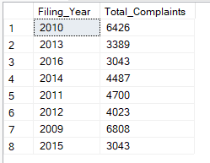

22. What is the trend of upheld complaints over the filing years?

SELECT Filing_Year, SUM(Upheld_Complaints) AS Total_Upheld_Complaints

FROM Automobile_Insurance_data

GROUP BY Filing_Year;

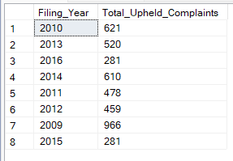

23. What is the trend of question of fact complaints over the filing years?

SELECT Filing_Year, SUM(Question_of_Fact_Complaints) AS Total_Question_of_Fact_Complaints

FROM Automobile_Insurance_data

GROUP BY Filing_Year;

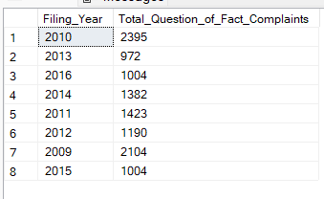

24. What is the trend of not upheld complaints over the filing years?

SELECT Filing_Year, SUM(Not_Upheld_Complaints) AS Total_Not_Upheld_Complaints

FROM Automobile_Insurance_data

GROUP BY Filing_Year;

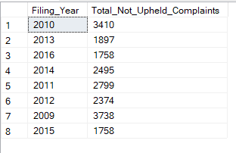

25. How many complaints were filed for each company?

SELECT Company_Name, SUM(Total_Complaints) AS Total_Complaints

FROM Automobile_Insurance_data

GROUP BY Company_Name;

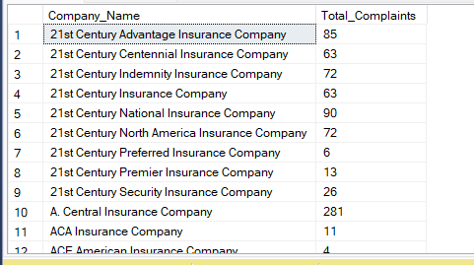

26. What is the distribution of complaint ratios across all companies?

SELECT Company_Name, Ratio

FROM Automobile_Insurance_data

ORDER BY Ratio;

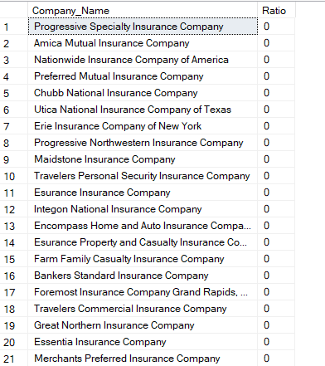

(TOTAL 1358 ROWS FETCHED)

27. How many companies have a complaint ratio higher than 1?

SELECT COUNT(Company_Name) AS Companies_With_High_Ratio FROM Automobile_Insurance_data

WHERE Ratio > 1;



28. How many companies have a complaint ratio less than or equal to 1?

SELECT COUNT(Company_Name) AS Companies_With_Low_Ratio

FROM Automobile_Insurance_data

WHERE Ratio <= 1;



29. What is the average complaint ratio per filing year?

SELECT Filing_Year, AVG(Ratio) AS Average_Complaint_Ratio

FROM Automobile_Insurance_data

GROUP BY Filing_Year;

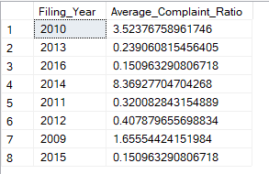

30. Which filing year had the highest average complaint ratio?

SELECT TOP(1)Filing_Year, AVG(Ratio) AS Average_Complaint_Ratio

FROM Automobile_Insurance_data

GROUP BY Filing_Year

ORDER BY Average_Complaint_Ratio DESC ;



31.Which filing year had the lowest average complaint ratio?

SELECT TOP(1)Filing_Year, AVG(Ratio) AS Average_Complaint_Ratio

FROM Automobile_Insurance_data

GROUP BY Filing_Year

ORDER BY Average_Complaint_Ratio ASC;



32. What is the distribution of upheld complaints across all companies?

SELECT Company_Name, Upheld_Complaints

FROM Automobile_Insurance_data

ORDER BY Upheld_Complaints DESC;

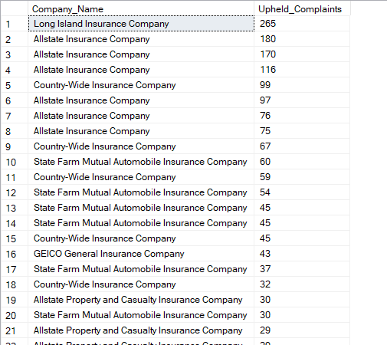

(TOTAL RETURN ROWS = 1358)

33. What is the distribution of question of fact complaints across all companies?

SELECT Company_Name, Question_of_Fact_Complaints

FROM Automobile_Insurance_data

ORDER BY Question_of_Fact_Complaints DESC;

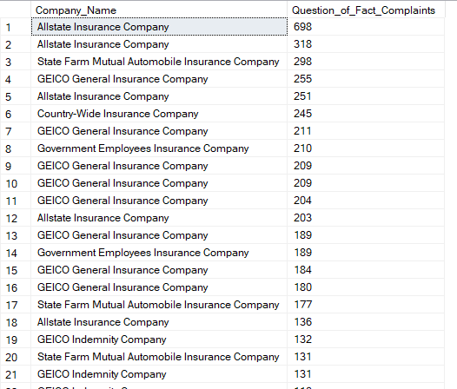

(TOTAL ROWS RETURNED = 1358)

34. What is the distribution of not upheld complaints across all companies?

SELECT Company_Name, Not_Upheld_Complaints

FROM Automobile_Insurance_data

ORDER BY Not_Upheld_Complaints DESC;

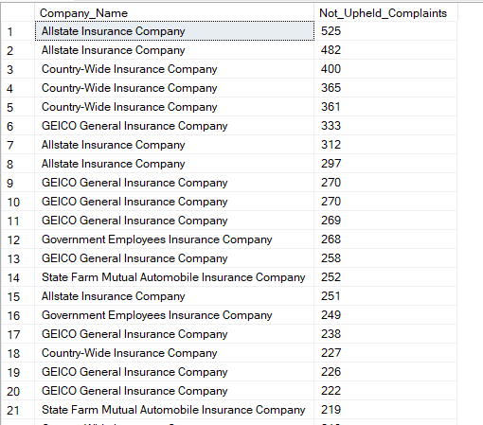

(TOTAL ROWS RETURNED = 1358)

35. How many companies have a higher number of upheld complaints than question of fact complaints?

SELECT COUNT(Company_Name) AS Companies_With_More_Upheld

FROM Automobile_Insurance_data

WHERE Upheld_Complaints > Question_of_Fact_Complaints;



36. How many companies have a higher number of question of fact complaints than upheld complaints?

SELECT COUNT(Company_Name) AS Companies_With_More_Question_of_Fact

FROM Automobile_Insurance_data

WHERE Upheld_Complaints < Question_of_Fact_Complaints;



38. What is the average ratio for companies with more upheld complaints than question of fact complaints?

SELECT AVG(Ratio) AS Average_Ratio_For_More_Upheld FROM Automobile_Insurance_data

WHERE Upheld_Complaints > Question_of_Fact_Complaints;



39.What is the average ratio for companies with more question of fact complaints than upheld complaints?

SELECT AVG(Ratio) AS Average_Ratio_For_More_Question_of_Fact

FROM Automobile_Insurance_data

WHERE Upheld_Complaints < Question_of_Fact_Complaints;



40. What is the distribution of premiums written across all companies?

SELECT Company_Name, Premiums_Written_in_Millions

FROM Automobile_Insurance_data

ORDER BY Premiums_Written_in_Millions DESC;

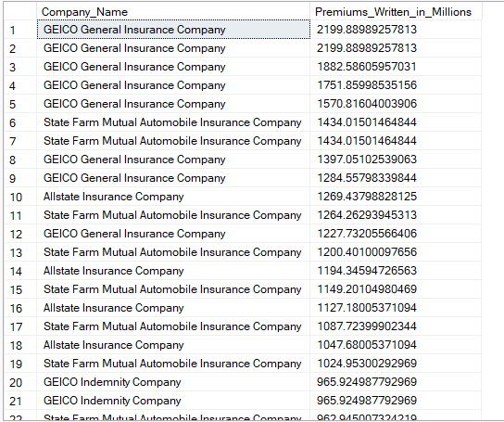

(TOTAL ROWS RETURNED = 1358)

41. How many companies have premiums written exceeding $100 million?

SELECT COUNT(Company_Name) AS Companies_With_High_Premiums

FROM Automobile_Insurance_data

WHERE Premiums_Written_in_Millions > 100;



42. How many companies have premiums written less than or equal to $100 million?

SELECT COUNT(Company_Name) AS Companies_With_Low_Premiums FROM Automobile_Insurance_data WHERE Premiums_Written_in_Millions <= 100;

