Task 1:- How is the shopping distribution according to gender?

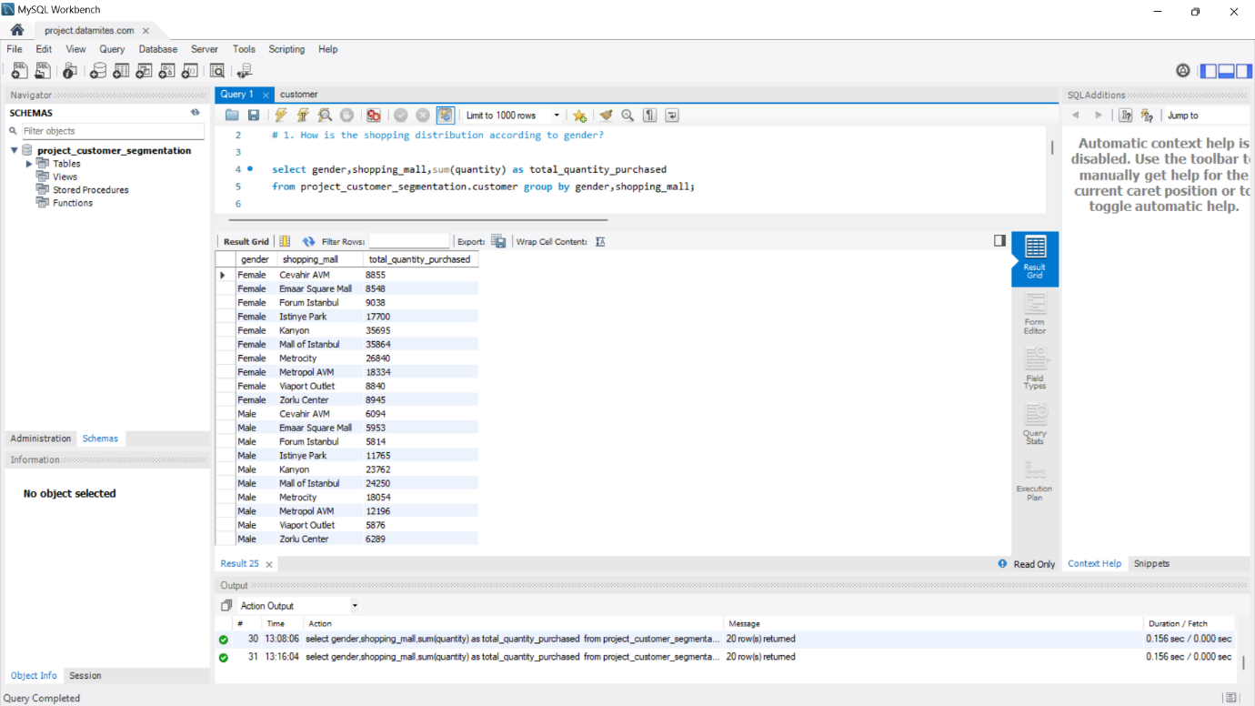

Task 2 :- Which gender did we sell more products?

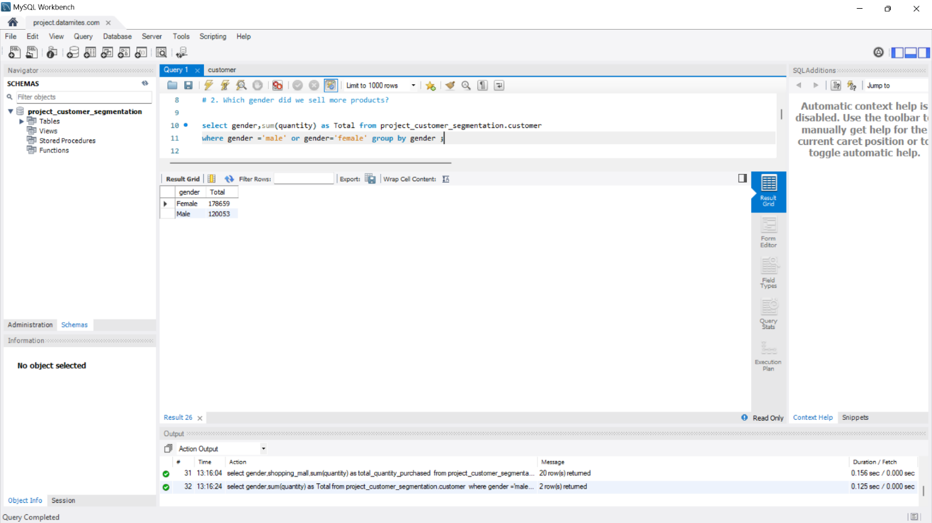

Task 3 :- Which gender generated more revenue ? 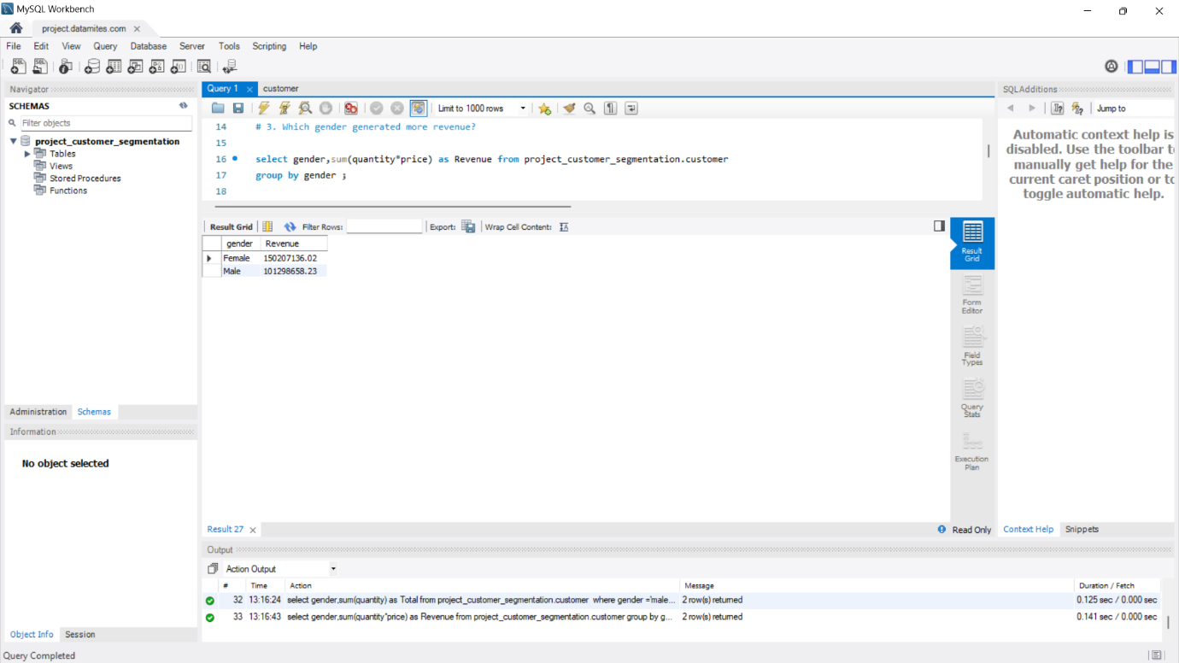

Task 4 :- Distribution of purchase categories to other column?

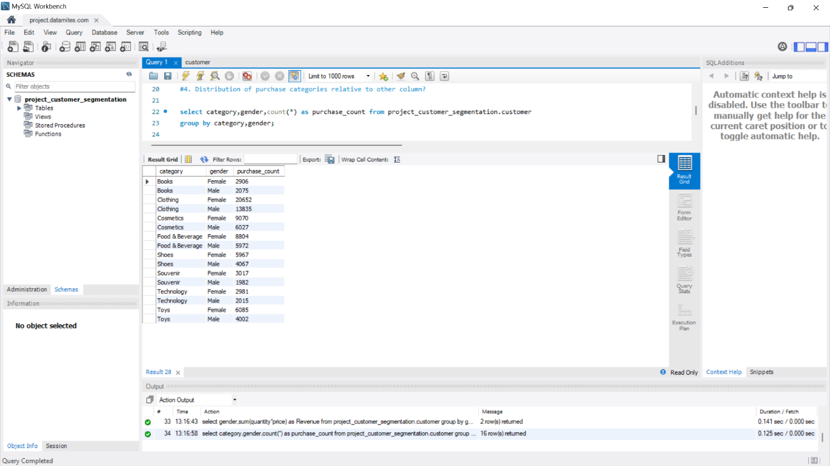

Task 5 :- How is the shopping distribution according to age ?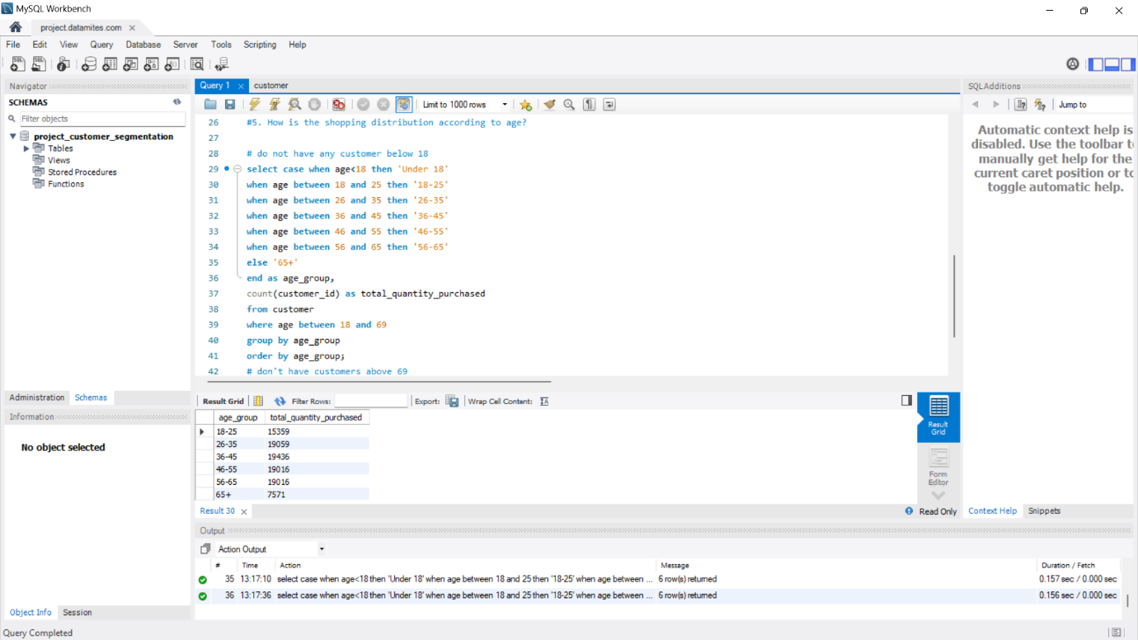

Task 6:- Which age cat did we sell more products to?

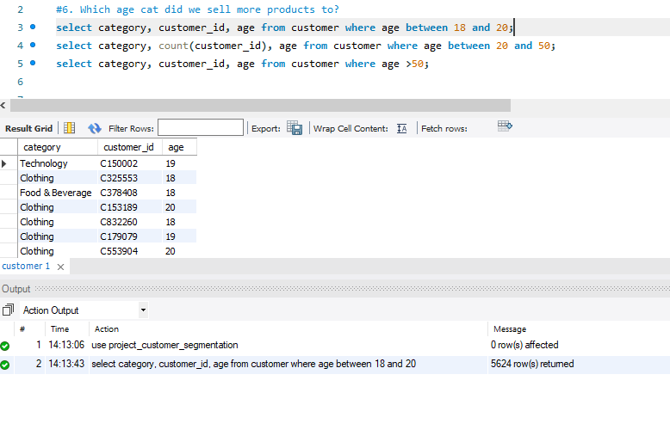

Task 7:- Which age cat generated more revenue?

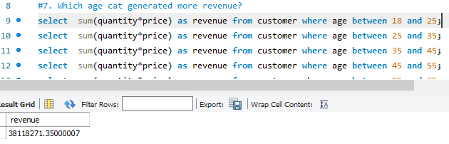

Task 8:- Distribution of purchase categories relative to other columns?

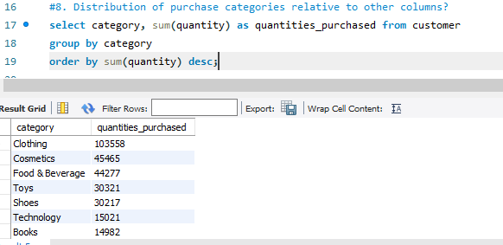

Task 10:- How is the distribution of the payment method?

