**HIVE ASSIGNMENT 1**

Command to copy from Local to HDFS: hadoop fs -copyFromLocal /home/cloudera/chin/sales_order_data.csv

Command to move file into desired directory of HDFS: hadoop fs -mv sales_order_data.csv /chin

Command to load data into table sales_order_csv : load data inpath '/chin/sales_order_data.csv' into table sales_order_csv

**a.Calculate total sales per year**

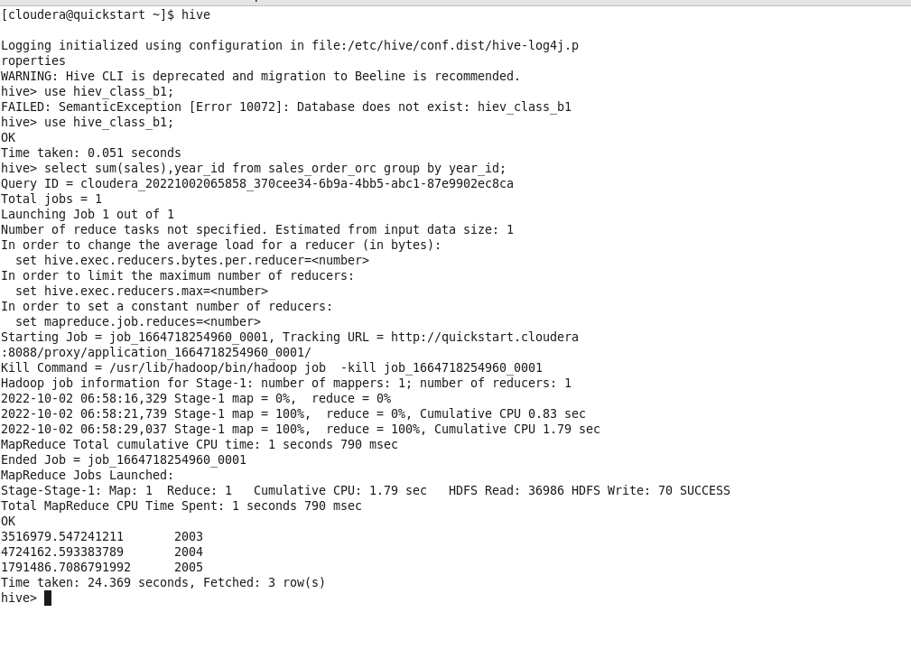

**b. Find a product for which maximum orders were placed**

Ans/Output: Vintage Cars

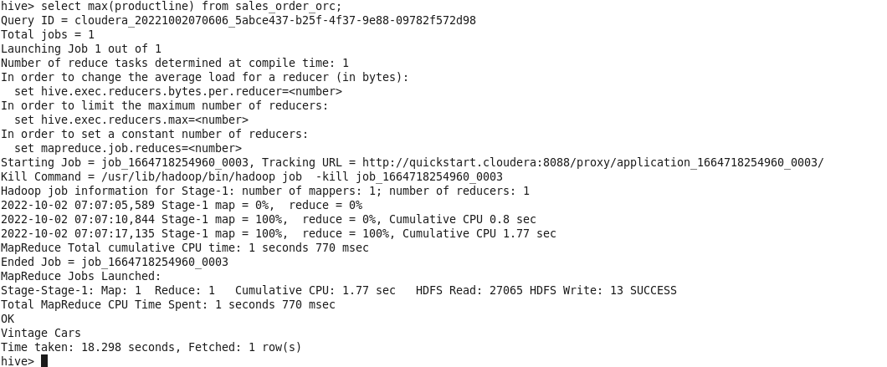

**c. Calculate the total sales for each quarter**

Ans/Output:

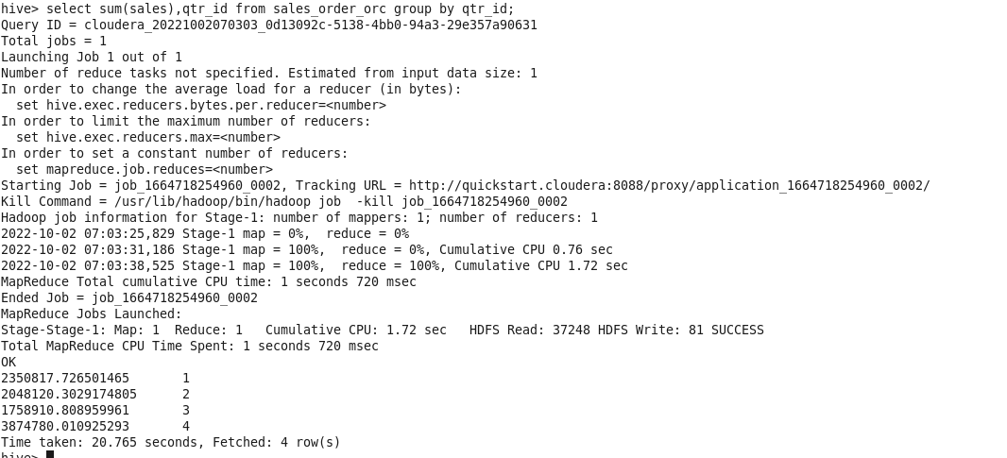

**d. In which quarter sales was minimum**

Ans/Output: We can see the sales and quarter id after querying and conclusion we have is quarter 2 has minimum sales and year is 2005.

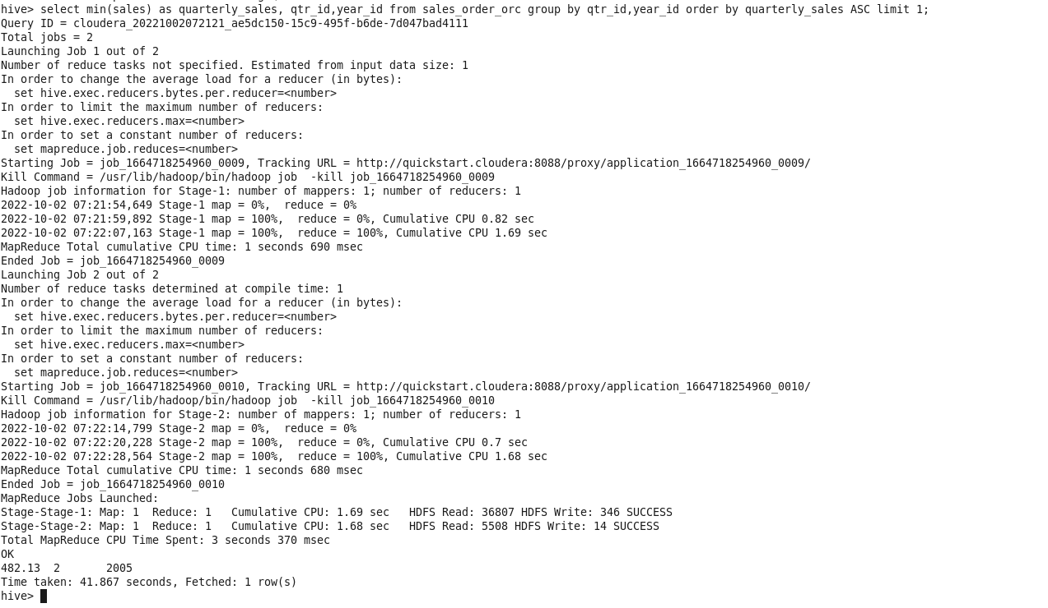

**e. In which country sales was maximum and in which country sales was minimum**

Ans/Output: Sales maximum was in USA and Sales minimum was in France.

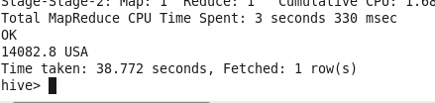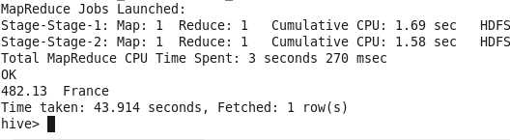

**f. Calculate quarter sales for each city**

**Ans/Output:**

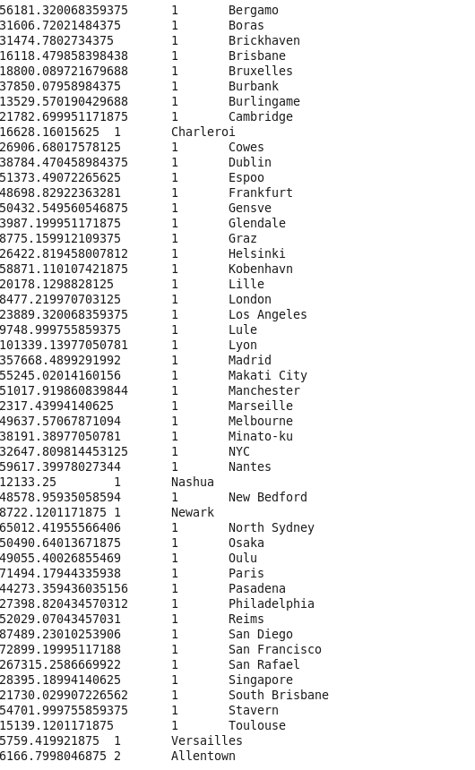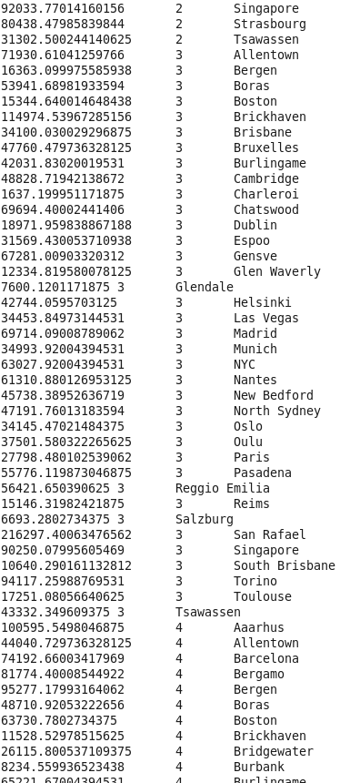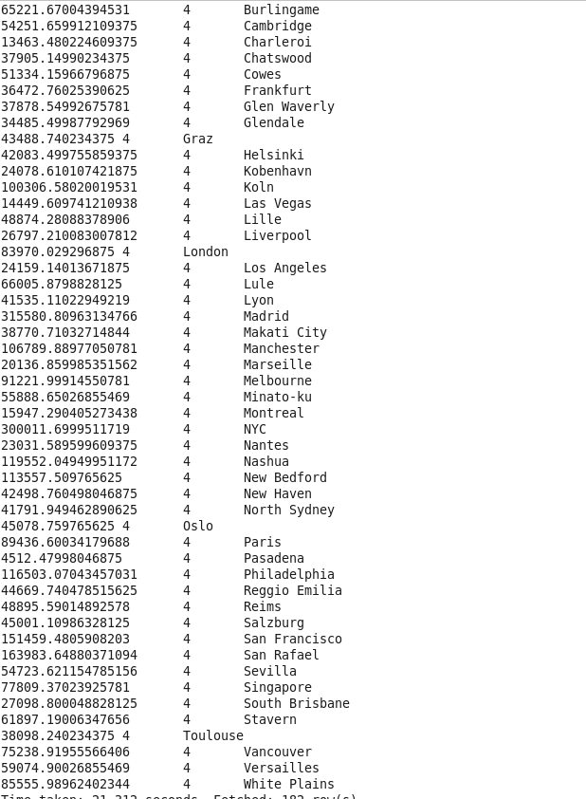

**h. Find a month for each year in which maximum number of quantities were sold**

Ans/Output:

Year 2005- Month 4- 97

Year 2004- Month 11- 55

Year 2003- Month 11- 50

