WALCHAND COLLEGE OF ENGINEERING
DEPARTMENT OF COMPUTER SCIENCE

Batch: T3

Assignment No. 9
Amortized Analysis
Name: Chinmay Nitin Kulkarni

PRN: 23510063

Problem Statement 1:
1) Aggregate Analysis — Dynamic Array Expansion In many applications (e.g., text editors, list-based inventory systems), data structures like dynamic arrays (vectors) are frequently resized when capacity is full. You are to analyze how resizing affects the performance over time. Implement a dynamic array that: Doubles its capacity when full. Tracks the number of element insertions. Record the cost of each insertion. Perform aggregate analysis to determine the amortized cost per insertion.
Expected Output:
Operation Insert 1 Insert 2 ... ...
Actual Cost Total Cost 1 2 ... 1 3 ... 1 1
We have to simulate how dynamic arrays (like std::vector) work — they double capacity when full.
We’ll:
- Insert n elements one by one.
- Track:
  - Actual cost of each insertion.
  - Total cost so far.
  - Amortized cost (total cost / number of insertions).

🔹 Approach / Algorithm
- Start with an array of initial capacity = 1.
- For each insertion:
  - If array not full → cost = 1 (simple insertion)
  - If array full →
    - Allocate new array (double capacity)
    - Copy existing elements (cost = number of elements copied)
    - Insert new element (cost = 1)
- Keep track of:
  - Actual cost per operation
  - Total cost (cumulative)
  - Amortized cost = total cost / total operations

Output:
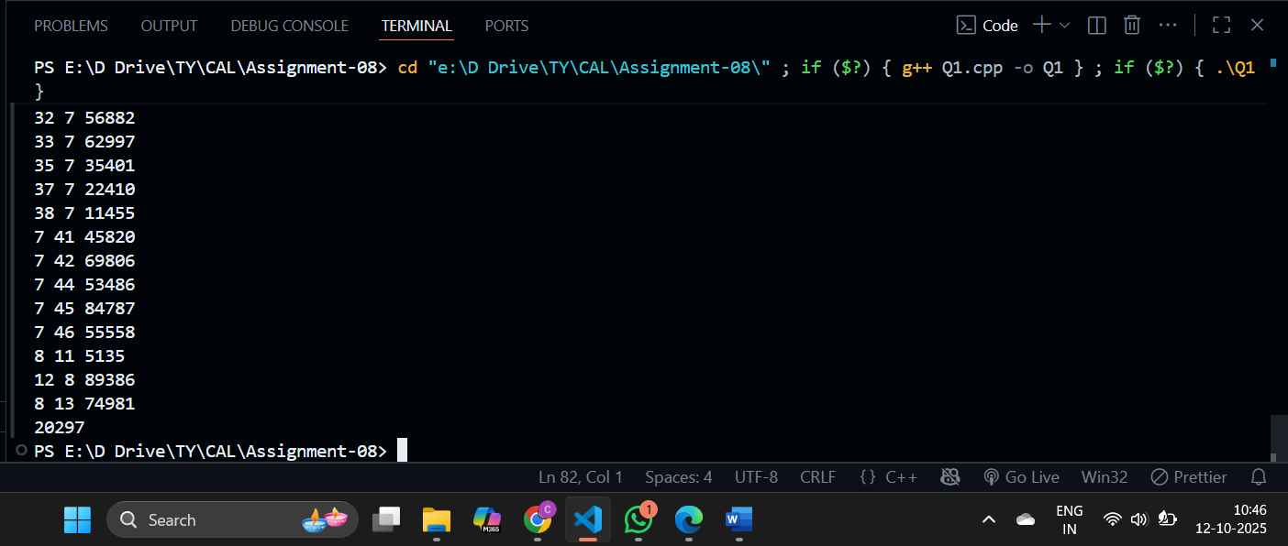

2) Accounting Method — Stack with Multipop Operation Consider a browser’s “Back” button implementation that uses a stack. Each operation can be: push(page) pop() multipop(k) (pop up to k items in one operation) Implement stack operations with multipop(k). Assign amortized costs using the accounting method: Push = 2 units (1 for push, 1 saved for pop) Pop = 0 units (use saved credit) Demonstrate that the total amortized cost of n operations is O(n).
Problem Understanding
We’re simulating a stack with three operations:
- push(x)
- pop()
- multipop(k) — pops up to k elements at once.
We’ll use the Accounting Method to assign amortized costs:
- push = 2 units → (1 actual + 1 credit saved)
- pop = 0 units → use saved credit
- multipop(k) → use up to k credits

🔹 Approach / Algorithm
- Maintain a stack (vector or array).
- Each push:
  - Add element.
  - Assign amortized cost 2 (1 for push + 1 credit saved).
- Each pop:
  - Remove element.
  - Use 1 saved credit → actual cost = 1, amortized = 0.
- multipop(k):
  - Pop up to k elements → actual cost = number of pops.
  - Each pop consumes saved credit, so amortized cost remains 0.

