WALCHAND COLLEGE OF ENGINEERING
DEPARTMENT OF COMPUTER SCIENCE

Batch: T3

Assignment No. 10
Complexity classes and Approximation algorithms
Name: Chinmay Nitin Kulkarni

PRN: 23510063

Problem Statement 1:
1) In defense systems or sensor networks, placing radars/detectors such that none interfere with each other mimics the n-Queen problem. Implement the n × n Queen problem using backtracking. Extend the solution for n = 8 and display all possible solutions. Analyze the time complexity and discuss why it’s an NP problem. Expected Output:
Operation Insert 1 Insert 2 ... ...
Actual Cost Total Cost 1 2 ... 1 3 ... 1 1
The N-Queen problem asks us to place n queens on an n × n chessboard such that:
- No two queens attack each other:
  - No same row
  - No same column
  - No same diagonal
This models problems like radar placement or sensor deployment — where no two devices should interfere.

🔹 Approach (Backtracking)
- Place one queen per row.
- For each row, try all columns:
  - If placing a queen at (row, col) is safe (no conflict with existing queens), place it.
  - Recur for next row.
  - If solution found → store it.
  - Backtrack (remove queen) and continue.
Why N-Queens is NP Problem
- The problem involves combinatorial search through all possible configurations of queens.
- Checking one configuration (verification) is polynomial, but finding all valid configurations requires exponential search.
- Hence, it belongs to the NP-complete class — non-deterministic polynomial time problems.

Output:
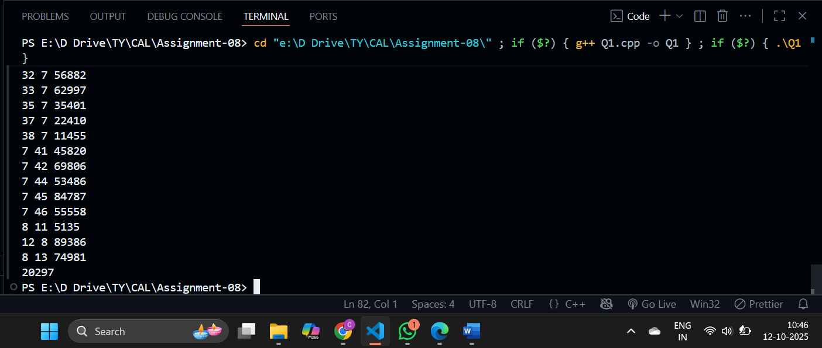

2) In wireless networks or exam scheduling, we must assign frequencies/time slots so that no two adjacent nodes (or exams) share the same color. Implement Graph Colouring using Backtracking. Input: Graph adjacency matrix. Output: Minimum number of colors required and coloring assignment. Verify that adjacent vertices do not share the same color Concept
We must assign colors (frequencies/time slots) to vertices such that:
- No two adjacent vertices share the same color.
- Use the minimum number of colors.
Applications:
- Wireless frequency assignment
- Exam scheduling
- Register allocation

🔹 Approach (Backtracking)
- Assign color 1 to vertex 0.
- For each vertex v, try all colors:
  - If no adjacent vertex has the same color, assign it.
  - Recur for next vertex.
- If assignment works for all vertices, print it.
- Backtrack otherwise.
Why Graph Coloring is NP-Complete
- It’s NP-hard to find the minimum number of colors (chromatic number).
- Checking a valid coloring is polynomial.
- Thus, it’s in NP.
- Finding minimal coloring cannot be done in polynomial time for general graphs (no efficient deterministic algorithm known).

