WALCHAND COLLEGE OF ENGINEERING
DEPARTMENT OF COMPUTER SCIENCE

Batch: T3 Assignment No. 1
Searching & Sorting Algorithm
Name: Chinmay Nitin Kulkarni

PRN: 23510063

Problem Statement 1:
You are given two sorted array, A and B, where A has a large enough buffer at the end to hold B. Write a method to merge B into A in sorted order.
Algorithms Used
- Two-pointer technique for merging two sorted arrays.
- Merge Sort
Related Theory
- Merging Two Sorted Arrays:
  - Given two arrays sorted in non-decreasing order, we can merge them into a single sorted array in linear time using two pointers (one for each array).
  - Complexity: O(n + m) time, O(n + m) space
Algorithm / Procedure
Use two indices:
- i → pointer for A (starting at 0).
- j → pointer for B (starting at 0).
Create a new array ans to store the merged output.
While both arrays have unprocessed elements:
- If a[i] < b[j], append a[i] to ans and move i.
- Else, append b[j] to ans and move j.
Copy remaining elements:
- Add remaining from A .
- Add remaining from B.
Output
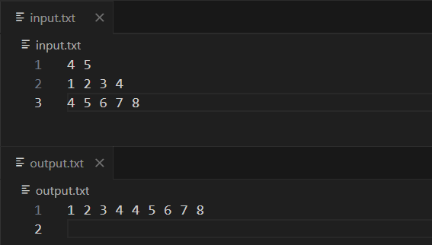
Problem Statement 2:
Write a method to sort an array of string so that all the anagrams are next to each other.
Algorithms Used
- Sorting with a custom comparator using the sorted characters of each string as the key
Related Theory
- Anagram definition: Two strings are anagrams if one can be formed by rearranging the letters of the other (e.g., "cat" and "tac").
- If we sort the characters of each string, all anagrams produce the same “canonical” form (key).
- Sorting the entire list by this key ensures all anagrams appear next to each other.
- Time complexity: O(n * m log m + n log n * m), where m is the max length of a word.
Algorithm / Procedure
Sorting key:
- For each string, create a key by sorting its characters.
Custom sort:
- Sort the array of strings using these keys as the comparison basis.
Output
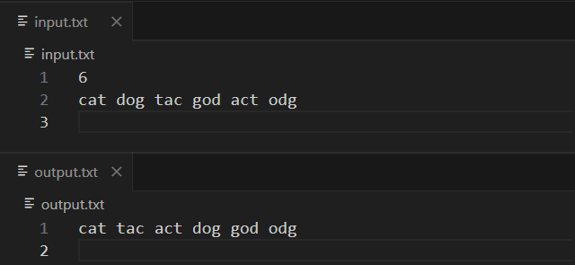

Problem Statement 3:
Given a sorted array of n integers that has been rotated an unknown number of times, write code to find an element in the array. You may assume that the array was originally sorted in increasing order.
EXAMPLE
Input: find 5 in {15, 16, 19, 20, 25, 1, 3, 4, 5, 7, 10, 14}
Output: 8 (the index of 5 in the array)
Algorithms Used
- Linear Search
Related Theory
- The problem is a search element in a rotated sorted array.
Algorithm / Procedure
Linear Search:
  - Loop i from 0 to n-1.
  - If v[i] == val, return i (index of found element).
Return result:
  - If loop completes without finding the value, return -1.
Output
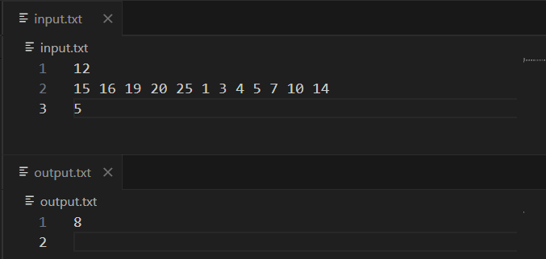

Problem Statement 4:
Imagine you have a 20GB file with one string per line. Explain how you would sort the file.
Steps to Sort the File:
Phase 1 – Creating Sorted Chunks
- Read in parts:
  - Read the file in smaller chunks that can fit into the available RAM
- Sort each chunk:
  - Sort each chunk in memory using a suitable sorting algorithm like Quicksort or Mergesort.
- Save sorted chunks:
  - Write each sorted chunk back to disk as a temporary file.
- Repeat:
  - Continue this process until the whole 20 GB file is split into several sorted temporary files (also called runs).

Phase 2 – Merging Sorted Chunks
- Open all sorted files:
  - Open each temporary file simultaneously.
- K-way merge:
  - Use a min-heap (priority queue) to find the smallest string among the first lines of all files.
  - Write the smallest string to the output file, then read the next line from the file that provided that string.
- Repeat until finished:
  - Continue until all temporary files are exhausted and merged into one final sorted file.
Complexity:
- Time Complexity: O(N log N) (similar to merge sort, plus disk read/write overhead).
- Space Complexity: Extra disk space approximately equal to the size of the original file (for temporary files).
Problem Statement 5:
Given a sorted array of string which is interspersed with empty string, write a method to find the location of a given string.
EXAMPLE
Input: find “ball” in {“at”, “”, “”, “ball”, “”, “”, “car”, “”, “”, “dad”, “”,””}
Output: 4
Algorithms Used
- Linear Search
Related Theory
- In a sorted array of strings with empty strings, the direct use of binary search becomes tricky because empty strings don’t provide comparison results.
Algorithm / Procedure
Search:
- Loop from i = 0 to n - 1.
- If v[i] matches the target string, return i + 1 (1-based index).
Output
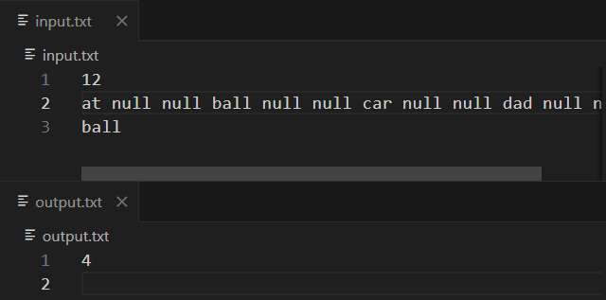

Problem Statement 6:
Given an M*N matrix in which each row and each column is sorted in ascending order, write a method to find an element.
Algorithms Used
- Binary Search applied on each row (O(M × log N) complexity).
Related Theory
- Since each row is sorted in ascending order, we can perform binary search on individual rows.
- This gives a complexity of O(M × log N), which is better than the brute-force O(M × N).
Algorithm / Procedure
Search:
- For each row:
  - Apply binary search:
    - If mid element equals val, return (row, mid).
    - If mid element > val, search left half.
    - Else search right half.
Return:
- If found, print (row_index, col_index).
- If not found in any row, print (-1, -1).
Output
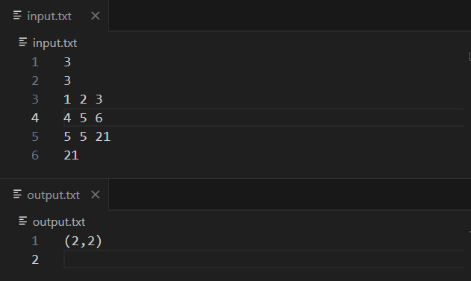

Problem Statement 7:
A circus is designing a tower routine consisting of people standing atop one another’s shoulders. For practical and aesthetic reasons, each person must be both shorter and lighter than the person below him or her. Given the heights and weight of each circus, write a method to compute the largest possible number of people in such tower. EXAMPLE:
Input(ht,wt): (65, 100) (70, 150) (56, 90) (75,190) (60, 95) (68, 110).
Output: The longest tower is length 6 and includes from top to bottom: (56, 90) (60, 95) (65, 100) (68, 110) (70, 150) (75, 190)
Algorithms Used
- Sorting Algorithm (std::sort())
Related Theory
- Pair Sorting in C++:
When sorting pair<int,int> in C++, the default comparator first compares the .first element; if equal, it compares the .second.
- Tower Formation:
Since the requirement is that each person must be shorter and lighter than the one below, sorting by height (and then weight) ensures the order naturally satisfies the condition.
- Time Complexity:
Sorting a list of n elements takes O(n log n) time, and printing is O(n).
Algorithm / Procedure
Sorting:
  - Apply sort() to arrange people in ascending order of height, and for equal heights, ascending order of weight.
Output
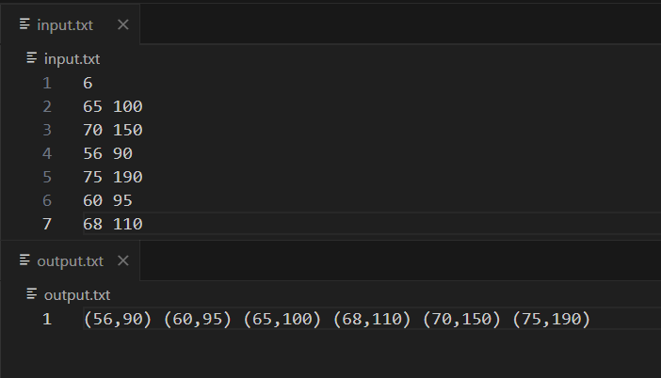

Problem Statement 8:
Imagine you are reading in stream of integers. Periodically, you wish to be able to look up the rank of number x (the number of values less than or equal to x). Implement the data structures and algorithms to support these operations. That is, Implement the method track (int x), which is called when each number is generated, and the method getRankOfNumber (int x), which return the number of values less than or equal to x (not including x itself).
EXAMPLE Stream (in order of appearance) : 5, 1, 4, 4, 5, 9, 7, 13, 3
getRankOfNumber(1) = 0
getRankOfNumber(3) = 1
getRankOfNumber(4) =3
Algorithms Used
- Sorting (std::sort):
Each time a number is added using track(int x), the vector is re-sorted in ascending order so the elements stay ordered.
- Linear Search:
The getRankOfNumber(int x) method iterates through the sorted vector to find the first value greater than x and calculates the rank.
Related Theory
- Rank of a Number:
The rank is defined as the number of elements strictly less than the given number x (excluding x itself, as per problem statement).
- Sorting for Order Maintenance:
By sorting after every insertion, the vector always remains ordered, making rank lookup possible via traversal.
- Time Complexity:
  - track(x): Insertion + Sorting = O(n log n) per element.
  - getRankOfNumber(x): Linear scan = O(n).
Algorithm / Procedure
- Initialization:
  - Maintain a vector v to store all numbers from the stream.
- Tracking New Numbers (track):
  - Push the new number into the vector.
  - Sort the vector in ascending order.
- Rank Lookup (getRankOfNumber):
  - Traverse the sorted vector.
  - Stop when an element greater than x is found.
  - Return index − 1 (since the problem definition excludes x itself).
  - If all elements are ≤ x, return the last index.
- Main Flow:
  - Read n numbers, call track() for each.
  - Read m queries, call getRankOfNumber() for each query and print the rank.

Output
