WALCHAND COLLEGE OF ENGINEERING
DEPARTMENT OF COMPUTER SCIENCE

Batch: T3 Assignment No. 2
Searching Algorithm
Name: Chinmay Nitin Kulkarni

PRN: 23510063

Problem Statement 1:
You are an IT company's manager. Based on their performance over the last N working days, you must rate your employee. You are given an array of N integers called workload, where workload[i] represents the number of hours an employee worked on an ith day. The employee must be evaluated using the following criteria: ∙ Rating = the maximum number of consecutive working days when the employee has worked more than 6 hours. You are given an integer N where N represents the number of working days. You are given an integer array workload where workload[i] represents the number of hours an employee worked on an ith day. Task Determine the employee rating.
Algorithms Used
simple linear scan
Related Theory
The rating is the maximum length of consecutive days where workload[i] > 6.
This is essentially finding the longest consecutive subarray that satisfies a condition.
Algorithm / Procedure
- Initialize two counters:
currentStreak = 0
maxStreak = 0
- Loop over the array:
If workload[i] > 6, increment currentStreak.
Else reset currentStreak = 0.
Update maxStreak = max(maxStreak, currentStreak).
- Print maxStreak.
Output
int workload[] = {3,5,6,8,9,5,7};
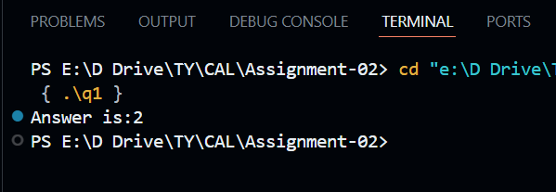
Problem Statement 2:
You have N boxes numbered 1 through N and K candies numbered 1 through K. You put the candies in the boxes in the following order: first candy in the first box, ∙ second candy in the second box, ∙ ....... ∙ ........ ∙ so up to N-th candy in the Nth box, ∙ the next candy in (N - 1)-th box, ∙ the next candy in (N - 2)-th box ∙ ........ ∙ ....... ∙ and so on up to the first box, ∙ then the next candy in the second box ∙ ...... and so on until there is no candy left. So you put the candies in the boxes in the following order: Find the index of the box where you put the K-th candy.
Algorithms Used
- Sorting with a custom comparator using the sorted characters of each string as the key
Related Theory
Candies are distributed in a zig-zag manner:
Forward direction (1 to N)
Backward direction (N to 1)
Repeat until all candies are placed.
We need to find the box index of the K-th candy.
Algorithm / Procedure
- Input:
Read two integers n (number of boxes) and k (number of candies).
- Compute rounds and remainder:
remaining = k % n → position within the cycle.
round = k / n → how many complete forward-backward cycles happened.
- If round == 0 (i.e., K is within the first forward pass):
  - The K-th candy will be placed in box = remaining.
Else (K lies in a later round):
  - The K-th candy will be placed in box = n - remaining (because of the zig-zag backward direction).
- Print the box index where the K-th candy is placed.

Output
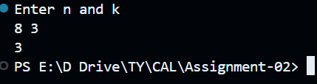

Problem Statement 3:
Implement and Explain Tower of Hanoi algorithm.
Algorithms Used
- Recurssion
Related Theory
- The problem is to implement tower of honoi.
Algorithm / Procedure
- Input n = number of disks.
- Define recursive function towerOfHanoi(n, source, helper, dest):
If n == 1, print move from source → dest.
Else:
  - Move n-1 disks from source → helper.
  - Move largest disk from source → dest.
  - Move n-1 disks from helper → dest.
  - Call function with pegs A, B, C.
Output
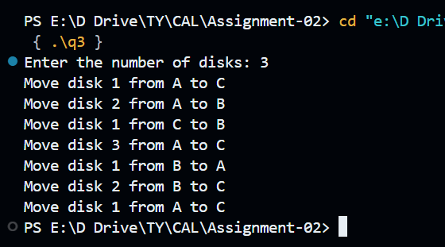

Problem Statement 4:
Algorithm:
Step 1: Define frog’s reachable region
The frog starts at (0,0).
After exactly T seconds, frog’s position (x, y) must satisfy:
  - x ≥ 0
  - y ≥ 0
  - x + y ≤ T
This forms a right-angled isosceles triangle with vertices (0,0), (T,0), (0,T).
Step 2: Define villager’s reported region
Square with bottom-left corner (X, Y) and side length s.
All valid points inside square satisfy:
X ≤ x ≤ X + s
Y ≤ y ≤ Y + s

Step 3: Intersection of regions
We need points (x, y) that lie in both:
Frog’s triangle region.
Villager’s square region.
So the conditions are:
x ≥ 0, y ≥ 0
x + y ≤ T
X ≤ x ≤ X + s
Y ≤ y ≤ Y + s

Step 4: Counting integer points
Initialize count = 0.
Loop through all x in [X, X+s].
For each x, loop through all y in [Y, Y+s].
Check conditions:
If x ≥ 0, y ≥ 0, and x + y ≤ T, then increment count.
Step 5: Output
Print the final value of count.

Problem Statement 5:
Lost Package Tracker Problem Statement: A logistics company stores the scanned timestamps (in hours) of packages entering a warehouse in an array timestamps[]. Sometimes, a timestamp is repeated due to re-scanning. A package is considered "lost" if its ID (timestamp) is missing between two valid timestamps. Task: Given a sorted but incomplete list of timestamps from start to end, find the first missing timestamp in the range. Input: timestamps = [1001, 1002, 1004, 1005] Output: 1003
Algorithm
  - Input array timestamps[] (sorted list).
  - Loop through array from index 0 to n-2:
  - If timestamps[i+1] != timestamps[i] + 1
→ Missing value = timestamps[i] + 1.
  - Print the missing timestamp and stop.
Output
int arr[] = {1001,1002,1004,1005};
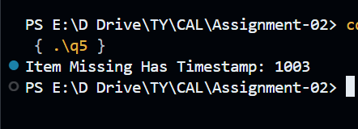

Problem Statement 6:
Implement linear search algorithm.
Algorithms Used
- Linear Search
Algorithm / Procedure
- Input n and array arr[].
- Input target element key.
- Loop through array:
- If arr[i] == key, return index.
- If not found, print "Not found".
Output
target=10;
int nums[]={6,7,9,2,3,1,4,2,5,0};

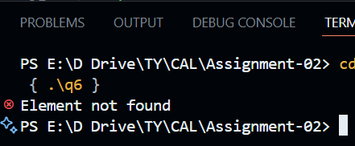

Problem Statement 7:
Implement Binary Search algorithm.
Algorithms Used
- Binary Search

Algorithm / Procedure
- Input sorted array arr[].
- Set low = 0, high = n-1.
- While low <= high:
mid = (low + high) / 2.
If arr[mid] == key, return index.
If arr[mid] > key, search left (high = mid - 1).
Else search right (low = mid + 1).
- If not found, print "Not found".
Output
target=100;
int nums[]={1,1,3,5,8,9,10,14,16,20};

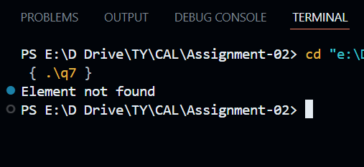

Problem Statement 8:
Signal Drop Detector Problem Statement: You're monitoring signal strengths over time using an array signal[]. A drop is defined as a strictly decreasing subsequence for at least 3 consecutive readings. Task: Find the number of such "signal drops" in the array. Input: signal = [5, 4, 3, 6, 7, 4, 3, 2] Output: 2 (drops: 5→4→3 and 7→4→3→2)

Algorithm / Procedure
- Input n and array signal[].
- Initialize drops = 0.
- Loop through array:
If there is a strictly decreasing sequence of length ≥ 3, count one drop.
Continue until sequence ends, then check next subsequence.
- Print number of drops.

Output
