WALCHAND COLLEGE OF ENGINEERING
DEPARTMENT OF COMPUTER SCIENCE

Batch: T3 Assignment No. 3
Divide and conquer strategy
Name: Chinmay Nitin Kulkarni

PRN: 23510063

Problem Statement 1:
Implement algorithm to Find the maximum element in an array which is first increasing and then decreasing, with Time Complexity O(Logn).
Algorithms Used:
Binary Search
Algorithm / Procedure
- Input: arr[] of size n (strictly increasing then decreasing).
- Use modified binary search:
Set low = 0, high = n-1.
While low <= high:
  - Find mid = (low + high)/2.
  - If arr[mid] > arr[mid-1] && arr[mid] > arr[mid+1], then arr[mid] is the maximum.
  - If arr[mid] > arr[mid-1] && arr[mid] < arr[mid+1], search right half (low = mid+1).
  - Else search left half (high = mid-1).
- Return the maximum element.
Output
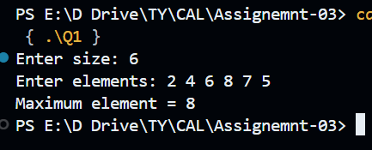

Problem Statement 2:
Implement algorithm for Tiling problem: Given an n×n board where n is of form 2k where k >= 1 (Basically n is a power of 2 with minimum value as 2). The board has one missing cell (of size 1 x 1). Fill the board using L shaped tiles. An L shaped tile is a 2 x 2 square with one cell of size 1×1 missing

Algorithm / Procedure
- Input: n × n board (where n = 2^k), and coordinates (missingX, missingY) of the missing cell.
- Place an L-shaped tromino tile at the center covering 3 quadrants and leaving one quadrant untouched (the one containing the missing cell).
- Recursively solve for each of the 4 quadrants (size n/2 × n/2).
- Base Case: When n == 2, place a single L-shaped tile.
Time Complexity: O(n²) (since every cell is covered once).
Output
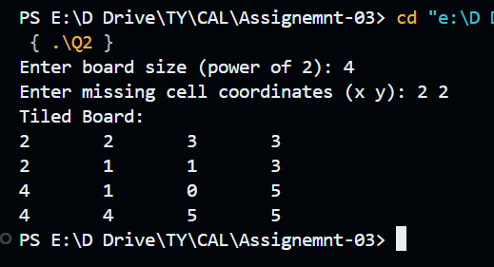

Problem Statement 3:
Implement algorithm for The Skyline Problem: Given n rectangular buildings in a 2 dimensional city, computes the skyline of these buildings, eliminating hidden lines. The main task is to view buildings from a side and remove all sections that are not visible. All buildings share common bottom and every building is represented by triplet (left, ht, right) ‘left’: is x coordinated of left side (or wall). ‘right': is x coordinate of right side ‘ht': is height of building. For example, the building on right side is represented as (1, 11, 5) A skyline is a collection of rectangular strips. A rectangular strip is represented as a pair (left, ht) where left is x coordinate of left side of strip and ht is height of strip. With Time Complexity O(nLogn)
Algorithm / Procedure
- Each building is represented as (left, height, right).
- Convert into events:
At left: add building height.
At right: remove building height.
- Sort all events by x-coordinate.
- Use a multiset / max-heap to track active building heights.
- Traverse events:
If new max height differs from previous height, record skyline point.
Time Complexity: O(n log n) (sorting + heap operations).

Output:
