WALCHAND COLLEGE OF ENGINEERING
DEPARTMENT OF COMPUTER SCIENCE

Batch: T3 Assignment No. 4
Divide and conquer strategy
Name: Chinmay Nitin Kulkarni

PRN: 23510063

Problem Statement 1:
Implement algorithm to Find the maximum element in an array which is first increasing and then decreasing, with Time Complexity O(Logn).
Algorithms Used:
Naïve matrix multiplication
Algorithm / Procedure
- Read two matrices of size n × n.
- Initialize the result matrix C[n][n] with 0.
- For each cell C[i][j], compute the sum of A[i][k] * B[k][j] for k = 0 → n-1.
- Print the result matrix.
Output
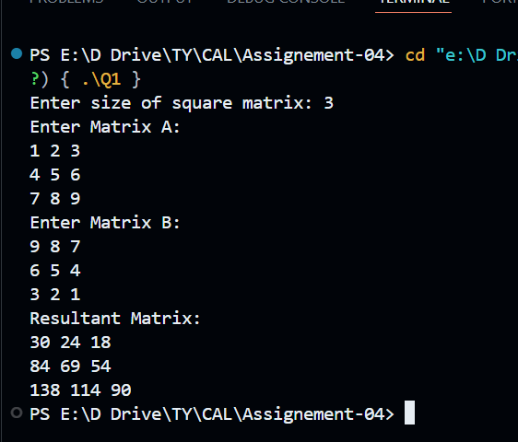
Time Complexity Justification
For every i (n times), every j (n times), we run a loop for k (n times).
Hence, total operations = n × n × n = O(n³).

Problem Statement 2:
Implement Strassen’s matrix multiplication for 3*3 matrix. Do analysis of algorithm with respect to time complexity.

Algorithm Used:
Strassen’s matrix multiplication

Algorithm / Procedure
- Input: Two 3×3 matrices A and B.
- Pad: Convert them to 4×4 matrices by adding 0s in the extra row and column.
- Apply Strassen’s Algorithm:
Divide into 2×2 submatrices.
Use 7 recursive multiplications instead of 8 (normal).
Combine results.
- Trim Back: From the 4×4 result, extract the top-left 3×3 portion (valid answer).

Output:
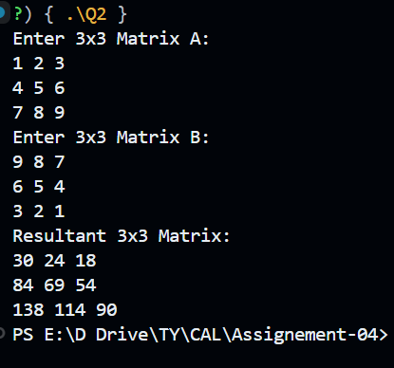

Time Complexity Analysis:
Naive multiplication: O(n³) = O(27) for 3×3.
Strassen’s algorithm: O(n^log₂7) ≈ O(n^2.807).
Faster asymptotically, but for small n like 3, padding overhead makes it slower in practice.
Still, the main advantage shows for very large matrices.

