WALCHAND COLLEGE OF ENGINEERING
DEPARTMENT OF COMPUTER SCIENCE

Batch: T3 Assignment No. 5
Divide and conquer strategy
Name: Chinmay Nitin Kulkarni

PRN: 23510063

Problem Statement 1:
You are working on the city construction project. You have A houses in the city. You have to divide these houses into B localities such that every locality has at least one house. Also, every house in a locality should have a telephone connection wire with each of the other houses in the locality.You are given integers A and B. Task Print the minimum and the maximum number of telephone connections possible if you design the city accordingly.
Algorithms Used:
Binary Search
Related Theory:
There are A houses and B localities.
Each locality has at least one house.
Within a locality, every pair of houses must have a telephone wire (so connections = complete graph).
You need to calculate:
Minimum number of connections
Maximum number of connections

Algorithm / Procedure
Number of wires in a locality of size n = nC2 = n*(n-1)/2.
Maximum connections:
Put as many houses as possible in one locality and only one house in others → (A-B+1) in one locality, rest 1 each.
→ Max = (A-B+1)*(A-B)/2.
Minimum connections:
Distribute houses as evenly as possible among B localities.
Let q = A/B, r = A%B.
- r localities will have (q+1) houses each.
- (B-r) localities will have q houses each.
→ Min = r * ((q+1)*q)/2 + (B-r)*(q*(q-1))/2.

Output
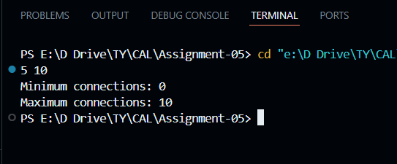

Problem Statement 2:
You are working in the Data Consistency team of your company. You are allocated a task as follows:
• You have a data stream consisting of an equal number of odd and even numbers. You can make separations in the data stream but the number of odd elements should be equal to the number of even elements in both partitions after separation. Also, if you make a separation between a number x and number y, then the cost of this operation will be |x-y| coins. You are given the following:
• An integer N
• An array arr
• An integer K
Task Determine the maximum number of separations that can be made in the array by spending no more than K coins.

Related Theory:
Array arr of size N with equal odd & even numbers.
A "separation" between arr[i] and arr[i+1] is valid only if both partitions (prefix/suffix) still contain equal count of odd & even numbers.
Cost of separation = |arr[i] - arr[i+1]|.
Total spent ≤ K.
Find maximum number of separations.

Algorithm / Procedure
- Track balance while traversing array:
Maintain counts of odd/even so far.
A separation is possible at position i if prefix has equal odd/even and suffix also will have equal odd/even.
- For each valid separation, note down the cost = |arr[i] - arr[i+1]|.
- Collect all possible costs in a vector.
- Sort costs ascending.
- Greedily pick separations while total cost ≤ K.
Output
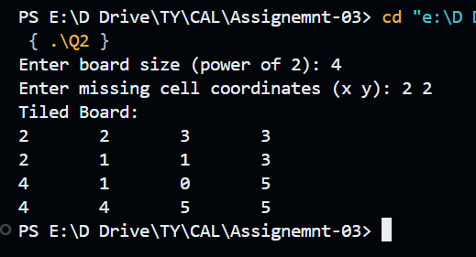

Problem Statement 3:
Implement algorithm for The Skyline Problem: Given n rectangular buildings in a 2 dimensional city, computes the skyline of these buildings, eliminating hidden lines. The main task is to view buildings from a side and remove all sections that are not visible. All buildings share common bottom and every building is represented by triplet (left, ht, right) ‘left’: is x coordinated of left side (or wall). ‘right': is x coordinate of right side ‘ht': is height of building. For example, the building on right side is represented as (1, 11, 5) A skyline is a collection of rectangular strips. A rectangular strip is represented as a pair (left, ht) where left is x coordinate of left side of strip and ht is height of strip. With Time Complexity O(nLogn)
Algorithm / Procedure
- Each building is represented as (left, height, right).
- Convert into events:
At left: add building height.
At right: remove building height.
- Sort all events by x-coordinate.
- Use a multiset / max-heap to track active building heights.
- Traverse events:
If new max height differs from previous height, record skyline point.
Time Complexity: O(n log n) (sorting + heap operations).

Output:
