WALCHAND COLLEGE OF ENGINEERING
DEPARTMENT OF COMPUTER SCIENCE

Batch: T3 Assignment No. 6
Greedy Method
Name: Chinmay Nitin Kulkarni

PRN: 23510063

Problem Statement 1:
Implement Kruskal’s algorithm & Prim's algorithm to find Minimum Spanning Tree (MST) of the given an undirected, connected and weighted graph.
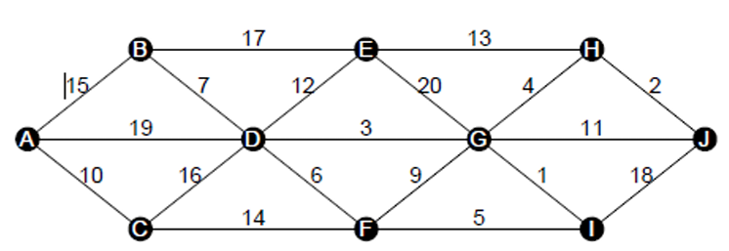
Q) How many edges does a minimum spanning tree for above example?
If the graph has n vertices and is connected, an MST has n - 1 edges. So for above example it will be 9

Q) In a graph G. let the edge u v have the least weight. is it true that u v is always part of any minimum spanning tree of G?.Justify your answers.
Not always part of every MST. If multiple edges tie for minimum weight, some MSTs may include other equal-weight edges instead. However, by the cut property, an edge that is the unique lightest edge crossing some cut must be in every MST; and any global minimum-weight edge is included in some MST.

Q) Let G be a graph and T be a minimum spanning tree of G. Suppose that the weight of an edge e is decreased. How can you find the minimum spanning tree of the modified graph? What is the runtime of your solution?
Edge weight decreased: Given MST T of G and an edge e = (x,y) whose weight decreases:
- If e is already in T then T remains an MST (or still optimal) — no change required.
- If e is not in T, add e to T (creating a single cycle). On that cycle, remove the edge with the maximum weight; the resulting tree is an MST of the modified graph.
- Runtime: to update a single decrease once, you can find the path between x and y in T and identify the maximum-weight edge on that path in O(n) time (DFS along the path). With preprocessing (LCA + max-edge on path), you can do repeated updates in O(log n) per query; for one-off update, O(n) is typical.

Algorithms Used:
Kruskal Algorithm
Algorithm / Procedure
Kruskal(G):
sort edges E by weight ascending
make DSU for n vertices
MST = []
for edge (u,v,w) in sorted E:
if find(u) != find(v):
union(u,v)
MST.append((u,v,w))
return MST
Prim(G, start):
visited = set()
pq = min-priority-queue // (weight, u, v) edges crossing cut
visited.add(start)
push all edges (start, v, w) into pq
MST = []
while pq not empty and |MST| < n-1:
(w,u,v) = pq.pop() // smallest crossing edge
if v in visited: continue
visited.add(v)
MST.append((u,v,w))
push all edges (v, x, w2) where x not visited into pq
return MST
Output
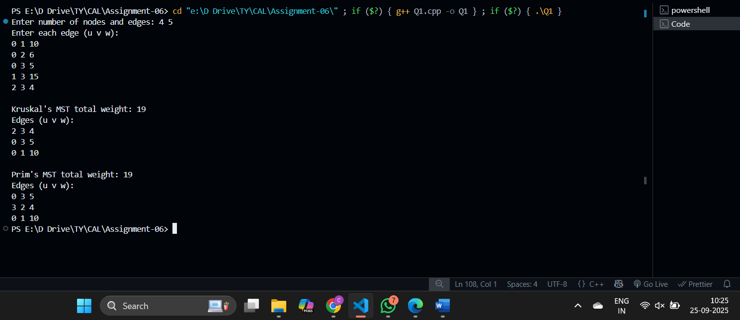

Problem Statement 2: Emergency Evacuation – Container Loading
Evacuating 200 families with varying luggage weights onto a bus with a capacity of 5000 kg.
Input sample: Bus Capacity = 5000
Families’ luggage = [45, 120, 300, 150, 90, 600, 75, 430, 250, 500, 60, 100, 700, 85, 95, 200, 320, 180, 150, 275, ...]
Implement conainer loading problem.

Algorithm used: Greedy by weight sorting
Related Theory:
Goal: maximize loaded weight ≤ capacity.
Greedy approach: sort by increasing weight, load until bus is full.
Works well when objective = load max number of families or nearly fill bus.
Algorithm / Procedure
Sort luggage weights ascending
Iterate through list:
if item fits → load
else skip
Output
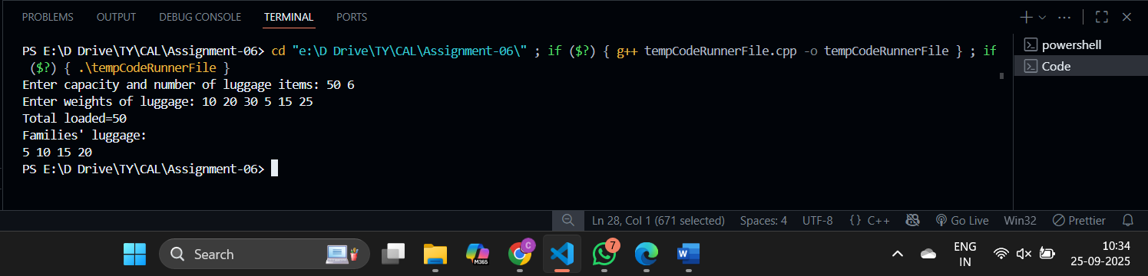

Problem Statement 3: Startup Pitch Scheduling – Job Sequencing
50 startups pitching to an investor, with deadlines (1–10 slots) and profits (10–500). Input sample: Startups = S1(deadline=2, profit=300), S2(1, 200), S3(3, 180), S4(2, 400), S5(1, 250), S6(3, 100), S7(4, 500), S8(2, 150), S9(3, 220), S10(4, 330), ... Slots Available = 10
Algorithm used: Greedy method
Related theory:
Sort jobs by profit ↓, assign each to latest available slot before its deadline.
Greedy optimal because it keeps high-profit jobs while leaving early slots open.

Algorithm / Procedure
Sort jobs by profit descending
For each job:
find latest free slot ≤ deadline
if found → assign
Output:
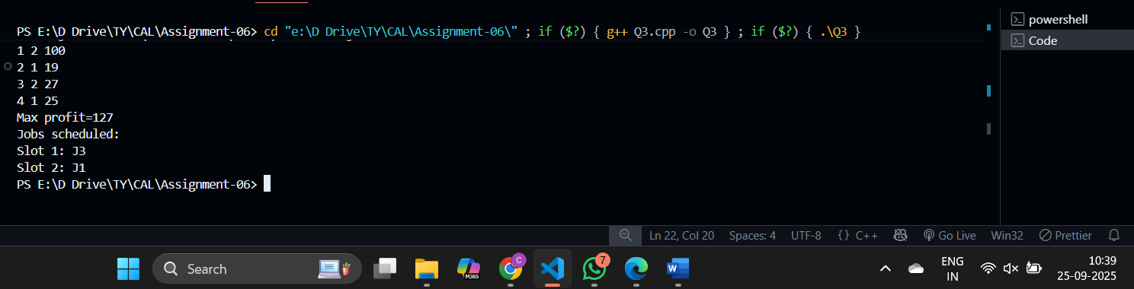
Problem Statement 4: Disaster Relief : Fractional Knapsack
Helicopter capacity = 1000 kg, 100 supply items (divisible & indivisible). Input sample: Capacity = 1000 Supplies = Rice(100, value=500), Medicine(50, value=400, indivisible), Water(200, value=600), Blankets(150, value=450, indivisible), Tents(300, value=800, indivisible), Wheat(120, value=300), Sugar(80, value=250), Oxygen(60, value=700, indivisible), Milk(90, value=350), FirstAid(40, value=500, indivisible), ...
Algorithm used: Greedy method
Related theory:
Sort items by ratio ↓.
For divisible items → take fraction.
For indivisible → take fully if fits, skip otherwise.

Algorithm / Procedure
Sort items by value/weight descending
For each item:
if indivisible and fits → take
if divisible → take as much as capacity allows
Output:
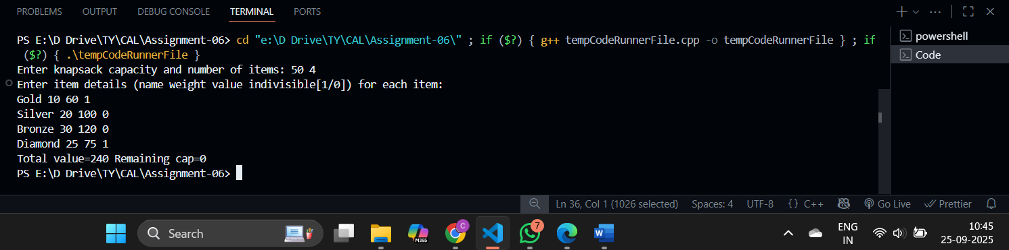

Problem Statement 5: Multi-Server Log Merging – Optimal Merge
A company has 20 log files with sizes from 5MB to 500MB. Logs arrive in rounds. Input: Round 1: [40, 120, 200, 10] Round 2: [30, 15, 250, 90, 60] Round 3: [100, 75, 35, 55, 85, 45] Round 4: [500, 300, 150, 25, 70]
Algorithm used: Greedy method
Related theory:
Always merge two smallest files first → minimizes total comparisons.

Algorithm / Procedure
Push all sizes into min-heap
While >1:
extract two smallest
cost = sum
total += cost
push back cost
Output:
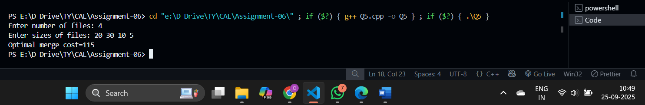

Problem Statement 6: Huffman Coding for IoT Sensor Data
IoT network with 20 sensors, each with frequency (occurrence per hour) and importance factor (1–5). Input: Sensors with (Frequency × Importance): Temp(400), Humidity(300), Pressure(600), Light(150), Gas(120), Motion(200), Smoke(100), Vibration(250), Sound(350), CO2(450), pH(80), Toxic(60), Voltage(220), Current(180), Wind(140), Rain(200), GPS(90), UV(70), Dust(160), Salinity(110) Expected Output: Shortest Codes → Pressure=‘0’, CO2=‘10’, Temp=‘110’, … Longest Codes → Toxic=‘1111110’, pH=‘1111111’ Average Code Length ≈ 5.3 bits

Algorithm used: Greedy method
Related theory:
Build codes by repeatedly combining two least frequent nodes.
Greedy ensures shortest average code length.

Algorithm / Procedure
Push all (freq,symbol) into min-heap
While >1:
pop two min
merge into new node
push back
Assign 0/1 along paths → codes
Output:
