WALCHAND COLLEGE OF ENGINEERING
DEPARTMENT OF COMPUTER SCIENCE

Batch: T3 Assignment No. 7
Dynamic Programming
Name: Chinmay Nitin Kulkarni

PRN: 23510063

Problem Statement 1:
You are given an array containing n integers. Your task is to determine the longest increasing subsequence in the array, i.e., the longest subsequence where every element is larger than the previous one. A subsequence is a sequence that can be derived from the array by deleting some elements without changing the order of the remaining elements. Input: The first line contains an integer n: the size of the array. After this there are n integers x1,x2,…..,xn: the contents of the array. Output: Print the length of the longest increasing subsequence.
Constraints: 1 ≤ n ≤ 2 * 105 1 ≤ xi ≤109
Example Input: 8 7 3 5 3 6 2 9 8
Output: 4

Related Theory:
We need the length of the longest strictly increasing subsequence. A classic O(n log n) solution (often called patience-sorting method) keeps an array tails where tails[len-1] = the smallest possible tail value of an increasing subsequence of length len. For each number x we find the first position in tails that is ≥ x and replace it with x (using lower_bound). The size of tails at the end is the LIS length.

Algorithm:
- Initialize empty array tails.
- For each element x in input:
  - Find index i = lower_bound(tails, x) (first element ≥ x).
  - If i is at end, append x.
  - Else replace tails[i] = x.
- Answer is tails.size().
Complexity
Time: O(n log n) — n numbers and each step uses binary search.
Memory: O(n) worst case for tails (actually ≤ LIS length).
Output:

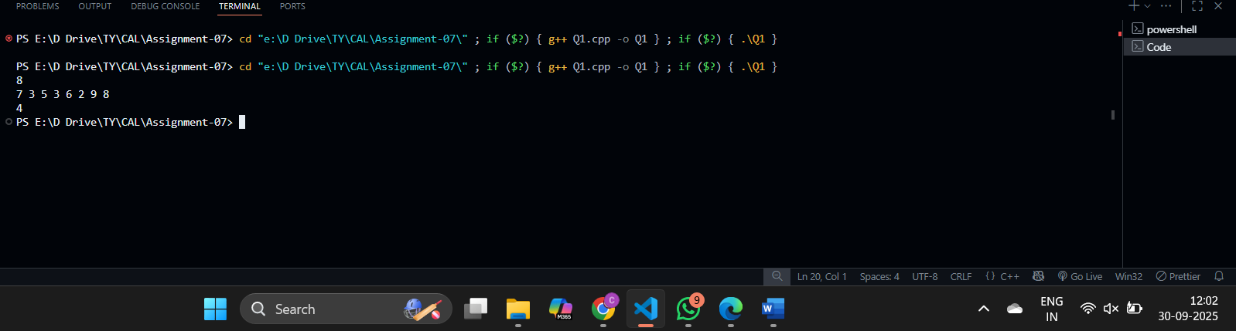

Problem Statement 2:
There are n people who want to get to the top of a building which has only one elevator. You know the weight of each person and the maximum allowed weight in the elevator. What is the minimum number of elevator rides? Input: The first input line has two integers n and x: the number of people and the maximum allowed weight in the elevator. The second line has n integers w1,w2…….,wn: the weight of each person. Output: Print one integer: the minimum number of rides. Constraints: 1 ≤ n ≤ 20 1 ≤ x ≤ 109 1 ≤ wi ≤ x Example
Input: 4 10 4 8 6 1
Output: 2

Related Theory:
This is classic bitmask DP. For every subset mask of people we maintain the best state (rides, last_weight) where:
- rides = number of rides used so far,
- last_weight = total weight in the current (last) ride.
We update by trying to put any not-yet-taken person into the current ride if possible; otherwise start a new ride. We keep the lexicographically minimal pair (rides, last_weight) for each subset (minimize rides first, then leftover weight to allow further additions).
Algorithm:
- Use dp[mask] = (rides, last_weight) initialized to (INF, 0), except dp[0] = (1, 0) (one empty ride).
- For each mask iterate people i not in mask:
  - If last_weight + w[i] <= x then candidate = (rides, last_weight + w[i]).
  - Else candidate = (rides+1, w[i]).
  - Update dp[mask | (1<<i)] with the lexicographically smaller candidate.
- Answer is dp[(1<<n)-1].rides.
Complexity
Time: O(n * 2^n) — iterate all masks and try every person.
Memory: O(2^n). Works for n ≤ 20.

Output
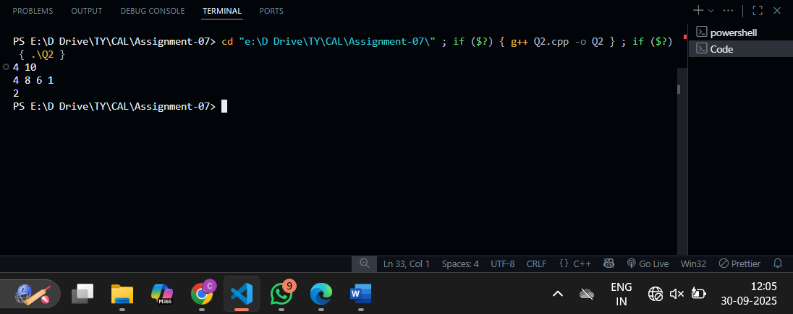

Problem Statement 3:
In Domino Solitaire, you have a grid with two rows and many columns. Each square in the grid contains an integer. You are given a supply of rectangular 2 × 1 tiles, each of which exactly covers two adjacent squares of the grid. You have to place tiles to cover all the squares in the grid such that each tile covers two squares and no pair of tiles overlap. The score for a tile is the difference between the bigger and the smaller number that are covered by the tile. The aim of the game is to maximize the sum of the scores of all the tiles. Here is an example of a grid, along with two different tilings and their scores.
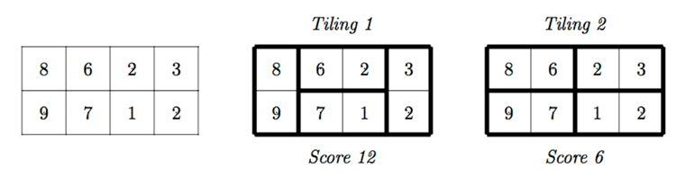
The score for Tiling 1 is 12 = (9−8)+(6−2)+(7−1)+(3−2) while the score for Tiling 2 is 6 = (8−6)+(9−7)+(3−2)+(2−1). There are other tilings possible for this grid, but you can check that Tiling 1 has the maximum score among all tilings. Your task is to read the grid of numbers and compute the maximum score that can be achieved by any tiling of the grid. Solution hint Recursively find the best tiling, from left to right. You can start the tiling with one vertical tile or two horizontal tiles. Use dynamic programming to evaluate the recursive expression efficiently. Input format The first line contains one integer N, the number of columns in the grid. This is followed by 2 lines describing the grid. Each of these lines consists of N integers, separated by blanks. Output format A single integer indicating the maximum score that can be achieved by any tiling of the given grid. Test Data: For all inputs, 1 ≤ N ≤ 105. Each integer in the grid is in the range {0,1,...,104}. Sample Input: 4 8 6 2 3 9 7 1 2 Sample Output: 12

Related Theory:
Process columns left → right by DP. Let dp[i] be the max score for columns 0..i-1 (i columns covered). For the next step:
- Place a vertical tile in column i (index i-1 in 1-based DP): adds abs(a[0][i-1] - a[1][i-1]) and comes from dp[i-1].
- Or if i >= 2, place two horizontals covering columns i-2 and i-1 (top row horizontal and bottom row horizontal). This adds abs(a0[i-2] - a0[i-1]) + abs(a1[i-2] - a1[i-1]), coming from dp[i-2].
That covers all possible tilings because at each leftmost uncovered column you either use the vertical covering that column or you must pair columns i-2 and i-1 with horizontal dominoes.
Algorithm:
dp[0] = 0
for i from 1..N:
dp[i] = dp[i-1] + abs(a0[i-1] - a1[i-1])
if i >= 2:
dp[i] = max(dp[i], dp[i-2] + abs(a0[i-2]-a0[i-1]) + abs(a1[i-2]-a1[i-1]))
Complexity
Time: O(N). Memory: O(N) or O(1) if optimized.
Output:
