Task 07: Ethical Decision Report for Syracuse Men’s Soccer

Prepared for: Athletic Director  
Prepared by: Chinmay Ranade  
Date: October 01, 2025

# Purpose

To provide data-driven, ethically grounded recommendations for improving team performance in the Syracuse Men’s Soccer 2024 season. This report synthesizes statistical performance data and LLM-generated insights into a decision-making framework for coaching staff and administrative leadership.

# Executive Summary

- Recommendation: Provide targeted finishing drills to Nicholas Kaloukian (Low Risk).  
- Rationale: Team-high shot attempts with one of the lowest conversion rates (6.25%).  
- Recommendation: Strengthen synergy between Gabe Threadgold and Michael Acquah (Medium Risk).  
- Rationale: Leading scorer and assister, respectively; performance synergy could enhance scoring potential.  
- Recommendation: Evaluate player fatigue effects after 30 minutes via additional performance tracking (Investigatory).  
- Confidence: Moderate, based on updated stats and verified player performance visuals.

# Background & Decision Context

This report is prepared for the Syracuse University Athletic Director to support evidence-based decisions on training, game strategy, and player development. Based on the 2024 season statistics and natural language model insights, the report addresses mid-season performance trends, individual efficiency, and tactical adjustments needed to enhance outcomes in future seasons. Decisions derived from this report are considered low to medium risk in nature, focusing on operational and coaching practices rather than personnel changes.

# Data & Methods

The data originates from the 2024 Syracuse Men’s Soccer official cumulative statistics (as of November 6, 2024), containing complete records on goals, assists, shots, games played, and minutes for each rostered player. This data was manually extracted from a public PDF document and entered into a structured format using Python and the pandas library.  
  
Two key performance metrics were calculated:  
- **Shot Conversion Rate** = Goals / Shots  
- **Goals Per Game** = Goals / Games Played  
  
These metrics were visualized using Matplotlib bar plots to identify standout performers and underutilized players. Large language models (ChatGPT and Perplexity AI) were used earlier to evaluate team performance, but all statistical summaries in this report were directly verified from source data.

# Findings

The following visuals show performance metrics for selected key players:

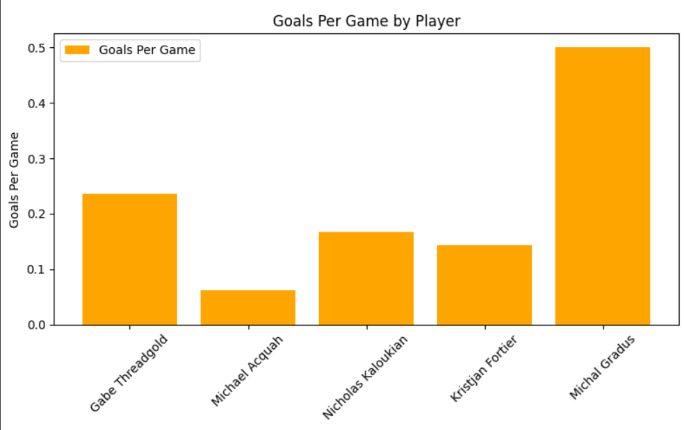

Figure 1: Goals Per Game by Player

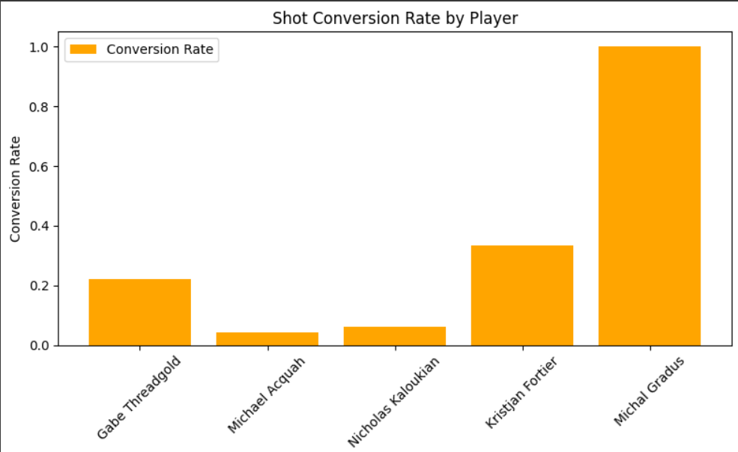

Figure 2: Shot Conversion Rate by Player

# Tiered Recommendations

**Low Risk (Operational)**:  
- Initiate precision-focused finishing drills for Nicholas Kaloukian. With 32 shots and only 2 goals, his conversion rate is the lowest among high-usage players. Improving his finishing ability could substantially increase overall goal production with minimal cost or disruption.  
  
**Medium Risk (Tactical/Strategic)**:  
- Develop offensive sequences that reinforce the connection between Gabe Threadgold (team-high 4 goals) and Michael Acquah (team-high 6 assists). Playmaking chemistry between top contributors may lead to a more reliable scoring pipeline. Tactical adjustments may be needed, such as formation shifts or role assignments.  
  
**Investigatory (Data-Driven Monitoring)**:  
- Investigate late-game efficiency by analyzing player performance post-30 minutes. Fatigue may contribute to missed scoring chances or defensive lapses. Tracking player metrics (distance covered, speed, shot accuracy) by game phase can guide substitutions and training load adjustments.

# Ethical / Legal Concerns

The dataset used in this report is publicly available and does not contain any private, sensitive, or medical information. The analysis respects ethical research norms, focusing solely on athletic performance indicators without making inferences about mental, emotional, or physical health.  
  
Bias considerations were addressed by:  
- Including multiple metrics to assess player contributions  
- Avoiding overemphasis on outlier stats (e.g., players with very few minutes like Michal Gradus)  
- Acknowledging uncertainty in LLM-generated suggestions and verifying them with real data  
  
Legal concerns are minimal due to the use of public performance data. Any future implementation involving biometric tracking would require explicit player consent and institutional review.

# Next Steps & Validation Plan

- **Expand Data Capture**: Introduce in-game tracking (e.g., GPS, time-split performance) to assess fatigue, recovery, and in-play decision-making accuracy.  
- **Player Development Monitoring**: Evaluate the effectiveness of new training interventions (e.g., finishing drills) via before/after metrics.  
- **Re-run Visual Analysis**: Re-generate key performance charts at mid-season next year to track progression.  
- **Incorporate Feedback**: Gather qualitative feedback from coaching staff to validate the applicability and impact of recommendations made here.  
- **Continuous Ethical Review**: Maintain a transparent, audit-friendly documentation process as LLMs and analytics continue to evolve.