1. Executive Summary
Modern enterprise applications frequently require handling extremely large datasets (10M+ records). Rendering such datasets directly in a browser is technically impractical due to:
• Browser memory limitations
• DOM rendering constraints
• Angular change detection overhead
The correct strategy is incremental data loading with virtualization.
Instead of loading all records simultaneously, the application loads only the data currently visible in the viewport.
This architecture enables:
• Smooth scrolling
• Low memory usage
• High responsiveness
• Scalability to 50M+ records

2. System Architecture Overview
The following architecture illustrates how large datasets are efficiently delivered to the frontend.
+-----------------------+
| User UI |
| (Angular 19 App) |
+-----------+-----------+
|
v
+-----------------------+
| AG Grid |
| Server-Side Model |
+-----------+-----------+
|
v
+-----------------------+
| Angular HTTP Layer |
| Request Management |
+-----------+-----------+
|
v
+-----------------------+
| REST API |
| Pagination & Filters |
+-----------+-----------+
|
v
+-----------------------+
| MongoDB |
| Indexed Query Engine |
+-----------------------+
Only small blocks of data (50–200 rows) are transferred per request.

3. Data Loading Flow
The following diagram illustrates how data is fetched dynamically while the user scrolls.
User Scrolls Grid
|
v
+--------------------+
| AG Grid detects |
| missing rows |
+---------+----------+
|
v
+--------------------+
| Datasource.getRows |
| invoked by grid |
+---------+----------+
|
v
+--------------------+
| Angular HTTP call |
| /api/data?start=X |
| &limit=100 |
+---------+----------+
|
v
+--------------------+
| Backend API |
| queries MongoDB |
+---------+----------+
|
v
+--------------------+
| MongoDB returns |
| required rows |
+---------+----------+
|
v
+--------------------+
| Grid renders rows |
| inside viewport |
+--------------------+
The user perceives continuous scrolling, even though data is fetched in segments.

4. Why Loading All Data Is Not Possible
If all records were loaded simultaneously:
10,000,000 rows
|
v
10,000,000 DOM elements
|
v
Browser Memory Exhaustion
|
v
Application Crash
Modern browsers typically struggle when DOM nodes exceed ~100,000 elements.
Therefore virtualization is mandatory.

5. Virtual Rendering (Core Optimization)
AG Grid uses viewport-based rendering.

Without Virtualization
Dataset Size
10,000,000 rows

Rendered Rows
10,000,000 rows

Result
Browser crash

With Virtualization
Dataset Size
10,000,000 rows

Visible Rows
40 rows

Rendered Rows
~50 rows (including buffer)

Result
Smooth UI
The grid dynamically replaces rows while scrolling.

6. Server-Side Row Model
The Server-Side Row Model ensures that only the required rows are requested from the server.

Request Block Diagram
+-------------------+
| Grid Viewport |
| Rows 0 – 40 |
+---------+---------+
|
v
+-------------------+
| Request Block |
| Rows 0 – 100 |
+---------+---------+
|
v
+-------------------+
| Cache Block |
| Stored in memory |
+---------+---------+
|
v
+-------------------+
| Scroll triggers |
| next block |
+-------------------+

Angular Configuration
gridOptions = {
rowModelType: 'serverSide',
cacheBlockSize: 100,
maxBlocksInCache: 10
};
This ensures:
• Small network requests
• Limited browser memory usage
• Efficient caching

7. Angular Change Detection Optimization
Angular's default change detection checks the entire component tree.
For large data grids, this can cause performance issues.

Default Behavior
User Scroll
|
v
Angular Zone Trigger
|
v
Full Application Change Detection
|
v
Slow Rendering

Optimized Behavior
Using OnPush Change Detection
User Scroll
|
v
Grid updates rows
|
v
Angular skips global detection
|
v
Fast UI response

Implementation
@Component({
changeDetection: ChangeDetectionStrategy.OnPush
})
export class GridComponent {}

8. Avoid Angular Cell Renderers
Each Angular cell renderer is a component instance.
Example dataset:
Rows: 1,000,000
Columns: 20

Total cells: 20,000,000
If Angular components were used:
20,000,000 Angular Components
|
v
Memory Explosion
|
v
Performance Collapse
Instead use lightweight functions.

Recommended
valueFormatter
valueGetter
cellStyle
Example:
{
field: 'price',
valueFormatter: p => `$${p.value}`
}

9. Angular Zone Optimization
Angular zones monitor all browser events.
Scrolling generates thousands of events.

Default Flow
Scroll Event
|
v
Angular Zone Trigger
|
v
Change Detection
|
v
Slow UI

Optimized Flow
Scroll Event
|
v
Handled Outside Angular Zone
|
v
Grid Updates Directly
|
v
Smooth Scrolling

Implementation
constructor(private ngZone: NgZone) {}

ngAfterViewInit() {
this.ngZone.runOutsideAngular(() => {
this.initializeGrid();
});
}

10. Row Buffer Optimization
The row buffer determines how many extra rows are rendered outside the viewport.
Viewport Rows: 40
Row Buffer: 10

Rendered Rows:
40 + 10 = 50

Benefits
• Smooth scrolling
• Reduced DOM size
• Lower CPU usage

Configuration
rowBuffer: 10

11. Column Virtualization
Large enterprise tables may have many columns.
Example:
Total Columns: 100
Visible Columns: 10
Without virtualization:
100 columns rendered
With virtualization:
Only 10 columns rendered

Configuration
suppressColumnVirtualisation: false

12. Enterprise-Scale Architecture Diagram
+---------------------+
| Users |
| Browser Interface |
+----------+----------+
|
v
+---------------------+
| Angular 19 |
| Application |
+----------+----------+
|
v
+---------------------+
| AG Grid |
| Server-Side Model |
+----------+----------+
|
v
+---------------------+
| API Gateway Layer |
+----------+----------+
|
v
+---------------------+
| Backend API |
| Pagination Queries |
+----------+----------+
|
v
+---------------------+
| MongoDB |
| Indexed Collection |
+---------------------+

13. Expected Performance
Metric | Expected Result
Initial Load | < 200 ms
Scroll Data Fetch | 50–150 ms
Memory Usage | < 100 MB
DOM Nodes | < 200
The architecture scales efficiently to 50M+ records.

14. Business Benefits
Implementing this architecture provides:
• Smooth UI for large datasets
• Reduced infrastructure load
• Improved user productivity
• Scalable enterprise platform
• Reduced browser crashes
This approach is widely used in financial dashboards, trading systems, analytics platforms, and enterprise admin panels.

15. Conclusion
Handling datasets larger than 10 million records requires a virtualized, server-driven architecture.
Using Angular with AG Grid and the Server-Side Row Model ensures:
• Efficient data delivery
• Minimal memory usage
• High responsiveness
This architecture allows the system to scale to tens of millions of records without compromising user experience.

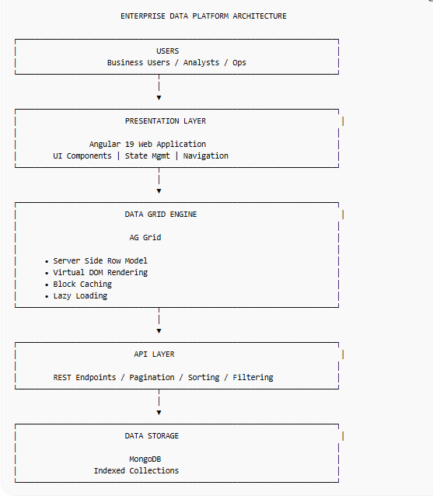

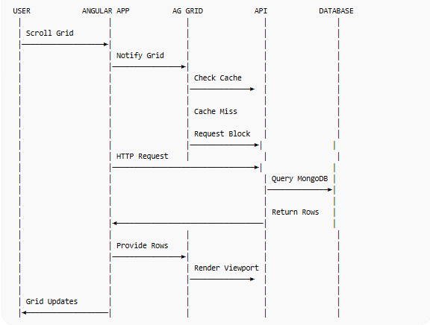

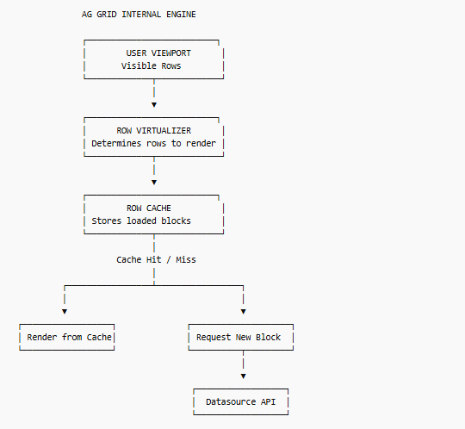

Data Block Loading Strategy
This diagram explains how 10M rows are split into manageable pieces.
FULL DATASET
10,000,000 ROWS
│
▼
┌───────────────────────┐
│ BLOCK SIZE = 100 rows │
└───────────────────────┘
│
▼
Block 1 → Rows 0–100
Block 2 → Rows 100–200
Block 3 → Rows 200–300
Block 4 → Rows 300–400
Block N → Rows 9,999,900–10,000,000
Grid cache example:
CACHE MEMORY
┌──────────────┐
│ Block 0-100 │
├──────────────┤
│ Block 100-200│
├──────────────┤
│ Block 200-300│
└──────────────┘
Older blocks get removed automatically.

5. Angular Performance Optimization Flow
DEFAULT ANGULAR FLOW
Scroll Event
│
▼
Angular Zone
│
▼
Global Change Detection
│
▼
Performance Drop
Optimized:
OPTIMIZED FLOW
Scroll Event
│
▼
AG Grid Internal Handling
│
▼
No Angular Change Detection
│
▼
Smooth Scrolling
Implementation:
ChangeDetectionStrategy.OnPush
NgZone.runOutsideAngular()

6. Scalability Chart (Management Slide)
This visual demonstrates scalability improvement.
RECORD COUNT vs RENDER PERFORMANCE
Rows Loaded Traditional Grid AG Grid Virtualization
----------------------------------------------------------------
10,000 Fast Fast
100,000 Slow Fast
1,000,000 Very Slow Fast
10,000,000 Browser Crash Fast
50,000,000 Impossible Scalable

7. Before vs After Architecture

Traditional Approach
Load All Data
│
▼
Huge Memory Usage
│
▼
Browser Crash

Optimized Architecture
Virtualization
│
▼
Lazy Loading
│
▼
Block Caching
│
▼
Fast Rendering

