Academic Year 2026-27 FY MCA- SEM I
Class Assignment1

Roll No: 21601206
Name: Chinmay Yannawar

01] write a program to read a file and count ow many vowels are present in its content . Is this code correct ?

def count_vowels_in_file(file_path):
vowels = "aeiouAEIOU"
count = 0
with open(file_path, "r", encoding="utf-8") as file:
text = file.read()
for char in text:
if char in vowels:
count += 1
return count
if __name__ == "__main__":
file_path = input("Enter the file path: ")
total_vowels = count_vowels_in_file(file_path)
print(f"Total vowels in the file: {total_vowels}")

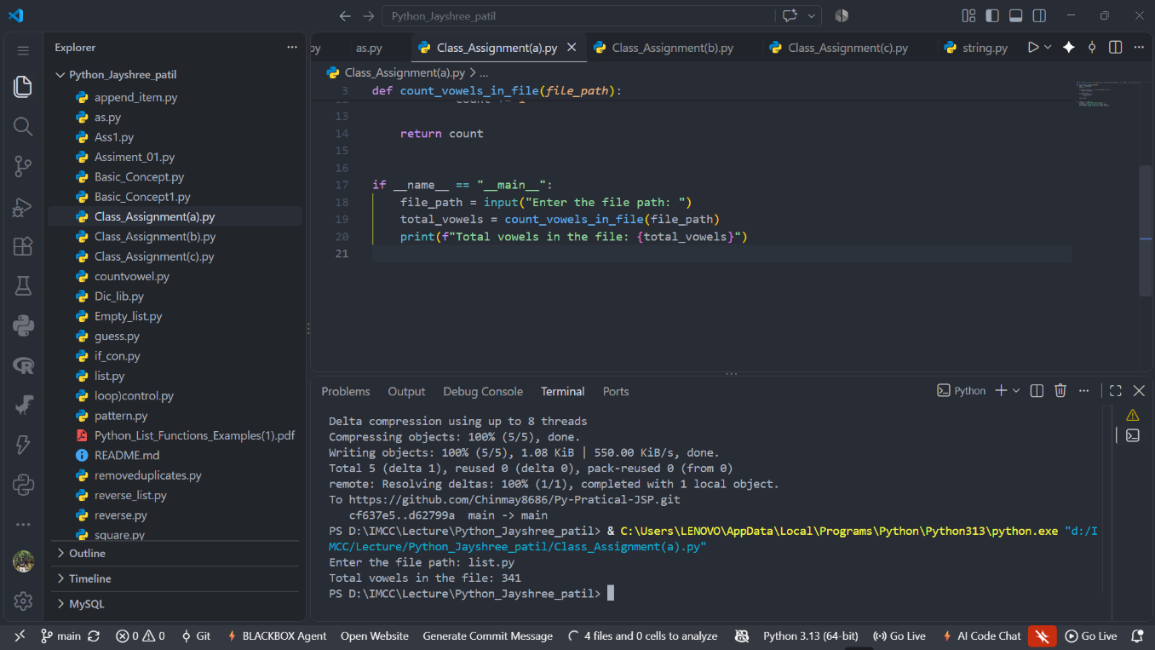
02] Read all lines from a file into a list. print the total number of lines and display te 2nd and 4 th line.
Solution :
file_path = input("Enter the file path: ")
with open(file_path, "r", encoding="utf-8") as file:
lines = file.readlines()
print("Total number of lines:", len(lines))
if len(lines) >= 2:
print("2nd line:", lines[1].strip())
else:
print("2nd line does not exist.")
if len(lines) >= 4:
print("4th line:", lines[3].strip())
else:
print("4th line does not exist.")

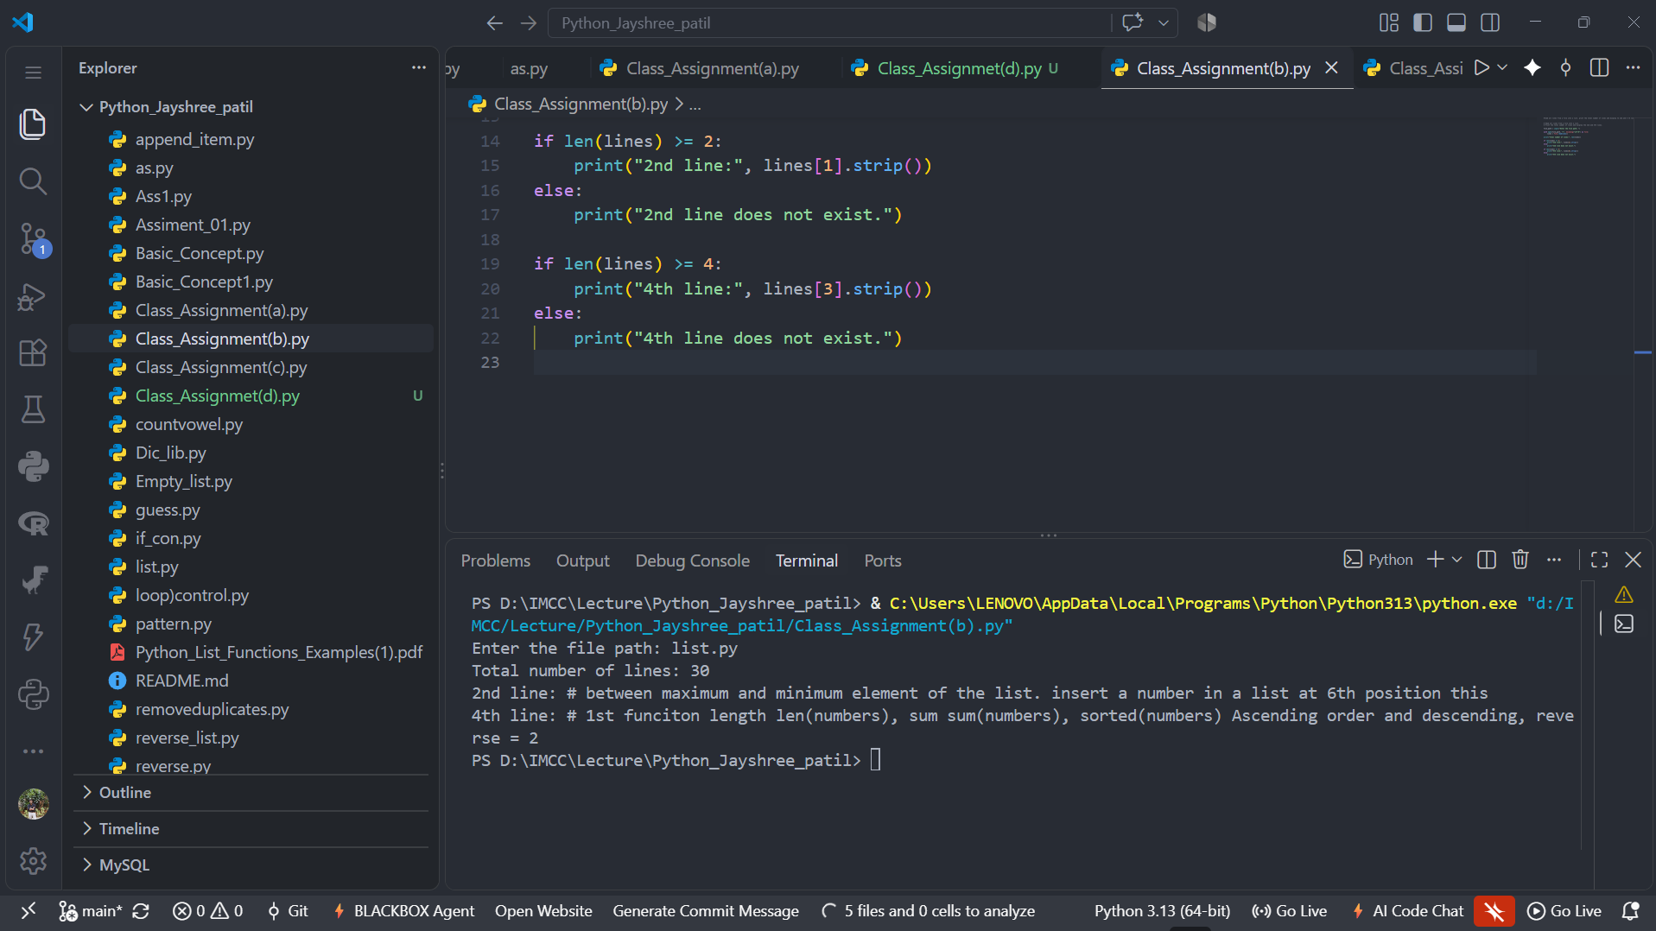

03. Take a sentence from the user, split it inot words, abd store them in a list. print te longest word.
Solution:
sentence = input("Enter a sentence: ")

# Split the sentence into words
words = sentence.split()

# Find the longest word
longest_word = max(words, key=len)

# Display the longest word
print("Longest word:", longest_word)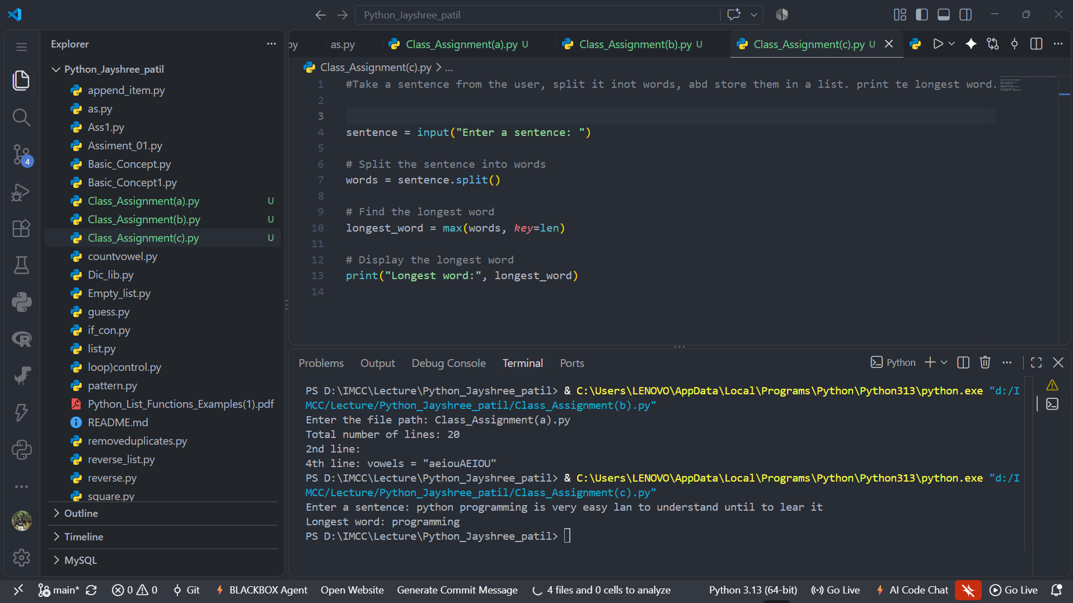

04] Read a file, split its content into words, and store them in a list.
i. Print the total number of words
ii. Print all unique words

Solution:

# Read a file, split its content into words, and store them in a list.

file_path = input("Enter the file path: ")

with open(file_path, "r", encoding="utf-8") as file:
text = file.read()

words = text.split()

# i. Print the total number of words
print("Total number of words:", len(words))

# ii. Print all unique words
unique_words = set(words)
print("Unique words:", unique_words)
