System description

Device diagram

In the figure below you can see the device diagram for the pozyx tag with all the high-level component blocks. Note that the pozyx anchors are similar but without the motion sensors as they are assumed to be immobile.

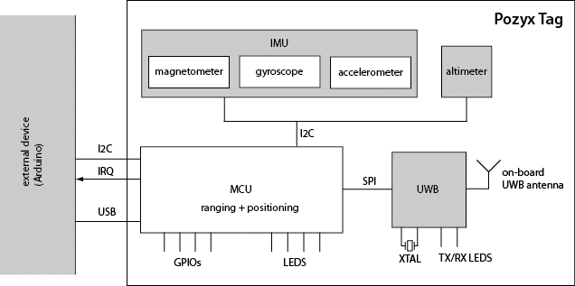   
The heart of he board is the microcontroller unit (MCU) that provides all the pozyx functionalities. The MCU communicates with all the on-board sensors and performs the ranging, positioning and calibration algorithms. The MCU also provides an interface to any external device (such as the Arduino) through the I2C protocol and an interrupt line. For the best performance, the MCU runs a real-time operating system, such that all functionalities are executed with little delay and high reliability. The MCU firmware can be upgraded through the onboard SWD interface or through USB.

The board contains various sensors such as a magnetometer, gyroscope, accelerometer and pressure sensor (altimeter). The sensor data is used by the MCU for positioning and can be also be captured by the user by interfacing with the MCU. The board is also equipped with an ultra-wideband (UWB) chip that provides the wireless capability of the device. The UWB chip requires a dedicated clock source which is calibrated during production up to 1 ppm for the best performance.