**Updating the Rounding App Directions**

Tap the Davita App icon (shown below)

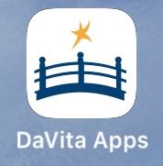

The Village login screen will load

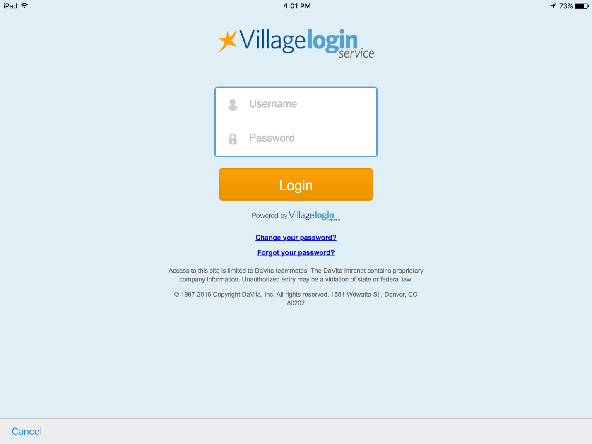

Use your system login credentials (user ID and password which is used to login to your work computer)

Once you log in, the landing page will be as shown in Screen 4

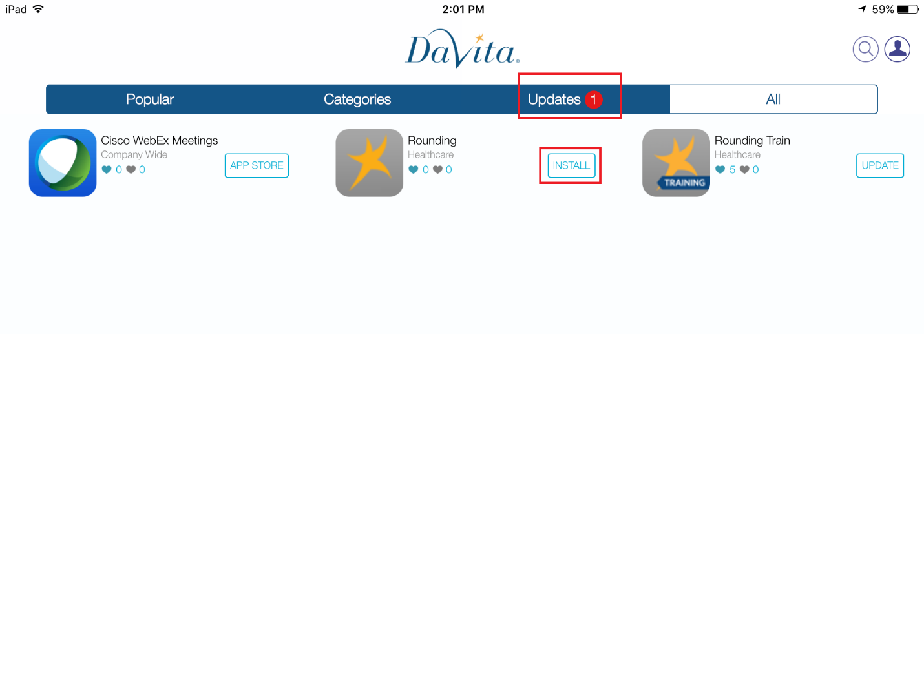

Tap on the “Update” tab or on INSTALL/UPDATE button shown next to the Rounding icon. (Note: Sometimes instead of the INSTALL button, the UPDATE button will be visible)

Tapping on INSTALL/UPDATE an alert window will show up with “Cancel” and “Install” button as shown in Screen 5  
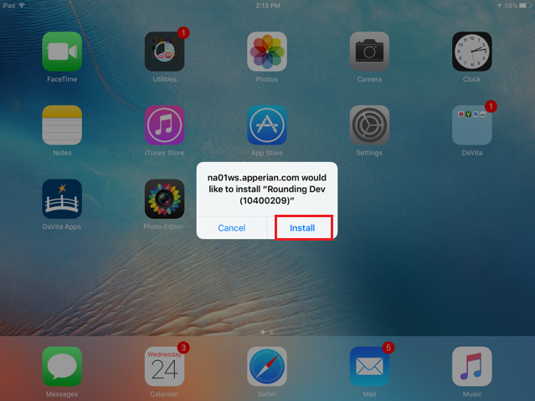

**Note:** This screen shot is of Dev Environment that’s why the message box shows “Rounding Dev”. You will receive a pop-up message referring to “Rounding”

Tapping on “Install” option (Marked red in Screen 5), the app will start installing (as shown in Screen 6).

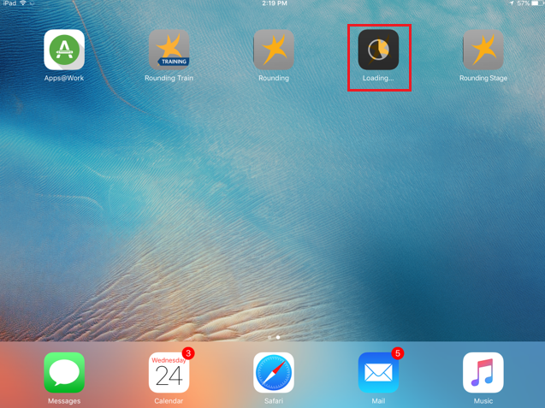

Wait for App to install completely. Once installation is done, the “Rounding” app icon will be visible on the iPad screen and tapping on it will take to the log in screen.

If you have any issues or are unable to access the new version of Rounding then please contact the VillageHealth IT team via a support ticket.