// Assignment 11.1

// Problem statement

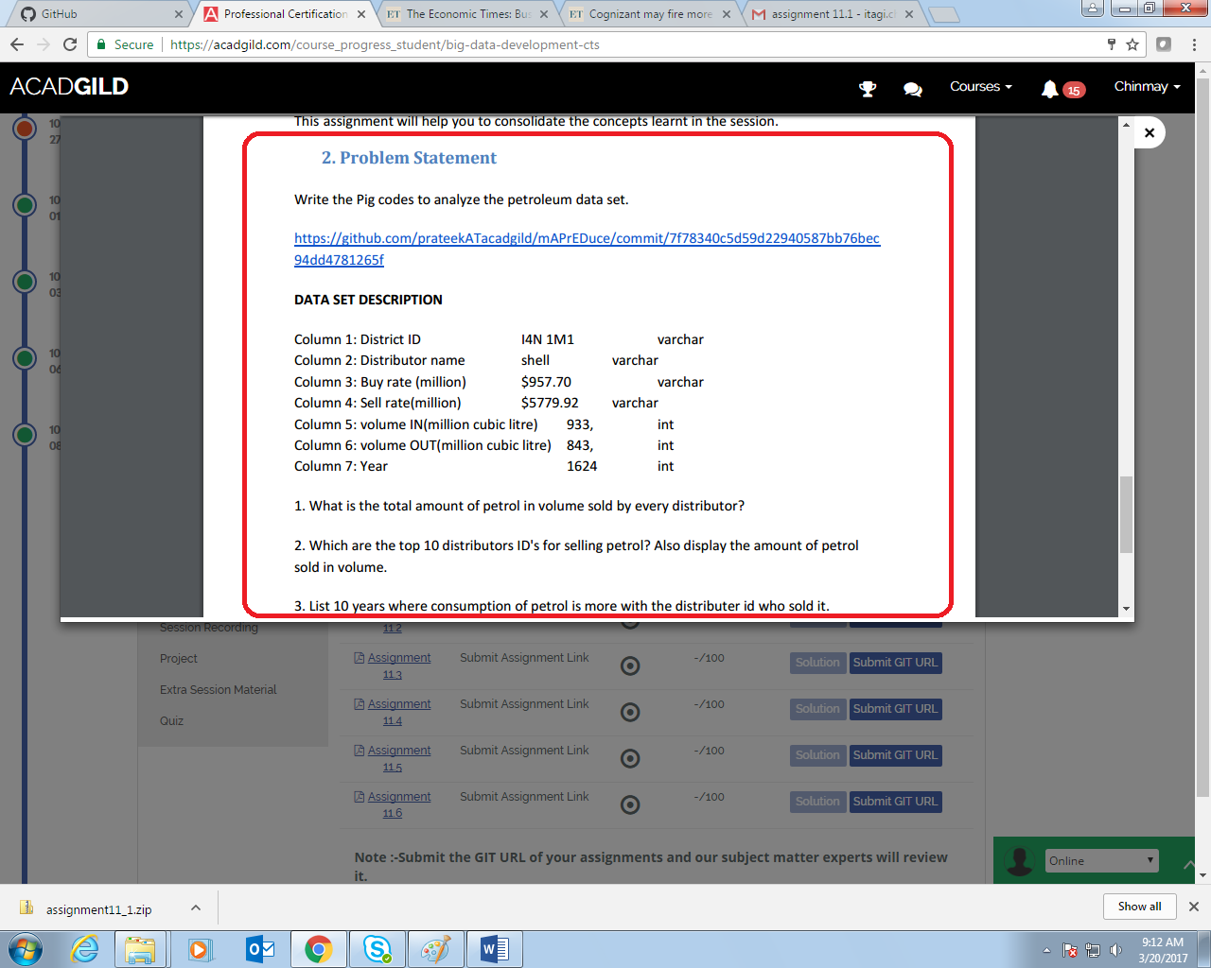

// Question 1

//Query

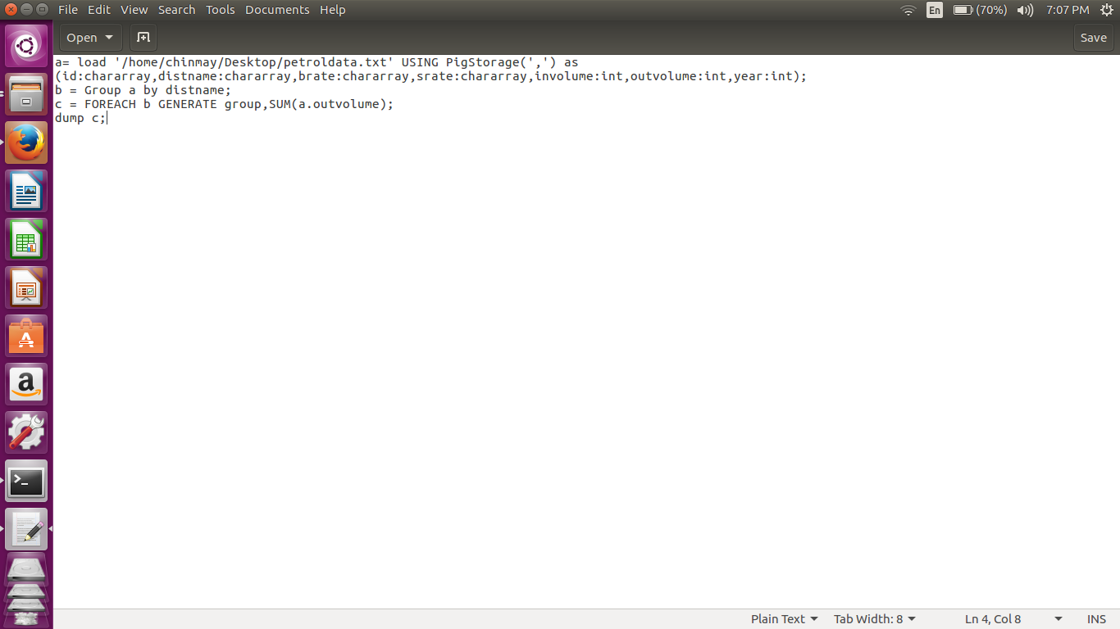

1) Group according to distributer name

2) Generate sum for each group

//Implementation command

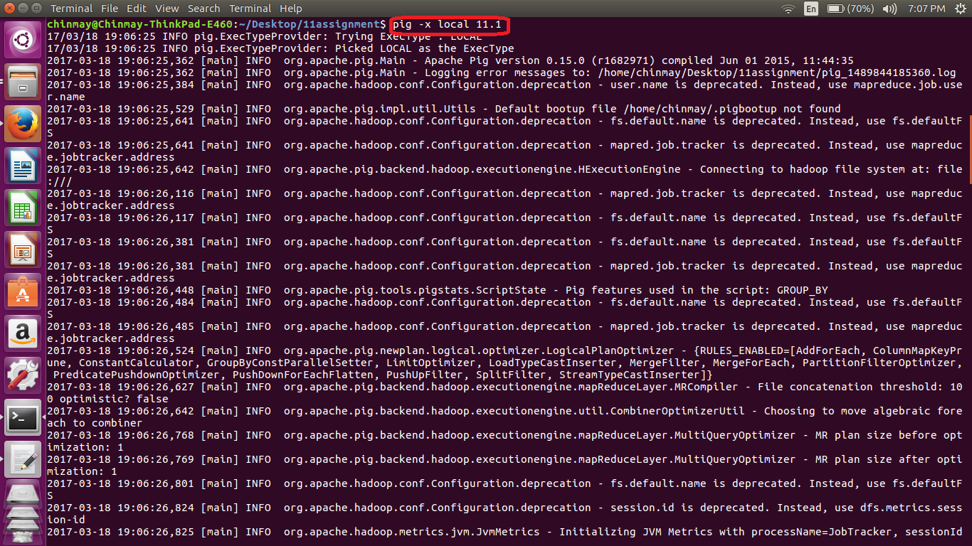

// Output

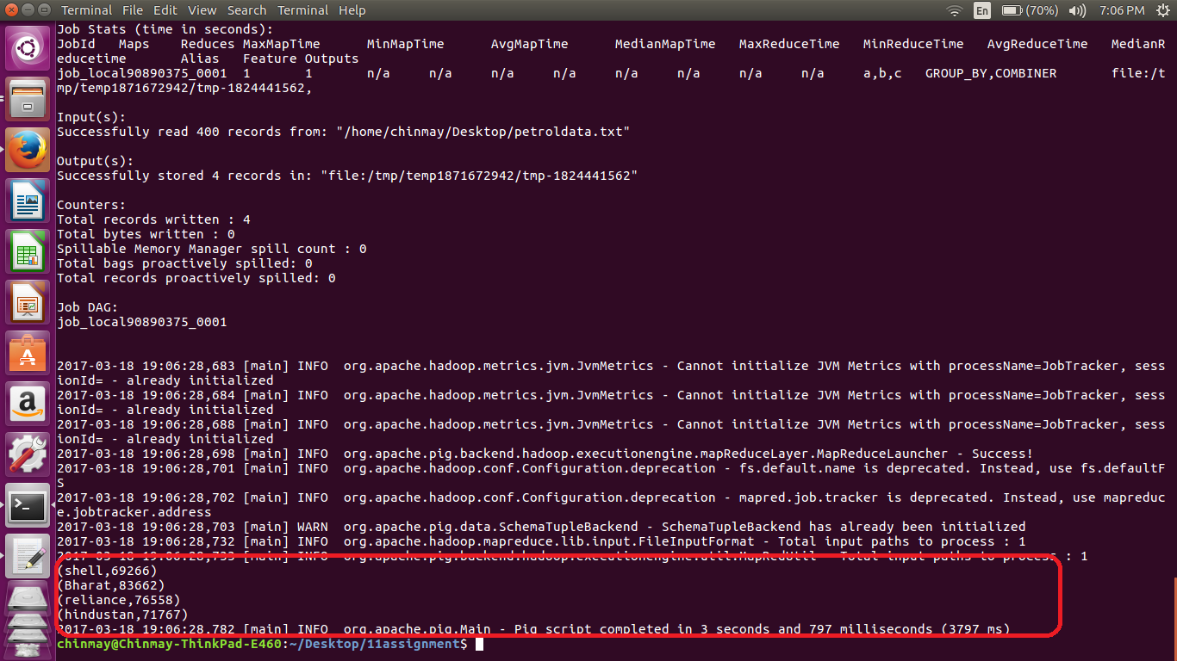

// Question 2

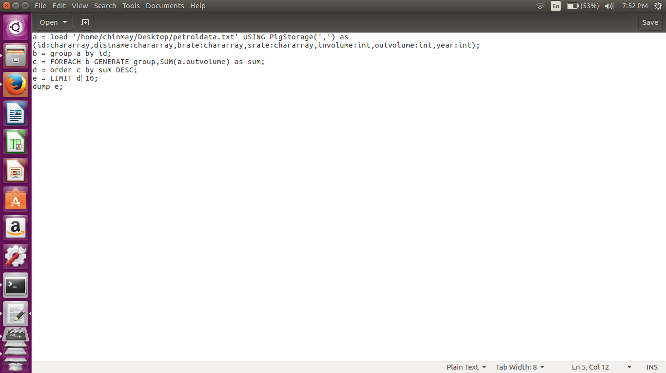

1. Group by id
2. Find sum of out volume for each group
3. Order by Descending order
4. Limit the output to first 10

//implementation command

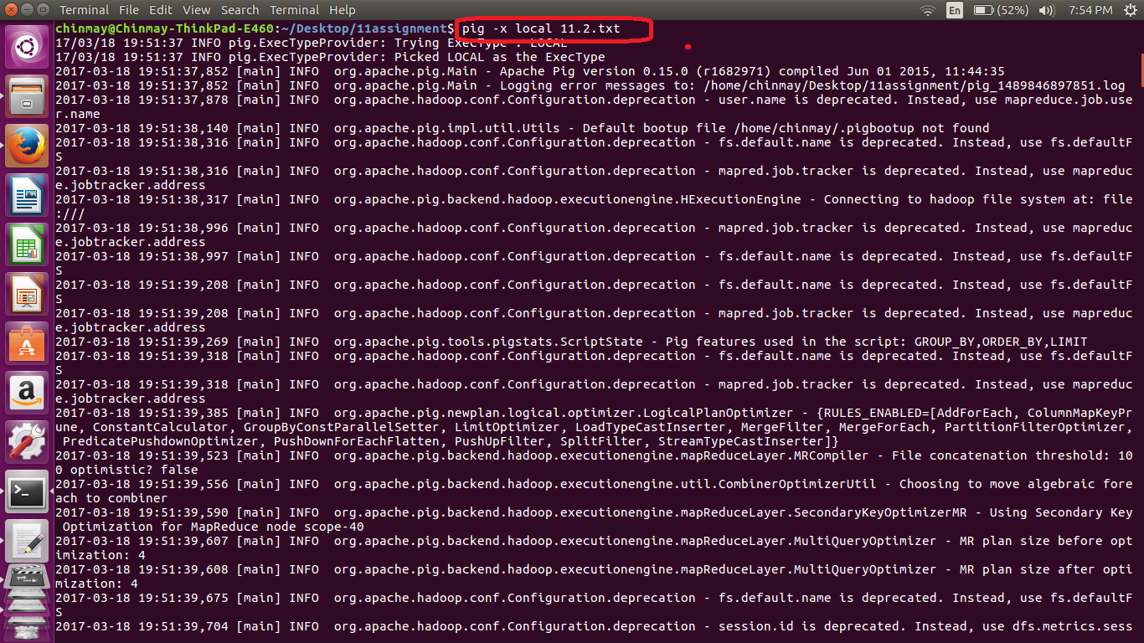

//Output

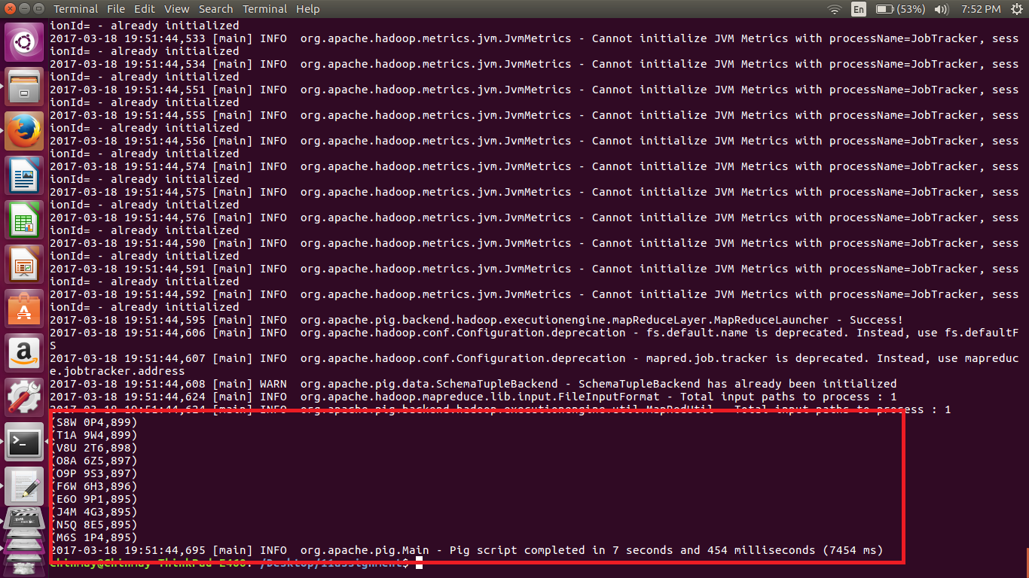

//Question 3

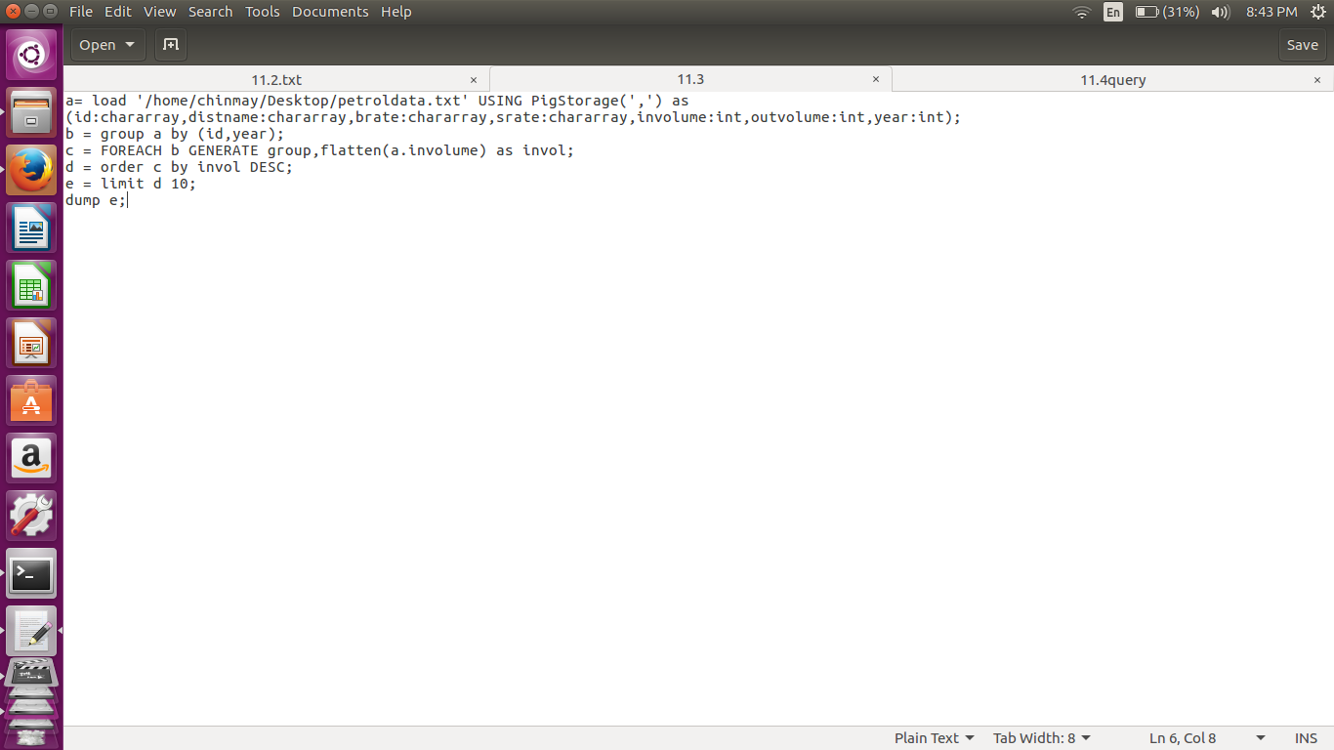

1. Group by id and year
2. Flatten the in volume
3. Order in descending order
4. Limit output to 10;

//implementation command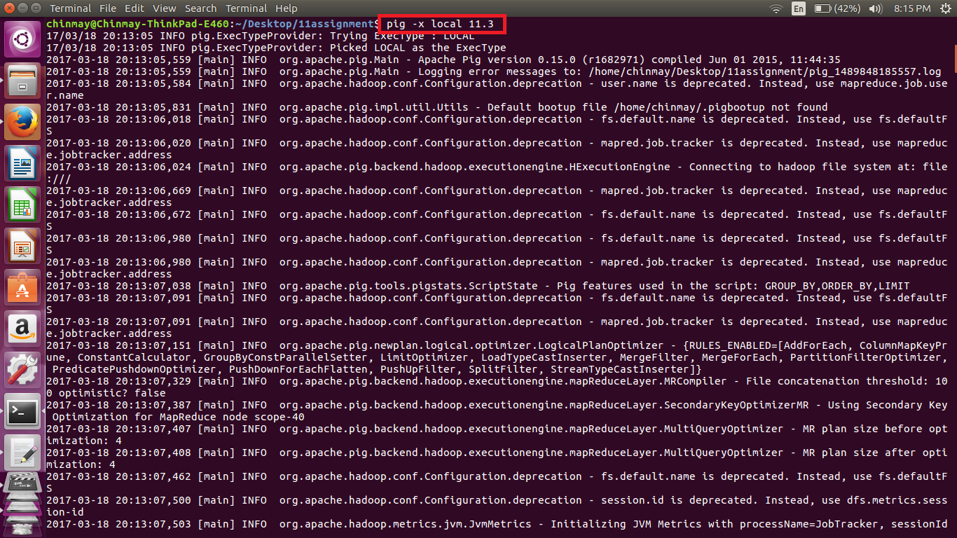

//output

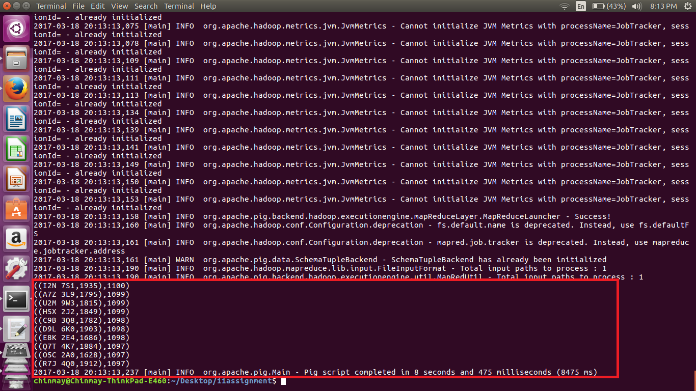

//Question 4

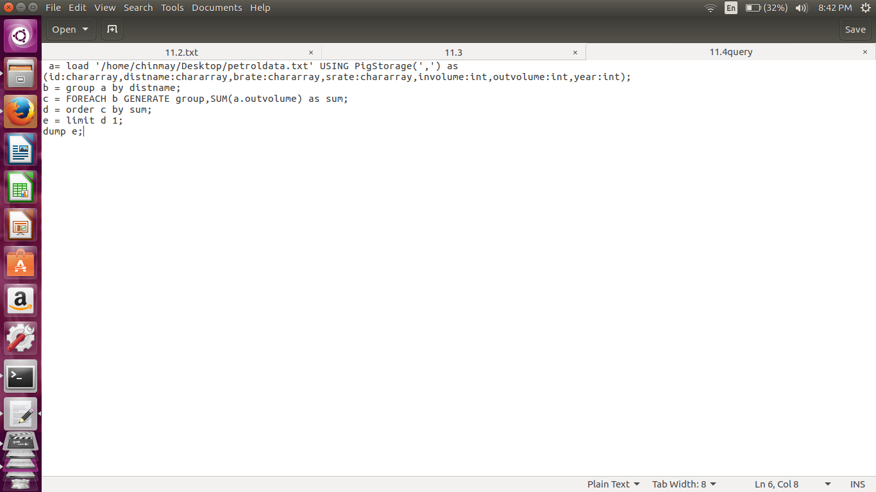

1) Group by Distributer name

2) Get the sum for each group

3) Order by sum in descending order

4)limit the output to 1

//implementation command

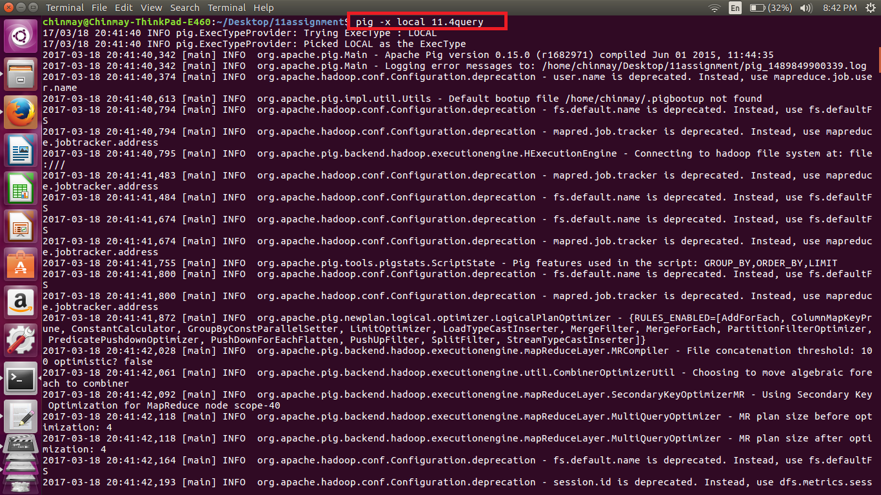

//output

