Write a Pig UDF To find the tweets posted by @realDonaldTrump from the given dataset. DATA SET DESCRIPTION Column 1 : id

Column 2 : handle

Column 3 : text

Column 4 : is_retweet

Column 5 : original_author

Column 6 : time

Column 7 : in_reply_to_screen_name

Column 8 : in_reply_to_status_id

Column 9 : in_reply_to_user_id

Column 10 : is_quote_status

Column 11 : lang

Column 12 : retweet_count

Column 13 : favorite_count

Column 14 : Longitude

Column 15 : Latitude

Column 16 : Place_id

Column 17 : Place_full_name

Column 18 : Place_name

Column 19 : Place_type

Column 20 : Place_country_code

Column 21 : Place_country

Column 22 : Place_contained_within

Column 23 : Place_attributes

Column 24 : Place_bounding_box

Column 25 : Source_url

Column 26 : Truncated

//udf code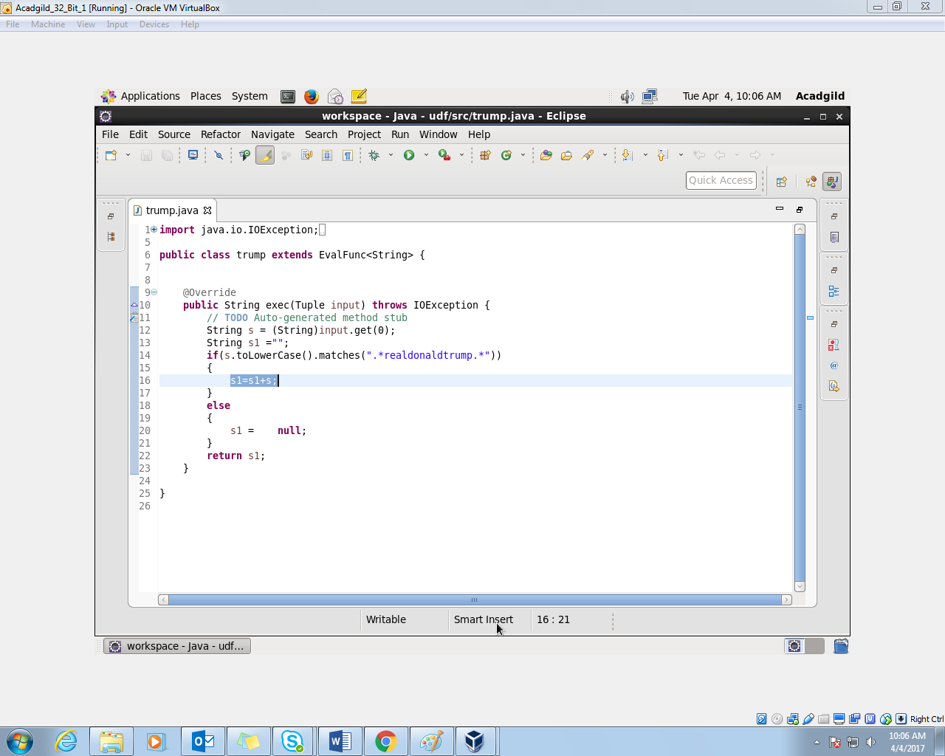

//Pig script

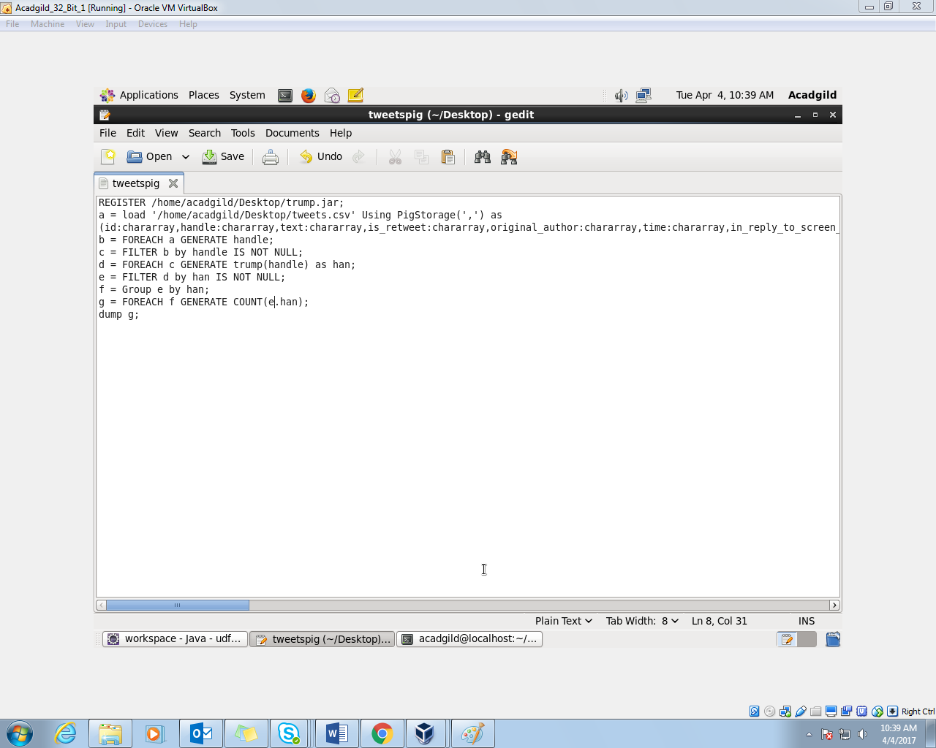

//implementation

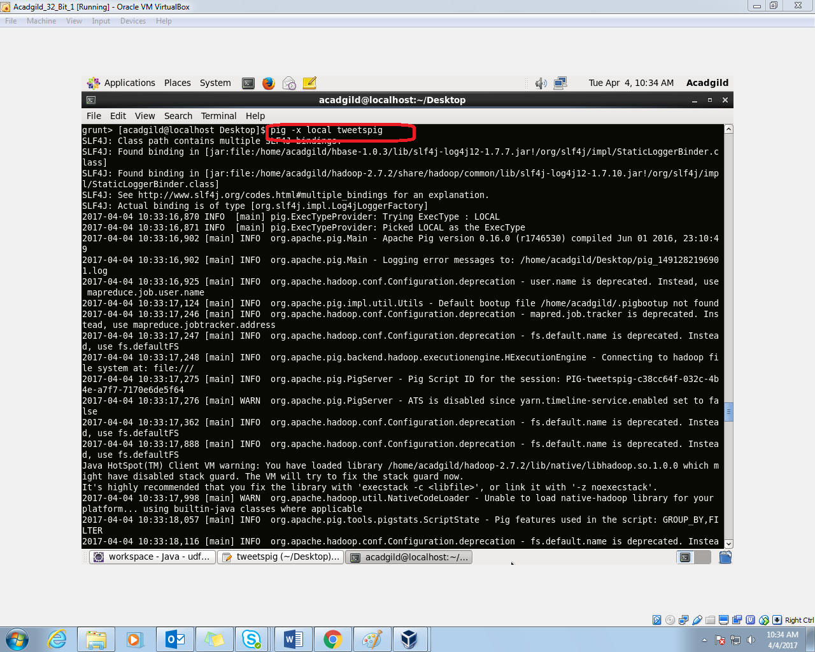

//output

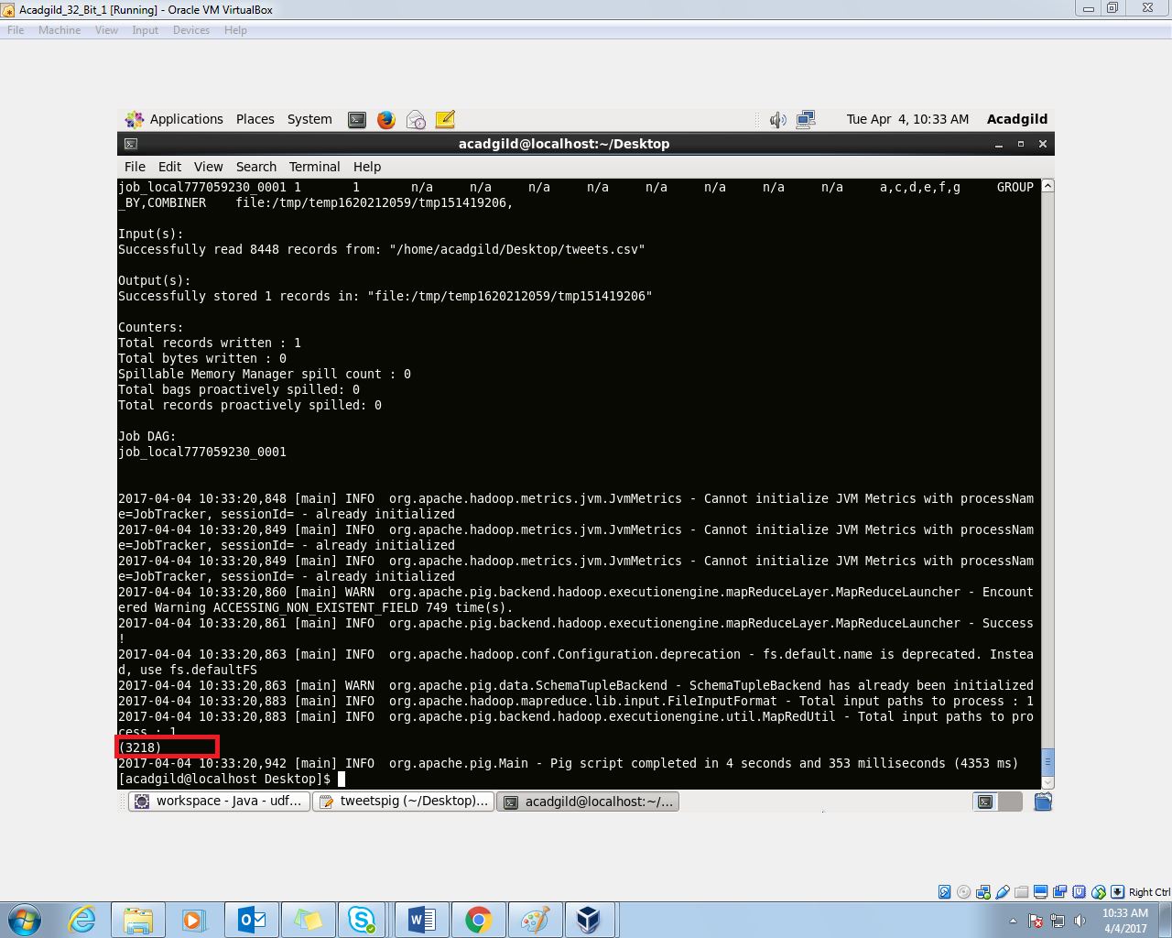

Number of Tweets by Donald Trump are - 3218