1.Find the top five kinds of GoogleKnowlege_Occupation people who were guests in the show, in a particular time period i.e., between '1/11/99' and 6/11/99. You need to write an UDF to compare the dates.

//UDF

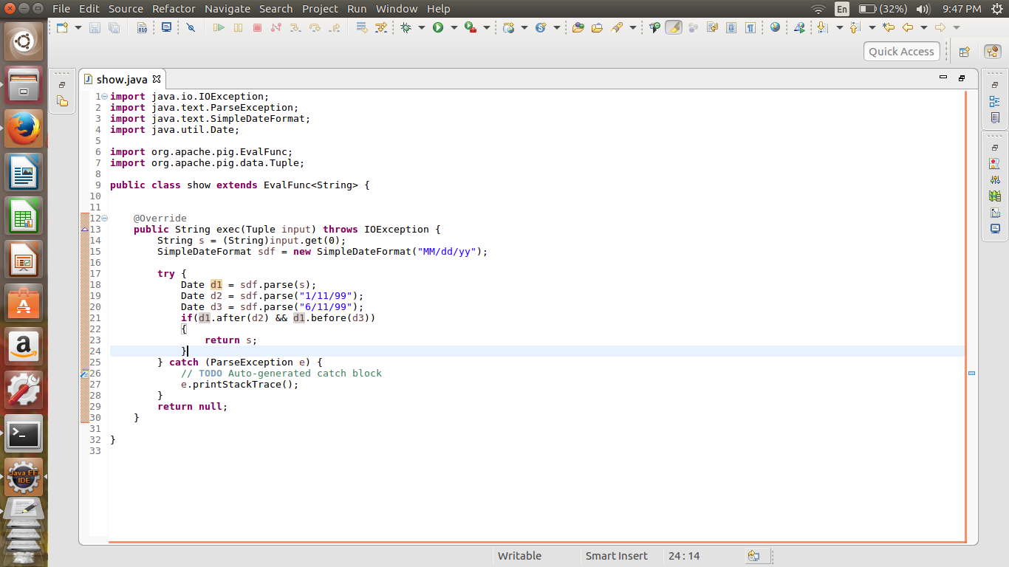

//Pig Script

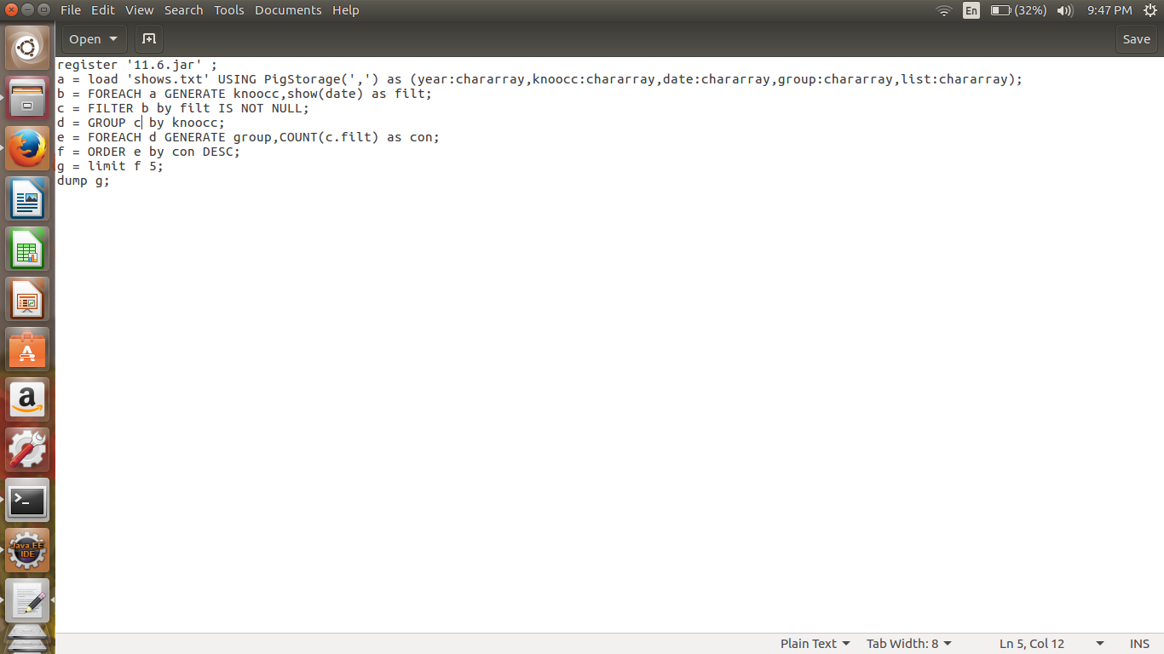

First filter using the udf function

The filter by not null condition

Group by Google occupation

Generate the count for each group

Order and limit by 5 to get the top 5;

//Implementation

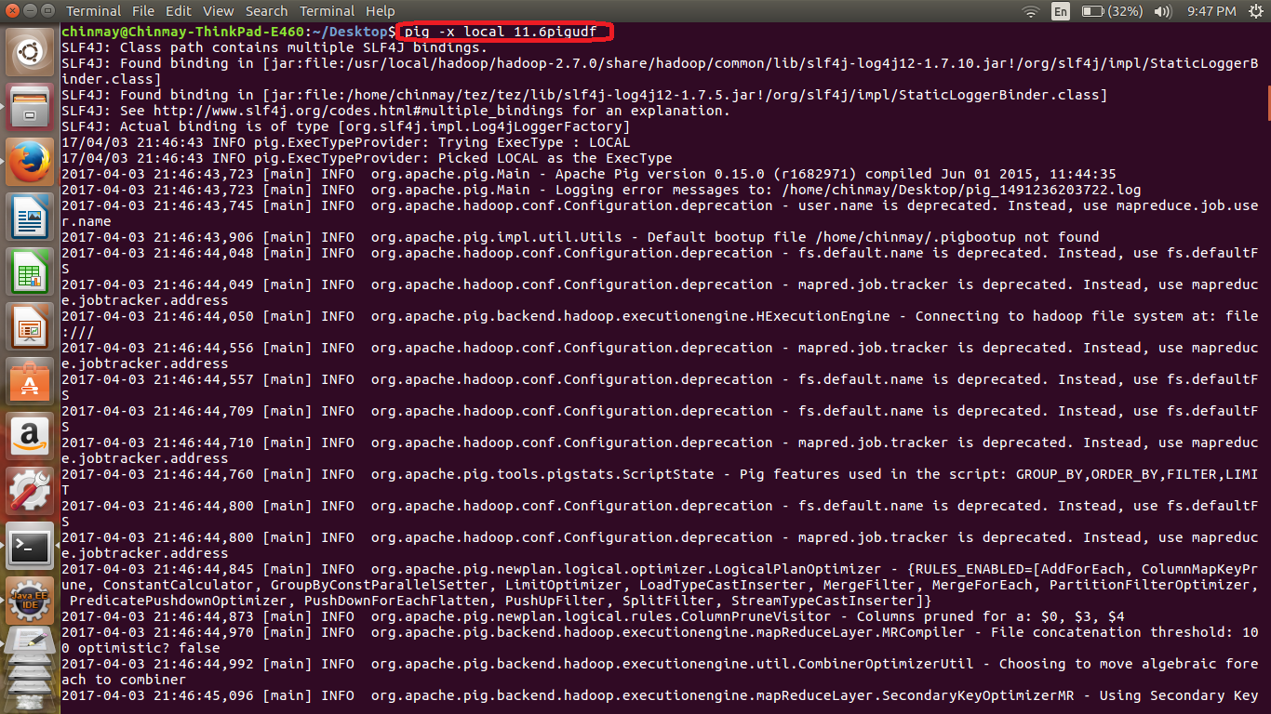

//output

