Perform wordcount operation in local mode .Share the code, explain the execution steps, and attach the output screenshot

//code

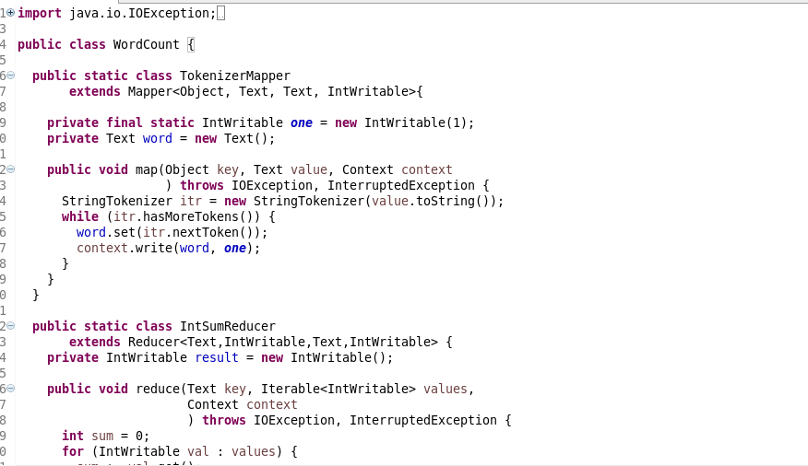

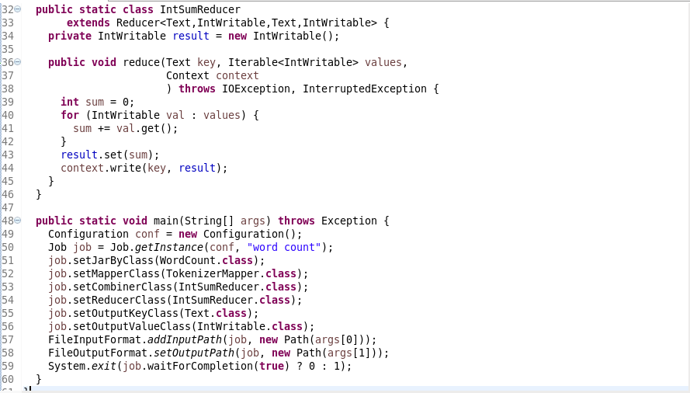

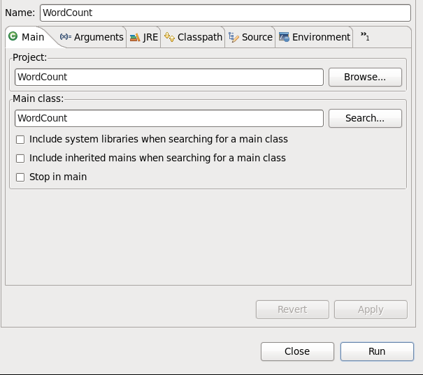

While executing in local mode one has to run the code as configurations.

And set the main class the project name etc.

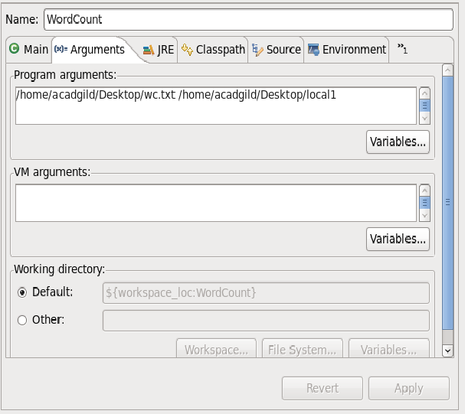

Here we are setting the input and output paths as the arguments.

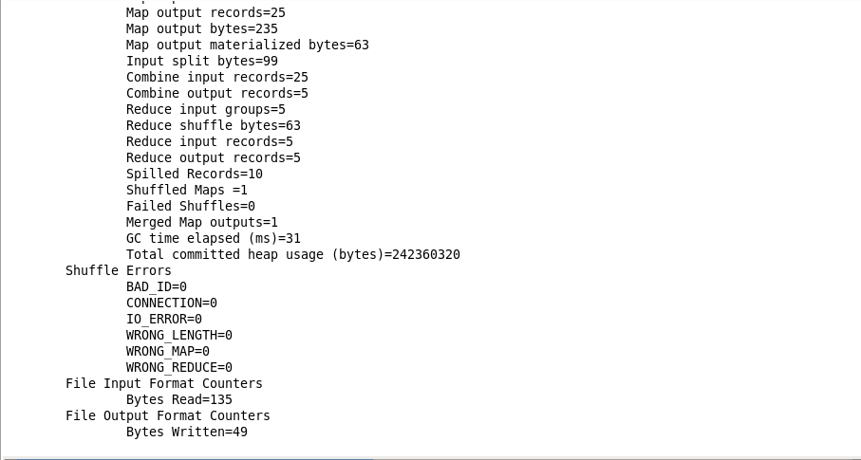

How shows the execution completion

//input

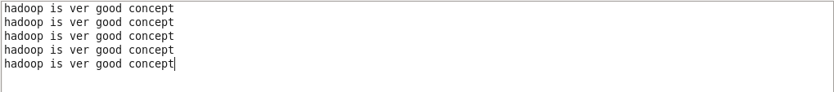

//output

