Execute Session 16 - Assignment 1 (Machine and Sensor data analysis) using Reduce side join and compare which join is faster in normal conditions.

//Driver class

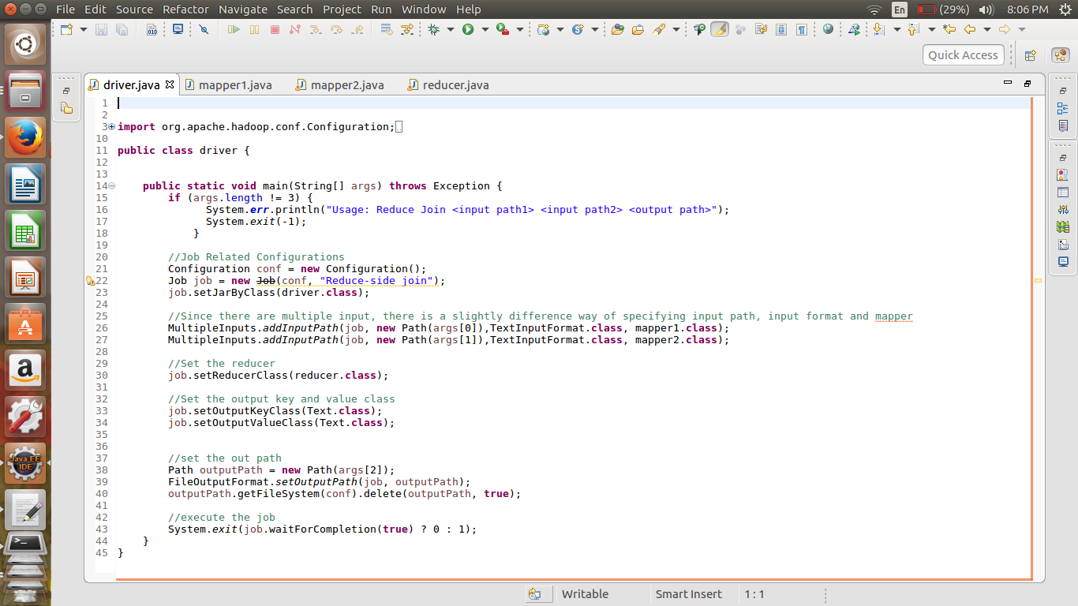

For taking inputs from different files multiple inputs are taken.

//Mapper Class

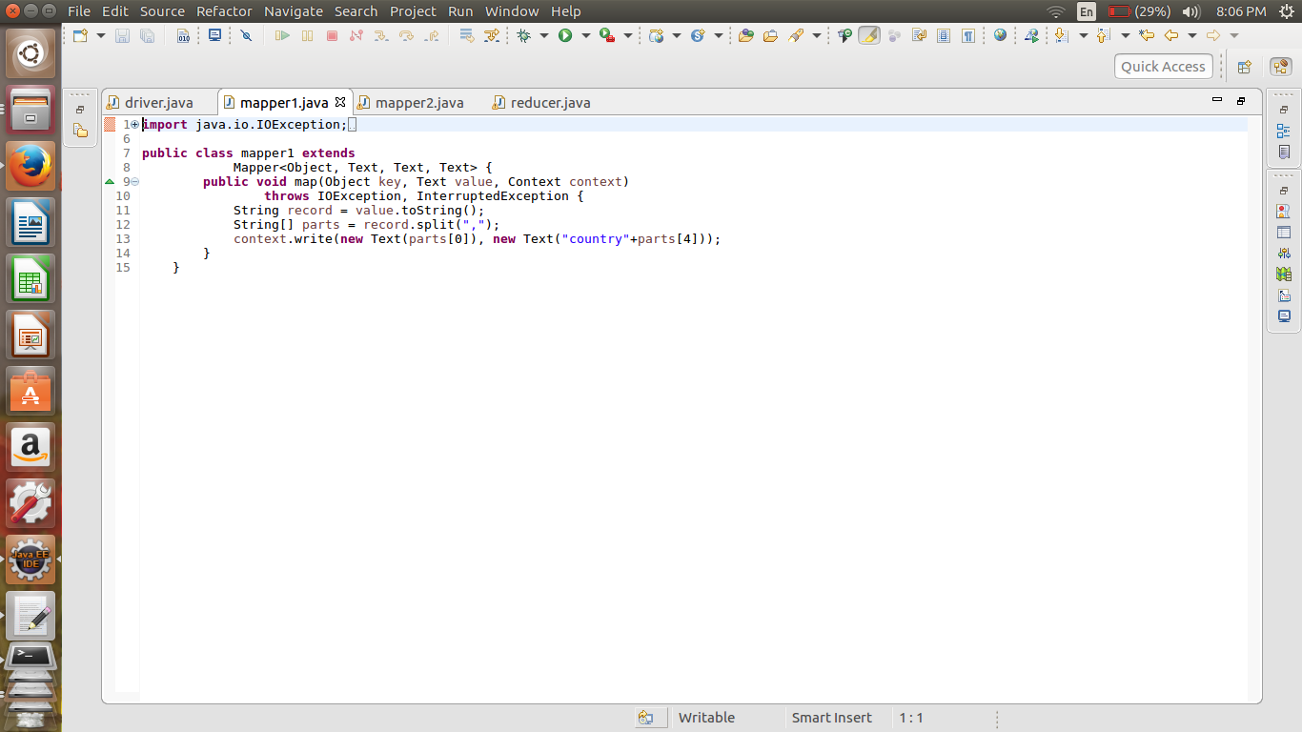

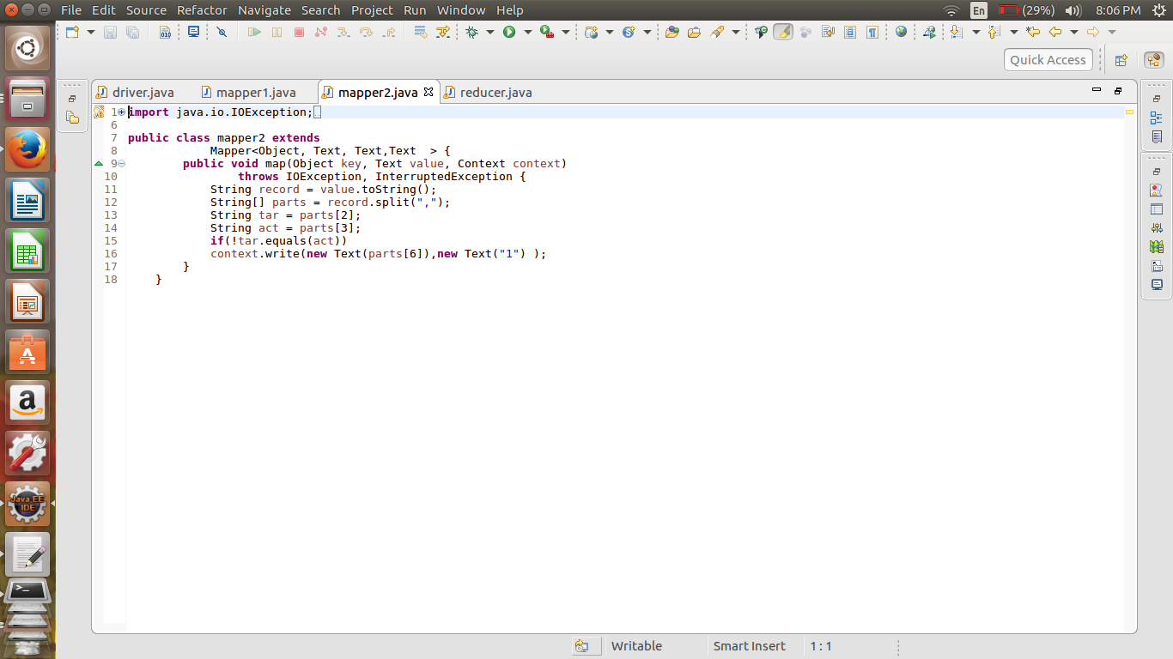

Here passing the same parameter as the key by both the mapper.

//reducer class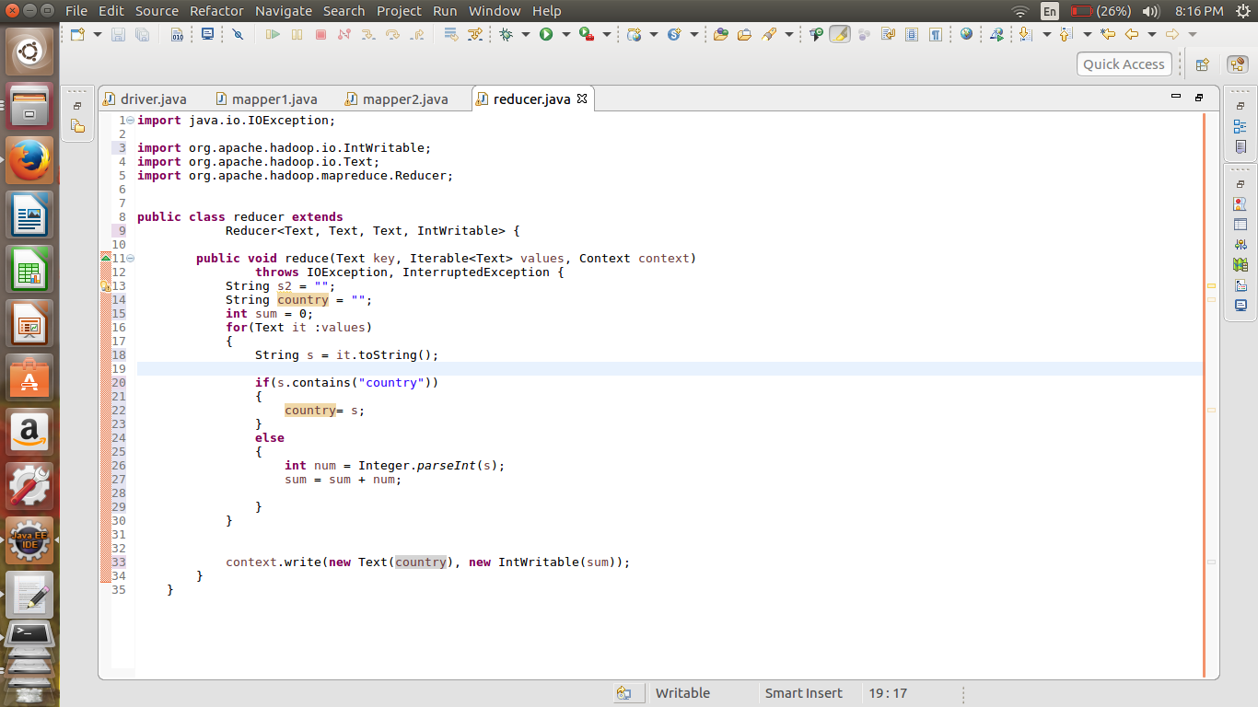

In the reducer we are passing the country as the key and summing up the temperature variations.

Reduce side join is performed in the above example.

//output

