Write a program that accepts the job_id as argument and returns a custom counter and a system counter (total records input to the map tasks) associated with that job.

//driver class for word count

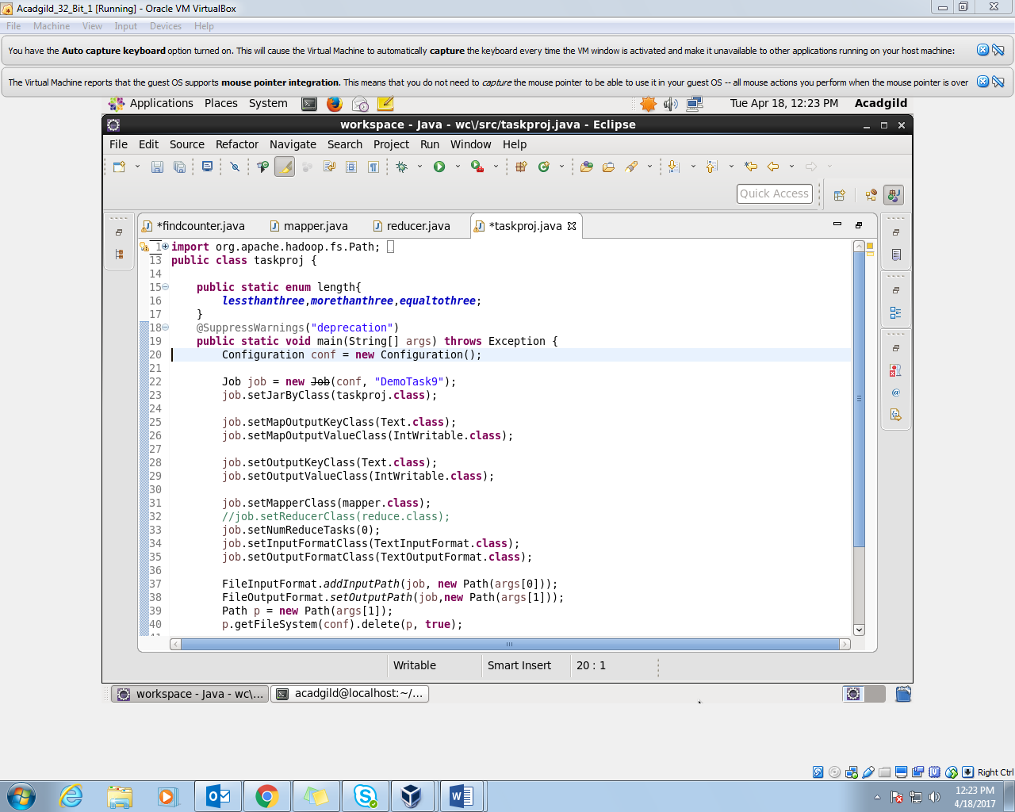

//mapper

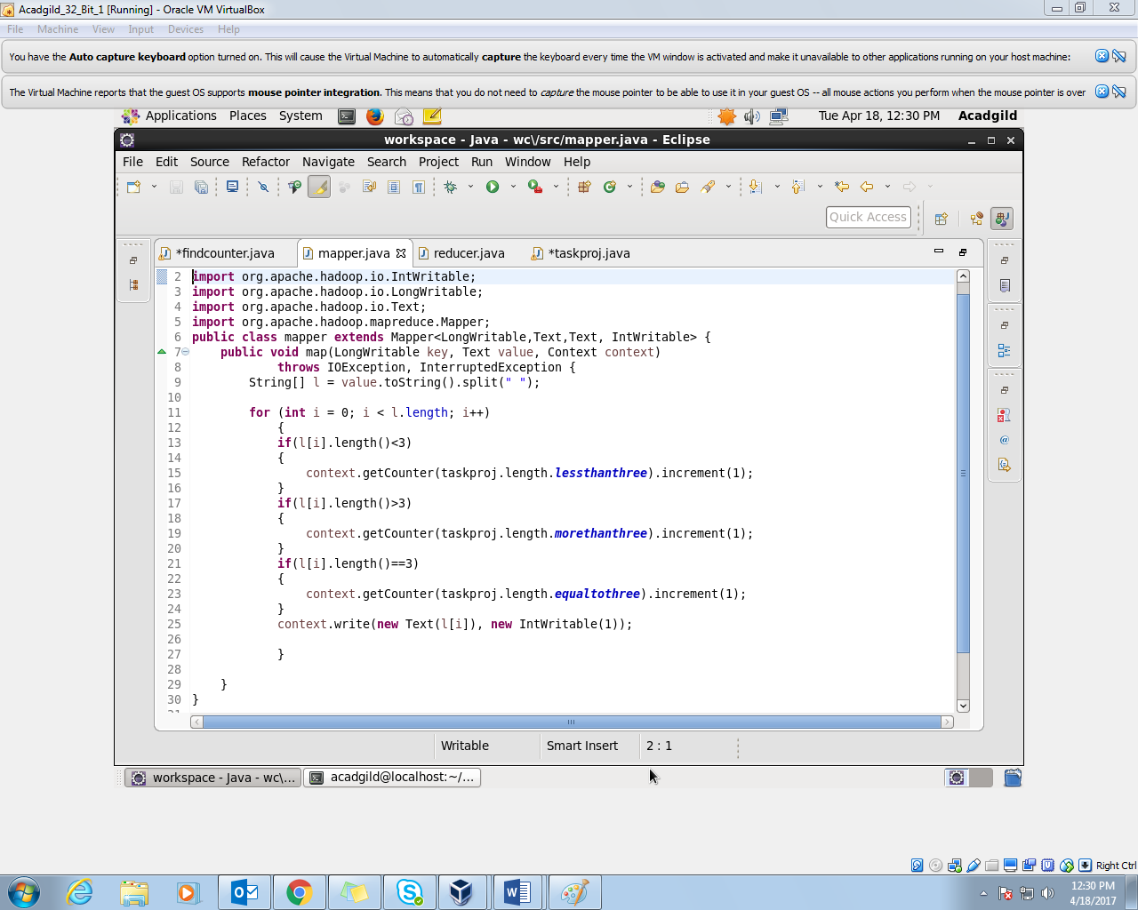

Here we have incremented the counter if the length of the word is equal to three or greater than three etc.

//reducer

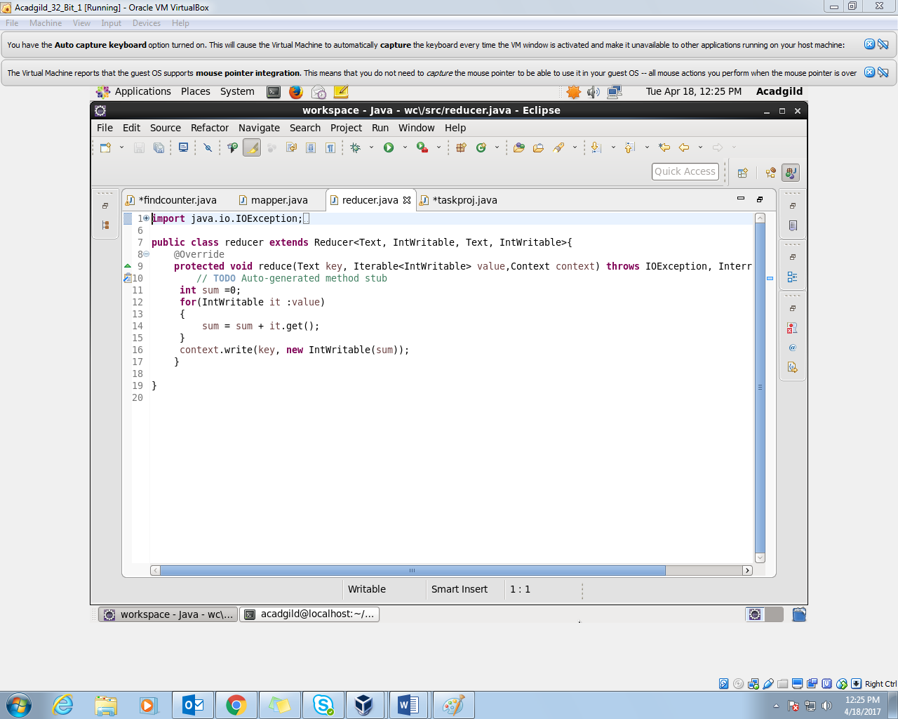

Here summing up all the occurrences of the word and generating the word count.

//job counter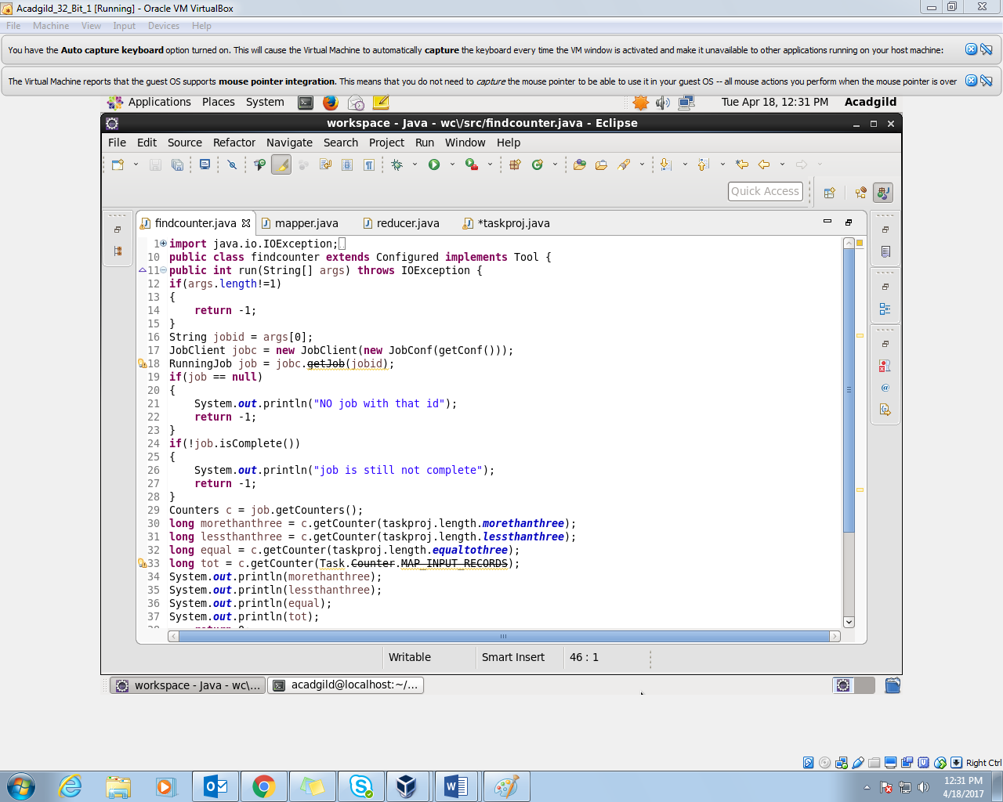

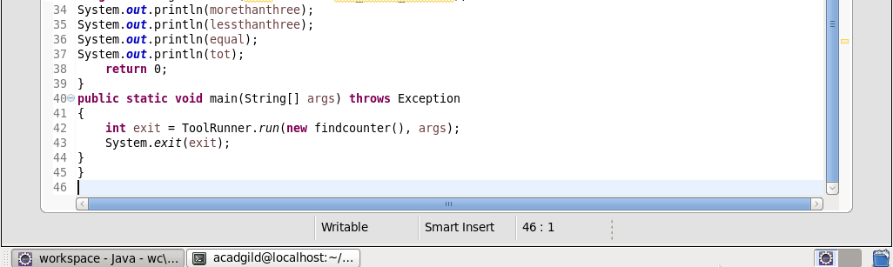

In this job we getting the job as the user input and checking if the job exists and if exists then checking if the job is completed or not and getting the custom counters as well as the task counter and displaying it.

//implementation

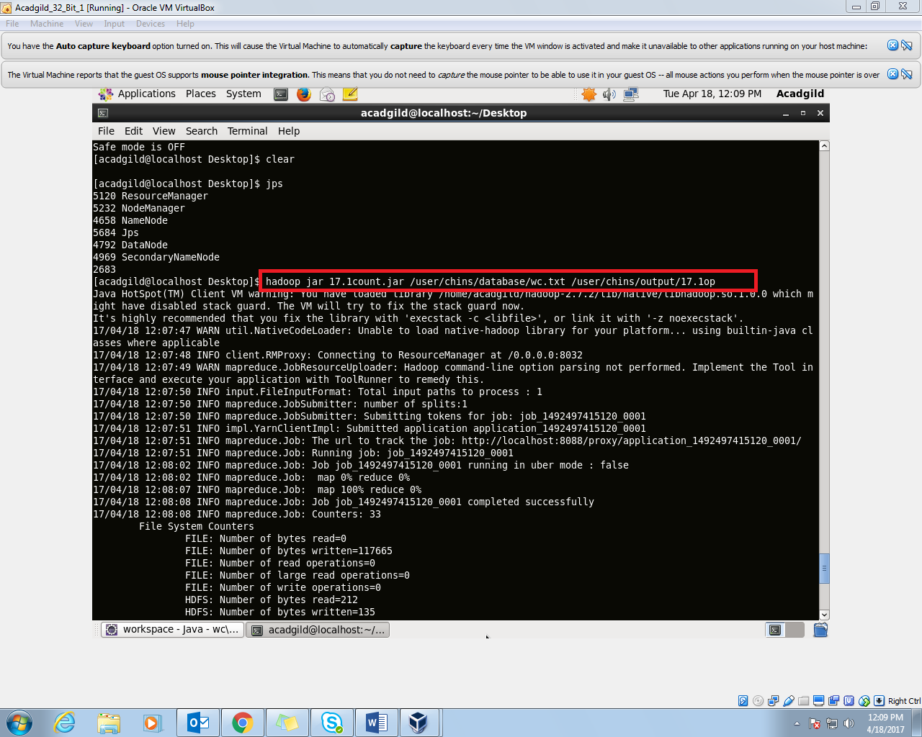

//output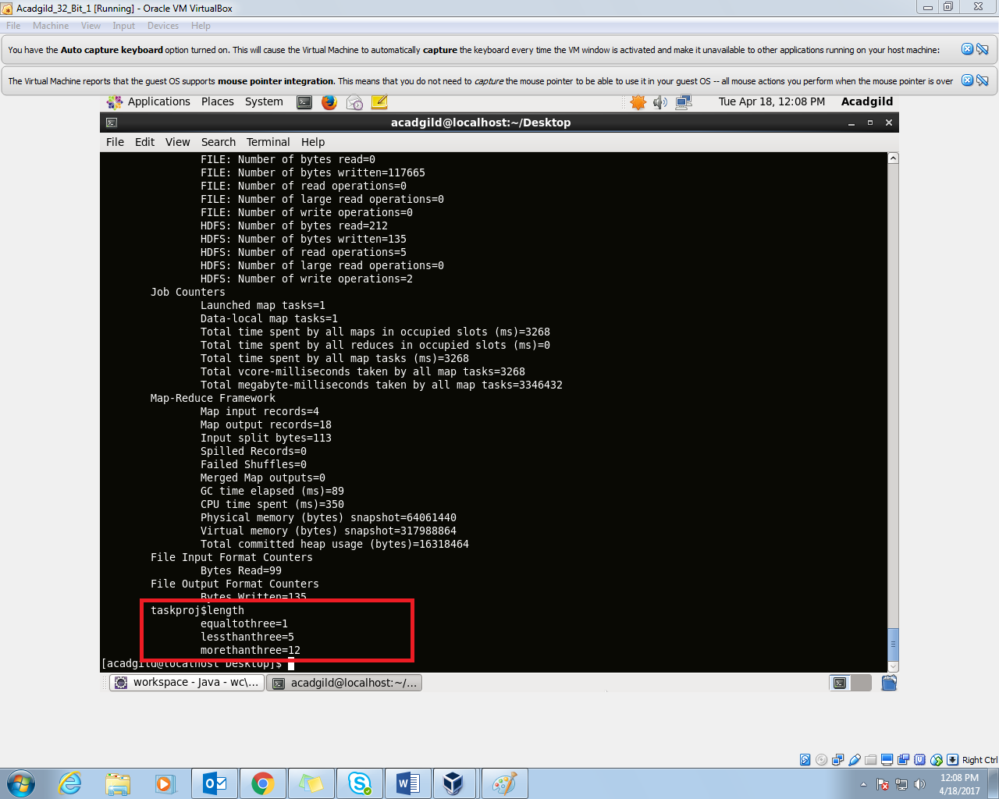

This output is where the custom counter is generated .

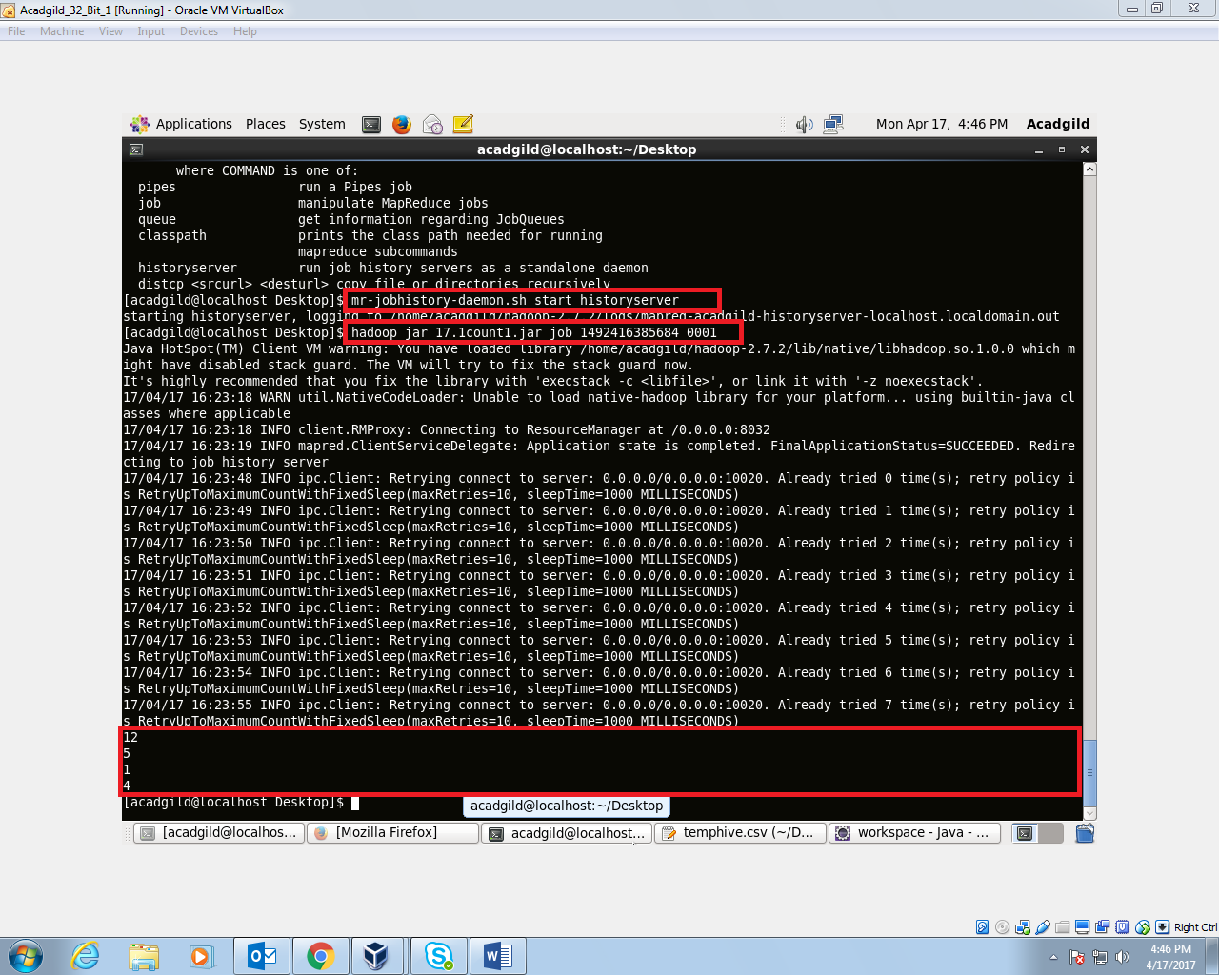

Here we are starting the history server and then taking the job id as the input argument and we can see that counters values are the same.