Question 1 - Run a map only job on the word count program using static configurations.

//driver

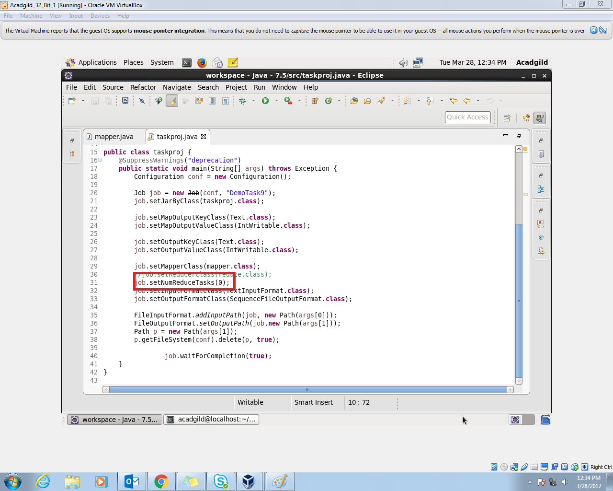

Made the number of reduce tasks to zero. Hence map only job .

// mapper

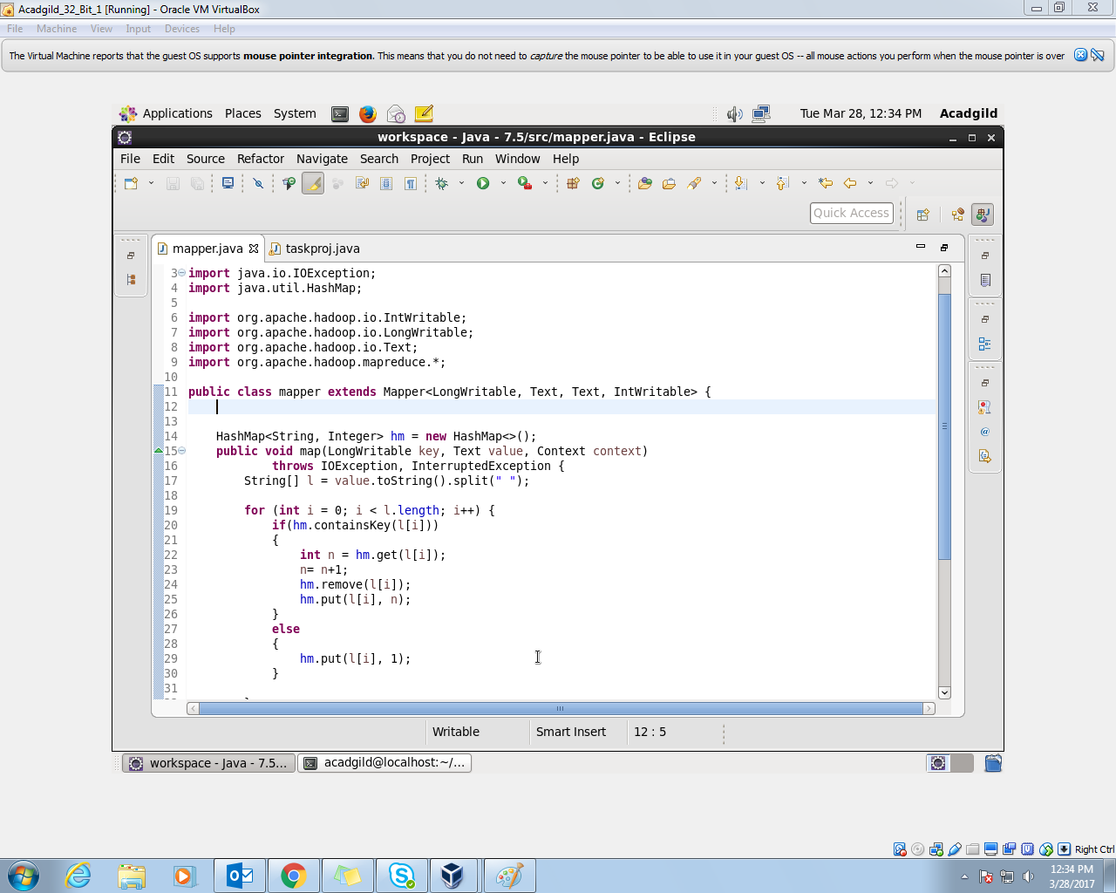

First Stored all the values of the words in hash map, then updated the hash map as the occurrences kept on increasing. If the word occurred for the first time then inserted the word as the key and value as one. Then using cleanup method key and value written into the context.

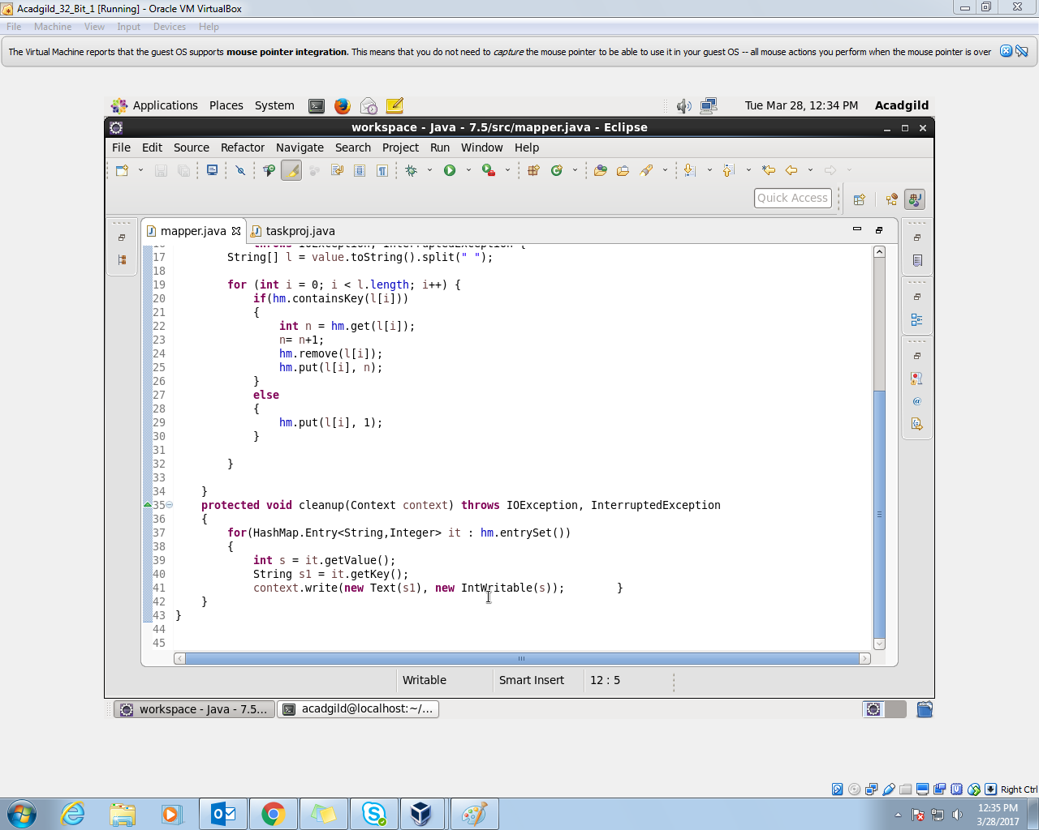

//implementation

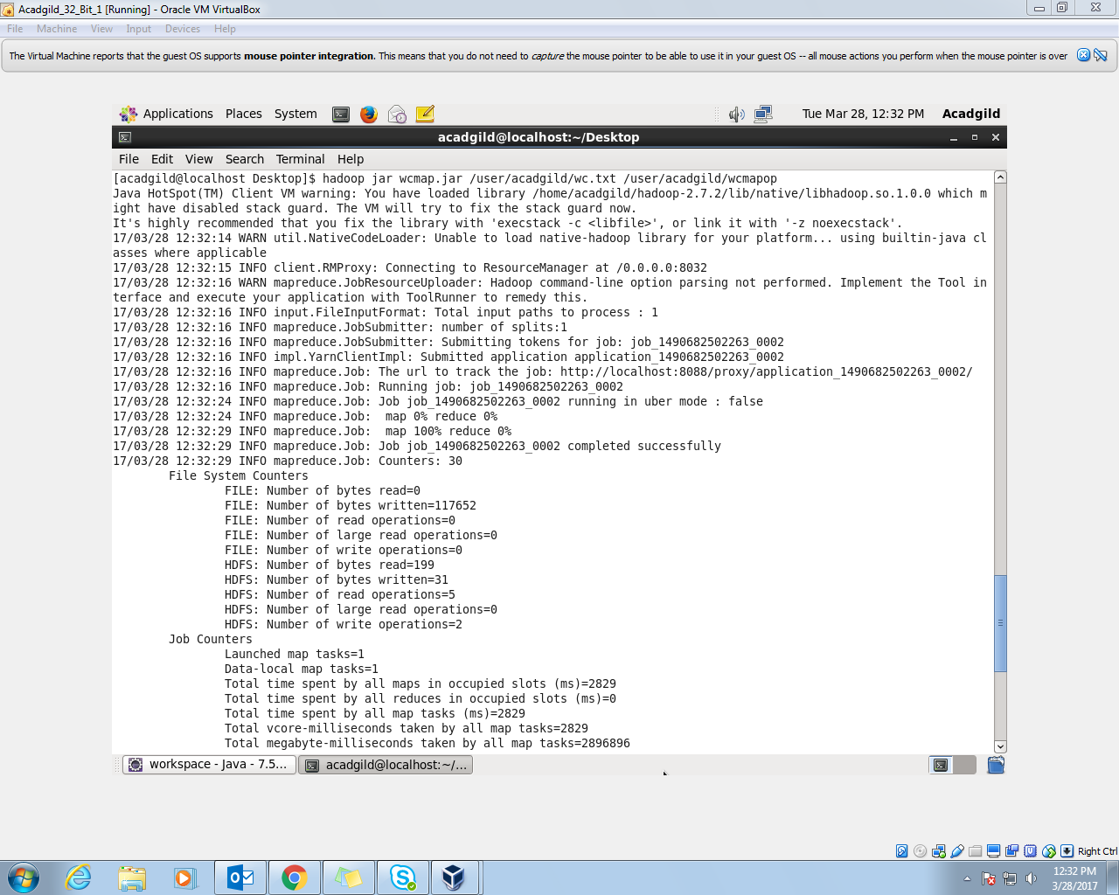

//dataset

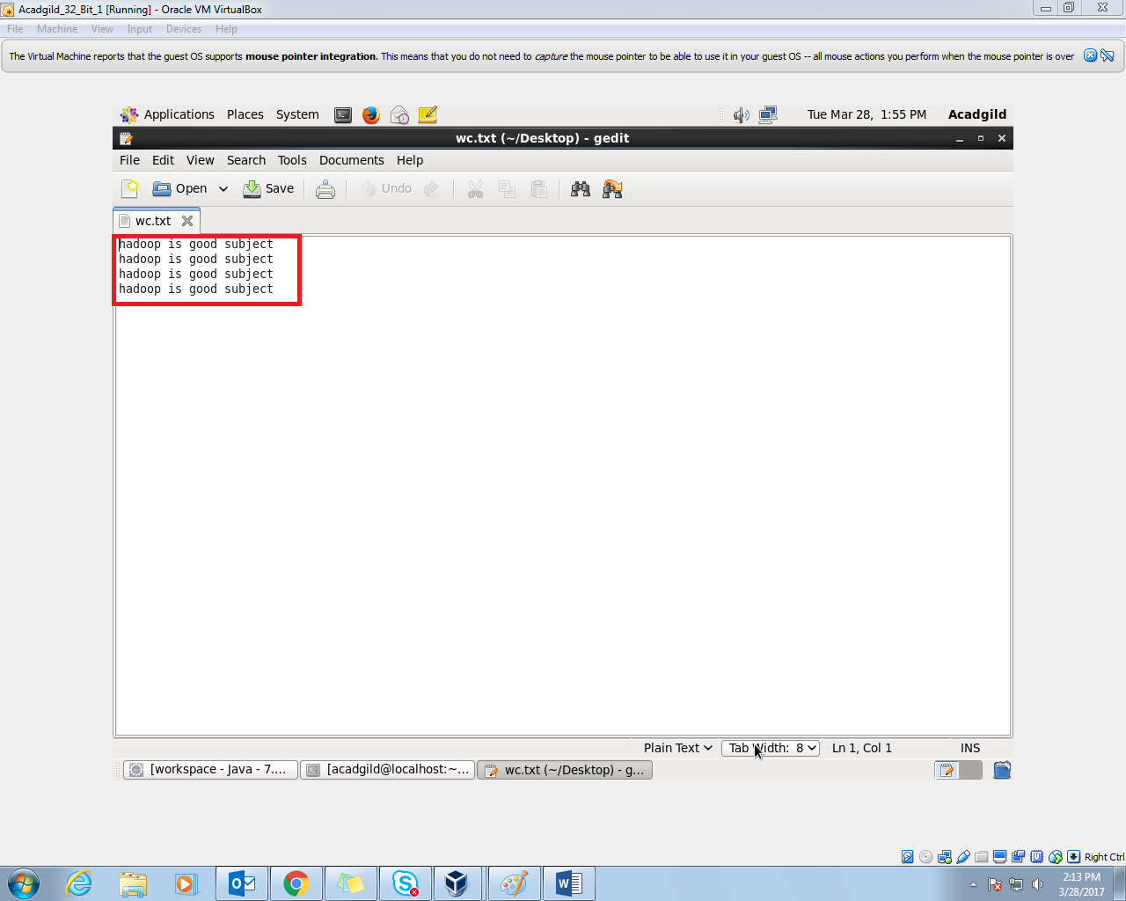

//output

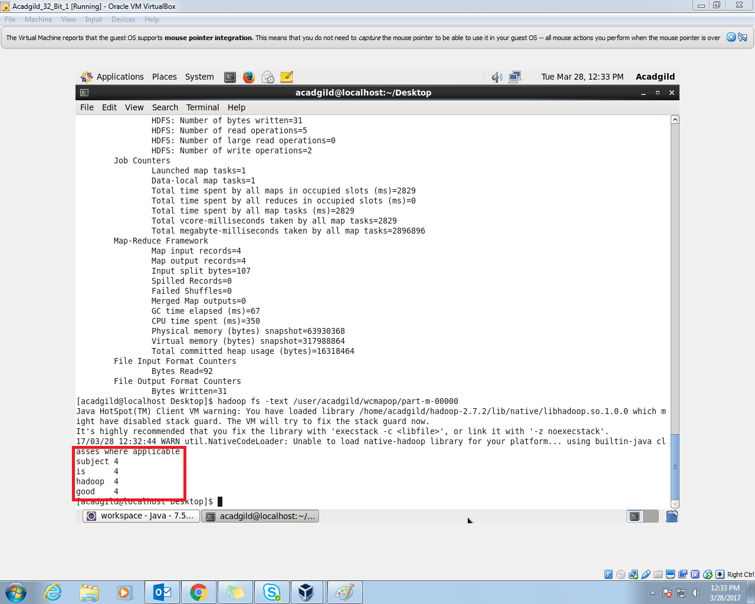

//Driver class

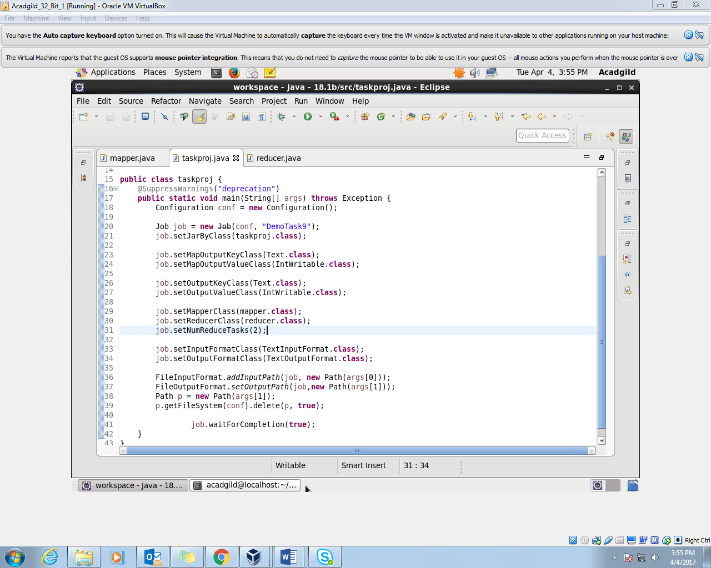

Question 2- Run the mapreduce word count program and set the number of reducers to 2 using static configurations.

//mapper class

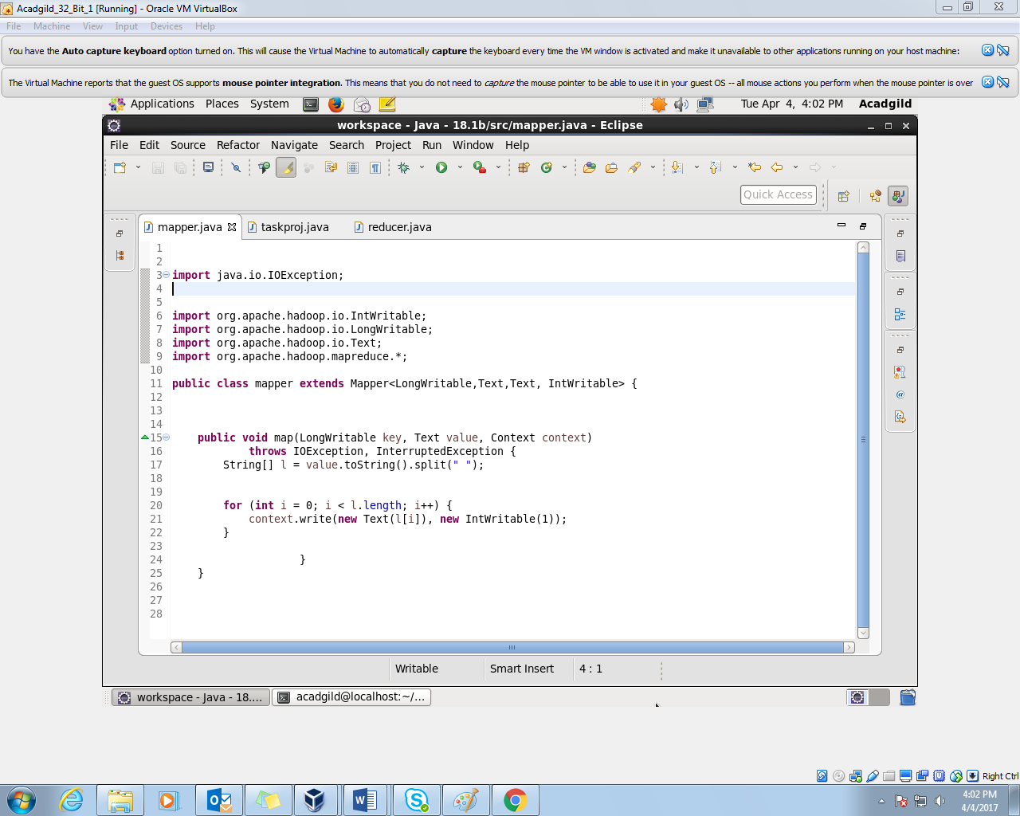

//reducer

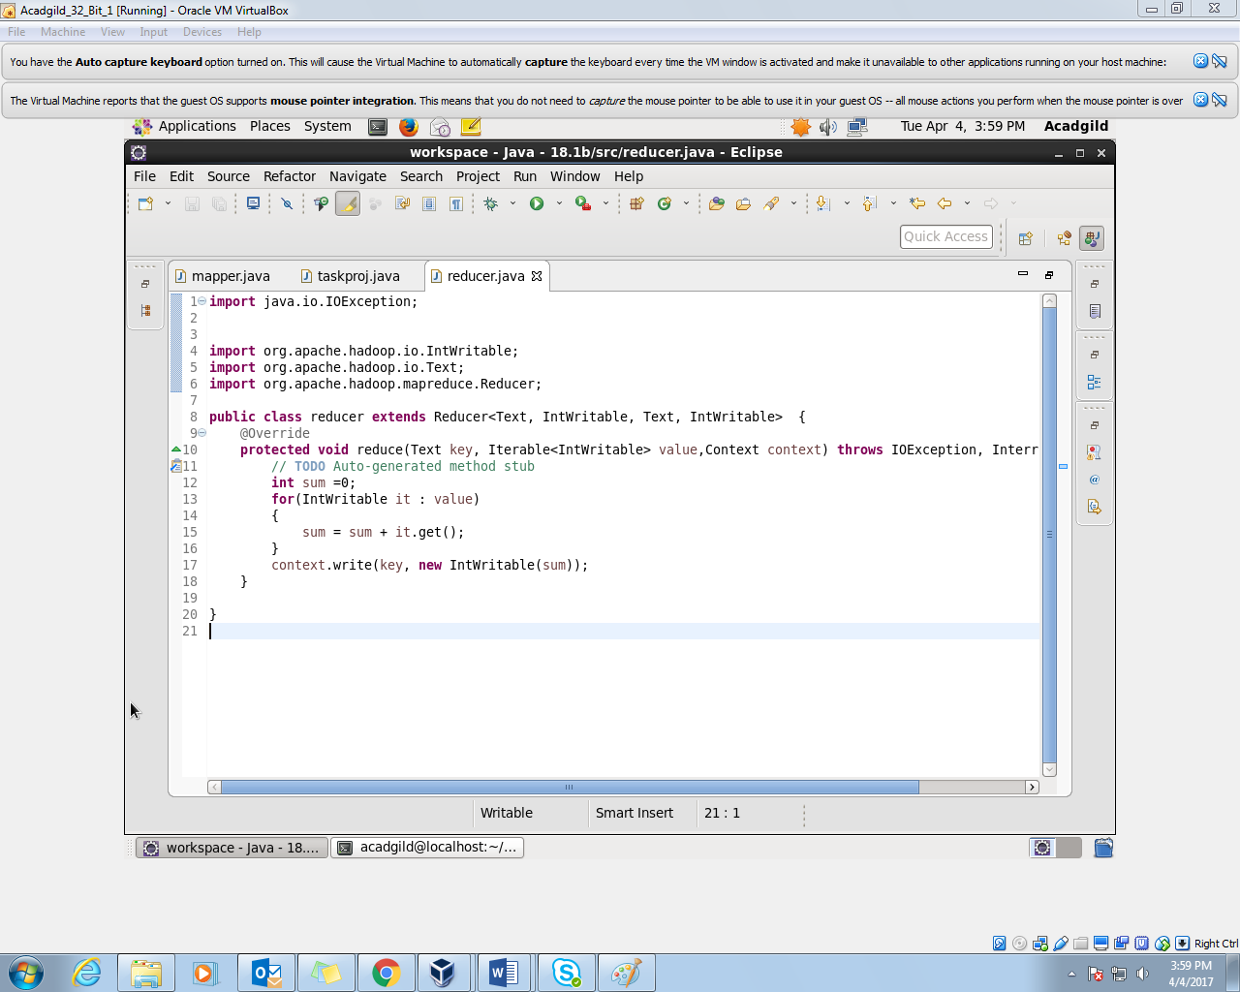

//input file

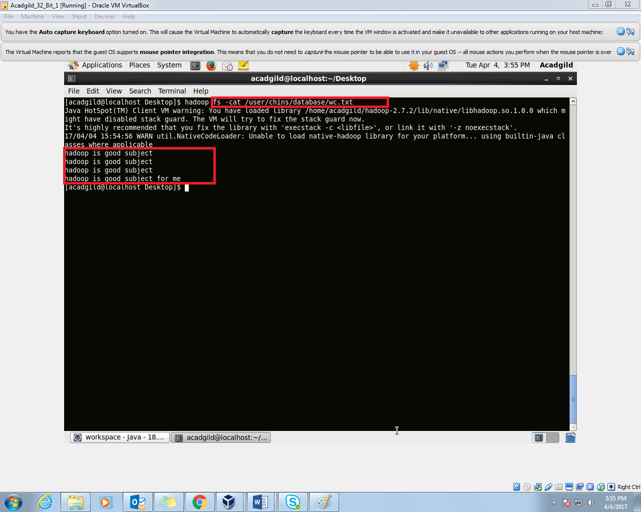

//output file

