1: Find out the top 10 destination people travel the most: Based on the given data, we can find the most popular destination that people travel frequently. There are many destinations out of which we will find only first 20, based on trips booked for particular destinations.

//mapper class

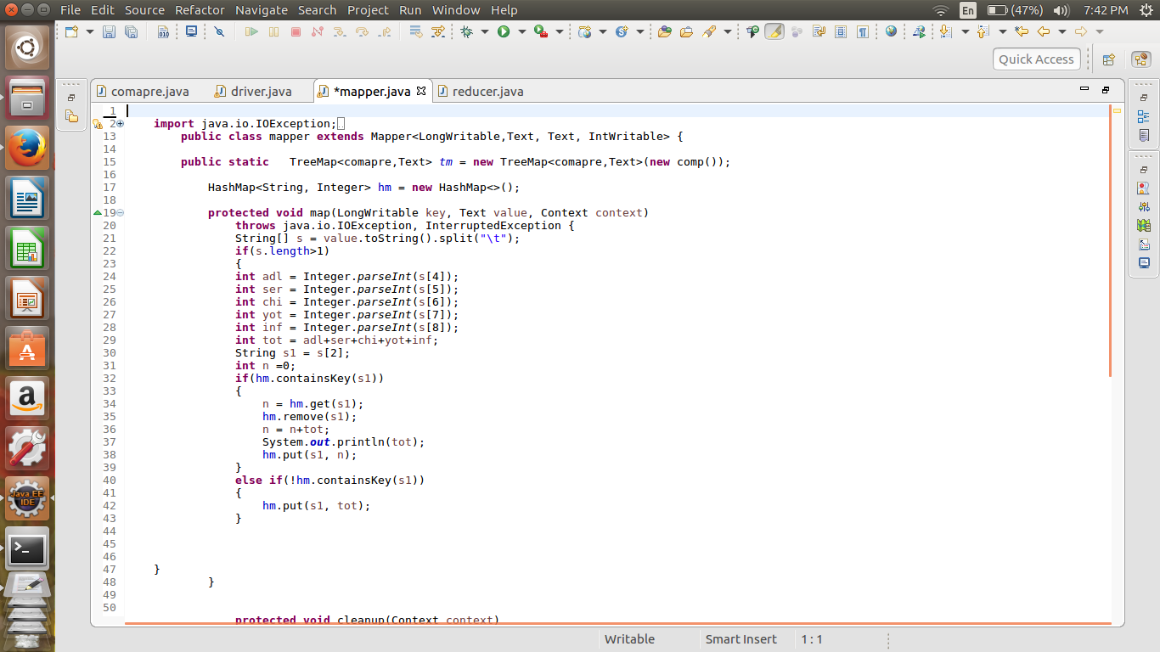

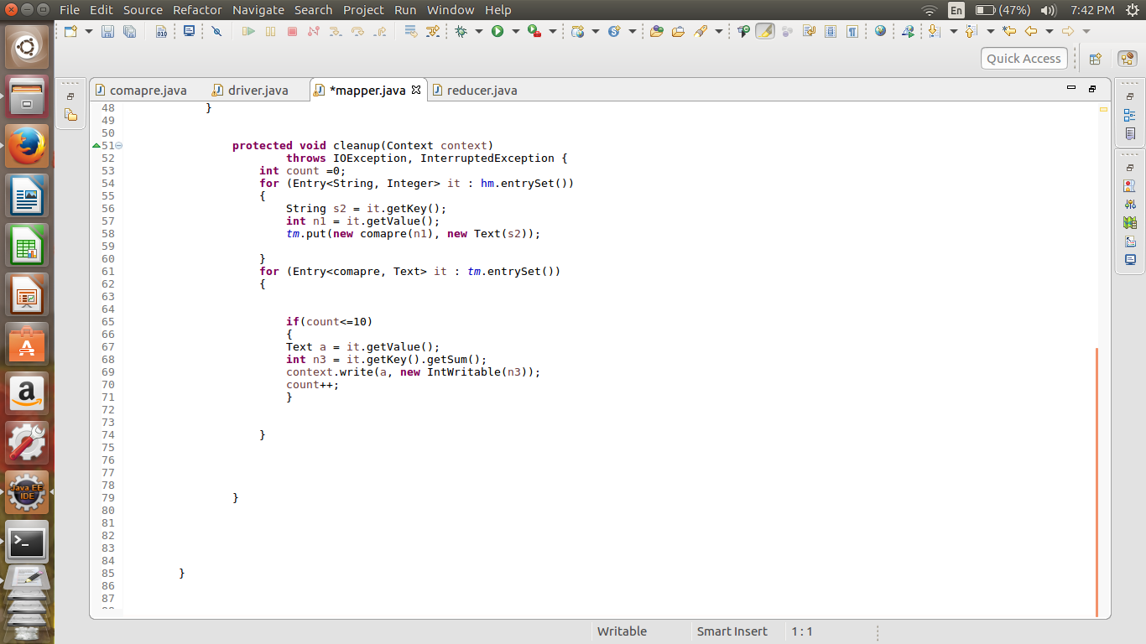

// reducer job

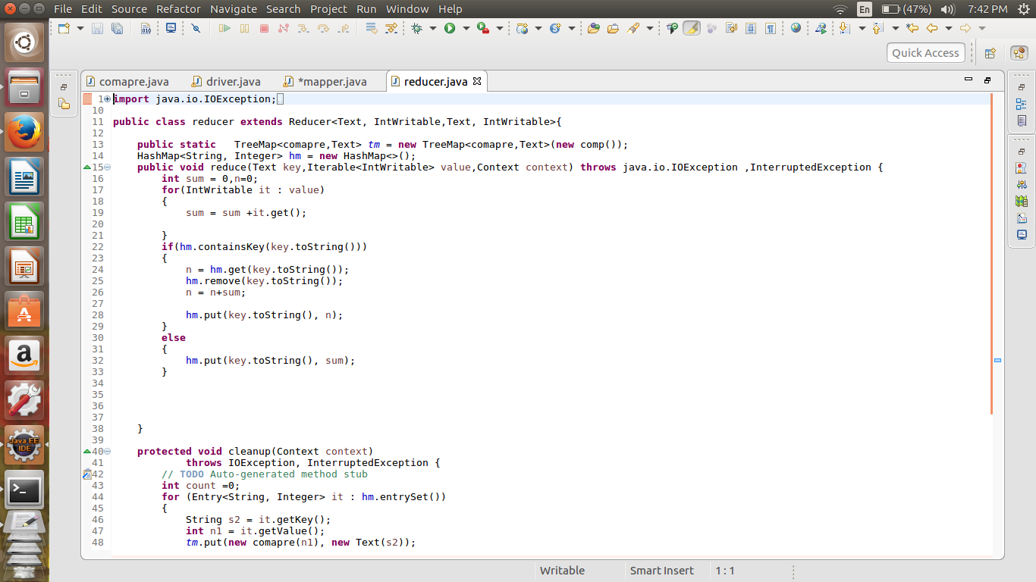

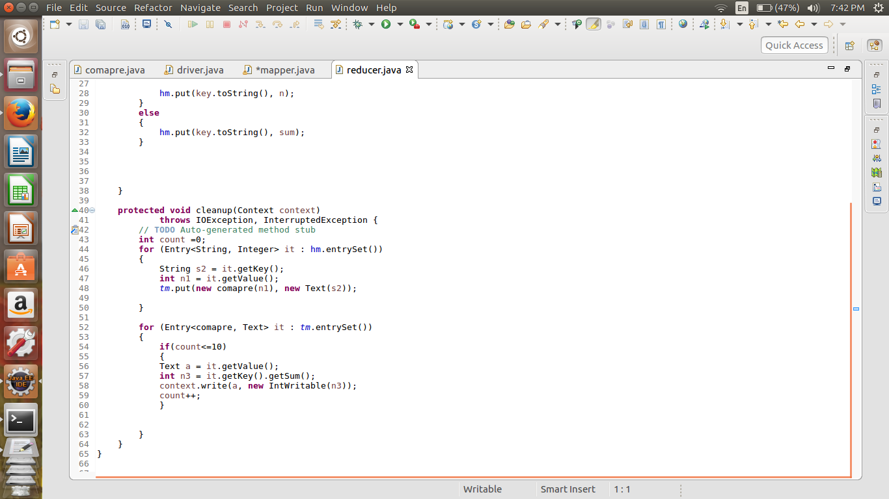

//comparator

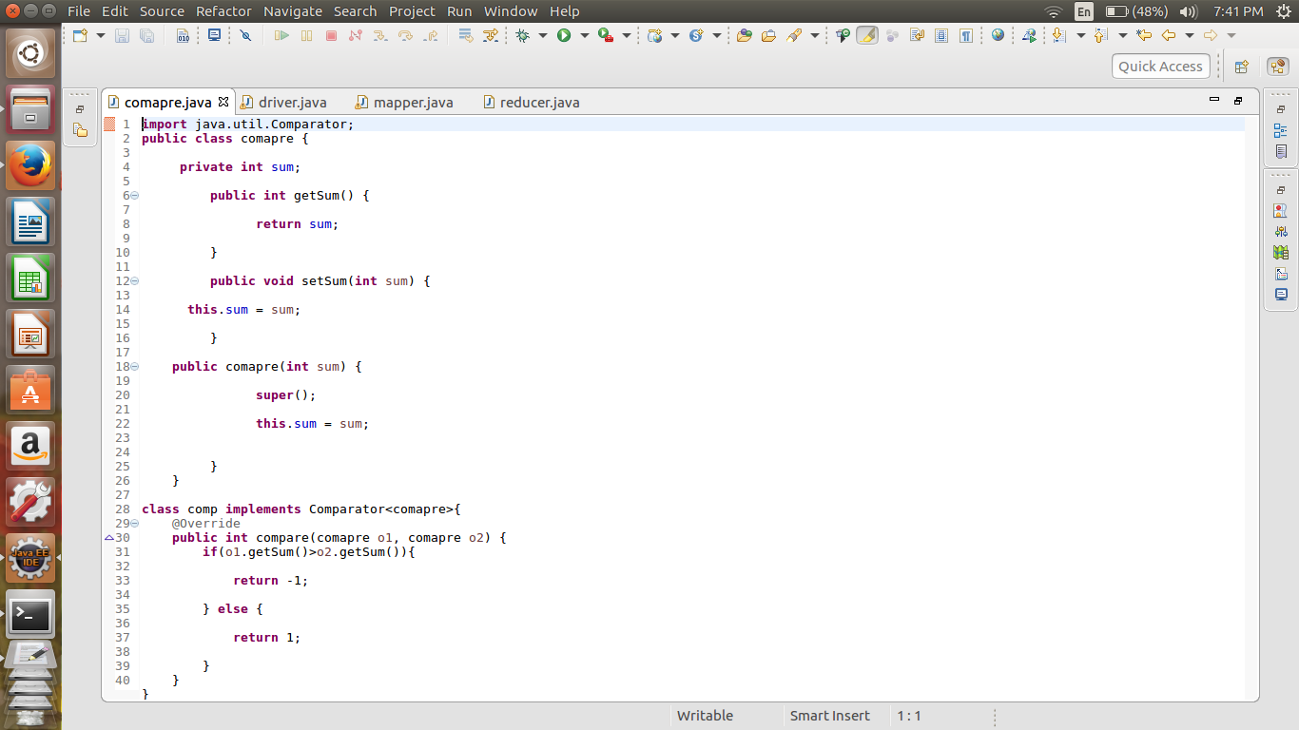

//output

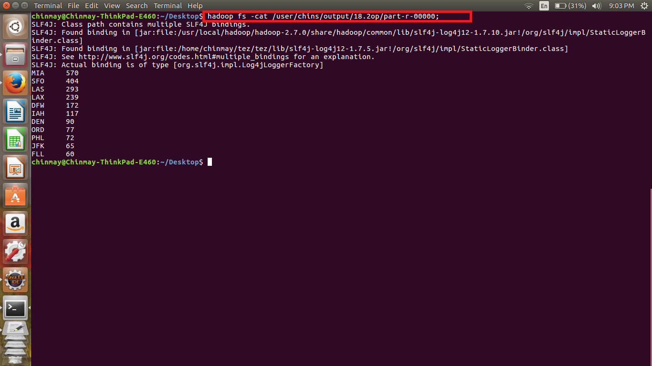

In the Mapper first storing all the values of single key and the no of people going to each key in the hash map then finding out the maximum 10 out of it.

In the reducer again we will do the similar process to get the top 10 values from all the mapper class.

For getting the top 10 values we are using the tree map.