Calculate the number of employees corresponding to each skill from the table 'employee' which is loaded in the Demo.

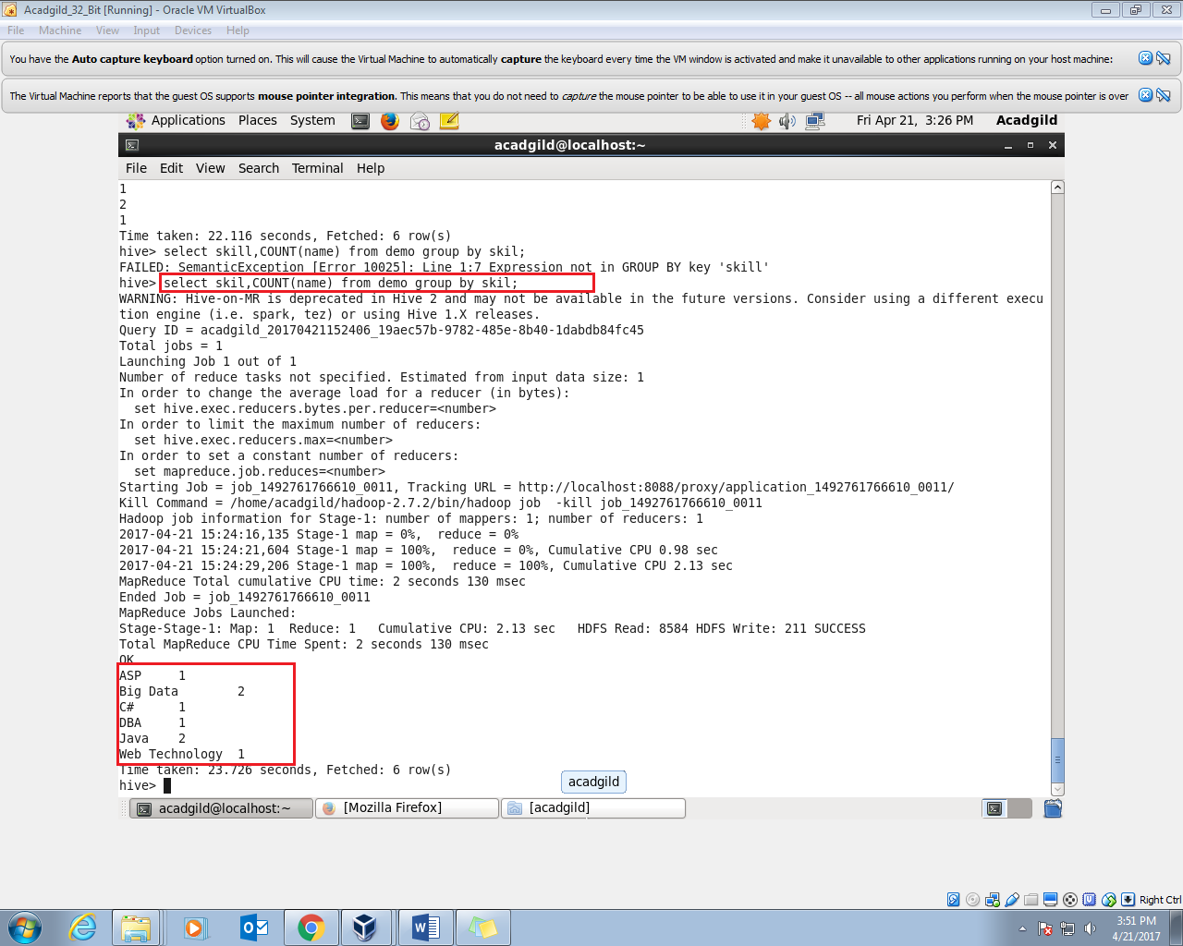

Here I am displaying the skill and the count of name in each skill as grouping it by the skill;