1.Write a hive query find the average age of male and female persons died in the titanic tragedy

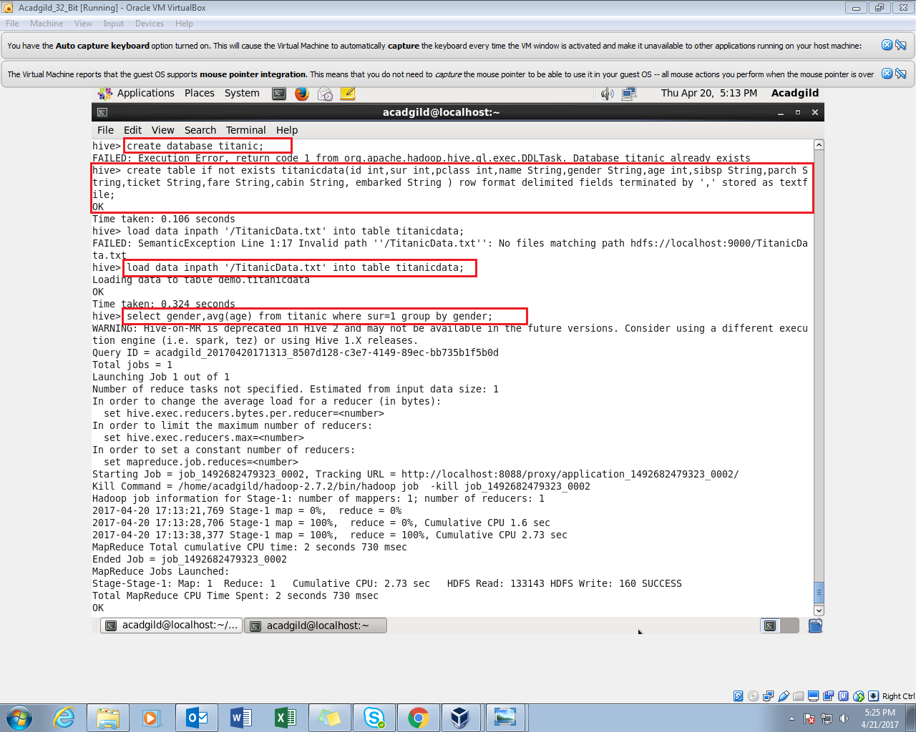

1. Created the database titanic

2. Created the table titanicdata with the respective data fields in the comma delimited format.

3. Loaded the titanic data in to the table.

4. Displaying the gender, and the avg age where survived is kept one and grouped by gender.

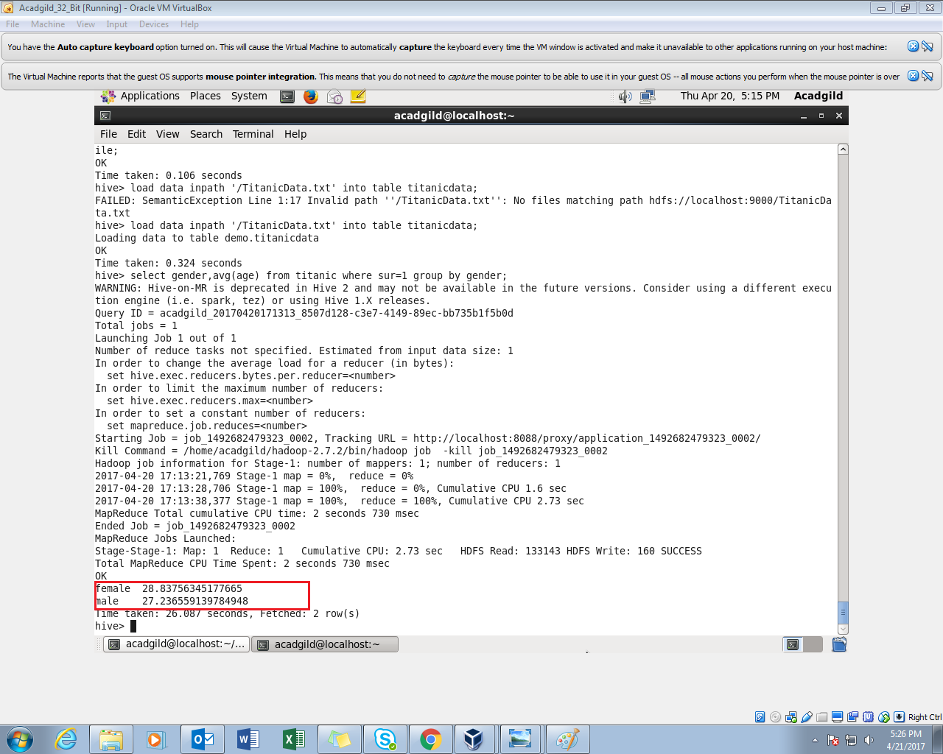

2.Write a hive query to find the number of people died and survived in each class

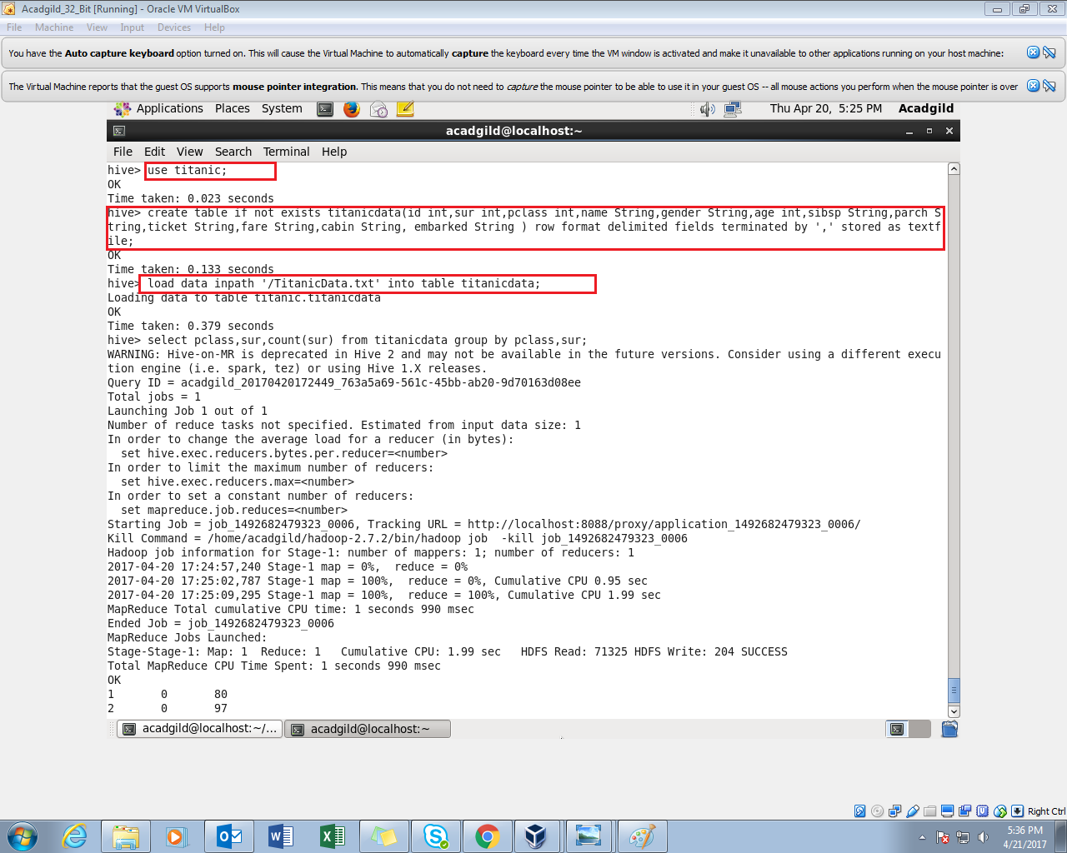

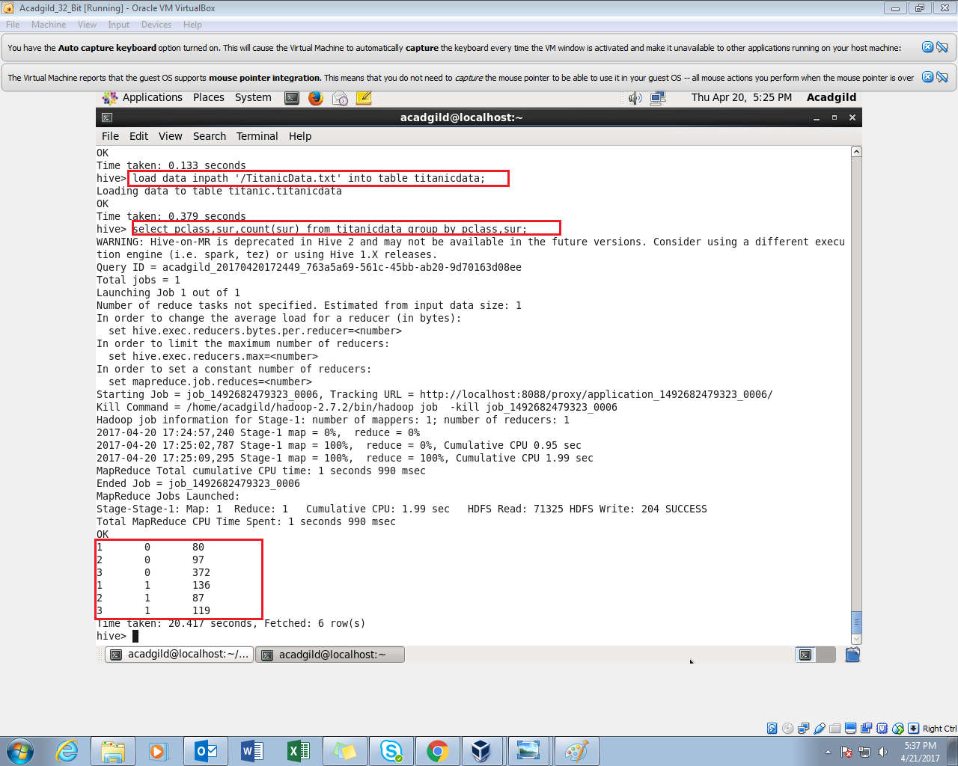

Here I Have groubed by both class as well as the survived/died condition. Hence we get the output as above.

For each class we survived and died.