Find out the average HP (Hit points) of all the Pokémons

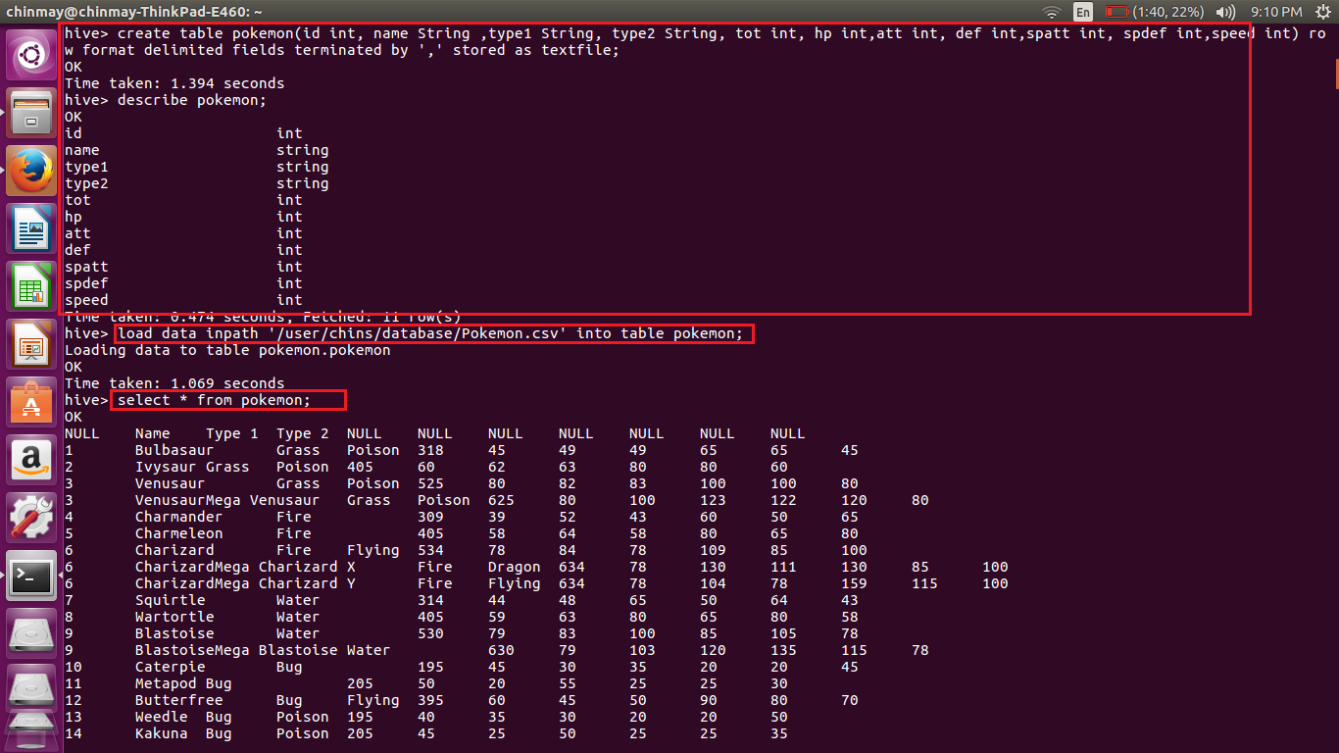

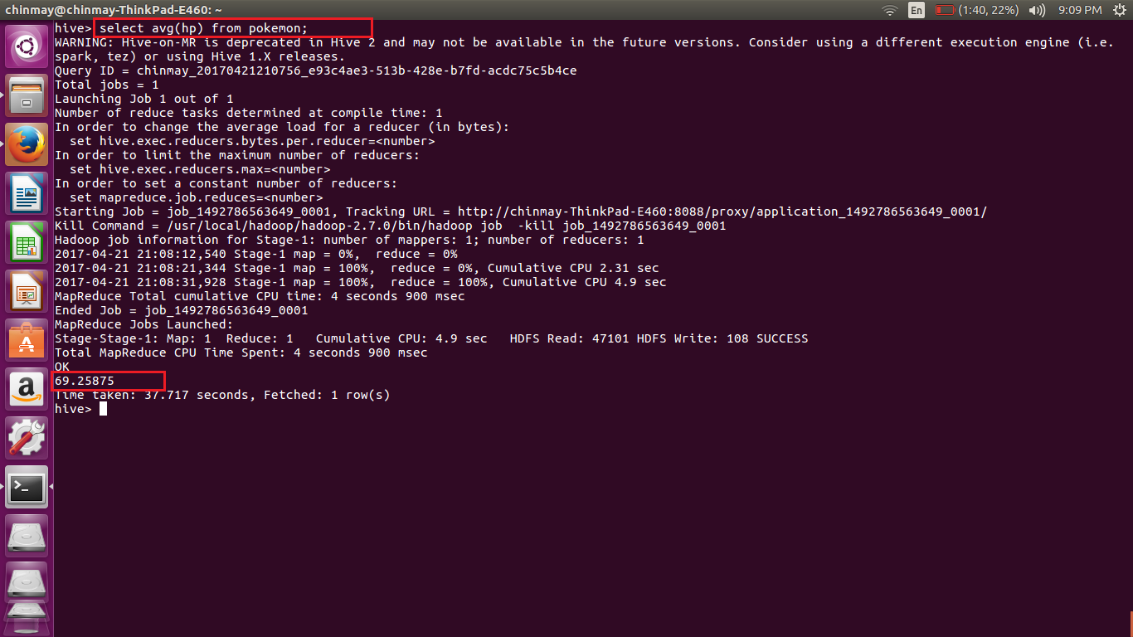

Find out the average Defense of all the pokemon

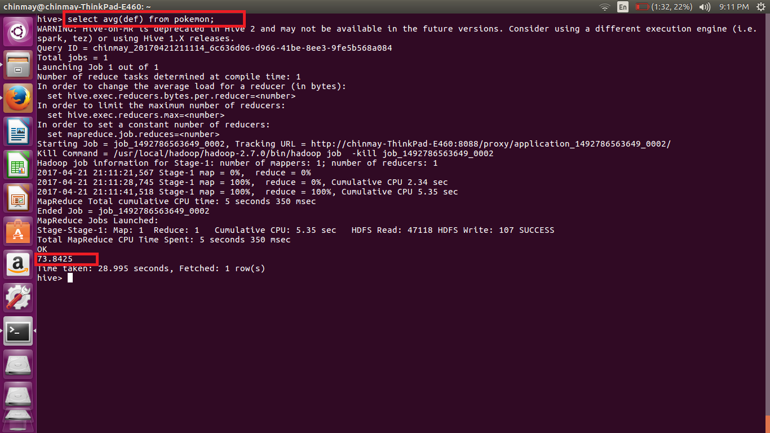

3. Find out the average Sp.Atk of all the pokemons

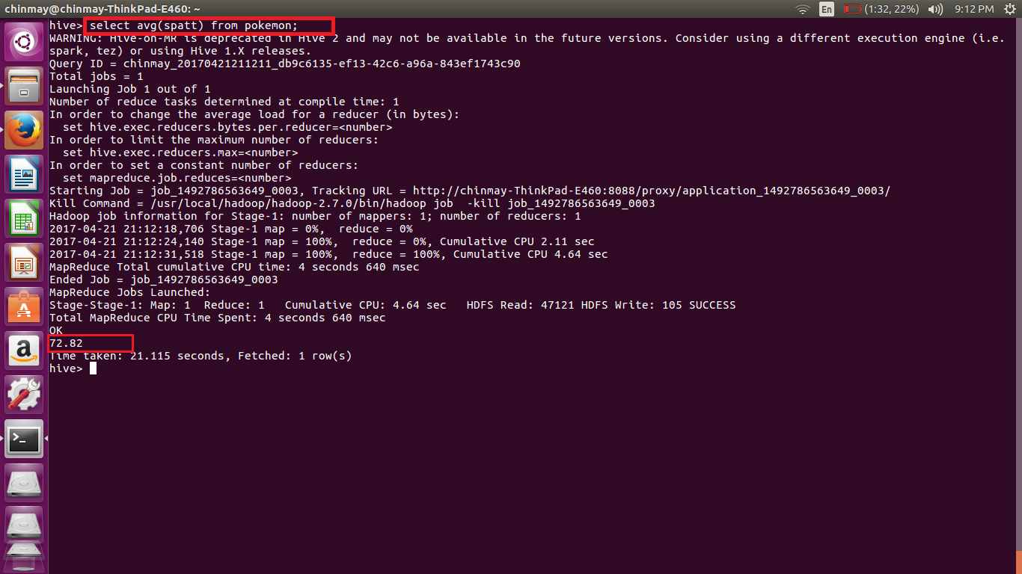

4. Find out the average sp.Def of all the pokemons

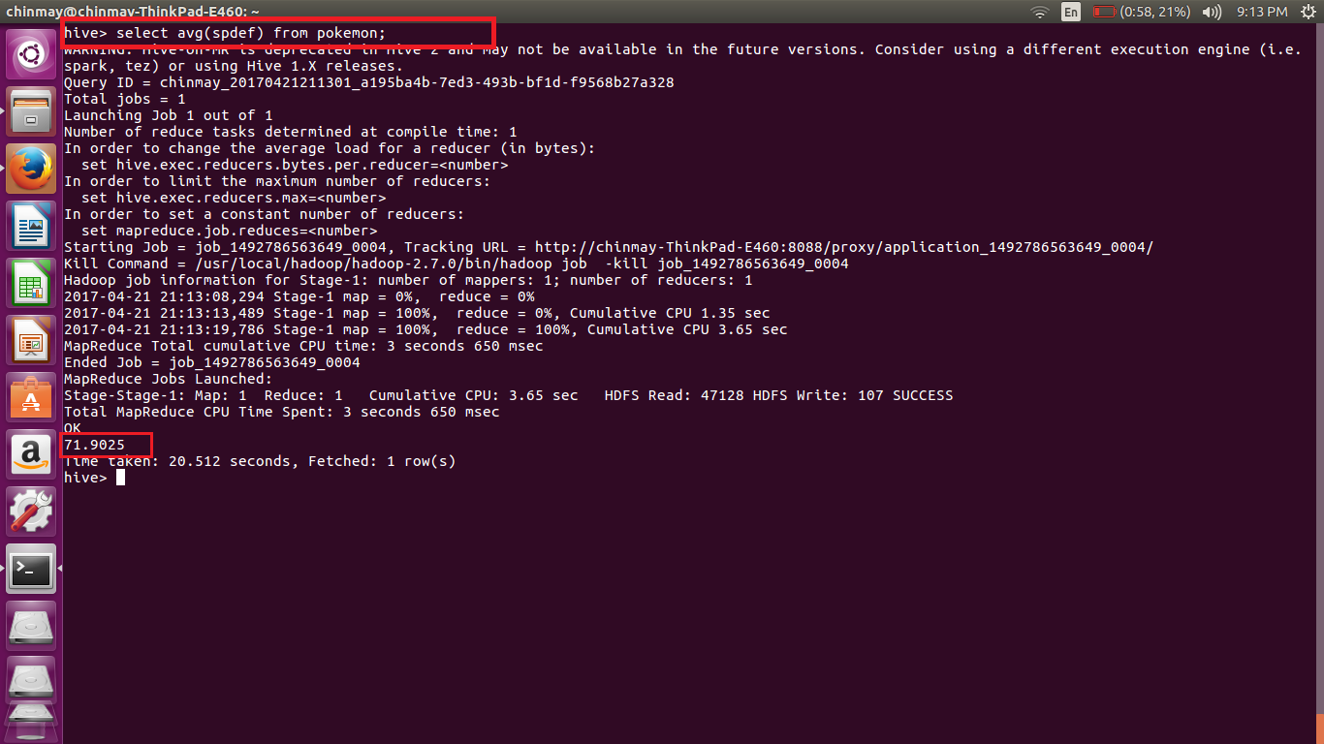

Find out the average Speed of all the pokemons

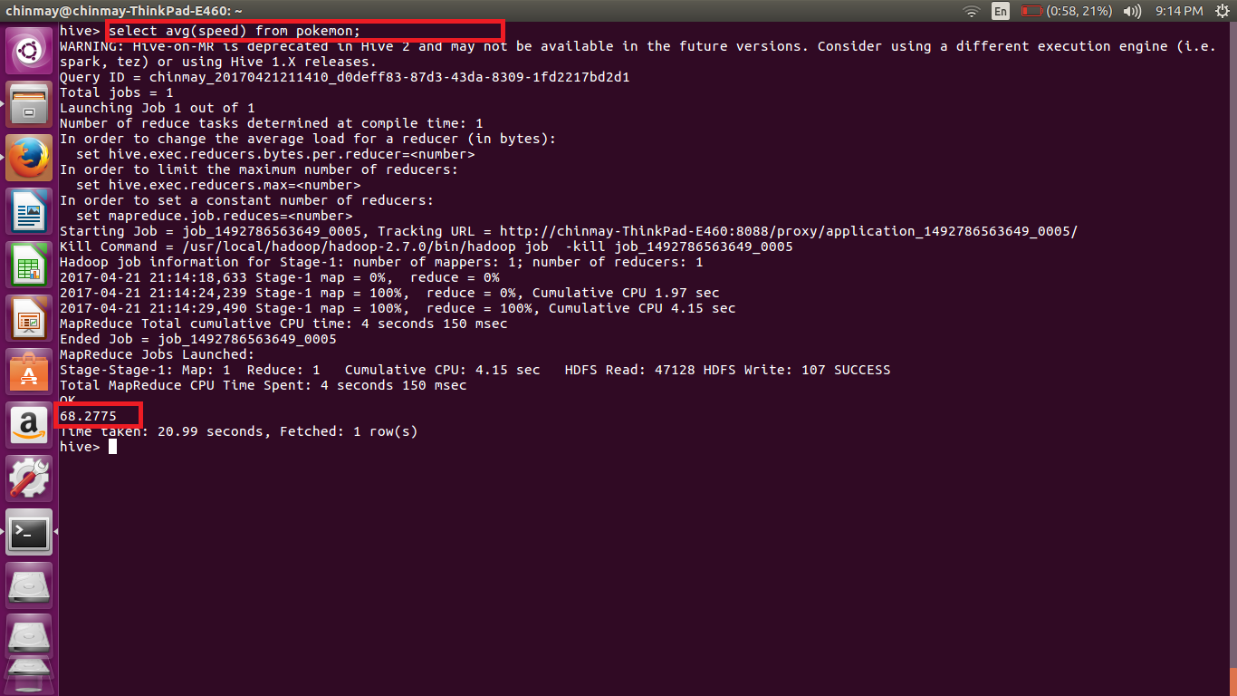

Here we have to generate the avg of different fields so we use the avg function of hive.

Here I am displaying only the avg() only

The command used is

***Select avg(“FIELD”) from pokemon;***