Q .Write a Hive program to find the number of medals won by each country in swimming.

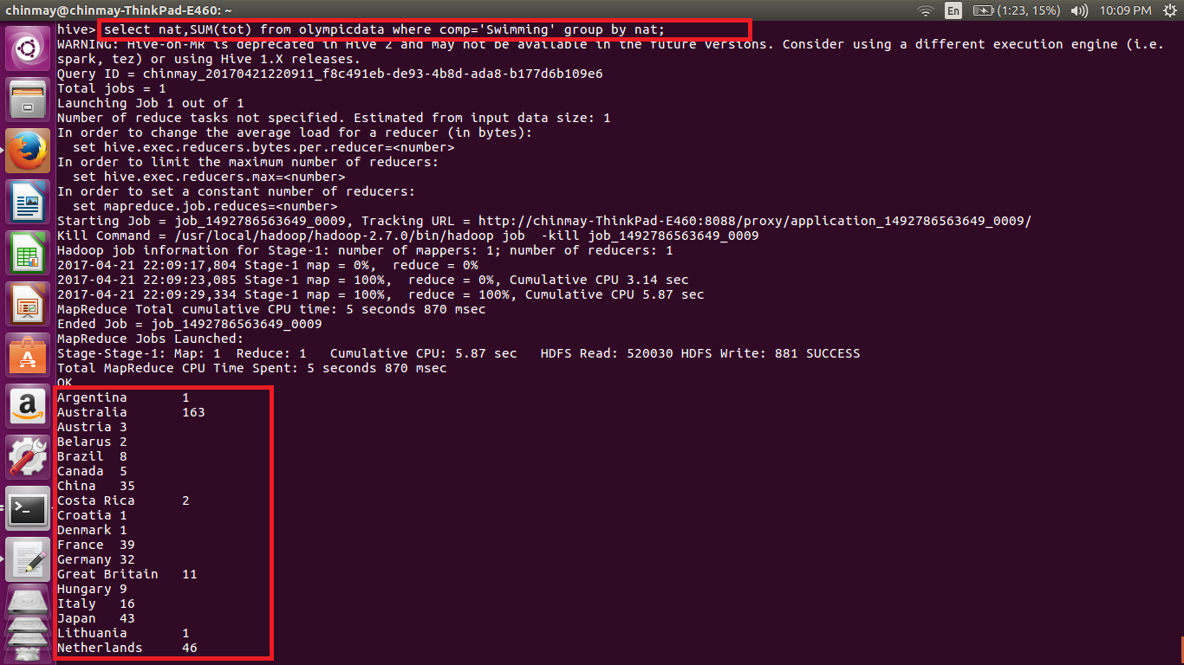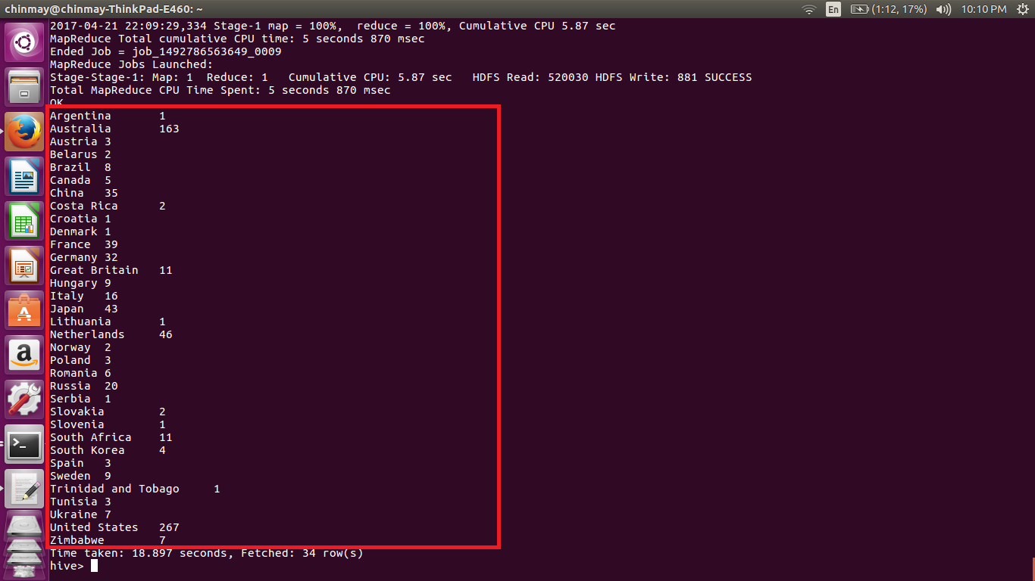

Here I have displayed the nationality and the sum of all the total medals and grouping it with the nationality so that we get the number of medals won by each nation. Also filtered the output by using the where clause.

Q Write a Hive program to find the number of medals that India won year wise.

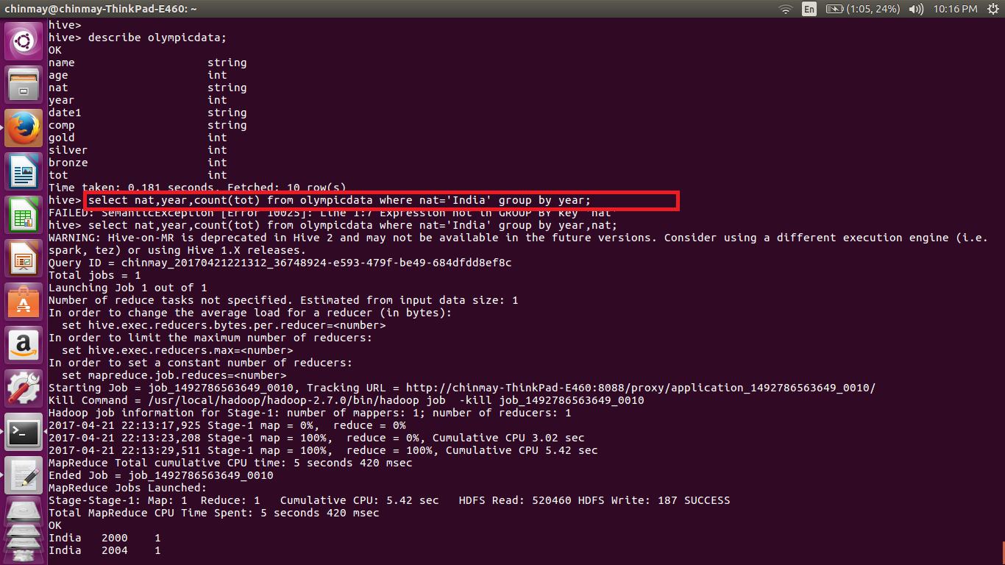

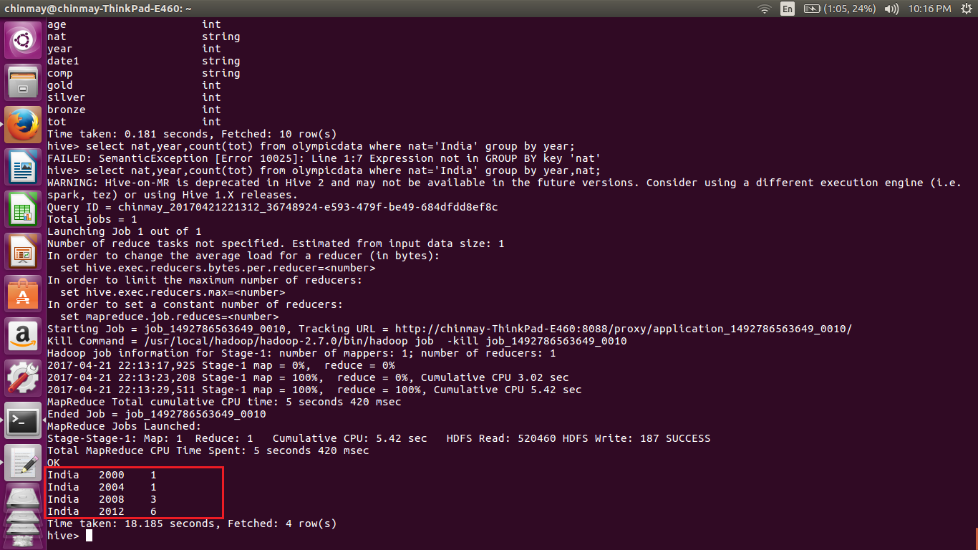

In this we are displaying the nationality ,year, and the count of total medals. We have filtered the data by limiting the values only to country INDIA using the where clause. And grouping is done using the year.