Write a Hive Program to find the total number of medals each country won

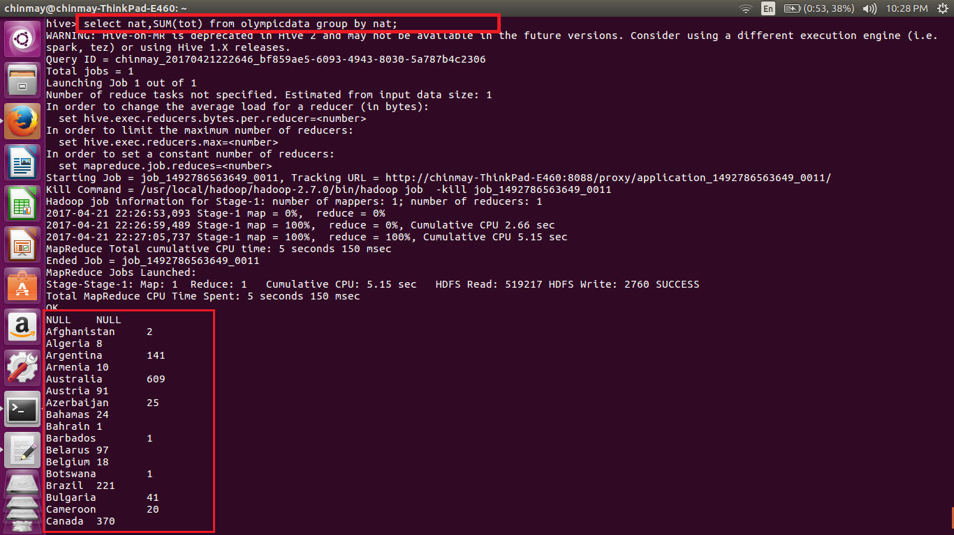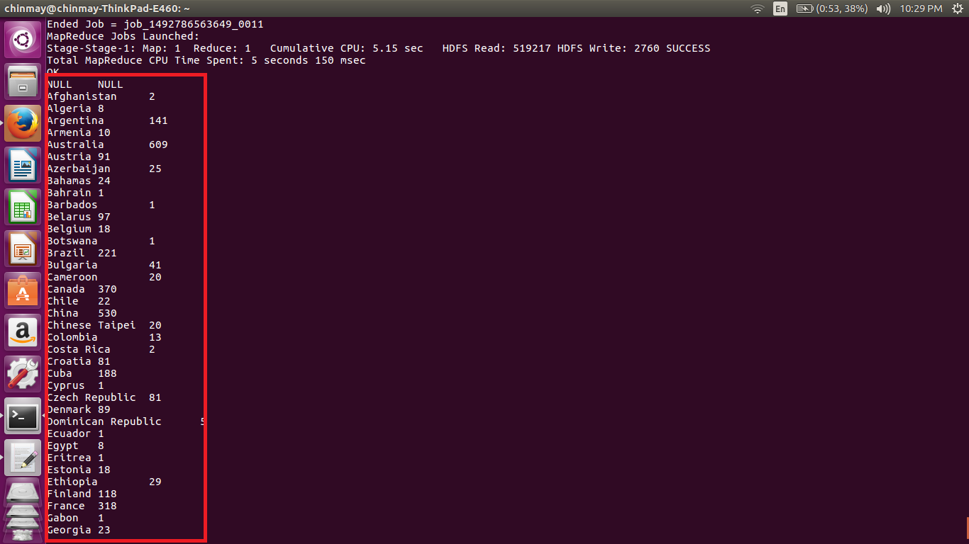

Here we are Displaying the nationality and sum of all the medals won and grouping by nation we will get the medals won by each nation.

Write a Hive program to find the number of gold medals each country won

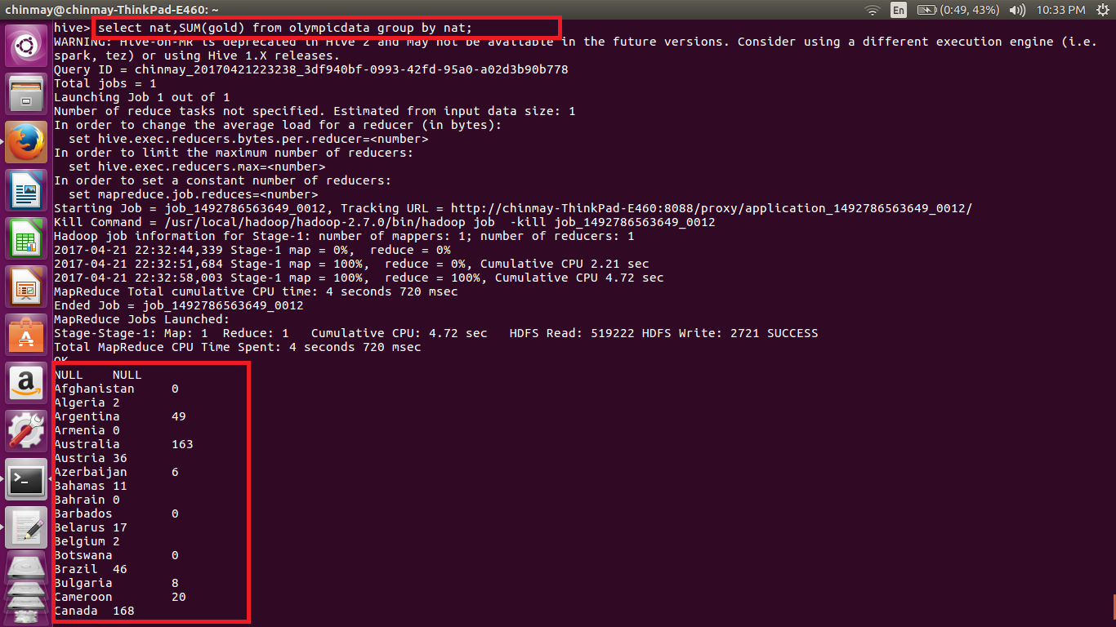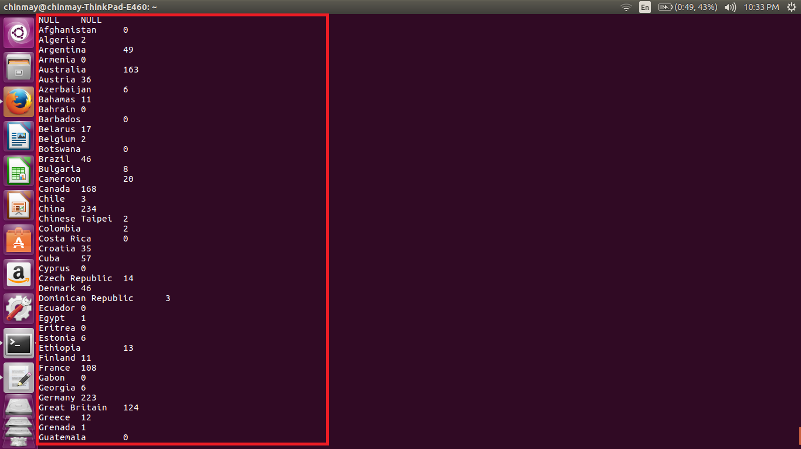

Here we have used the same code to get the number of gold medals. The only change here is in the SUM() function we are passing the gold as argument which is the field containing the gold medals won by each induvidual.